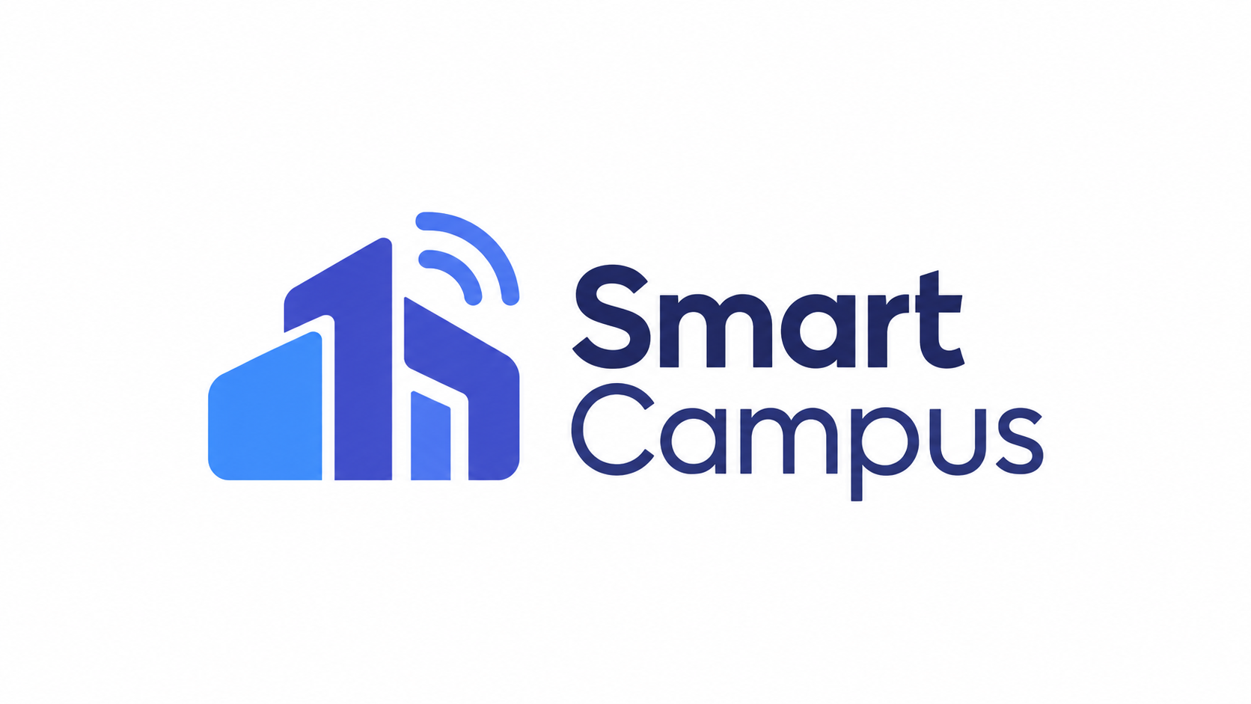
United International University

FINAL PROJECT REPORT
Smart Campus
Advanced Object Oriented Programming Project

Group Name | [LEAVE PLACEHOLDER]
Group Members | [LEAVE PLACEHOLDER FOR MEMBER NAMES AND IDS]
Course Code | [LEAVE PLACEHOLDER]
Section | [LEAVE PLACEHOLDER]
Trimester | [LEAVE PLACEHOLDER]
Submitted To | [LEAVE PLACEHOLDER]
Project Title | Smart Campus
Submission Type | Final Project Report

1. Introduction
Smart Campus is a role-based campus management and digital operations platform for a university environment. The system integrates academic activities, administrative supervision, student services, teacher workflows and security operations through a single Spring Boot backend and React frontend.
The application supports four primary roles: Admin, Teacher, Student and Security. Each role receives a dedicated dashboard with its own navigation and authorized functions, while the data and services are coordinated through the same backend system.
The project is designed as an Advanced Object Oriented Programming implementation. It combines persistent domain models, service-layer business logic, role-based security, REST APIs, collection-based processing, background simulation and socket-based shuttle telemetry in one campus-oriented application.

A. Objective
- Centralize academic, administrative, campus-service and security operations in one platform.
- Provide role-specific dashboards and authorization for Admin, Teacher, Student and Security users.
- Support schedule, roster, attendance and absence-excuse workflows.
- Provide campus communication through notices, announcements and user notifications.
- Represent emergency, visitor, gate, parking and incident-management workflows for campus security.
- Show shuttle visibility through a simulated bus/socket feed and OpenStreetMap visualization.
- Demonstrate Advanced OOP and Java concepts including encapsulation, layered design, collections, persistence, exception handling, threading and socket networking.
- Provide CampusAI as an authenticated campus assistant using current role/project context where configured.

B. Background and Motivation
University activities often depend on separate systems for academic administration, classroom scheduling, communication, transport, resource booking, student support, visitor management and security response. When these workflows are disconnected, users must move between several tools and information can become difficult to track.
Smart Campus addresses this issue by combining representative workflows into one integrated project. The motivation is not to claim production deployment, real GPS hardware or physical IoT integration, but to demonstrate how a campus digital twin can be modeled with object-oriented entities, services and secure role-based interfaces.

2. Project Description
The project follows a layered full-stack architecture:
- React and Vite frontend with Lucide React icons and Leaflet/OpenStreetMap for shuttle visualization.
- Spring Boot REST backend using Java 21, Spring Security, service classes and controllers.
- Spring Data JPA and Hibernate for persistence through repository interfaces.
- Current runtime database configuration: H2 in-memory database at jdbc:h2:mem:smart_campus_db;MODE=MySQL, with the H2 console enabled. The Maven project also includes the MySQL connector, but the latest application.properties uses H2 for the current local runtime.
- Session-based authentication and role-based authorization for dashboard and API access.
- CampusAI endpoint and widget, backed by a configurable Gemini/OpenAI-compatible API gateway when an API key is provided.
- Background campus telemetry simulation and TCP socket-based bus telemetry simulation.
The backend uses controllers for authentication, dashboards, admin operations, teacher workflows, student portal features, security operations, emergency alerts, notifications, file upload and chatbot requests. Service classes keep business operations separate from controllers, while models such as User, TeachingSchedule, AttendanceSession, CampusVisitor, EmergencyAlert, MaintenanceComplaint, Bus, BusRoute and LabEquipment represent the main domain objects.

Major Features by Role

Admin
Feature Group | Verified Scope
Dashboard Overview | Shows campus telemetry, active rooms, buses, maintenance queue, audit stack and administrative metrics.
User / Student / Teacher Management | Provides account, role, active-status, profile and academic-user management screens.
Academic Setup | Maintains departments, courses, buildings and classrooms through admin-only endpoints.
Academic Operations | Manages class schedules, active-class monitoring, attendance monitoring and room reservations.
Campus Operations | Groups visitor, lost and found, events, cafeteria, parking and transport management.
Lab & Equipment | Lists lab hardware and reviews student equipment booking requests.
Smart Classrooms | Displays classroom capacity, occupancy and simulated power-use status.
Communication / Notices | Publishes campus notices and role-targeted announcements with notification fan-out.
Maintenance and Audit Stack | Processes maintenance complaints through queue logic and records administrative actions through a stack-based history.

Teacher
Feature Group | Verified Scope
Faculty Overview | Summarizes next class, teaching schedule, active class status and recent notices.
Schedule and Classes | Displays assigned teaching schedules and class start/end controls.
Student Roster | Lists students enrolled in the teacher's assigned course sections.
Attendance Management | Creates attendance sessions, records statuses and displays attendance history.
Absence Excuse Review | Allows teachers to review student-submitted absence excuses.
Office Hours & Queries | Manages office-hour slots and booking status with locking for concurrent booking attempts.
Room Reservation | Allows room reservation requests using available-room data.
Announcements and Issues | Publishes class-targeted announcements and reports maintenance issues.
Notifications | Shows teacher-specific notifications from system workflows.

Student
Feature Group | Verified Scope
Student Overview | Shows student campus summary, next class, attendance summary, tickets and appointments.
Class Schedule | Displays enrolled courses, section, room and timing information.
Attendance & Excuses | Shows attendance summaries and supports absence-excuse submission.
Faculty Office Hours | Allows students to browse and book faculty office-hour slots.
Lab / Equipment Booking | Lists available hardware and supports equipment booking requests.
Lost & Found, Events and Cafeteria | Provides student-facing campus-service boards and menus.
Shuttle Fleet | Shows simulated shuttle routes and live-feeling location updates on OpenStreetMap.
Support Tickets and Notifications | Lets students submit maintenance/support tickets and view notification updates.
Emergency Information | Displays active emergency information through the shared emergency banner and related APIs.

Security
Feature Group | Verified Scope
Security Overview | Summarizes visitors, incidents, parking occupancy, gate counts and emergency state.
Visitor and Pass Management | Reviews visitor requests and manages visitor pass status.
Pass Verification and Gate Terminal | Supports pass verification and gate access logging workflows.
Parking Control | Displays parking zones, occupancy and operational status.
Emergency Command | Broadcasts and tracks emergency alerts.
Incident Management | Records and reviews security incidents with status and severity.
Security Map / Operational View | Provides an operational campus map view for security monitoring.
Bus Fleet and Notifications | Shows bus-fleet status and role-specific notification updates.

CampusAI
CampusAI is implemented as an authenticated dashboard chatbot. The backend builds a role-aware context that may include current user details, campus telemetry, notices, bus locations and role-specific dashboard data. The chatbot service sends that context to a configurable Gemini or OpenAI-compatible gateway when GEMINI_API_KEY and related properties are available.
CampusAI should therefore be described as a context-assisted campus assistant, not an omniscient system. If the AI service is not configured, the implemented service returns a clear configuration message rather than inventing answers.

Advanced OOP and Java Course Concepts
- Encapsulation is visible across model classes such as User, Classroom, BusRoute, MaintenanceComplaint and AttendanceSession, where data is represented through fields and accessors.
- Layered object-oriented architecture separates controllers, services, repositories, DTOs and domain models.
- Collections are used for campus workflows: Queue for FIFO maintenance complaint processing, Stack for administrative action history and Set for unique gate/student check-in tracking.
- Threading is implemented through CampusSimulationWorker, which runs a background daemon thread to update simulated campus telemetry.
- Socket networking is implemented through BusServerSocketManager and BusClientSimulator for simulated shuttle telemetry packets.
- Persistence is handled with Spring Data JPA/Hibernate repositories over the current H2 in-memory database configuration.
- Exception and validation handling appear in API error responses, service validation and controller-level exception handling.
- Role-based security is implemented through Spring Security, BCrypt password hashing, session login and route/API authorization rules.

3. Key Screenshots
The following screenshots were captured from the current running application using the seeded demo accounts. They are representative major-feature views rather than a complete capture of every small button or sub-feature.
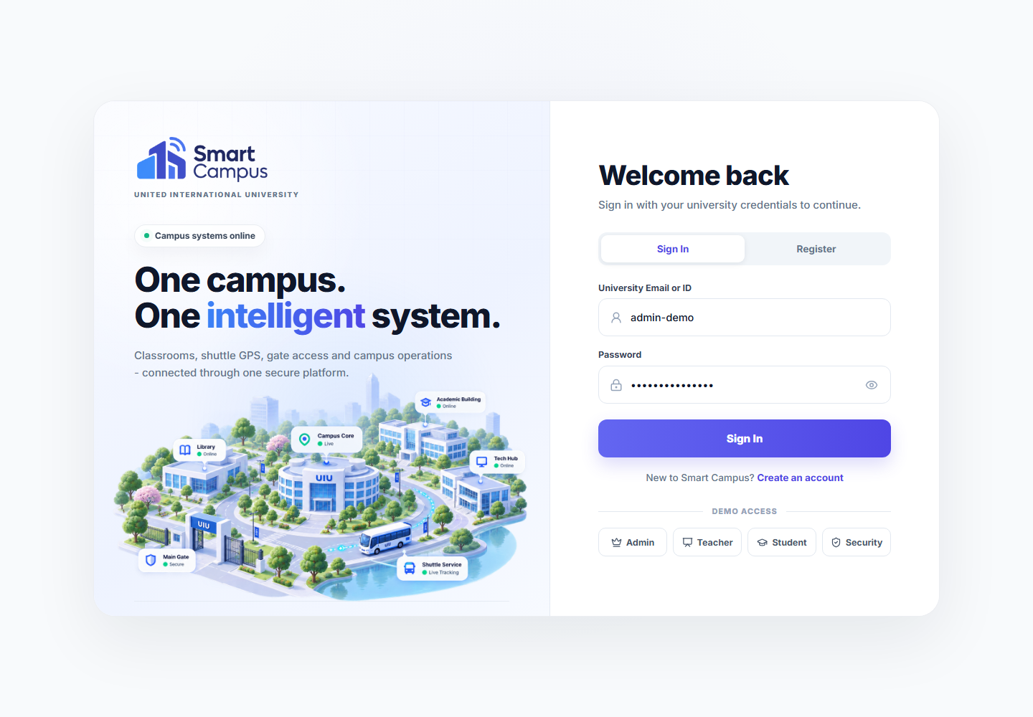
Fig 1: Login and Authentication - Role-based sign-in screen with demo access for Admin, Teacher, Student and Security users.
Summary: This screen represents the entry point of Smart Campus. It provides session-based sign-in for existing users and demo access for the four implemented roles, allowing the system to route Admin, Teacher, Student and Security users to their authorized dashboards. This feature is necessary because the project depends on role-specific access rather than one common interface for all users.

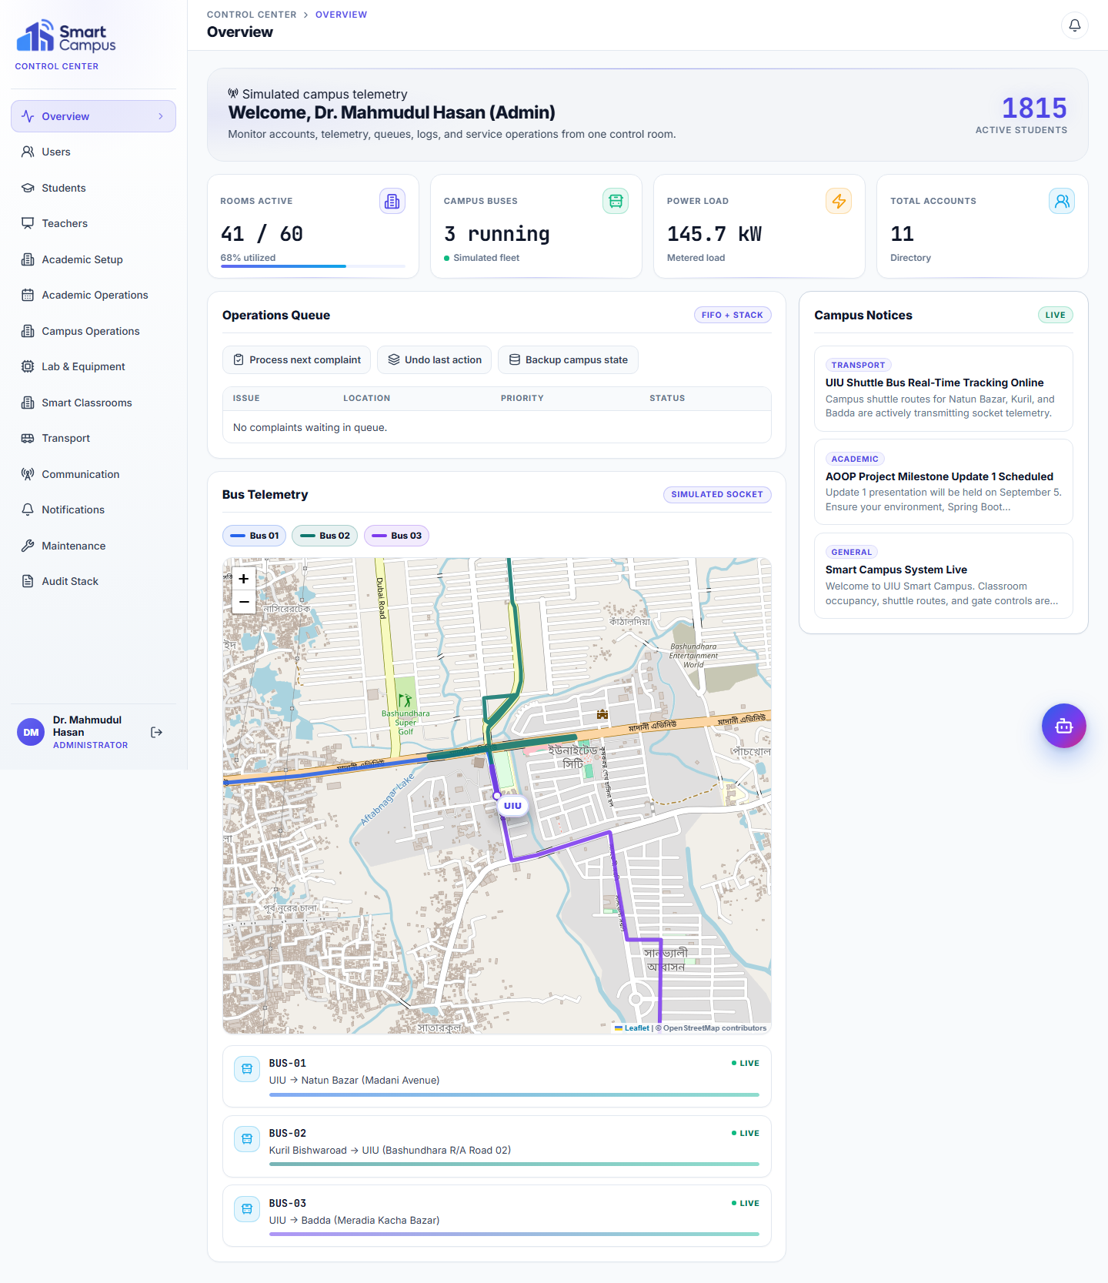
Fig 2: Admin Overview Dashboard - Campus telemetry, maintenance queue, audit stack and administrative summary information.
Summary: The Admin overview works as a central control panel for campus operations. It combines simulated campus telemetry, maintenance queue status, audit-stack actions, campus notices and shuttle information so an administrator can quickly understand the current system state. The feature connects academic administration with operational monitoring in one dashboard.

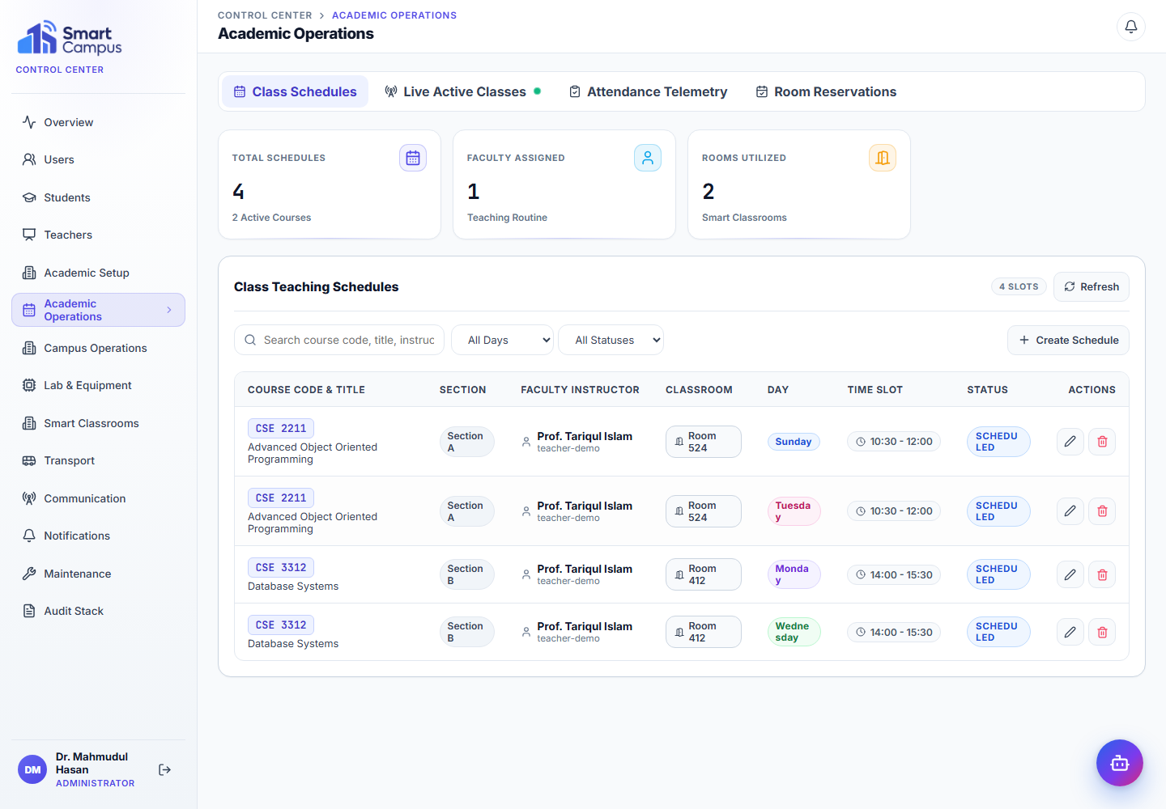
Fig 3: Admin Academic Operations - Schedule, attendance and classroom reservation monitoring for academic administration.
Summary: The Academic Operations area supports administrative supervision of schedules, active classes, attendance monitoring and room reservations. It is important because academic activities depend on accurate class, room and attendance records. In the project, this section is backed by Spring Boot services and JPA-managed entities for schedules, sessions and reservations.
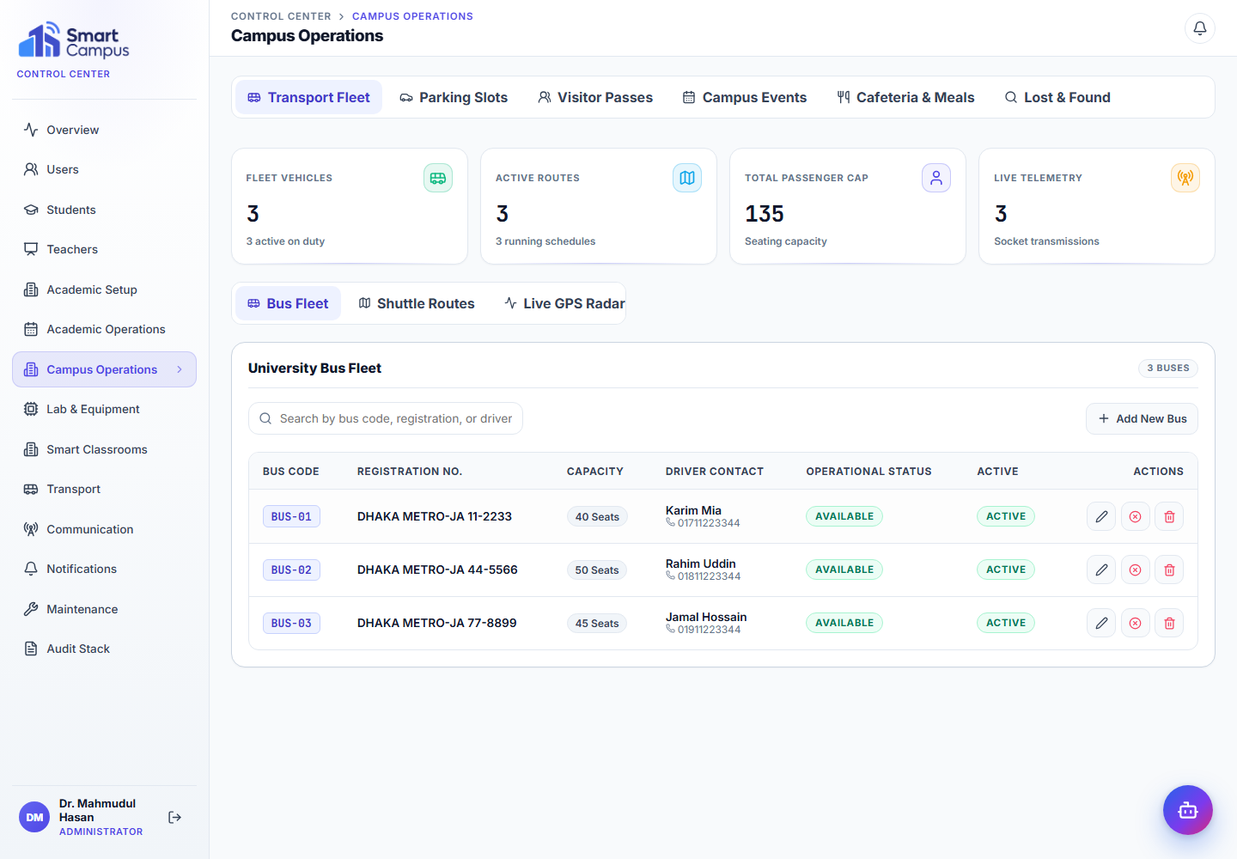
Fig 4: Admin Campus Operations - Visitor, lost and found, events, cafeteria, parking and transport management areas.
Summary: Campus Operations groups non-academic services such as visitors, lost and found, events, cafeteria, parking and transport. This feature is included because a smart campus platform should also represent daily campus services that affect students, staff and administration. The screen shows how these service areas are organized under one admin workflow.

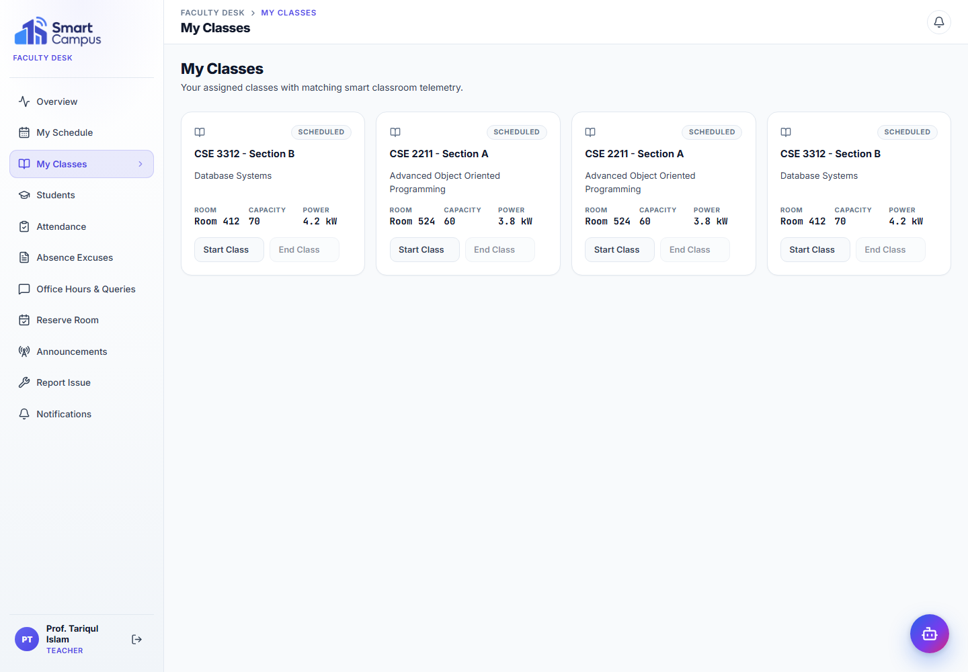
Fig 5: Teacher Classes - Faculty class control for scheduled courses and active class status.
Summary: The Teacher Classes screen allows a faculty user to view assigned classes and manage class state. This is needed because teachers require a focused workspace separate from administrative controls. The feature connects teaching schedules with class-session actions, helping the system track whether a class is scheduled, active or completed.
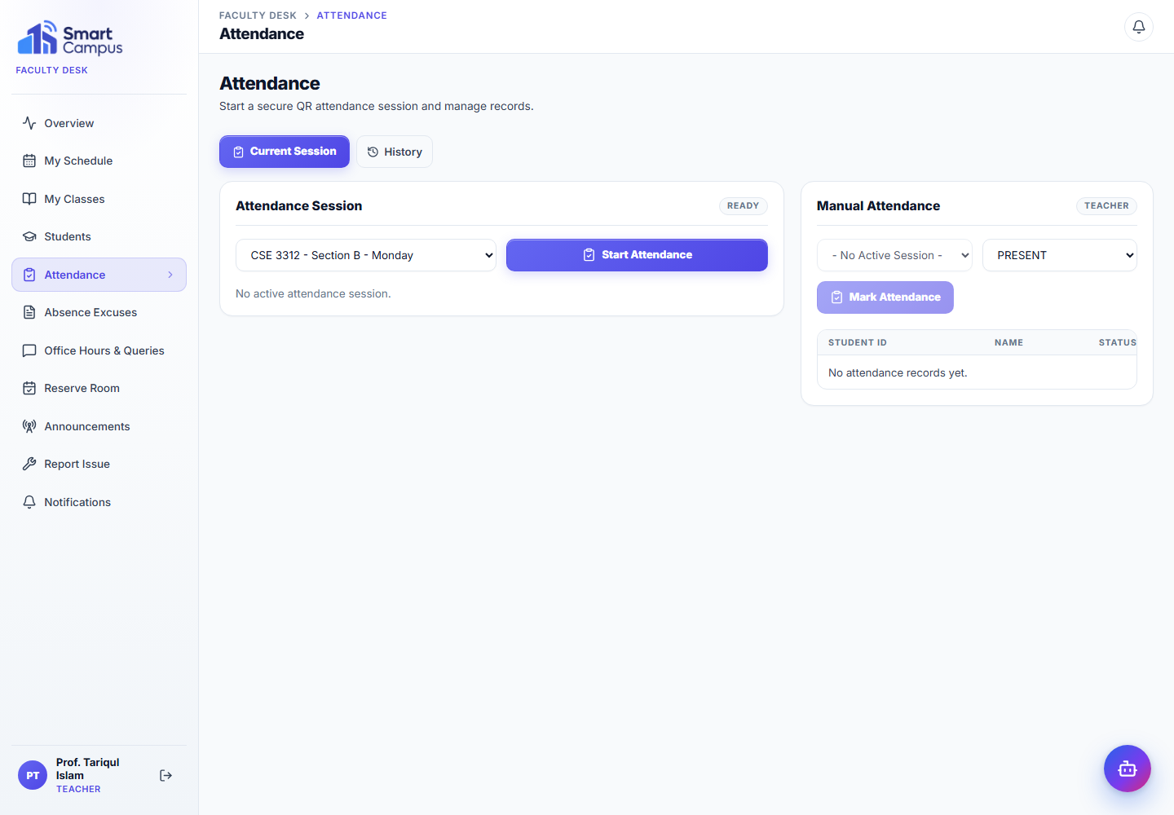
Fig 6: Teacher Attendance Management - Attendance sessions, student records and attendance-history workflow.
Summary: The Attendance Management screen lets teachers create attendance sessions, review enrolled students and record attendance status. This feature is central to the academic workflow because attendance data is used by both teachers and students. In the backend, attendance sessions and records are persisted as separate objects, demonstrating a clean object-oriented model.

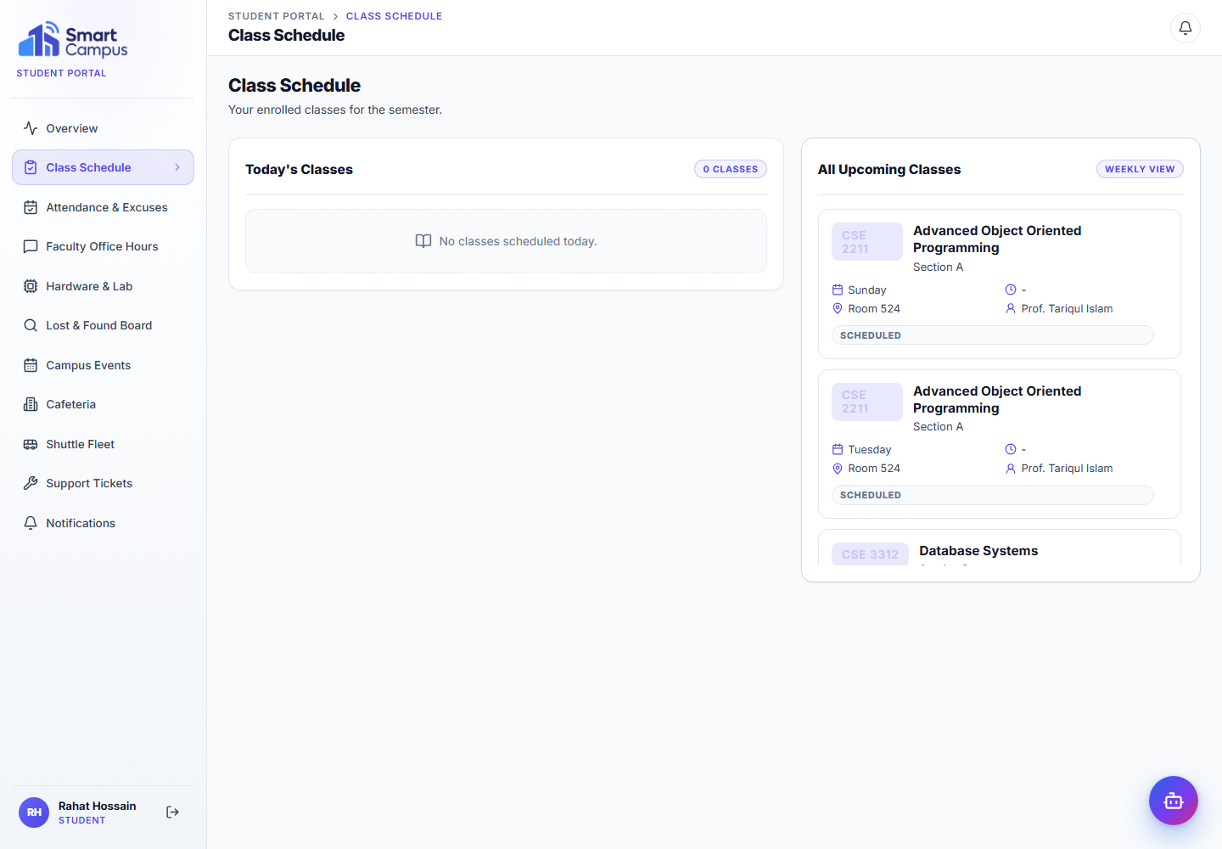
Fig 7: Student Class Schedule - Student academic schedule and course information shown in the learner portal.
Summary: The Student Class Schedule screen shows the learner's enrolled course schedule, including course, section, room and timing information. It is useful because students need a simple place to check academic routine information without accessing teacher or admin-only tools. The schedule is generated from enrollment and teaching-schedule data.
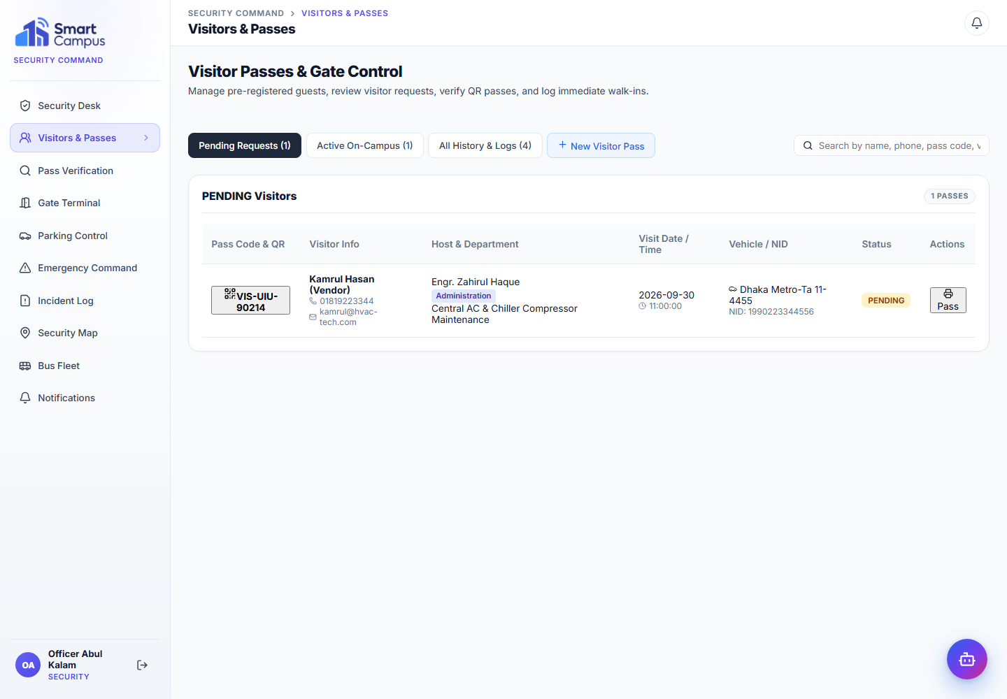
Fig 8: Security Visitor and Pass Management - Visitor requests, pass status and gate-facing operational data.
Summary: The Security visitor and pass-management screen supports reviewing visitor information and tracking pass status. This feature is needed for campus access control because visitor approval, check-in and pass verification are security-facing operations. The implementation uses security-specific dashboard routes and backend services so these functions remain separate from student and teacher workflows.

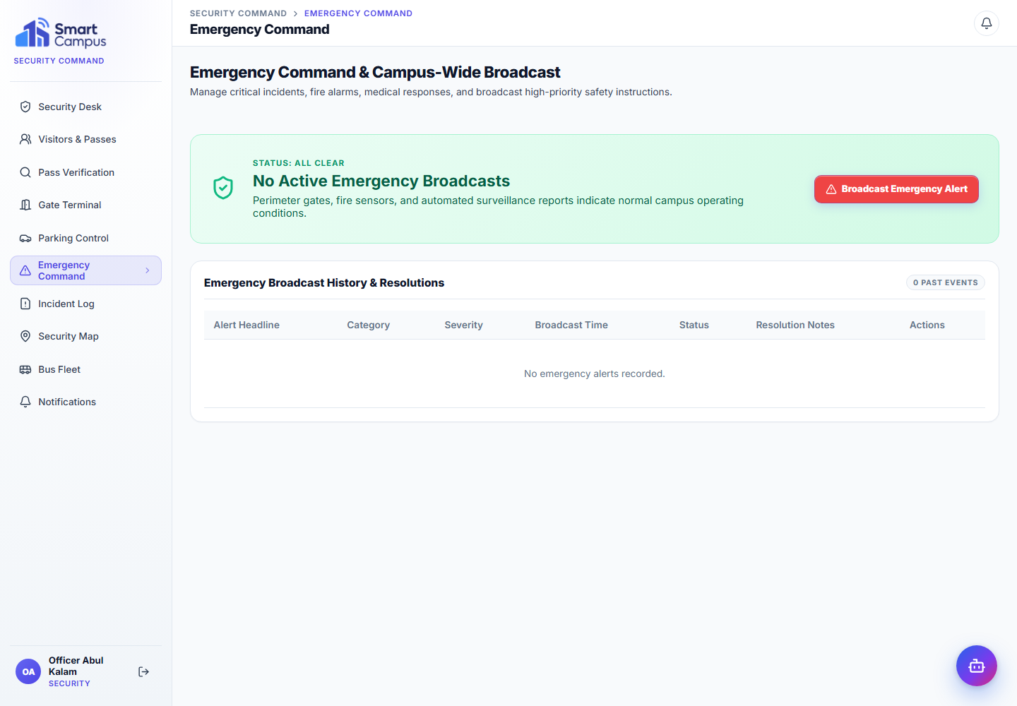
Fig 9: Emergency Command - Security emergency broadcast and current alert-management workflow.
Summary: The Emergency Command screen is used by security staff to broadcast and manage emergency alerts. This feature is important because urgent campus information must be visible across the system quickly. In the project, emergency alerts are stored through backend entities and can be surfaced to authenticated users through the active emergency banner.

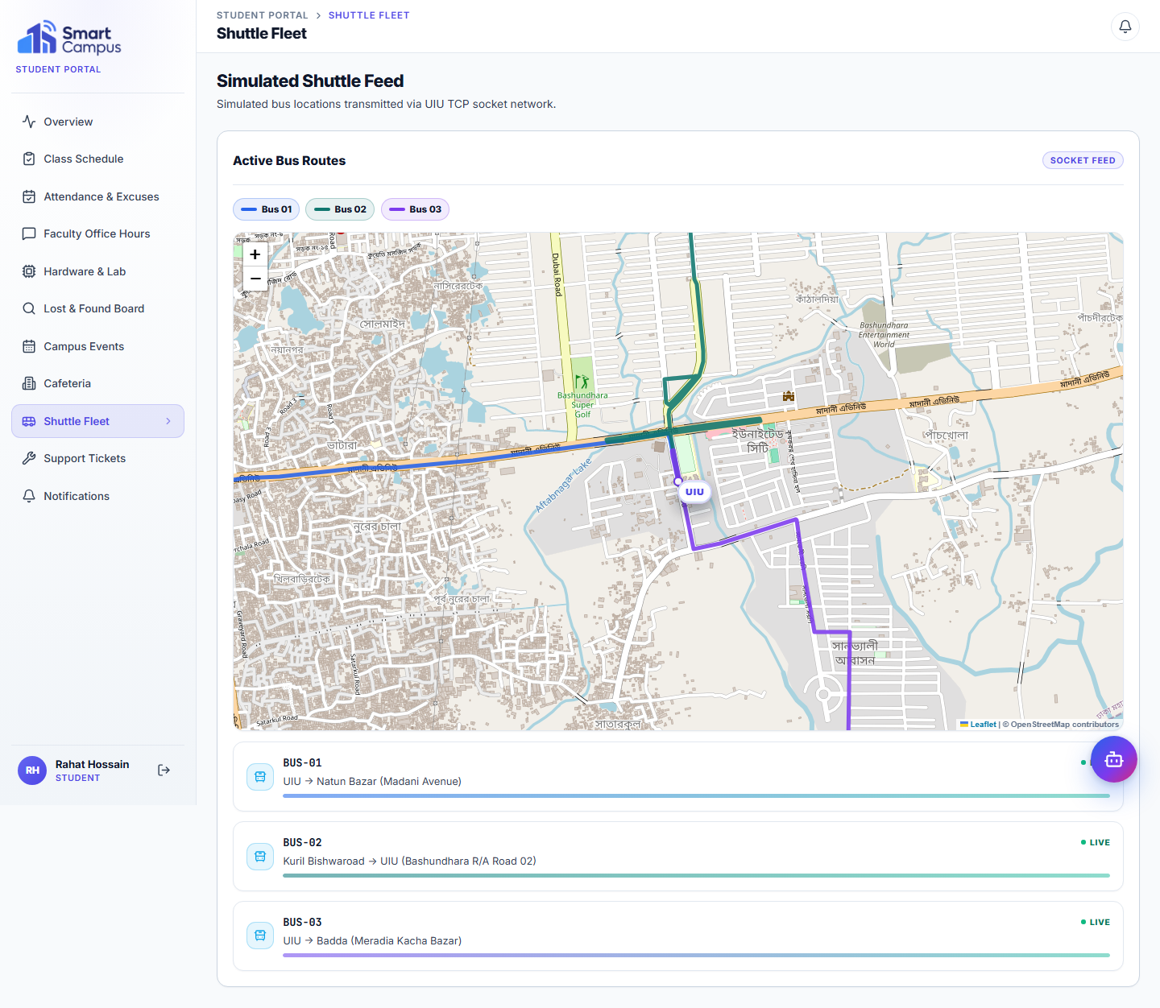
Fig 10: Interactive Shuttle Fleet - Leaflet/OpenStreetMap visualization of simulated shuttle routes and socket-fed bus status.
Summary: The Shuttle Fleet screen visualizes simulated bus routes on Leaflet/OpenStreetMap. It demonstrates how transport information can be presented to students through a map-based interface, while the backend uses a socket-based simulation for shuttle telemetry. The project does not claim real GPS hardware; it models how such data could be displayed if connected later.

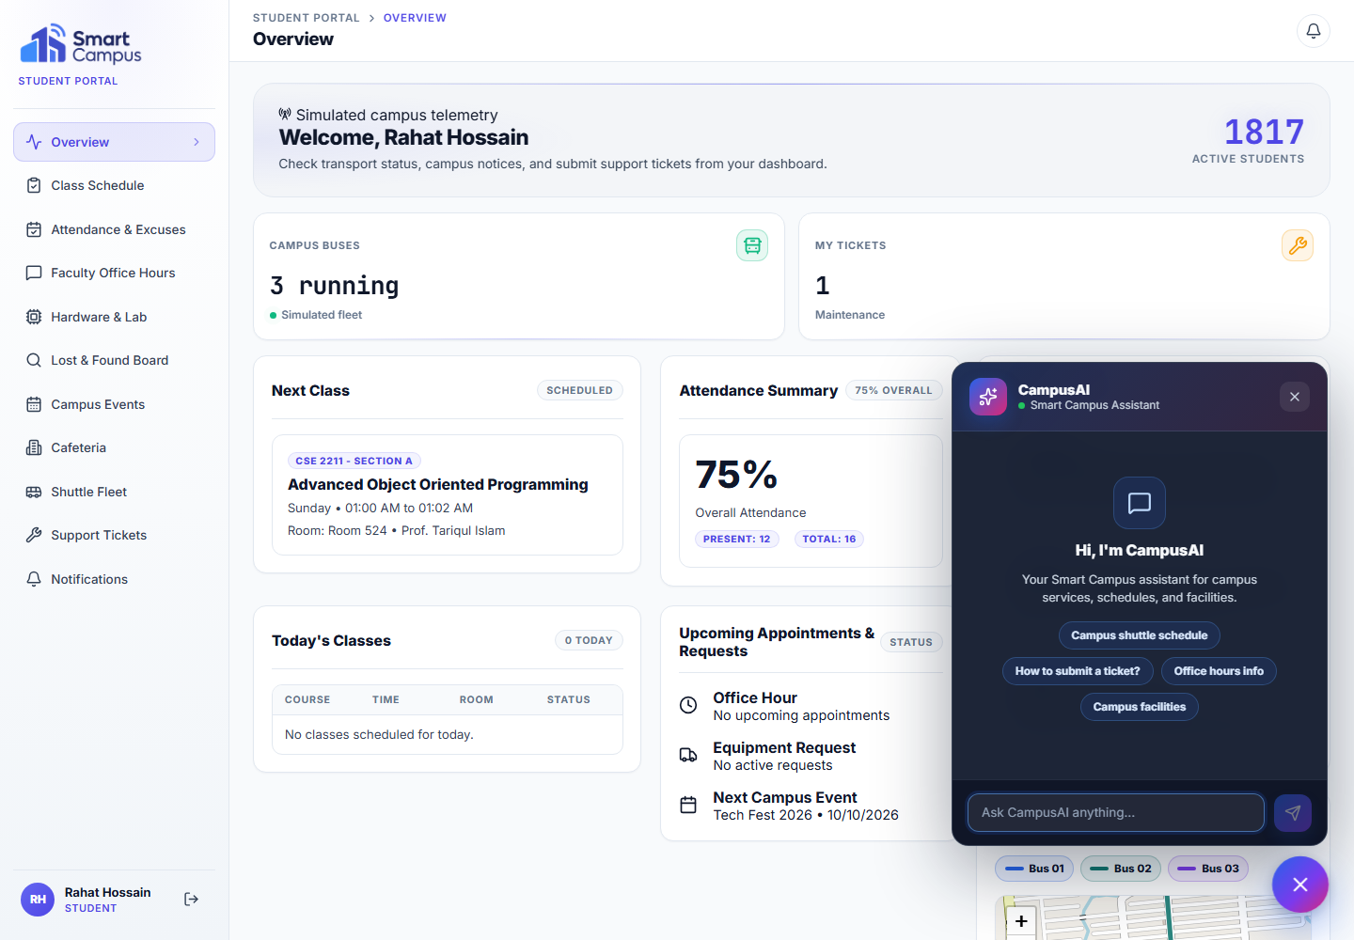
Fig 11: CampusAI Chatbot - Authenticated dashboard assistant panel with role-aware campus assistance prompts.
Summary: CampusAI is the dashboard assistant for answering campus-related questions using authenticated context where available. It is useful because students, teachers and staff may need quick guidance about schedules, campus services or dashboard features. The backend prepares role-aware context and sends it to the configured AI gateway when the required API configuration is present.
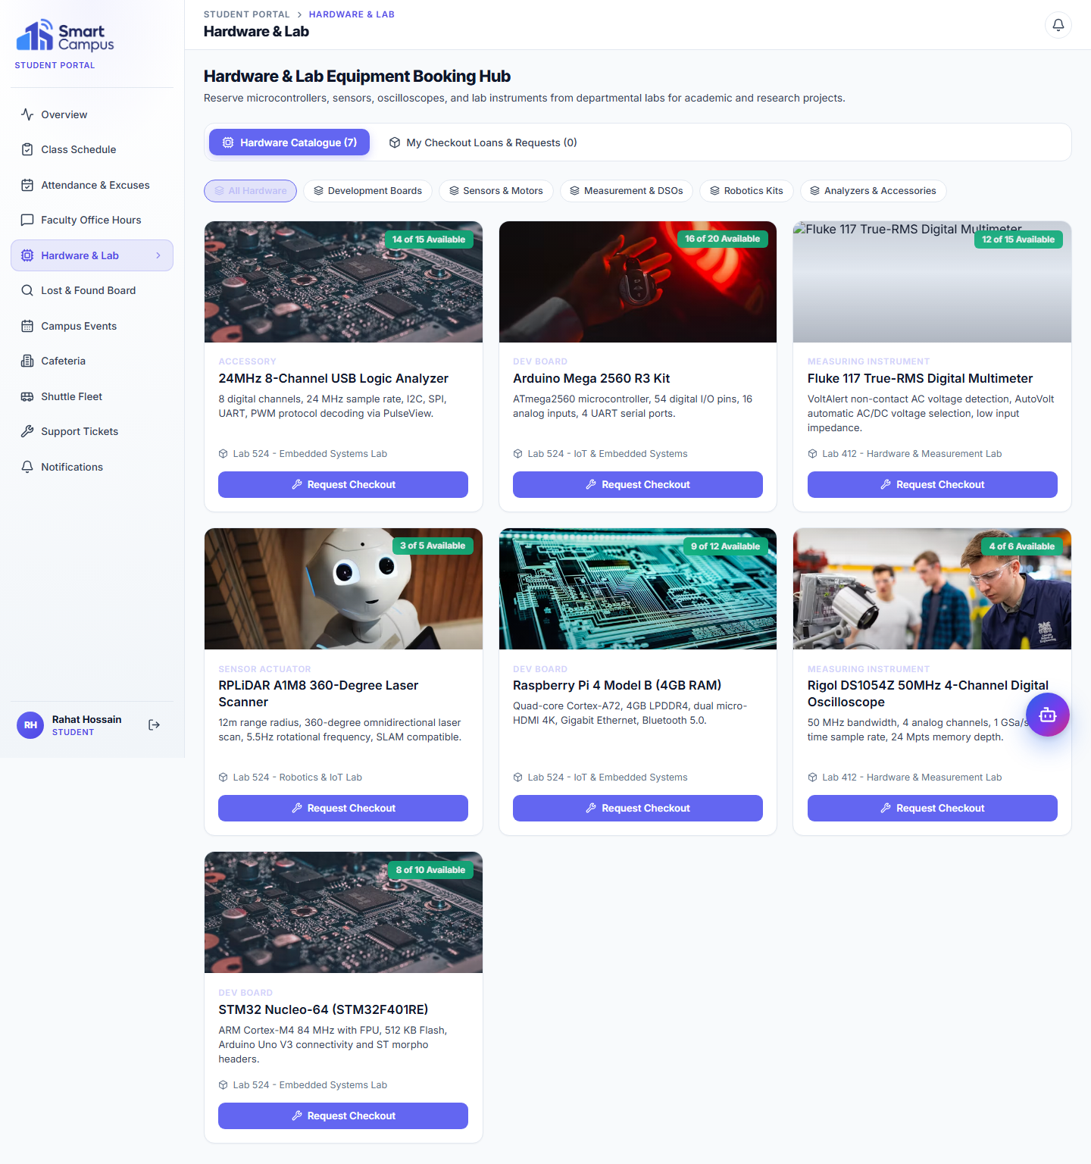
Fig 12: Lab and Equipment Booking - Student hardware catalogue and equipment booking workflow.
Summary: The Lab and Equipment screen allows students to browse available hardware and request equipment bookings. This feature is relevant for a university environment because lab resources need controlled checkout and availability tracking. The workflow connects student requests with admin-side review through persistent objects and service-layer logic.

4. Future Works
- Deploy the system to a cloud or production hosting environment with environment-specific configuration.
- Add persistent cloud file storage for uploads and supporting documents.
- Integrate real GPS hardware for shuttle locations instead of the current simulated socket feed.
- Integrate physical IoT sensors for room occupancy and environmental readings instead of simulated telemetry.
- Add camera-based QR scanning for gate or attendance verification where appropriate.
- Expand analytics, reporting and export features for attendance, transport, maintenance and security data.
- Develop a mobile application for students, teachers and security staff.
- Increase automated test coverage across frontend workflows, security rules and backend services.
- Apply production security hardening, audit review, rate limiting and secret-management practices.

5. Conclusion
Smart Campus demonstrates how academic workflows, student services, teacher operations, administration, campus communication, security response, transport visibility and AI-assisted information access can be combined into one role-based university platform.
The project is especially relevant to Advanced Object Oriented Programming because it connects object modeling with practical Java systems: service-layer design, Spring Security, persistence, collections, threading, socket networking and structured REST APIs. The current application should be understood as a strong academic prototype with simulated telemetry and shuttle data, not as a production deployment or real hardware integration.

