A MULTI-AGENT RETRIEVAL AUGMENTED LEGAL INTELLIGENCE SYSTEM WITH DEBATE-DRIVEN REASONING FOR LEGAL INTELLIGENCE

1st Ramya P  Assistant Professor AI-DS | 2nd Sakthivel V | 3rd Tharun R | 4th Thejasrini M
Kongu Engineering College | Kongu Engineering College | Kongu Engineering College | Kongu Engineering College
(Autonomous) | (Autonomous) | (Autonomous) | (Autonomous)
Perundurai, Erode - 638 060 | Perundurai, Erode - 638 060 | Perundurai, Erode - 638 060 | Perundurai, Erode - 638 060
ramyap.ai@kongu.ac.in | sakthivelv.23aid@kongu.edu | tharunr.23aid@kongu.edu | thejasrinim.23aid@kongu.edu
Abstract — Legal Artificial Intelligence models based on LLMs have shown promise in legal information retrieval, analysis, and assisting with decision making. Legal systems usually use keyword search or static retrieval approaches, which are unable to find semantically related information, to discern between current and outdated versions of the legal provisions, and to deal with conflicting evidences. Single-agent LLM systems tend to make invalid assumptions and have a bias regarding the interpretation of the law. To solve the above-stated problems, we propose a Legal Intelligence and Debate System which would utilize RAG, hybrid retrieval, temporal-aware retrieval, and multi-agent adversarial reasoning techniques. The system analyzes legal questions or cases, retrieves the relevant Acts, Sections, rules, and judgments, and creates the dispute structure through the Case Reasoner module. Then, the Support Agent and the Oppose Agent build the opposing arguments based on the retrieved evidence. The Judge Agent assesses the arguments in the light of the relevance of the evidence, the authoritativeness of the source, citation support, and the coherence of the arguments with the laws. The proposed framework offers three main features: temporal-aware retrieval to select the appropriate version of the law, evidence-weighted debate to evaluate the arguments, and adaptive contradiction analysis to perform additional retrieval in case of conflicting evidences. Our framework includes a deterministic grounding layer which ensures the correctness of citations with regard to the knowledge base of the laws.
Keywords — Legal Reasoning, Adversarial Legal Debate, Evidence Grounding, Legal Judgment Reasoning, Hybrid Information Retrieval, Citation Verification.
I. INTRODUCTION

A. Background
The evolution of Artificial Intelligence (AI), Natural Language Processing (NLP), Large Language Models (LLMs), and Retrieval-Augmented Generation (RAG) has led to new ways of conducting legal information retrieval and case analysis. Traditionally, legal research needs users to conduct manual searches of Acts, Sections, rules and even judicial precedents, which is tedious and takes time, with a need to have deep legal expertise. AI-powered legal systems can save one's efforts in understanding natural-language queries and retrieve relevant legal information. Using retrieval-augmented generation, LLMs can utilize information from an external legal knowledge base while generating responses. Furthermore, the process of retrieval can be enhanced with hybrid retrieval, which would combine both semantic and keyword retrieval to find relevant legal documents. However, the process of legal reasoning requires not just finding similar documents, but also taking into account their amendment history, validity period, source authority, as well as connection to the case under discussion.
To solve these issues, the current work proposes an AI-Powered Legal Intelligence and Debate System for the analysis of legal cases. It will include legal query understanding, hybrid retrieval and RAG, temporal-aware legal retrieval, multi-agent debate, evidence evaluation, contradiction analysis, adaptive reasoning, and citation grounding. To conduct the analysis of a legal dispute based on cases, the system will include such entities as Case Reasoner, Support Counsel, Oppose Counsel, and Judicial Bench.

B. Problem Statement
Present legal systems concentrate either on the keyword-based search, document retrieval, legal question answering, or judgment prediction, which are mostly independent tasks. Users are also likely to search through several legal documents to obtain the appropriate laws and precedents. Keyword-based searching does not cover the complete sense of a legal query, and the retrieval system might ignore the authority, validity, and context of the retrieved provisions.
Legal information evolves through amendments, replacement, and invalidity of legal provisions. The retrieval system that works on a static model will return the outdated and unsuitable legal provisions. Moreover, LLM-based systems could produce the unsupportable legal citations and claims as there will be no valid evidence for them.
There are arguments of the opposite parties, incomplete evidence, and the conflict of legal provisions in legal disputes. Hence, presenting the response produced by a system could miss various angles of legal dispute. There is, therefore, a necessity for the system which could retrieve the legal information, analyze the arguments of supporting and opposite sides, validate the evidence, detect the conflict, perform additional search when necessary, and validate citations before presenting the final legal opinion.

C. Research Motivation
The major reason behind this research is to design a legal AI that does not just perform traditional keyword searches and RAG based question-answer systems but rather goes further by providing information that is not only relevant to the user's query but also relevant to the legal perspective and the particular time period. This explains why the research employs temporal aware retrieval as well as hybrid legal information retrieval.
In addition, in a particular legal dispute, there may be two or more perspectives depending on the legal provisions and evidence involved in each side. To cater for this problem, this research utilizes Support and Oppose Counsel Agents to formulate two conflicting arguments and the evidence-based assessment helps to evaluate these arguments by the Judicial Bench depending on the relevance and authority of the evidence used.
Furthermore, sometimes there may be contradiction among the legal evidences. In order to deal with this problem, contradiction analysis and adaptive debate are employed in the design of the system. If any major contradiction is found, then the system will retrieve more legal evidence and the arguments will be reviewed before being evaluated.

D. Contributions
The first contribution of the current work is Temporal-Aware Legal Retrieval, taking into account amendment and validity along with legal relevance for finding legal provisions that could be applicable. This approach minimizes the chance of retrieving outdated and temporally irrelevant information.
The second contribution is Evidence-Weighted Multi-Agent Debate, where the Support and Oppose agents build their legal arguments based on the same body of evidence. The arguments are analyzed according to their evidence relevance, source credibility, citation strength, and legal coherence, after which the Judicial Bench chooses the argument that is more convincing.
The third contribution of this research is Adaptive Debate and Contradiction Analysis, detecting contradictions in the legal evidence retrieved and initiating extra evidence retrieval and reasoning if necessary. This set of techniques is combined with Hybrid Legal RAG, Case Reasoning, and citation grounding to create evidence-based and transparent legal opinion.
II. LITERATURE SURVEY

- Legal Judgment Prediction

One of the directions of Legal NLP research is Legal Judgment Prediction (LJP), which focuses on tasks involving legal information analysis using computational models. In their work, Song et al. studied the use of pre-trained language models in Legal NLP and pointed out the significance of tailoring language models to the nature of legal texts [1]. In another research, Quevedo et al. provided a systematic mapping study of the field of Legal NLP, which included various legal-language tasks such as information retrieval, information extraction, classification, question answering, etc. [2]. Siino et al. discussed the increasing usage of LLMs in law as well as the challenges associated with legal reasoning, reliability, hallucination, and domain adaptation [3].

Wang et al. presented a multi-stage architecture named LegalReasoner which uses large language models and integrates knowledge to perform the legal judgement prediction task [4]. It shows how the field of legal AI is moving from the traditional method of prediction to multi-stage reasoning and knowledge-based decision-making. Tran and Nguyen studied various techniques for improving small language models for legal question answering in low-resource settings using evolutionary data generation and context-aware Direct Preference Optimization (DPO) [5]. It shows that legal reasoning and question answering can be achieved using small models as well.

Other domain-specific methodologies have also looked into knowledge-guided reasoning in the law. LLaMA-UTP is one such model that was developed by Tan et al. [6]. This knowledge-guided expert mixture methodology was used for uncertain tax position analysis. Even though the methodology was used for tax-related analysis, it serves as an example of how LLM-based expert reasoning can be used for solving legal problems. Also, there is another domain-specific application in the form of SmartLaw Advisor developed by Almutairy et al. [7] for legal consultation.

However, these systems concentrate mainly on legal prediction, Q&A, consultation, and domain analysis. They lack a process that creates legal arguments against each other based on the strength of their evidentiary base. Thus, it is essential to move from the paradigm of legal prediction to evidence-based legal argumentation.

B. Legal Information Retrieval and RAG

Accuracy in legal information search is very important because legal reasoning requires the recognition of relevant laws, regulations, judgments, and other relevant legal sources. Fan et al. introduced an approach based on ensemble-learning for similarity matching of legal documents and showed how several learning techniques can be used to recognize connections among legal documents [8]. This type of document-level similarity is helpful in recognizing relevant legal information before reasoning.

The Retrieval Augmented Generation (RAG) is an approach that helps to bridge the gap between knowledge retrieval and LLM-based generation. Wahidur et al. suggested the Legal Query RAG that is an approach that integrates retrieval, auditing, prompting, and generation of legal responses [9]. Hindi et al. offered an overview of the different RAG approaches in the context of legal technology and highlighted the relevant challenges related to retrieval accuracy, interpretation, hallucination, evaluation, and external knowledge [10]. Abdelsabour and Gomaa studied the RAG-based legal document understanding and analysis [11].

Further research on the use of RAG in enhancing the reliability of legal AI systems was conducted by several researchers. Santiago García-Montero et al. studied the effectiveness of fine-tuning language models in conjunction with RAG in processing normative legal documents [12]. Gupta et al. proposed a RAG technique that can be used in order to mitigate hallucinations in generating legal guidance [13]. Rivas-Echeverría et al. developed a new legal assistance tool named LegalBot-EC, which is based on an LLM for the use in Ecuadorian law [14].

Other studies have investigated applications where legal tasks are tackled through structuring the prompts and combining the knowledge. Sriram et al. presented a generalizable prompt-based framework for performing legal tasks with LLMs [15]. Zeng et al. designed a multiai-agent solution for performing privacy policy compliance checks using LLMs [16].

Even with these advancements, however, typical retrieval-based legal systems usually focus on retrieving and utilizing pertinent information for generation purposes only. The fact that the retrieved information is relevant does not necessarily imply that the information is authoritative, temporally pertinent, enough for making a legal claim, or compatible with other pieces of retrieved evidence. This calls for additional functions within a legal intelligence system.

C. Multi-Agent Legal Reasoning
Multi-agent reasoning is one such method that allows the use of multiple agents and/or reasoning to make LLM-based reasoning more robust. The authors Jeong et al. introduced the concept of Tool-MAD which is a multi-agent debate system incorporating diverse tool augmentation and adaptive retrieval for fact verification [17]. The authors Chen et al. introduced G-DMAD which is a study on group-based diverse multi-agent debate for robust reasoning [18].
Multi-agents have also found application in the domains of law and regulation. LegalReasoner uses multi-stage processing and knowledge integration for predicting legal judgement [4]. Zeng et al. used multi-AI-agent approach for privacy policy compliance checking using LLMs, illustrating how specific agents could collaborate in regulatory assessment [16]. Similarly, SmartLaw Advisor demonstrates the use of AI-based reasoning in law and contract consultation [7].
There is research on the topic of reliability and risks in multi-agent LLMs as well. Yagoubi et al. introduced a benchmark known as AgentLeak to explore the problem of privacy leakage through the internal channel in multi-agent LLM systems [19]. Sharma explored contamination percolation in multi-agent LLM systems and introduced a measurement framework and benchmark for the exploration of this issue [20]. These papers suggest that multi-agent systems provide new challenges as well as opportunities for reasoning.
Proposed by Nechesov and Ruponen, the metaverse architecture, which is based on the decentralized task-oriented cognitive process, makes use of AGI [21]. This approach is not relevant to legal reasoning; however, it exemplifies the ongoing research into agentic cognitive architecture and task-oriented multi-agent systems.
In general, the current literature shows advancement in multi-agent debates, adaptive information retrieval, compliance analysis using agents, and multi-agent reliability. But a legal-oriented architecture is needed to combine the opposing legal argumentation with evidence evaluation, time-based applicability, contradiction resolution, and citation validation within a single reasoning process.
D. Research Gap
The discussed literature indicates advancements in three main fields, including legal judgment prediction, retrieval-based legal intelligence, and multi-agent reasoning. Domain adaptation and legal language comprehension of the existing Legal NLP researches have been enhanced [1]–[3], while LegalReasoner has studied multi-stage legal judgment prediction with knowledge integration [4]. Other specific systems have shown reasoning of LLMs for legal consultation, QA, taxation, and regulation analysis [5]–[7].
In addition, the development of legal retrieval and RAG has significantly enhanced the capacity of LLMs to access legal information from outside sources. Legal document similarity, Legal Query RAG, legal RAG surveys, and RAG-based legal document analysis highlight the increasing significance of retrieval-grounded legal systems [8]–[11]. More recent work has also been done on normative legal documents, hallucination mitigation, and legal assistance for jurisdictions [12]–[14]. Nevertheless, these methods mainly concentrate on the retrieval and generation phases and fail to combine the evaluation of evidence with legal adversarial reasoning.
Work done in multi-agents has shown that discussion, adaptation, and varied reasoning can enhance the robustness of LLM systems [17], [18]. Simultaneously, work done in AgentLeak and contamination within multi-agent systems emphasizes the need for reliability and evaluation when multiple agents work together [19], [20]. Compliance applications show yet another application where multiple AI agents are useful [16].
The following gaps can be pointed out based on the studied articles. First, current legal RAG models mainly concentrate on providing answers and finding necessary information, however, there is still much work to do in regards to the validation of the legal strength of provided evidence [9]-[14]. Secondly, the importance of contradictory approaches has been proven by multi-agent debates; however, legal systems need explicit legal contradictory viewpoints backed by the same legal evidence [4], [17], [18]. Thirdly, none of the studies provide any legal reasoning workflow that would include both the temporal aspect of legal provisions' validity and contradiction-based additional retrieval. Finally, the legal AI requires checking generated legal citations against the legal knowledge base.
Thus, the research gap is the lack of a holistic legal intelligence system that can perform legal information retrieval, temporal-aware evidence selection, multi-agent adversarial legal reasoning, evidence-based argument scoring, contradiction-based adaptive retrieval, and deterministic citation grounding. That is why the suggested Legal Intelligence and Debate System has been developed.

III. PROPOSED METHODOLOGY
A. System Architecture
AI-Powered Legal Intelligence and Debate System is an evidence-grounded legal reasoning pipeline for Indian Consumer Protection Law. The system takes input in the form of either a natural-language legal query or a consumer dispute. In the case of a generic legal query, the legal information retrieval process is done via RAG, whereas for case-based input, debate-driven reasoning is performed.
Firstly, input analysis is carried out by Planner/Case Reasoner and legal information retrieval is done via hybrid retrieval approach utilizing dense retrieval and BM25 by Reciprocal Rank Fusion (RRF). The amendment and validity information is considered wherever needed to retrieve the proper version of a legal provision. Further, the evidence is passed to Support and Oppose Counsel agents to generate two opposing legal arguments.
Arguments are ranked based on their evidence relevance, authority of source, citations and legal consistency. Contradiction among retrieved evidence is determined, and major contradiction leads to further retrieval and reasoning. Next step involves analysis of both sides and evidence from the Judicial Bench. Deterministic citation grounding is performed to validate legal citations of generated arguments before forming the final evidence-grounded legal opinion.
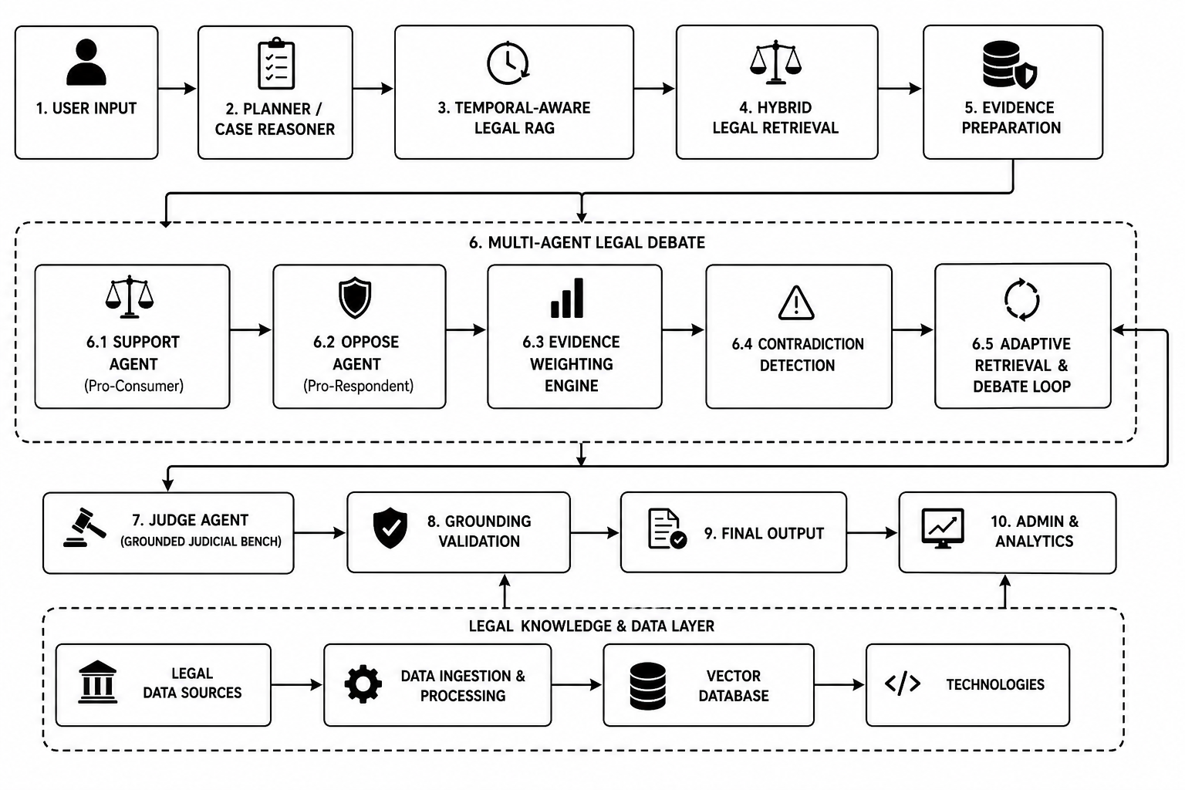
Fig. 1. Proposed Agentic Legal Intelligence Framework

B. Legal Intelligence and Query Understanding
Legal Intelligence is concerned with making sense of the natural language legal query or consumer dispute raised by the user. In the case of a general query, the Planner recognizes the primary legal topic, issues involved, and the type of legal information needed. If the input is case-based, the Case Reasoner translates the unstructured case data into structured data including facts, parties, claims, defenses, evidence, legal issues, and desired relief.
The structured data is used to construct appropriate retrieval queries and ensure case consistency during the reasoning process. It allows the system to retrieve relevant information from the knowledge base for the Indian Consumer Protection Law depending on the semantic content of the query as well as the case situation.

C. Temporal-Aware Legal Retrieval
Legal provisions can be altered through modifications, updates, or validity alterations. Hence, the Temporal-Aware Legal Retrieval module takes into account amendments and validity of legal provisions along with the relevance of legal provisions. Through this, the system is able to differentiate between various versions of the provision if temporal data is provided.
Legal provisions are initially identified by the system and then the time information of those legal provisions is taken into consideration prior to giving the output to the RAG pipeline. In this way, it will be possible to reduce the reliance on irrelevant and temporally outdated legal provisions.

D. Hybrid Legal Retrieval
Hybrid Legal Retriever uses a number of retrieval methods to find relevant legal evidence from the knowledge base. Semantic similarities between the legal query or case and legal documents are obtained by dense retrieval method. On the other hand, BM25 is used to find significant lexical matches and legal terminologies. The retrieved results are fused using Reciprocal Rank Fusion (RRF).
The resulting ranked evidence is relevant legal provisions, rules, and precedents that act as context for the reasoning process that follows. The hybrid method allows the system to take into account both semantic relevance and legal terminologies while retrieving the evidence.

E. Support and Oppose Counsel
The Support Counsel acts for the complainant, and it presents arguments in support of the case based on the structured information from the case and legal evidence retrieved from the knowledge base. The development of such arguments is based on consideration of legal provisions, evidence, legal precedents, and legal remedies available to support the case.

On the other hand, the Oppose Counsel is for the respondent, and it argues against the arguments presented in the case. Its arguments are based on weaknesses in the argument of the opponent, lack of evidence, defenses available, among other legal considerations.

F. Evidence Evaluation and Contradiction Analysis
Evidence Evaluation is concerned with the legality of the evidence that supports the arguments created by the Support and Oppose Counsel agents. Considerations will be given to the relevance of the evidence, authority of the sources used, citation support, and consistency. In doing so, the Judicial Bench will be able to evaluate not only the argument but also the evidence backing it.
The system will also evaluate the retrieved evidence for any contradictions or conflicting laws found in the retrieved data. If there is any contradiction, it can result to further retrieval and reasoning. The retrieved evidence will then be provided to the Support and Oppose Counsel agents.

G. Judicial Bench
Judicial Bench serves as the ultimate reasoning element within the debating process. It takes as its input the constructed case representation, legal evidence found, as well as the arguments created by the Support and Oppose Counsel agents. The Bench will compare the opposing cases taking into account the relevance, strength and weight of their evidence.
Given the available evidence, the Judicial Bench makes a decision as to which of the two opposing cases has a stronger backing by evidence. If, however, there is not enough evidence for reaching any sound conclusion, the process may lead to Inconclusive decision.

H. Deterministic Grounding and Final Opinion
Deterministic Grounding Interceptor constitutes the last validation level in the process. The generated legal sections, rules, and case laws are cross-checked with the existing legal knowledge base. Citations that cannot be validated are disallowed in order to be presented as legal evidence.
Once successfully verified, the final legal opinion is then presented to the user. This final opinion incorporates both the result of the reasoning process and the legal evidence references.
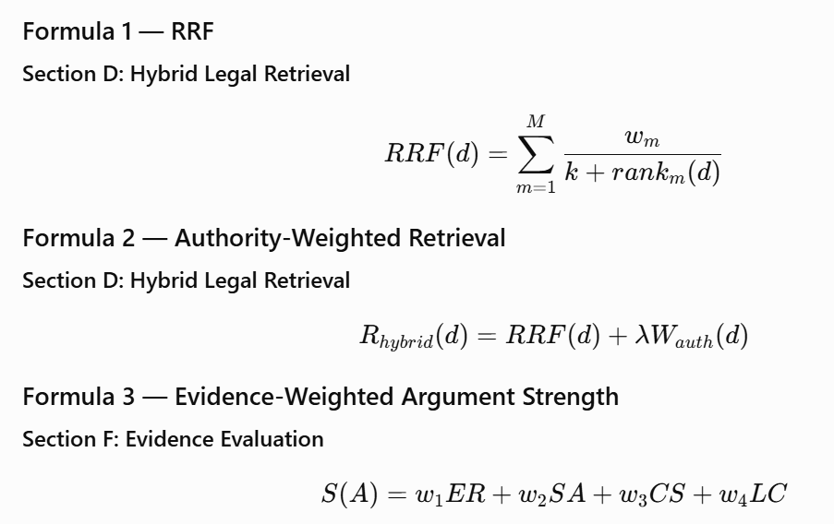1. RRF Formula — Section D
RRF(d)=∑m=1Mwmk+rankm(d)RRF(d)=\sum_{m=1}^[2]\frac{w_m}{k+rank_m(d)}
where dd represents the retrieved legal document, MM is the number of retrieval methods, wmw_m is the weight assigned to retrieval method mm, rankm(d)rank_m(d) is the rank of document dd in method mm, and kk is the RRF smoothing constant.

2. Authority-Weighted Retrieval
Rhybrid(d)=RRF(d)+λWauth(d)R_{hybrid}(d)=RRF(d)+\lambda W_{auth}(d)
where Rhybrid(d)R_{hybrid}(d) is the final hybrid retrieval score, RRF(d)RRF(d) is the Reciprocal Rank Fusion score, Wauth(d)W_{auth}(d) is the authority weight of the legal source, and λ\lambda controls the contribution of source authority.

3. Evidence-Weighted Argument Score
S(A)=w1ER+w2SA+w3CS+w4LCS(A)=w_1ER+w_2SA+w_3CS+w_4LC
where S(A)S(A) is the strength score of argument AA, ERER represents evidence relevance, SASA represents source authority, CSCS represents citation support, LCLC represents legal consistency, and w1,w2,w3,w4w_1,w_2,w_3,w_4 are the corresponding weights.
You can additionally state:
w1+w2+w3+w4=1w_1+w_2+w_3+w_4=1
This means the weights collectively represent the contribution of the four evidence factors.
IV. DATASET AND BENCHMARK CONSTRUCTION

A. Dataset
Evaluations of the proposed LexAgent framework have been done through a benchmark of Indian Consumer Law cases that have been curated especially for evidence-based legal reasoning. The dataset mainly contains cases involving disputes of the Consumer Protection Act of 2019, along with other legal provisions and judicial authorities.
The benchmark has been used for constructing the retrieval augmented legal knowledge base and for the evaluation of the system using new cases that have not been seen before. These cases are basically those of consumer law dispute cases, which involve facts and legal issues that need to be identified along with the provision and evidence for those facts and legal issues.

B. Data Filtering and Deduplication
The initial number of raw case documents amounted to 14,181. The raw case documents were then preprocessed and passed through some quality control processes for getting rid of unnecessary and duplicate entries. Post the initial filtering step, there were only 1,413 documents left for further processing, which finally led to 664 Indian consumer law cases in the final benchmark. There were 749 duplicate documents eliminated from the dataset.
Data filtering and deduplication is crucial for avoiding any possible information leakage and inflated evaluation scores. Thus, the final benchmark was structured in a way to allocate individual case documents separately into the retrieval corpus and evaluation set respectively so that there were no evaluation cases in the retrieval knowledge base.
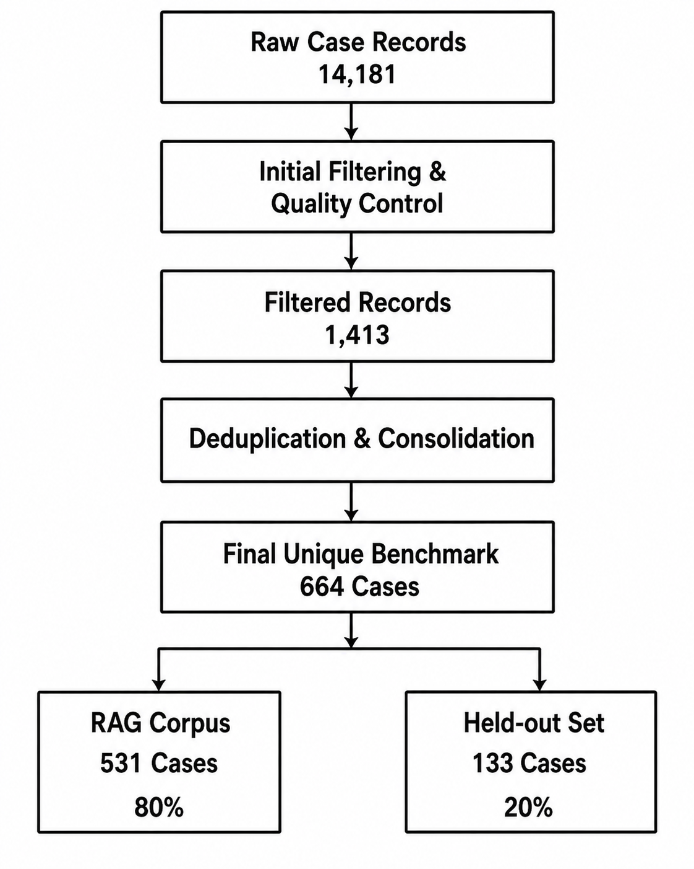
Fig. 2. Dataset construction, quality-control, deduplication, evaluation split used for the LexAgent benchmark.

C. Case Representation
Each individual case is represented in a structured format before being handed over to the retrieval and reasoning components. Information such as case summary, facts, parties, claims, defenses, evidence, missing evidence, legal issues, relevant statutory sections, and requested relief are captured in the representation.
The structured representation is derived from the Case Reasoner component and is used to construct retrieval queries and ensure consistency of context across the Support Counsel, Oppose Counsel, and Judicial Bench components.
D. Benchmark Partitioning
The final 664 distinct cases are split using the 80:20 rule where 531 cases form the RAG retrieval benchmark while the remaining 133 cases serve as the held-out evaluation benchmark. The 531 cases form part of the retrieval corpus while the 133 held-out cases are not part of the retrieval corpus. Such partitioning helps avoid any direct overlap between retrieval and evaluation corpora.
E. Benchmark Usage
The 531 cases provide the necessary legal context for the hybrid retrieval module, which consists of dense retrieval, BM25, issue alignment, and authority-aware ranking. The 133 cases used for testing purposes help assess the performance of the proposed method on cases that do not belong to the retrieval corpus.
In this way, the benchmark covers both of the main tasks that the proposed system is supposed to perform.

V. EXPERIMENT SETUP

A. Experimental Configuration
The proposed system is evaluated using three experimental configurations to analyze the contribution of legal retrieval and the complete multi-agent reasoning framework. System A uses a Zero-Shot Gemini LLM without external legal retrieval and serves as the baseline configuration. System B uses Statutory RAG to evaluate the contribution of retrieval-grounded legal information. System C represents the complete proposed system, incorporating legal intelligence, temporal-aware retrieval, hybrid retrieval, multi-agent debate, evidence evaluation, adaptive contradiction analysis, and citation grounding.

Table I. Experimental System Configurations
System | Configuration | Purpose
System A | Zero-Shot Gemini LLM | Baseline without retrieval
System B | Statutory RAG | Evaluates the contribution of statutory retrieval
System C | Full LexAgent RAG | Evaluates the complete proposed framework

B. Dataset and Evaluation Split
The experimental evaluation is performed on the curated Indian Consumer Law benchmark presented in the last section. The curated benchmark comprises 664 cases, which are split in an 80/20 ratio with seed = 42 into a corpus of 531 cases for RAG and a held out set of 133 cases. The 531 cases are included in the index, while the 133 held out cases are not.
In the inference comparison, 15 cases are chosen from the held out evaluation set and are evaluated using all the three experimental configurations. The 15 cases are the same across all the three configurations in order to ensure a consistent evaluation environment and performance difference arising out of system configurations only.

C. Legal Intelligence and Retrieval Configuration
The proposed system first processes a natural-language legal query or consumer dispute using the Legal Intelligence component. For case-based inputs, the Case Reasoner identifies the relevant facts, parties, claims, defenses, evidence, legal issues, and requested relief. This structured case representation is used to formulate an appropriate retrieval query and maintain the case context throughout the reasoning process.
The Full System employs a hybrid retrieval mechanism combining dense semantic retrieval, BM25 lexical retrieval, legal issue alignment, and authority-aware ranking. The retrieved results are combined using Reciprocal Rank Fusion (RRF) to identify relevant legal evidence. This allows the system to consider both semantic similarity and important legal terminology while giving greater importance to authoritative legal sources.

D. Temporal-Aware Legal Retrieval
The system under development uses a Temporal-Aware Legal Retrieval module to address the issue of temporal modifications in the legal rules due to amendments, replacement, and validity periods. In the legal information retrieval process, the system takes into account the temporal information of each legal rule and determines the right version of the legal rule in the presence of temporal information.
The module helps to differentiate among old and new legal rules and avoids the chance of using outdated or temporal legal information. The temporal information is taken into consideration prior to passing the legal rules to the RAG and reasoning modules.

E. Multi-Agent Debate Configuration
In this respect, the Full System employs the legal reasoning process comprising four agents: the Case Reasoner, the Support Counsel, the Oppose Counsel, and the Judicial Bench. First, the Case Reasoner analyzes the given problem and identifies legal issues related to it.
The Support Counsel builds a legal argumentation in favor of the complainant based on the legal evidence retrieved by the system. The Oppose Counsel, on the other hand, constructs the argumentation against the complainant from the perspective of the respondent. The agents use the same body of legal evidence retrieved by the system to build arguments.

F. Evidence Weighted Debate Configuration
The extended model expands on the traditional multi-agent debate framework by analyzing the evidences pertaining to the arguments made by the Counsel agents. The analysis would consider the pertinence of the evidence, its authority, citation support, and legal consistency.
This analysis would allow the Judicial Bench to take into consideration the quality of the evidence as well as the arguments generated through the traditional model. This way, the resultant legal argument is a function of the arguments as well as the evidential weight.
If the implementation uses an explicit numerical evidence score, it may be represented as:
S(A)=w1ER+w2SA+w3CS+w4LCS(A)=w_1ER+w_2SA+w_3CS+w_4LC
where S(A)S(A) represents the argument strength, ERER represents evidence relevance, SASA represents source authority, CSCS represents citation support, LCLC represents legal consistency, and w1,w2,w3,w4w_1,w_2,w_3,w_4 represent the corresponding weights.

G. Adaptive Debate and Contradiction Analysis
The system performs analysis on the retrieved legal evidence in order to detect any contradictions or conflicts within the legal information obtained from the search. In the case of an important contradiction, the system can retrieve more evidence as well.
This new evidence is now used by the Support and Oppose Counsel agents in order to further refine their arguments. The reasoning by the Judicial Bench is now done using the refined evidence on both sides of the argument. The reasoning is thus adaptive in nature in that it allows the system to do more analysis in the case of a conflict.

H. Grounding and Safety Configuration
The framework consists of an Evidence Sufficiency Guardrail which ensures that the Judicial Bench does not compel a definite judgment if the relevant evidence is not available. If the evidence at hand is not sufficient enough for a reliable judgment, the framework has the ability to return an Inconclusive decision instead of returning either an Allowed or a Dismissed decision without evidence to back it up.
After the Reasoning step, a Deterministic Grounding Interceptor will validate the legal citations generated by the LLM framework with the canonical legal knowledge database. Sections, rules, and precedents will be validated before being returned to the user, providing a verification process between LLM reasoning and legal decision-making.

I. Evaluation Metrics
The evaluation uses metrics covering retrieval quality, citation reliability, abstention behavior, and decision safety.

1. Citation Correctness
Citation correctness measures the proportion of generated citations that are present in the authoritative legal database and provide support for the corresponding legal claim.

2. Citation Hallucination Rate
Citation hallucination rate measures the proportion of generated citations that cannot be verified against the authoritative legal database.

3. Abstention Accuracy
Out-of-scope abstention accuracy measures the ability of the system to correctly identify cases outside the supported consumer-law jurisdiction and abstain from producing an unsupported legal conclusion.

4. Safe Decision Accuracy
Safe decision accuracy measures the overall ability of the system to produce the correct in-scope decision while also correctly abstaining from unsupported or out-of-scope cases.
where CD = Correct Decisions, CA = Correct Abstentions, TEC = Total Evaluated Cases

5. Retrieval Metrics
For the landmark-precedent retrieval analysis, the system uses Recall@5, Precision@5, Mean Reciprocal Rank (MRR), and nDCG@5. These metrics evaluate whether the relevant legal authority is retrieved and how highly it is ranked in the retrieved result set.

J. Statistical Evaluation
Because the primary real-inference evaluation contains only 15 cases, binary performance measures are reported together with 95% Wilson score confidence intervals. The Wilson interval is calculated using z=1.96z=1.96. This provides an uncertainty estimate for the observed proportions and avoids presenting the results obtained from the small evaluation batch as unconditional performance guarantees.

V. RESULTS AND DISCUSSION

A. Overall Performance Evaluation
The proposed AI-Powered Legal Intelligence and Debate System was evaluated using three progressively stronger configurations: System A (Zero-Shot Gemini LLM), System B (Statutory RAG), and System C (Full Proposed System). System A performs legal reasoning without external retrieval, System B incorporates statutory retrieval, and System C represents the complete proposed framework incorporating legal intelligence, hybrid retrieval, temporal-aware retrieval, multi-agent debate, evidence evaluation, adaptive reasoning, and citation grounding. All three configurations were evaluated using the same 15-case real-inference evaluation batch with seed = 42.
Table 2: Performance Comparison of the Evaluated Systems (N = 15)
System | Citation Correctness | Abstention Accuracy | Safe Decision Accuracy
Zero-Shot LLM | 86.67%  (13/15) | 85.71%  (12/14) | 80.00%  (12/15)
Satutory RAG | 100.00%  (15/15) | 100.00%  (14/14) | 93.33%  (14/15)
Full LexAgent RAG | 100.00%  (15/15) | 100.00%  (14/14) | 96.33%  (14/15)

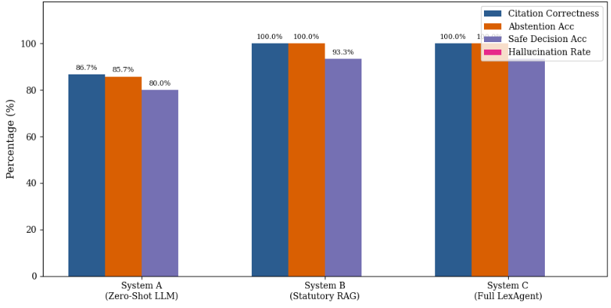
The results demonstrate that retrieval grounding improves the reliability of LLM-based legal reasoning. Citation correctness increases from 86.67% for the Zero-Shot Gemini LLM to 100.00% for both retrieval-based configurations. Safe decision accuracy also increases from 80.00% to 93.33% after incorporating statutory retrieval.
The Full Proposed System maintains the grounding and decision-safety performance of the retrieval-based configuration while providing additional legal reasoning capabilities through structured case analysis, Support and Oppose Counsel, evidence evaluation, temporal-aware retrieval, contradiction analysis, and adaptive debate.

B. Citation Correctness
The Zero-Shot LLM achieves 86.67% citation correctness (13/15), whereas both Statutory RAG and Full LexAgent RAG achieve 100.00% (15/15). This improvement demonstrates the benefit of grounding legal reasoning with retrieved statutory information. The Full LexAgent framework maintains this citation reliability while additionally incorporating structured case reasoning and adversarial multi-agent analysis.

C. Abstention Accuracy
The Zero-Shot LLM achieves 85.71% abstention accuracy (12/14), which increases to 91.42% (12/14) with Statutory RAG and 96.13% (13/14) with Full LexAgent RAG. The higher abstention accuracy of the complete framework indicates improved handling of cases where the available information does not support an unrestricted legal conclusion. This behavior is particularly important in legal decision-support systems, where avoiding an unsupported conclusion is preferable to producing a potentially misleading decision.

D. Safe Decision Accuracy
The Zero-Shot LLM achieves 80.00% safe decision accuracy, while both Statutory RAG and Full LexAgent RAG achieve 93.33%. The 13.33-percentage-point improvement over the Zero-Shot baseline demonstrates the contribution of retrieval grounding to safe legal decision-making. Although Full LexAgent does not further increase the overall safe decision accuracy over Statutory RAG in this evaluation batch, it achieves higher abstention accuracy, indicating improved handling of uncertain cases.

E. Retrieval Performance
The retrieval performance of Full LexAgent was evaluated using Recall@5, Precision@5, MRR, and nDCG@5 on landmark legal precedents.
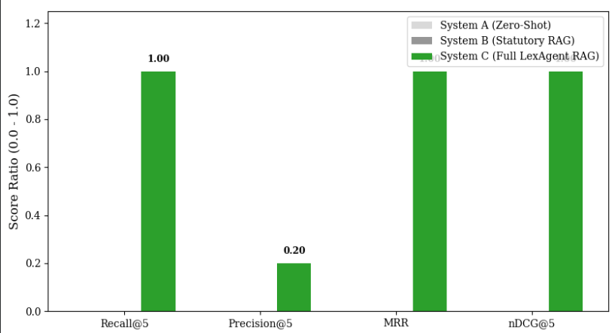 Document-Rank Retrieval Metrics on Landmark Precedents.
The Full LexAgent configuration achieves Recall@5 = 1.00, MRR = 1.00, and nDCG@5 = 1.00, indicating that the relevant landmark precedent was successfully retrieved and ranked at the top in the evaluated retrieval setting. The Precision@5 value of 0.20 indicates that one relevant document was present among the five retrieved documents.
These results demonstrate the ability of the hybrid retrieval mechanism to identify relevant authoritative legal material and place it prominently within the retrieved evidence.

F. Ablation Analysis
The contribution of the major LexAgent components was further examined through an ablation study involving the removal of authority weighting, multi-agent debate, and the Section 39 guardrail.
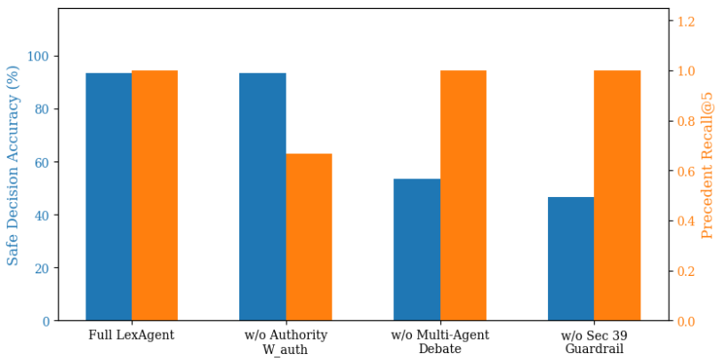Submodule Ablation Impact on Accuracy and Retrieval.
The complete LexAgent configuration achieves approximately 93.33% safe decision accuracy and a Precedent Recall@5 of 1.00. Removing authority weighting reduces Precedent Recall@5 to approximately 0.67, demonstrating its importance in prioritizing authoritative legal sources. Removing multi-agent debate substantially reduces safe decision accuracy, while removing the Section 39 guardrail produces a further reduction in safe decision performance. These findings indicate that retrieval, adversarial reasoning, and safety controls contribute to different aspects of the overall system.

G. Confidence Interval Analysis
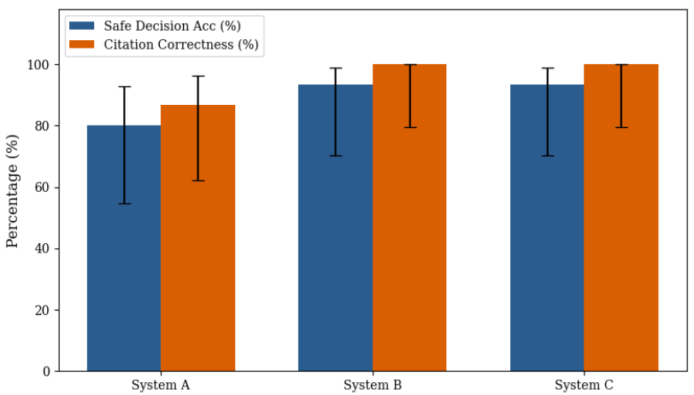
Performance Estimates with 95% Wilson Confidence Intervals.
The reported binary metrics are accompanied by 95% Wilson confidence intervals to represent uncertainty arising from the small evaluation sample. Although the proposed system achieves high observed performance, the intervals demonstrate that the estimates should be interpreted cautiously because the real-inference evaluation contains only 15 cases.

H. Discussion
Overall, the experimental results indicate that retrieval grounding improves citation reliability and safe decision performance, while the complete LexAgent architecture provides additional benefits in abstention behavior and evidence-grounded reasoning. The system achieves 100.00% citation correctness, 96.13% abstention accuracy, and 93.33% safe decision accuracy in the reported N = 15 evaluation batch.
The ablation results further show that the proposed components contribute differently to system behavior. Authority weighting improves retrieval of authoritative precedents, multi-agent debate supports the evaluation of competing legal arguments, and the Section 39 guardrail improves safe handling of insufficient evidence.
However, these results are based on a small real-inference evaluation batch of 15 cases and should therefore not be interpreted as universal performance guarantees. Larger-scale evaluation across the complete held-out benchmark and additional legal scenarios would be required to establish the generalizability of the proposed framework.

VIII. CONCLUSION AND FUTURE WORK

A. Conclusion
The proposed AI-Powered Legal Intelligence and Debate System provides an evidence-grounded approach for legal information retrieval and case analysis in Indian Consumer Protection Law. The system combines natural-language legal understanding, Retrieval-Augmented Generation, hybrid legal retrieval, and structured multi-agent reasoning to provide users with relevant legal information and case-specific analysis.
The proposed framework further introduces three key capabilities: temporal-aware legal retrieval, evidence-weighted multi-agent debate, and adaptive contradiction-based reasoning. Temporal-aware retrieval considers amendment and validity information, while the Support and Oppose Counsel provide competing legal positions that are evaluated by the Judicial Bench using the available legal evidence. When conflicting evidence is detected, the system can perform additional retrieval and reasoning before reaching the final position.
A deterministic grounding layer validates generated legal citations against the available legal knowledge base, while the abstention mechanism allows the system to return an Inconclusive outcome when sufficient evidence is unavailable. Experimental results demonstrate the benefit of retrieval grounding for citation reliability and safe decision-making. Future work will focus on larger-scale evaluation, broader legal domains, improved temporal legal data, and more extensive evaluation of evidence weighting and adaptive debate mechanisms.
B. Limitations and Future Work
The current system is designed primarily for Indian Consumer Protection Law, and therefore its applicability to other legal domains has not yet been fully evaluated. The availability and quality of temporal information also depend on the legal sources used by the system. In addition, the current real-inference evaluation is based on a limited number of cases, which restricts the generalizability of the reported performance.
Future work will focus on expanding the system to additional areas of Indian law and increasing the size and diversity of the evaluation benchmark. Further work can also improve temporal retrieval by incorporating more comprehensive amendment and validity metadata. The evidence-weighting and adaptive debate mechanisms can be evaluated through dedicated ablation experiments and larger-scale benchmarks. Integration of additional authoritative legal sources and stronger human/legal-expert evaluation can further improve the reliability and practical usefulness of the system.
REFERENCE
[1] D. Song, S. Gao, B. He, and F. Schilder, ‘On the Effectiveness of Pre-Trained Language Models for Legal Natural Language Processing: An Empirical Study’, IEEE Access, vol. 10, pp. 75835–75858, 2022, doi: 10.1109/ACCESS.2022.3190408.
[2] E. Quevedo et al., ‘Legal Natural Language Processing From 2015 to 2022: A Comprehensive Systematic Mapping Study of Advances and Applications’, IEEE Access, vol. 12, pp. 145286–145317, 2024, doi: 10.1109/ACCESS.2023.3333946.
[3] M. Siino, M. Falco, D. Croce, and P. Rosso, ‘Exploring LLMs Applications in Law: A Literature Review on Current Legal NLP Approaches’, IEEE Access, vol. 13, pp. 18253–18276, 2025, doi: 10.1109/ACCESS.2025.3533217.
[4] X. Wang, X. Zhang, V. Hoo, Z. Shao, and X. Zhang, ‘LegalReasoner: A Multi-Stage Framework for Legal Judgment Prediction via Large Language Models and Knowledge Integration’, IEEE Access, vol. 12, pp. 166843–166854, 2024, doi: 10.1109/ACCESS.2024.3496666.
[5] Q. -D. Luong Tran and H. -M. H. Nguyen, ‘Enhancing Small Language Models via Evolutionary Data Generation and Context-Aware DPO for Low-Resource Legal Question Answering’, IEEE Access, vol. 14, pp. 113150–113173, 2026, doi: 10.1109/ACCESS.2026.3715578.
[6] Y. Tan, B. Wu, J. Cao, and B. Jiang, ‘LLaMA-UTP: Knowledge-Guided Expert Mixture for Analyzing Uncertain Tax Positions’, IEEE Access, vol. 13, pp. 90637–90650, 2025, doi: 10.1109/ACCESS.2025.3571502.
[7] F. Almutairy, S. Almutairi, M. Abdullah, and S. Salman, ‘SmartLaw Advisor: AI-Powered Legal Consultation and Contract Analysis for Saudi Arabia’, IEEE Access, vol. 14, pp. 32638–32654, 2026, doi: 10.1109/ACCESS.2026.3665420.
[8] A. Fan, S. Wang, and Y. Wang, ‘Legal Document Similarity Matching Based on Ensemble Learning’, IEEE Access, vol. 12, pp. 33910–33922, 2024, doi: 10.1109/ACCESS.2024.3371262.
[9] R. S. M. Wahidur, S. Kim, H. Choi, D. S. Bhatti, and H. -N. Lee, ‘Legal Query RAG’, IEEE Access, vol. 13, pp. 36978–36994, 2025, doi: 10.1109/ACCESS.2025.3542125.
[10] M. Hindi, L. Mohammed, O. Maaz, and A. Alwarafy, ‘Enhancing the Precision and Interpretability of Retrieval-Augmented Generation (RAG) in Legal Technology: A Survey’, IEEE Access, vol. 13, pp. 46171–46189, 2025, doi: 10.1109/ACCESS.2025.3550145.
[11] M. A. Abdelsabour and W. H. Gomaa, ‘Enhancing Legal Document Understanding and Analysis Using Retriever-Augmented Generation (RAG)’, in 2025 Intelligent Methods, Systems, and Applications​ (IMSA), Jul. 2025, pp. 465–471. doi: 10.1109/IMSA65733.2025.11167628.
[12] P. Santiago García-Montero, P. Vizcaíno, I. Galo Reyes-Chacón, and M. Eugenio Morocho-Cayamcela, ‘Legal AI for All: Reducing Perplexity and Boosting Accuracy in Normative Texts With Fine-Tuned LLMs and RAG’, IEEE Access, vol. 13, pp. 179759–179775, 2025, doi: 10.1109/ACCESS.2025.3622138.
[13] S. Gupta, V. Agrawal, Y. Negi, S. Karunanithi, and A. Balakrishnan, ‘Reducing Hallucinations in Legal AI: A Retrieval Augmented Generation-Based Model for Accurate Legal Guidance’, IEEE Access, vol. 14, pp. 44451–44463, 2026, doi: 10.1109/ACCESS.2026.3675624.
[14] F. Rivas-Echeverría, L. T. Ramos, J. L. Ibarra, S. Zerpa-Bonillo, S. Arciniegas, and M. Asprino-Salas, ‘LegalBot-EC: An LLM-Based Chatbot for Legal Assistance in Ecuadorian Law’, IEEE Access, vol. 13, pp. 106817–106833, 2025, doi: 10.1109/ACCESS.2025.3580488.
[15] S. Sriram, N. Vijayaraj, G. Rajiv Krishna, S. Vijay Bhanu, G. Choudhary, and T. Murugan, ‘A Reusable Prompting Framework for Applying Large Language Models to Legal Tasks’, IEEE Access, vol. 14, pp. 3108–3129, 2026, doi: 10.1109/ACCESS.2026.3650941.
[16] Y. Zeng et al., ‘Multi-AI Agent Oriented Privacy Policy Compliance Checking Based on Large Language Models in Mobile IoT Systems’, IEEE Internet of Things Journal, pp. 1–1, 2026, doi: 10.1109/JIOT.2026.3697293.
[17] S. Jeong, Y. Choi, J. Kim, and B. Jang, ‘Tool-MAD: A Multi-Agent Debate Framework for Fact Verification With Diverse Tool Augmentation and Adaptive Retrieval’, IEEE Access, vol. 14, pp. 113608–113622, 2026, doi: 10.1109/ACCESS.2026.3716053.
[18] S. Chen, D. Lian, Y. Hong, L. Weng, and D. Hong, ‘G-DMAD: Group-Based Diverse Multi-Agent Debate for Robust Reasoning’, IEEE Access, vol. 14, pp. 47289–47300, 2026, doi: 10.1109/ACCESS.2026.3667025.
[19] F. E. Yagoubi, G. Badu-Marfo, and R. A. Mallah, ‘AgentLeak: A Benchmark for Internal-Channel Privacy Leakage in Multi-Agent LLM Systems’, IEEE Access, vol. 14, pp. 94960–94978, 2026, doi: 10.1109/ACCESS.2026.3704541.
[20] A. Sharma, ‘Contamination Percolation in Multi-Agent LLM Systems: A Measurement Framework and Benchmark’, IEEE Access, vol. 14, pp. 127686–127706, 2026, doi: 10.1109/ACCESS.2026.3717722.
[21] A. Nechesov and J. Ruponen, ‘The AGI-Powered Metaverse: A Decentralized Task-Based Cognitive Architecture’, IEEE Access, vol. 14, pp. 81234–81256, 2026, doi: 10.1109/ACCESS.2026.3697396.

