User Guide

Login Page

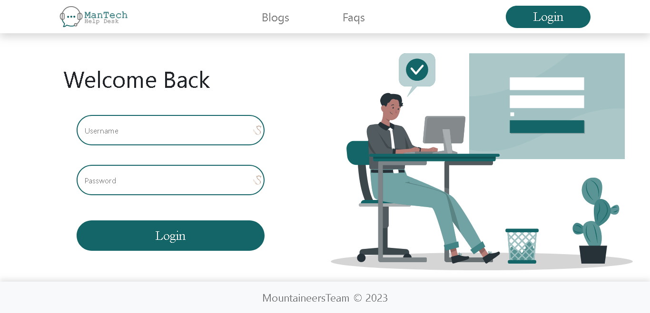

Login Page:

- Admin, Regular User, and Technician can register from the same page.

Waiting Complaint Page

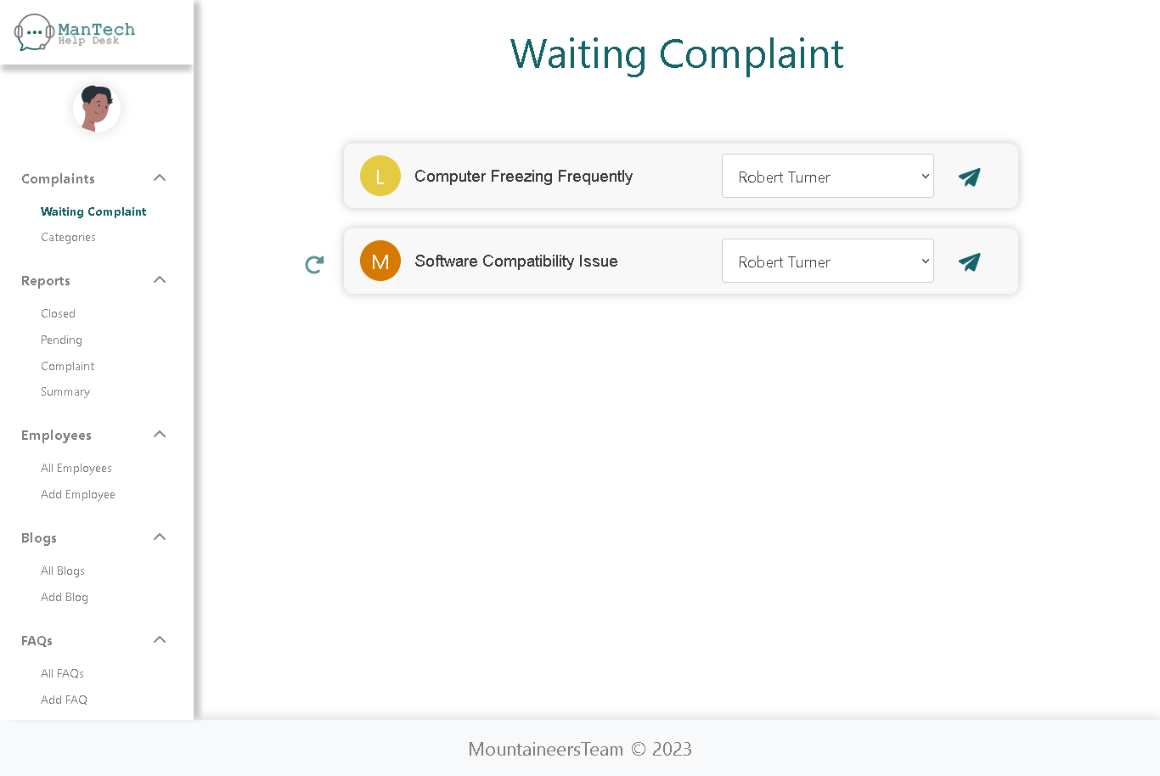

Complaint page:

If logged in as an admin, the following page will be displayed. -

- On this page, the admin can review waiting Complaint and assign them to any technician.

Complaint Details Page

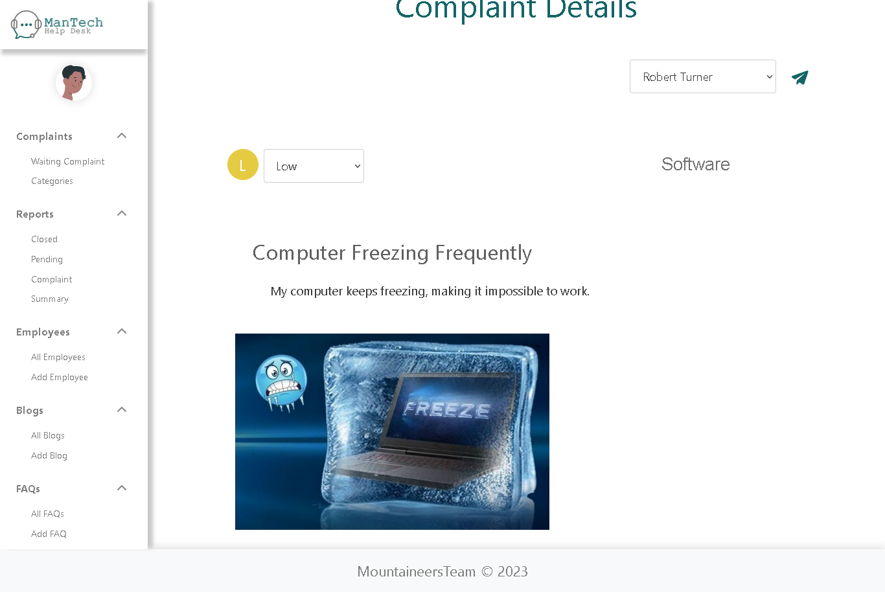

Complaint Details Page:

- On this page, the admin can view the details of the Complaint, edit its priority, and assign it to a technician.

Categories Page

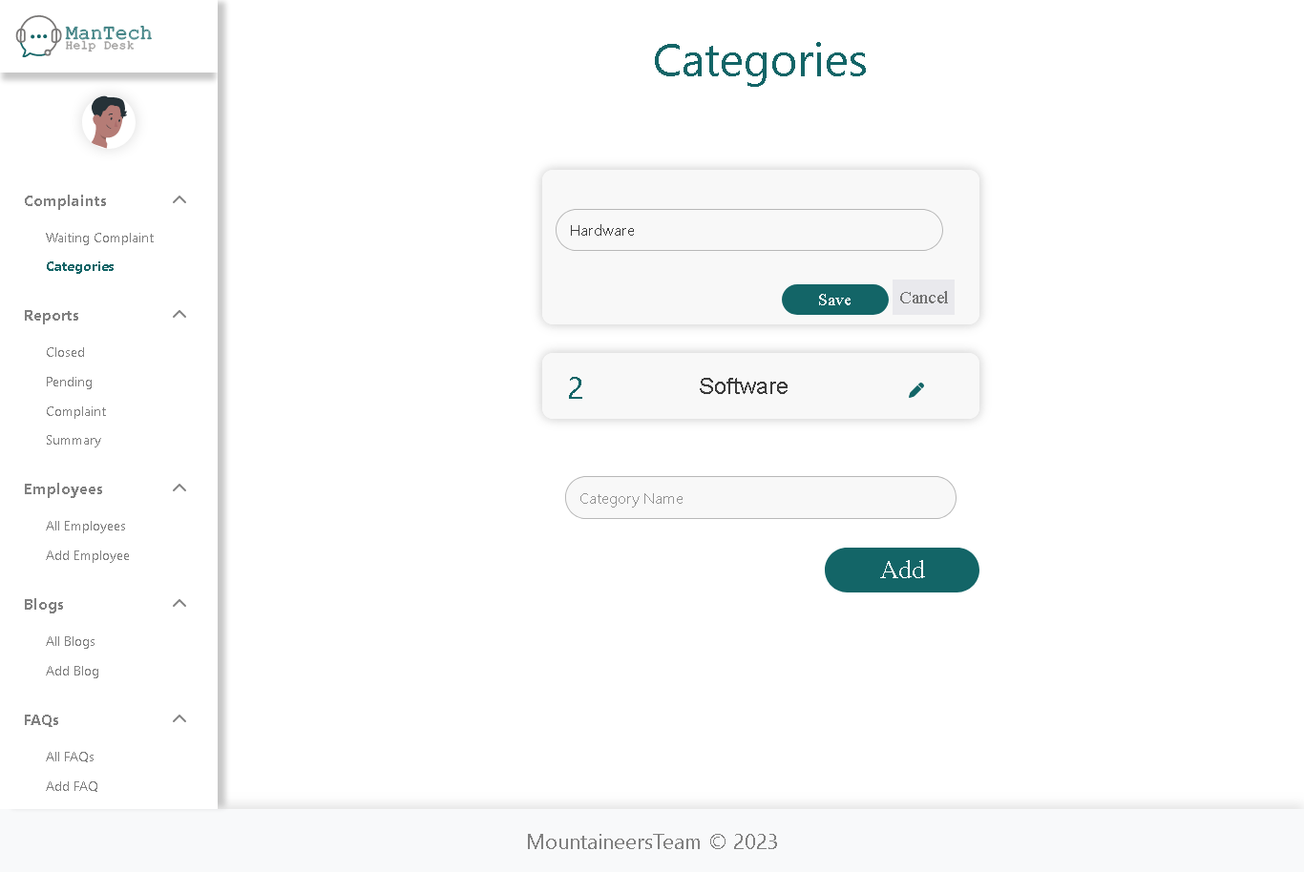

Categories Page:

- On this page, the admin can add a new Categories, delete or modify an existing Categories

Reports Page

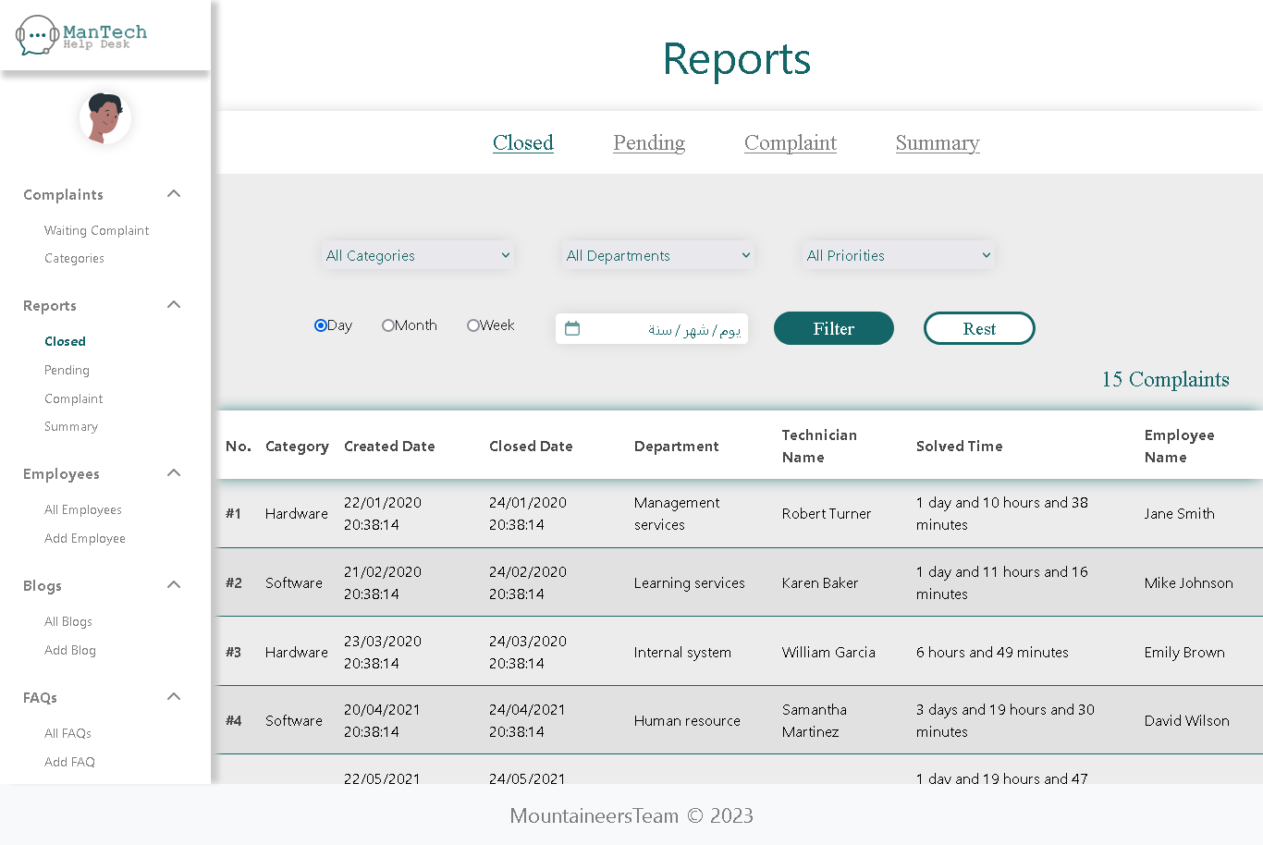

Reports Page:

- On this page, The admin can filter the Complaint based on their status on this page.

- the admin can review reports for all Complaint and apply filters based on time duration, department, category, and Complaint priority.

Reports Summary Page

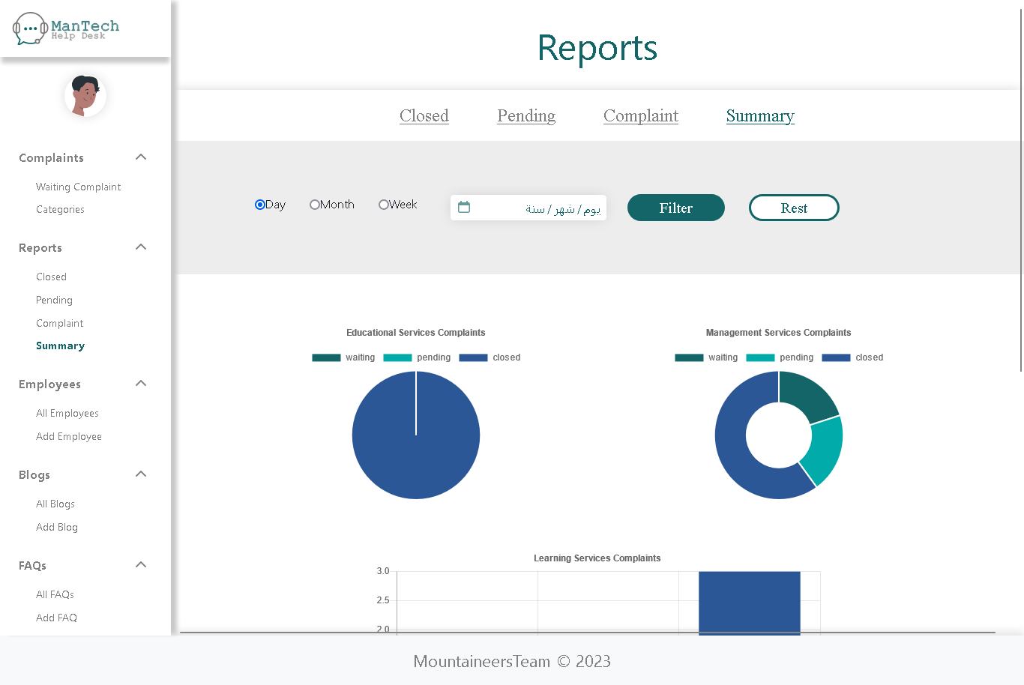

Reports Summary Page:

- On this page, the admin can review charts and diagrams illustrating the Complaint, and filter them based on monthly, weekly, or daily summaries.

Employees Page

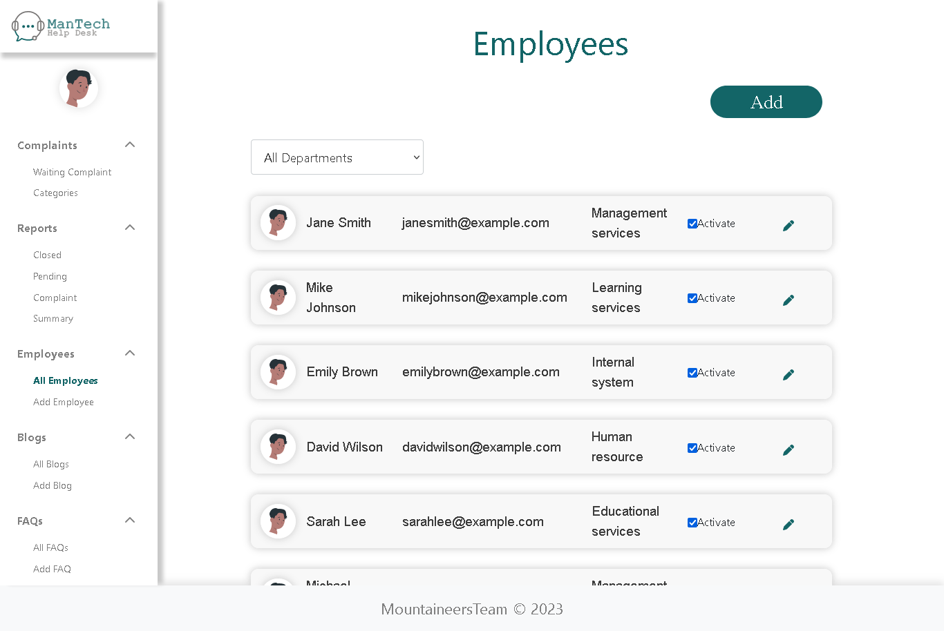

Employees Page:

- On this page, the admin can view all employees and apply filters based on departments.

- Additionally, it is can to modify employee data and activate or deactivate users and add users.

Blogs Page

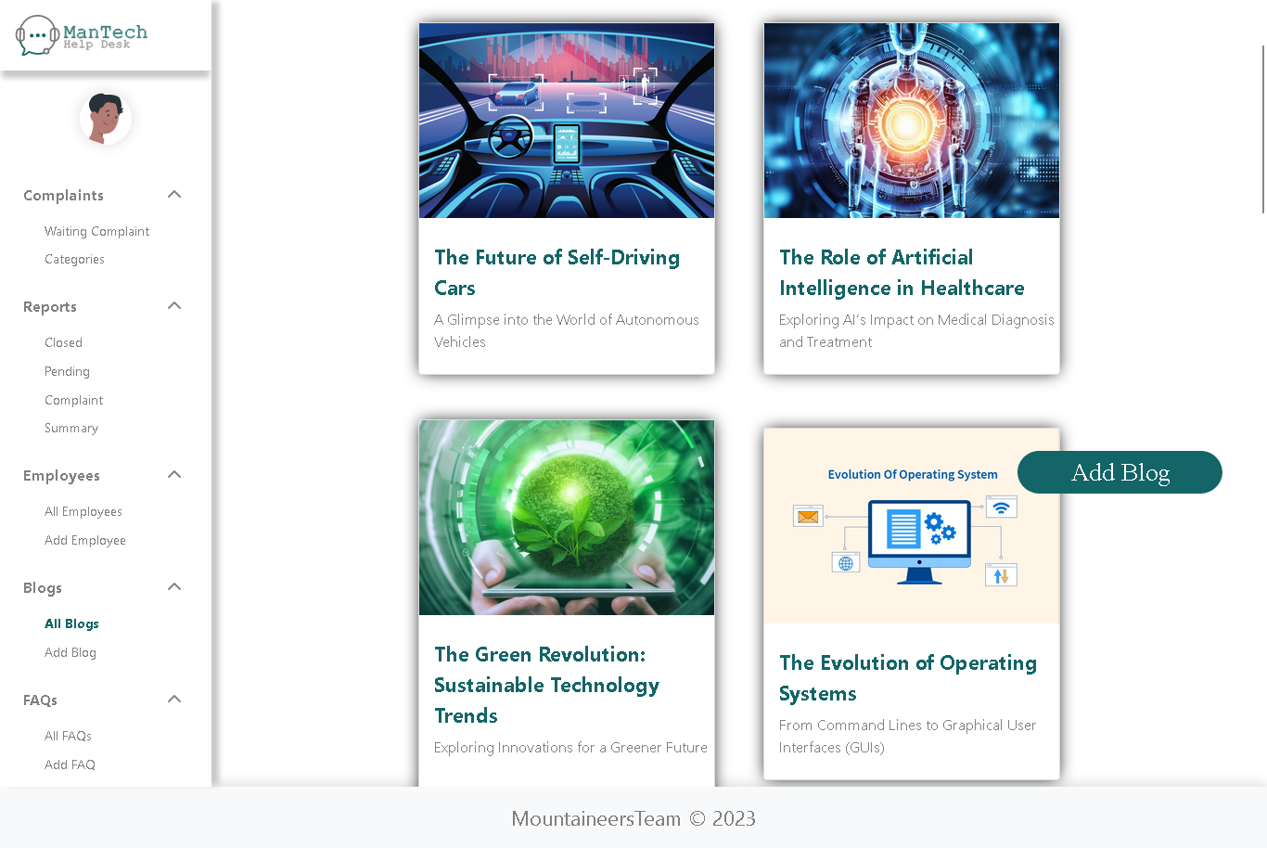

Blogs Page:

- On this page, the admin can view all blog, edit or delete any blog, and also add new blog.

FAQs Page

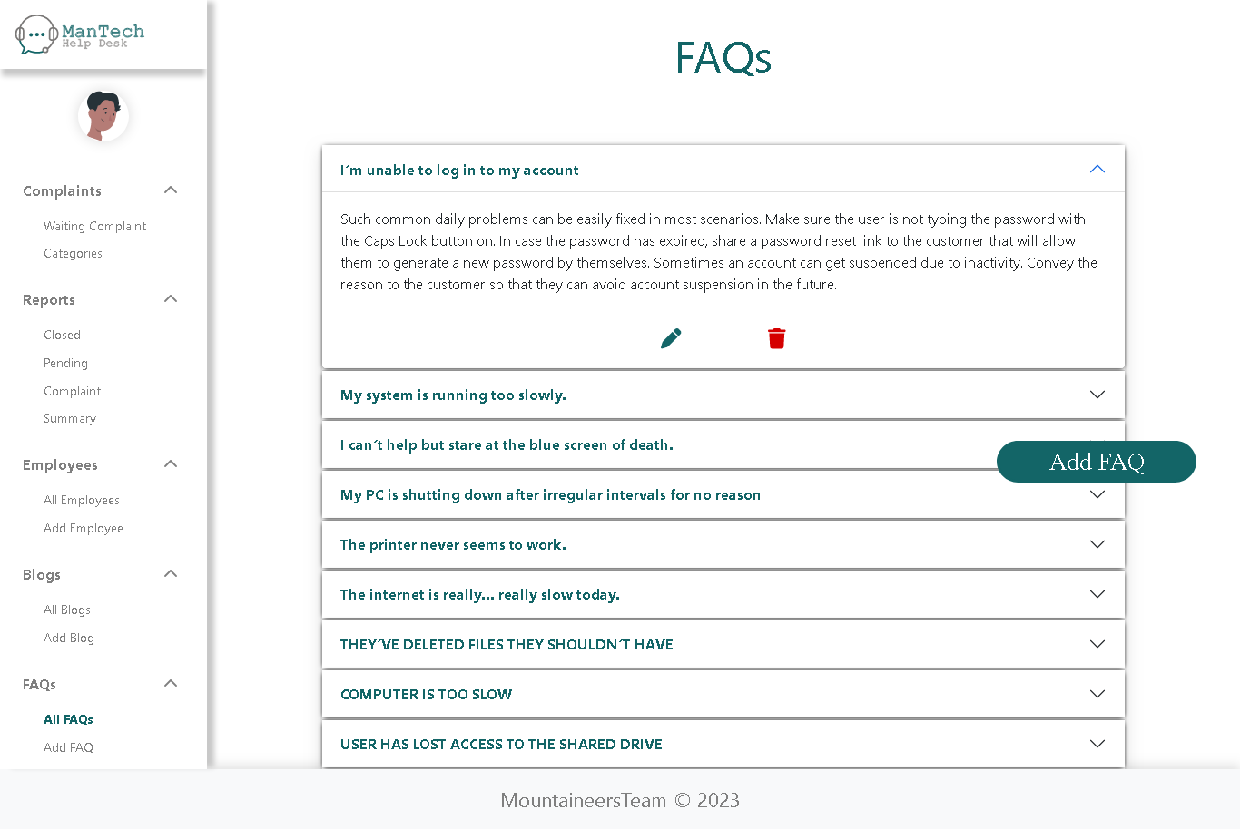

FAQs Page:

- On this page, the admin can view the Frequently Asked Questions (FAQs), edit, delete, and add new FAQs.

Profile Page

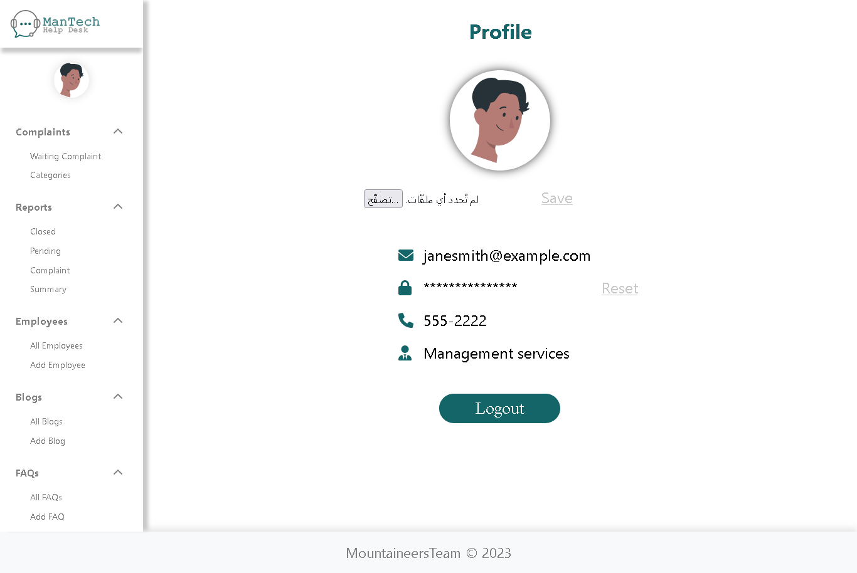

Profile Page:

- On this page, the admin can view their profile, edit the profile picture, and reset the password.

Note: Instructions below apply if the user registers as an admin.

Complaint user Page

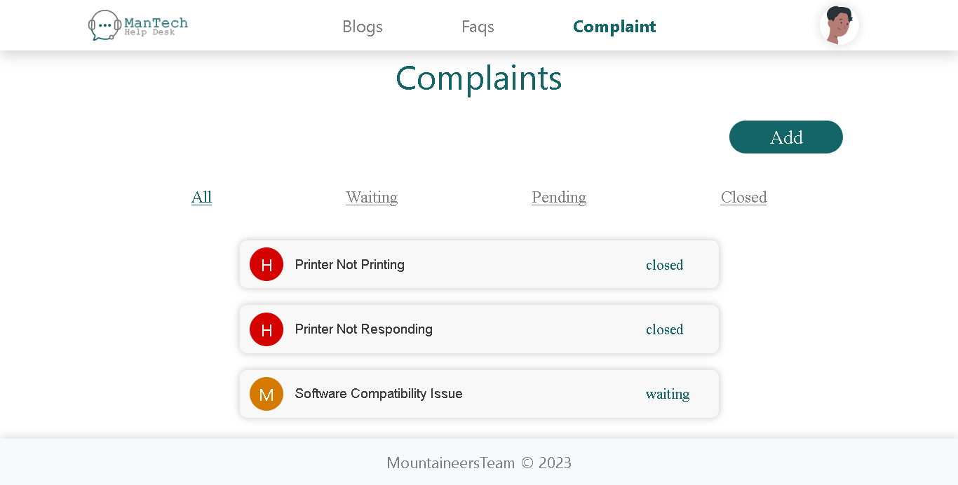

Complaint user Page:

- If the user registers as a normal user, this will be the first page that appears to them.

- The user can view all the Complaint they have created and can modify any Complaint as long as its status is not closed.

- Additionally, the user can filter the Complaint based on their status.

FAQs user Page

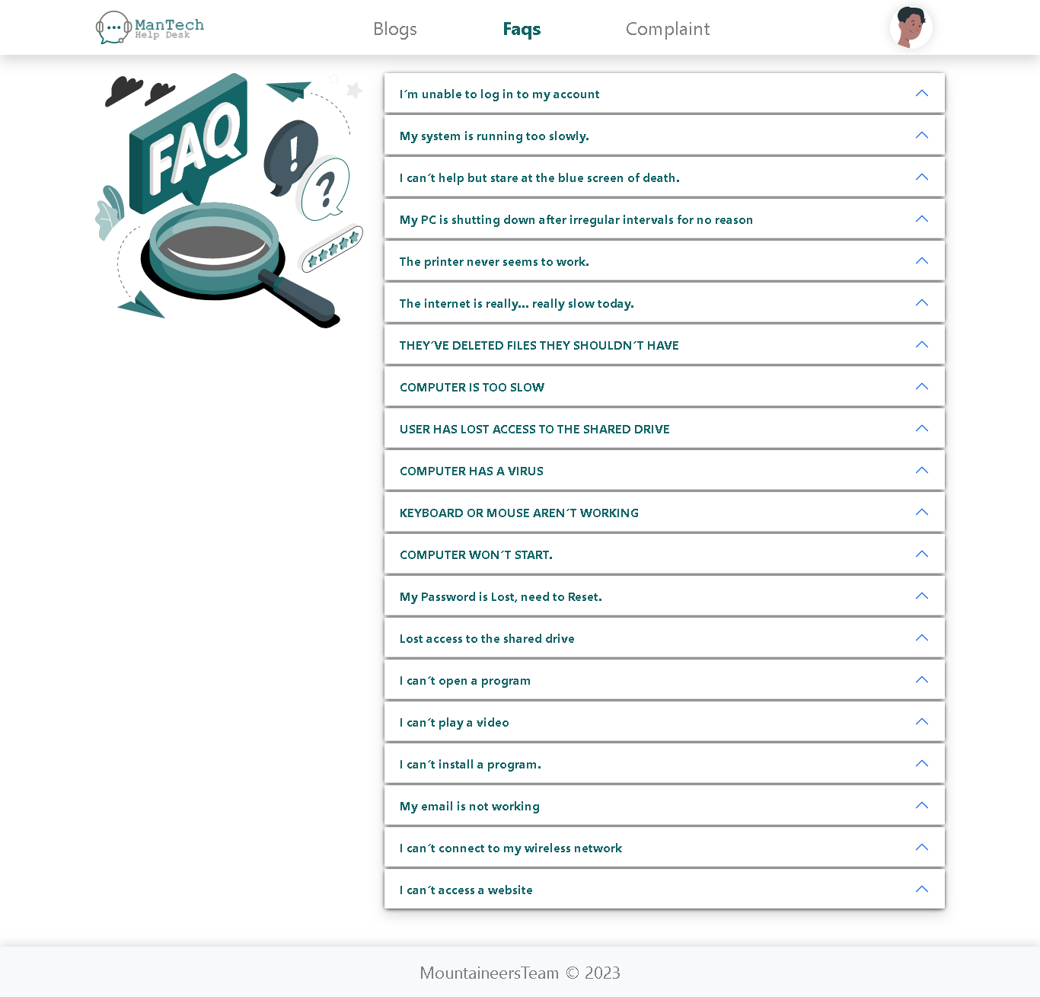

FAQs user Page:

- On this page, the user can browse FAQs, and when clicking on any FAQ, its details will be displayed.

Blogs user Page

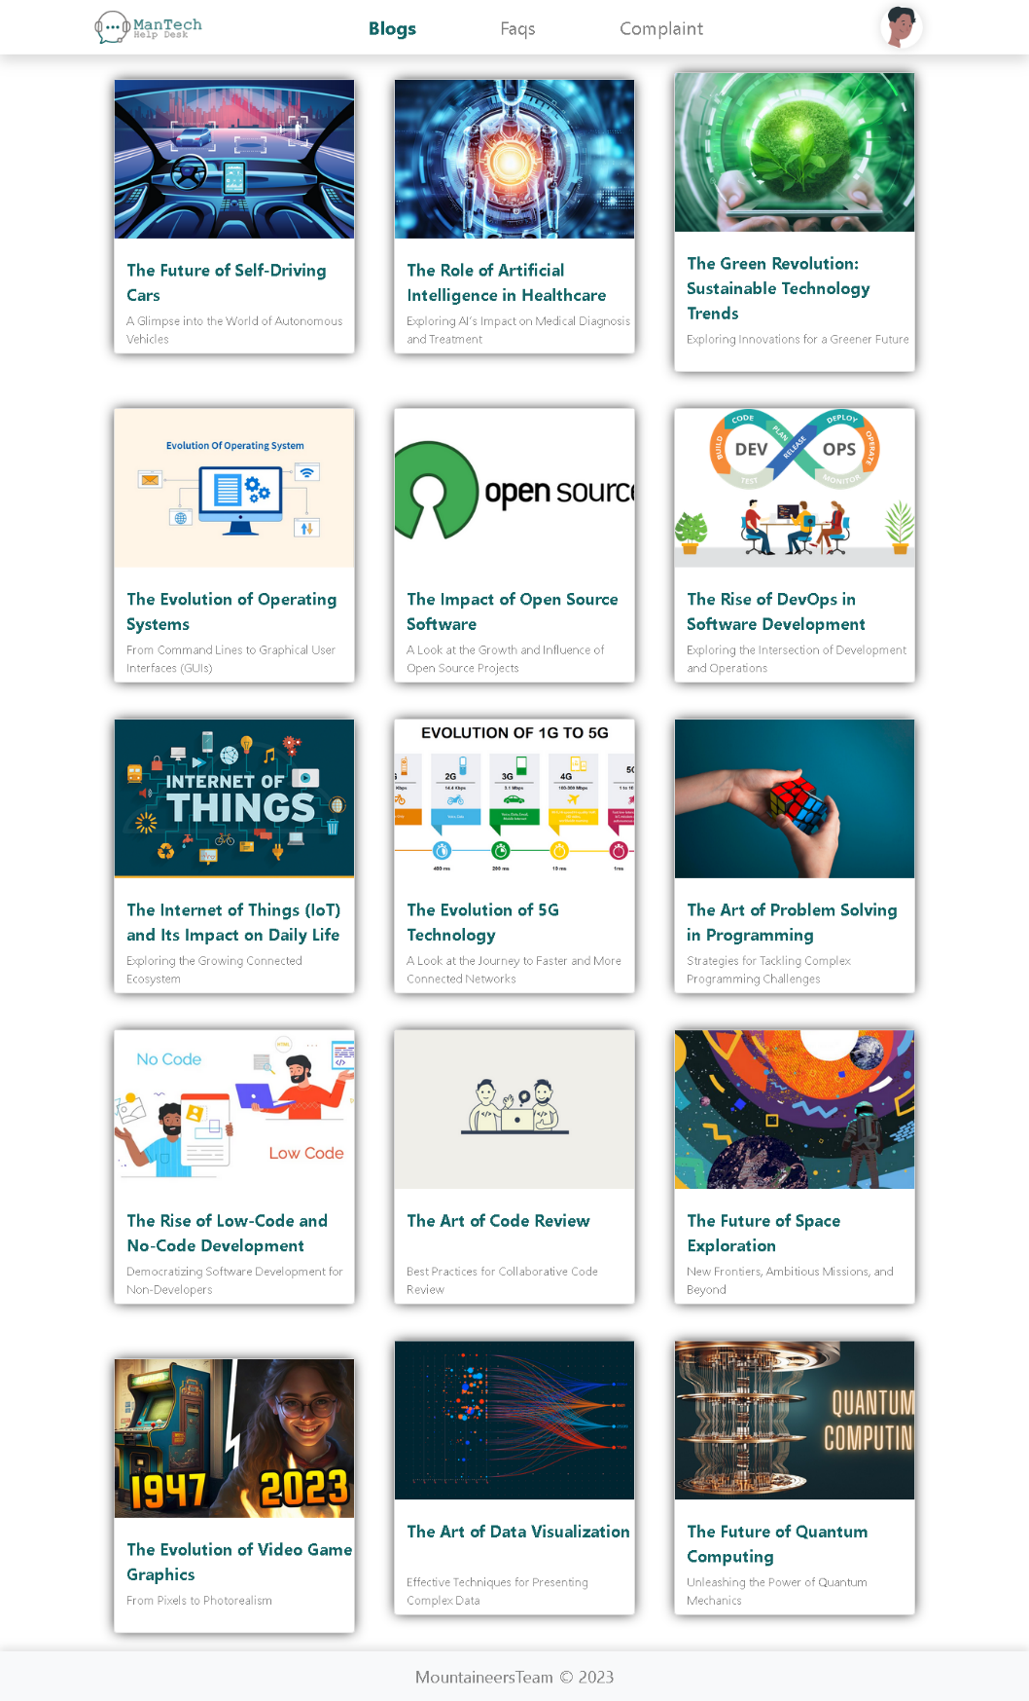

Blogs user Page:

- On this page, the user can view all blog posts, and when clicking on any of them, their details will be displayed.

Note: Instructions below apply if the user registers as a normal user.

Complaints Technical Page



Complaints Technical Page:

- When the user registers as a technician, this page will appear.

- This page displays the Complaints assigned to this technician.

The technician can filter the Complaints based on their status. -

Complaints Details Technical Page

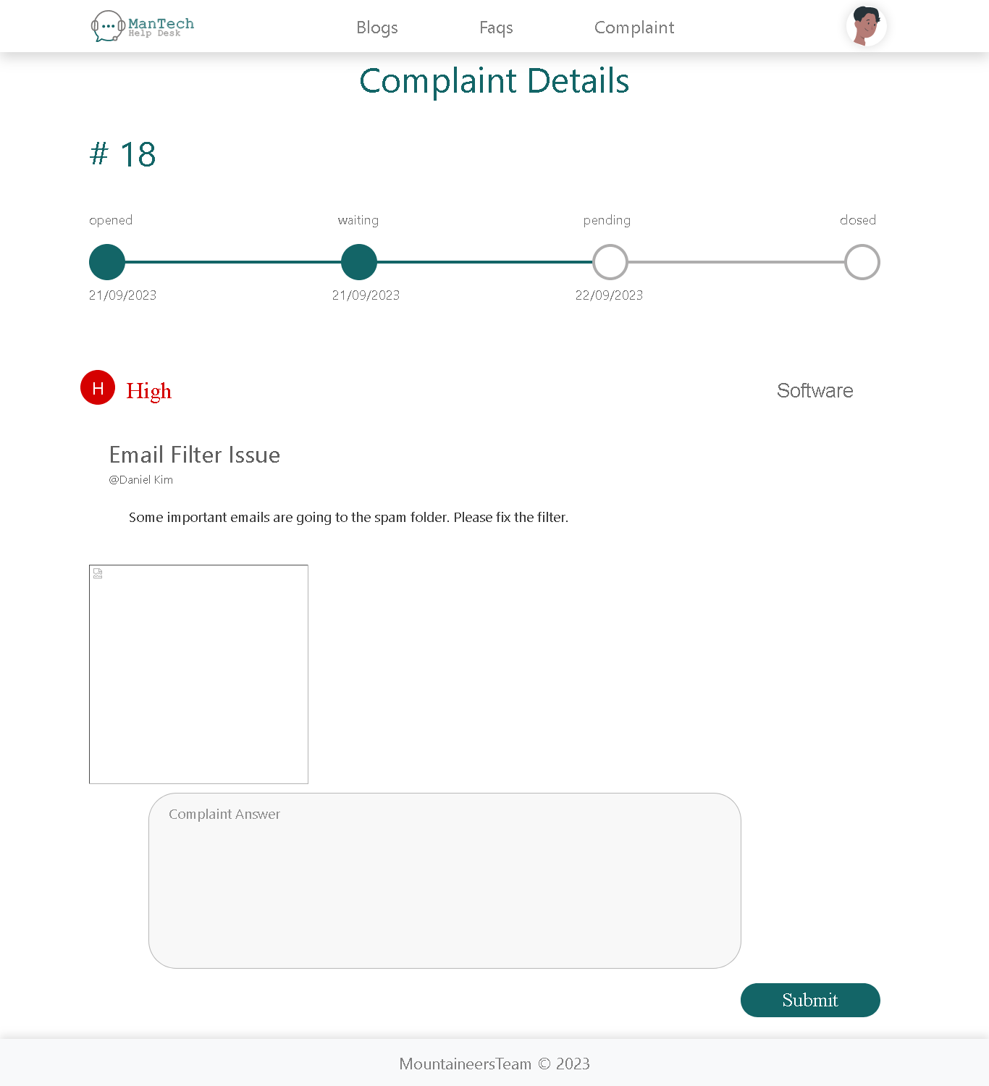

Complaints Details Technical Page:

- The technician can access the details of the Complaints and provide a solution if the Complaint has not been closed yet.

- The technician also has two similar pages for blogs and FAQs, similar to the pages available for normal users.