Auto-Tagging-System
An Auto-Tagging System is a technology used to automatically assign descriptive tags or labels to content, such as text, images, audio, or video, based on the content's features or characteristics. These systems are often powered by machine learning, natural language processing (NLP), and computer vision technologies, depending on the type of data.
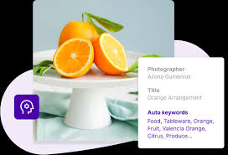
Why Is Auto-Tagging Important?
Auto-tagging is essential for businesses that want to stay ahead of the curve. By automatically tagging every final URL, businesses can detect trends and focus on issues that matter most to their customers.
Additionally, auto-tagging saves you the work of manually tagging each URL, which can be time-consuming and prone to error.
Finally, auto-tagging lets you see how effectively your ad clicks translate into customer actions, such as purchases or sign-ups.
With this information, you can adjust your campaigns accordingly to maximize your return on investment. In short, auto-tagging is a valuable tool that no business should be without.
Dataset
Text Cleaning and Pre Processing
First major step is to clean the data. It contains variou html and urls links, punctuations, single letter alphabets and stopwords which dosent convey much information regarding what topics they are related to.
Steps are as follows.
- Combining the title and text part of our dataset.
- Removing all the punctuations, alphabets through the regex and white spaces and stopwords
- Finally lowercasing all the words present in the text.
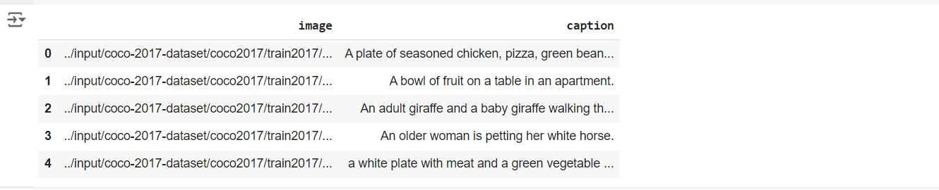
- Reshaping our target variable(tag). Since they are 100 , we will be apply MultiLableBinarizer for sckit learn library. 100 columns more will be more in palce of one.
- Applying Tfidf vectorizer over the text_cleaned part of our dataset having max_features= 10000 (keping only 10000 top words) and max_df=0.8 (words appearing in more than 80 % of text are removed) and Word2Vec model (keeping number of features = 100 initially and then varying) for feature engineering
- Splitting the data using train_test_split using sklearn.model_selection library in 80/20 ratio and then using the logistic regression for prediction.
Feature Engineering
TFIDF: Term frequency and Inverse Document Frequency
The code initializes a tokenizer object for text vectorization using TensorFlow. In natural language processing, a tokenizer is responsible for converting raw text data into numerical form, which can then be used by machine learning models. This process involves breaking the text into individual words or tokens, and then converting these tokens into numerical indices that can be fed into the model.
1-A TextVectorization object is created by calling the tf.keras.layers.TextVectorization class. The purpose of this object is to convert the text into integer sequences that represent the words. Some arguments for this layer are as follows:
- max_tokens = VOCABULARY_SIZE: This limits the number of unique tokens (words) that the tokenizer will handle to VOCABULARY_SIZE. Any word not in the top VOCABULARY_SIZE words will be considered "out of vocabulary."
- standardize = None: By setting this to None, the default standardization process is skipped. Normally, the tokenizer would convert the text to lowercase and strip punctuation, but in this case, no such transformation is applied.
- output_sequence_length = MAX_LENGTH: This defines the maximum length of the sequences. If a text is shorter than this, it will be padded, and if it is longer, it will be truncated.

2-Adapting the Tokenizer: The tokenizer.adapt() function is used to fit the tokenizer to the data. In this case, captions['caption'] represents the text data (captions), and the tokenizer learns the vocabulary and how frequently words appear within this dataset. Without this adaptation step, the tokenizer wouldn't know how to map the words in the data to numerical tokens.
3-A StringLookup object is created using tf.keras.layers.StringLookup. This object maps words to integer indices. This is useful for converting words into their corresponding token indices in the vocabulary. Some arguments for it are:
- mask_token = "": The empty string is used as the "mask" token, which represents padding or words that aren't part of the vocabulary.
- vocabulary = tokenizer.get_vocabulary(): This sets the vocabulary that the tokenizer learned from the data. The vocabulary is the list of unique words found in the data, sorted by frequency.
4-The invert=True flag is used in the second StringLookup object to perform the reverse mapping. This means it will map integer indices back to words. For example, after the model makes predictions, you can convert the predicted token indices back into the original words using this object. The same vocabulary learned by the tokenizer is used here.

In this pipeline, the words are converted into numbers, similar to how a TF-IDF vectorizer converts words into weighted numerical values based on their importance in a corpus. However, instead of calculating importance based on term frequency and inverse document frequency, this method uses the frequency of each word within the dataset to create a dictionary of word indices.

Word2Vec Word Embeddings
Word2vec is a group of related models that are used to produce word embeddings. These models are shallow, two-layer neural networks that are trained to reconstruct linguistic contexts of words. Word2vec takes as its input a large corpus of text and produces a vector space, typically of several hundred dimensions, with each unique word in the corpus being assigned a corresponding vector in the space. Word vectors are positioned in the vector space such that words that share common contexts in the corpus are located close to one another in the space. There are two models for generating the embeddings, CBOW(Continous Bag of words) and skip gram model. CBOW is used for small corpus, it is fast but for larger corpus skip gram is better, takes a little more time than CBOW. Here skip gram is used, below its explanation.
Skip Gram
a technique used to learn word embeddings, which are dense vector representations of words. It is part of the Word2Vec framework developed by Google and is particularly useful for capturing the semantic meaning of words based on their surrounding context in a corpus.
How Skip-Gram Works:
The Skip-Gram model works by predicting the context (neighboring words) given a central word. The idea is that words appearing in similar contexts tend to have similar meanings, and this relationship is encoded in the learned word embeddings.
- Window Size: You mentioned a window size of 2. In this case, the Skip-Gram model considers 2 words before and 2 words after the target word to form the context. This means that for each target word, you would try to predict the surrounding 4 words (2 on the left and 2 on the right).
- Objective: The goal of the model is to maximize the probability of the context words given the target word. It does this by training on pairs of (target word, context word).
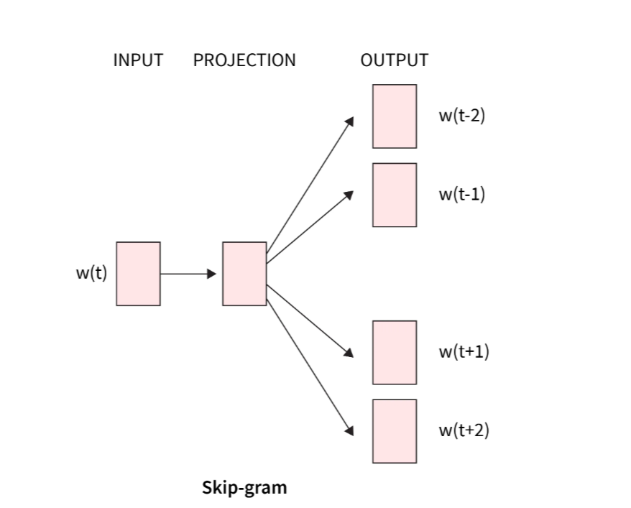
Skip-Gram Overview (with a focus on network structure):
- Vocabulary Construction:
  - The first step in the Skip-Gram model is to build the vocabulary from the corpus. Each unique word in the corpus is assigned an index. This vocabulary is typically large; for example, you might have 10,000 unique words in the vocabulary.
- One-Hot Encoding:
  - Once the vocabulary is constructed, each word is represented as a one-hot vector. For example, if you have 10,000 words in your vocabulary, each word will be a 10,000-dimensional vector with a single "1" at the index corresponding to that word and "0"s everywhere else.
Example:
  - Vocabulary index: {'quick': 1, 'brown': 2, 'fox': 3, ...}
  - "fox" in one-hot encoding (assuming an index of 3): [0, 0, 1, 0, ..., 0] (with 10,000 dimensions)
- Training Example Pairs:
  - For each word in the corpus, training pairs are created based on the window size. If the window size is 2, the model will try to predict the 2 words before and 2 words after the target word.
  - For each target word, 4 pairs (context words) are generated (in this case, with window size 2). If you slide this window across the text, you'll have multiple pairs per word, depending on its context in the corpus.
- Skip-Gram as a Two-Layer Neural Network:
  - The Skip-Gram model can be represented as a two-layer neural network. The architecture is as follows:
    - Input Layer: The input is a one-hot encoded vector representing the target word (e.g., 10,000 dimensions for a 10,000-word vocabulary).
    - Hidden Layer (Embeddings): This is a weight matrix of size (vocabulary_size x embedding_size) (e.g., 10,000 x 300). It contains the word embeddings.
    - Output Layer: The output is a probability distribution over the entire vocabulary (e.g., a 10,000 x 1 vector) for predicting the context words around the target word.
- Output Probabilities:
  - Given an input word (in one-hot form), the network’s output will be a vocabulary-sized vector (e.g., 10,000 x 1) that represents the probabilities of all words in the vocabulary being in the context of the input word.
  - The model’s goal is to increase the probability of the actual context words for the given input word while reducing the probabilities of unrelated words.
- Training Process:
  - The training process involves adjusting the weights of the hidden layer using backpropagation. The network tries to predict the context words, and the error between the predicted and actual context words is used to update the weights.
  - For each training pair (target word, context word), the weights of the hidden layer are adjusted so that the network learns which words are more likely to appear in similar contexts.
- Weight Matrix (Embeddings):
  - The weight matrix of the hidden layer (of size 10,000 x 300) is the final embedding matrix. This matrix contains the learned dense vector representations (embeddings) for each word.
  - Words that frequently appear together in similar contexts will have similar embeddings, and the distance between these word vectors reflects their semantic similarity.
- Word Embedding Extraction:
  - To get the embedding vector for a specific word, you multiply the word's one-hot encoded vector with the weight matrix (the hidden layer). Since the one-hot vector has "1" at the index of the target word and "0"s elsewhere, this operation selects the corresponding row from the embedding matrix.
  - This row represents the dense vector (e.g., a 300-dimensional vector) for the word, capturing its relationships with other words in the vocabulary.
Simplified Example:
- Input: The word "fox" (one-hot vector of size 10,000).
- Hidden Layer (Embedding Matrix): A weight matrix of size (10,000 x 300).
- Output: A vector of probabilities (size 10,000 x 1), where the goal is to maximize the probability of "quick," "brown," "jumps," and "over" for the word "fox."
By training this network over many words and contexts, the embedding matrix (the hidden layer) gets updated to encode useful semantic information about words and their contexts.

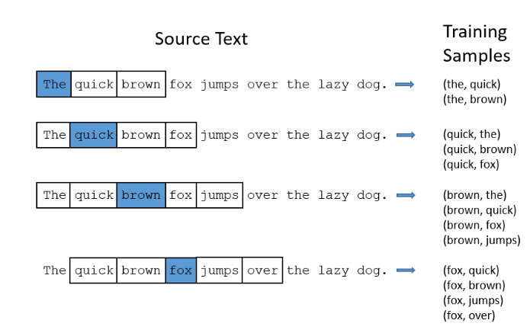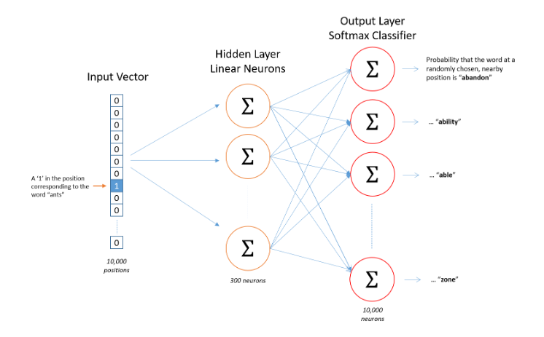
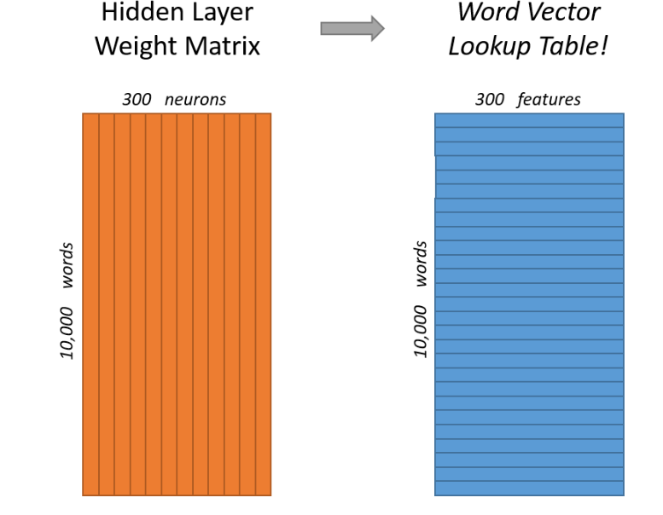

Fitting the model

Using CNN based Deep Learning model
how the CNN (Convolutional Neural Network) model works for text classification using an embedding layer is quite good, but I’ll fine-tune the details to ensure clarity and correctness. Here's a more detailed step-by-step breakdown:
1. Embedding Layer:
- The sentence, "I like this movie very much!", is passed through an embedding layer. Each word in the sentence is mapped to a dense vector representation (embedding) of size "d".
  - For example, if d = 100, each word in the sentence will be represented as a vector of size 100 (a dense, learned vector representing the word's meaning).
  - Word embeddings capture semantic information about words, with similar words having similar vector representations.
2. Convolutional Filters:
- Filter sizes: In this model, convolutional filters with sizes 2, 3, and 4 are used.
  - A filter size of 2 means the filter will look at two consecutive words at a time (e.g., "I like", "like this", etc.) and try to capture information from word pairs.
  - Similarly, a filter size of 3 looks at triplets of words (e.g., "I like this", "like this movie") and a filter size of 4 looks at quadruples of words.
  - These filters are designed to capture n-grams (word patterns of size n) and identify patterns in the sentence.
3. 1D Convolution:
- This is a 1D Convolution because the model slides the filters along the sentence in the vertical direction, where each word is represented by its embedding vector of size d.
  - In text CNNs, the width of the filter is equal to the embedding size d, meaning the filter will fully capture the information across all dimensions of each word embedding.
  - For example, if the filter is 2x100, it will slide over two consecutive word embeddings, each of size 100, and compute a weighted sum of these vectors.
4. Convolution Operation:
- The convolution operation involves sliding the filters over the sentence and performing element-wise multiplication between the filter weights and the word vectors, followed by summing them up.
  - The result of the convolution is a scalar value representing the "activation" for that particular window of words.
  - After sliding the filter across the entire sentence, the model generates a feature map, which is essentially the collection of these activations for the entire sentence.
5. Activation Function:
- Once the filter slides over the sentence, the obtained values are passed through an activation function (like ReLU), which introduces non-linearity into the model and helps in learning complex patterns.
  - ReLU is a common choice, which replaces all negative values with zero while keeping positive values intact.
6. Feature Maps:
- The convolution operation with each filter generates a feature map.
  - Each filter size (e.g., 2, 3, 4) will generate a separate feature map, as each filter size captures different kinds of patterns (bigrams, trigrams, etc.).
  - If you have 10 filters for the 2-word convolution, 10 filters for the 3-word convolution, and so on, each will produce its own feature map after sliding over the sentence.
7. Global Max Pooling:
- After the convolution, Global Max Pooling is applied to each feature map. This operation selects the maximum value from each feature map. The intuition behind this is that the highest activation value in each feature map represents the most important or salient information captured by the corresponding filter.
  - This reduces the dimensionality and keeps the most important information.
  - The max-pooled values from all the feature maps are then concatenated to form a single feature vector.
  - Average Pooling is an alternative, where instead of selecting the maximum value, the average value is taken across the feature map. This retains more information but might not capture the most important signals as strongly as max-pooling does.
8. Final Feature Vector:
- After applying pooling, the model now has a single feature vector that represents the entire sentence. This vector is a combination of the most important features extracted by the convolutional filters.
9. Softmax Layer:
- The final feature vector is passed to the Softmax layer, which computes a probability distribution over the possible output classes (e.g., categories for text classification like "positive" or "negative" sentiment).
  - Softmax is used in multi-class classification tasks and outputs probabilities for each class. It ensures that the sum of probabilities across all classes is 1.
  - The class with the highest probability is chosen as the model's prediction.
  - The softmax function is defined as:
  - 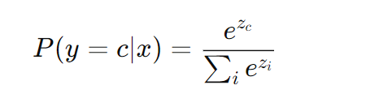
​​ where z is the raw score (logit) for class c and the softmax normalizes these logits into probabilities.
10. Learning Through Backpropagation:
- During training, the CNN learns the filter weights using backpropagation.
  - The loss function (usually cross-entropy for classification tasks) calculates the error between the predicted output and the true label.
  - The error is propagated back through the network, and the weights (including the convolutional filter weights) are updated to minimize this error.
  - Over time, the model learns to adjust the filter weights to extract the most useful features for classifying the sentences.

Steps:
- First tokenize the text. In this way every document will be converted into a sequence of words identified by their token number. To do this, we will use Tokenizer from keras.preprocessing.text.
- After tokenization, we will define the input length for the embedding layer
- Reshaping our target variable
- We will build our model by adding the embedding layer , Conv1D layer, GlobalMax Pool 1D, Dense Layer.
- Compile the model using "adam" optimizer, loss='binary_crossentropy' and "accuracy" as a metric.
- Adam : It is most widely used optimizer; it is a combination of RMS prop and momentum which are used to accelerate the gradient descent
- Cross Entropy Binary Loss: It computes the loss by treating every class(eg, 100 here ) as a binary classification problem
- Model Training :
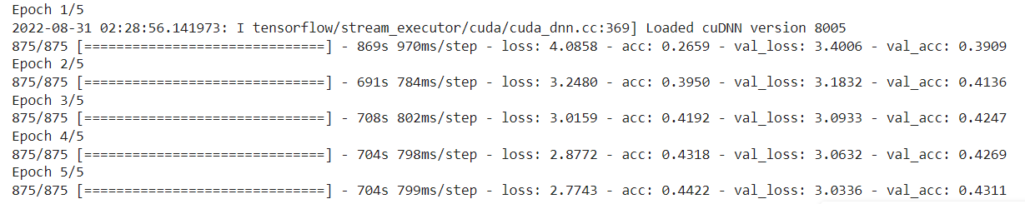

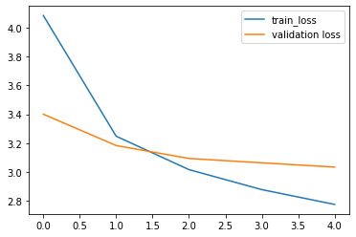

Performance of the model

