SafeSight
Construction Site PPE Recognition Using Neural Networks and Transfer Learning
MLAI 504 | Neural Networks & Deep Learning | Research report + post-training result fields
Student: Ali Tarhini and Mohammad Zaiter Instructor: Dr zien ibrahim Date: 2/11/2026

Executive Summary
This project compares a dense multilayer perceptron, multiple convolutional neural networks, a randomized hyperparameter search and an ImageNet-pretrained MobileNetV2 for four-class classification of annotated construction safety-equipment regions. The four categories are Hardhat, NO-Hardhat, Safety Vest, and NO-Safety Vest. The problem matters because visual screening of missing protective equipment can assist human safety audits, subject to validation and supervision.
Results are intentionally not fabricated. Selected best model: fine-tuned MobileNetV2. Held-out macro-F1: 90.91%. Held-out accuracy: 91.45%. Unsafe-class recall: 92.43%.

1. Problem, objective, and scope
Research question: Does transfer learning improve macro-F1 and missing-equipment recognition against scratch networks when evaluated on region crops from held-out construction photographs? The independent unit of partitioning is the original image, not the cropped region. The classifier processes already annotated bounding boxes, not full camera frames. Person-to-equipment attribution and localization are outside the task; this prevents overclaiming automatic workplace compliance.

2. Dataset provenance and legal use
Source: Roboflow Universe Projects, Construction Site Safety, v27, YOLOv8 export, CC BY 4.0. URL: https://universe.roboflow.com/roboflow-universe-projects/construction-site-safety/dataset/27 . Public version page reports 2,801 exported images (2,605 train, 114 validation, 82 test) and multiple object classes, not all of which are used here. The source project overview describes 717 images; 2,801 represents augmented/exported examples. Record the actual downloaded counts after running: 2,605, 114, 82. Target class counts are computed from YOLO labels by the notebook and saved in crop_manifest.csv. The exported augmentation and skewed split ratios are limitations.

3. Exploration, cleaning and preprocessing
YOLO labels contain class ID and normalized bounding-box center/width/height. The pipeline checks malformed rows, unreadable images, absent label files, invalid coordinate values and crops smaller than 12 pixels. It clips padded coordinates to image bounds and logs all exclusions to annotation_audit.csv. It does not replace corrupt data with guessed labels. Image-region area distributions, class frequencies and sample visualizations are included. All regions are converted to RGB, resized to 160×160 and normalized to [0,1]. MobileNetV2 inputs are further mapped to [−1,1]. Class weights are computed from training only. Missing annotations are not interpreted as absence of PPE.
Leakage controls: respect image-level Roboflow partitions before cropping; verify filename-disjoint partitions and exact SHA256 duplicates; prohibit choosing parameters on test. Because augmented variants and site sequences may resemble each other, a further perceptual and location-based deduplication would strengthen external validity.

4. Model design and lecture integration
Lecture 02 explains neurons/perceptrons: a single linear separator cannot express complex nonlinear appearance. Lecture 03 motivates an MLP with hidden layers; the 64×64 flattened RGB baseline establishes a meaningful low-cost starting point. Lecture 06 motivates convolution, spatial locality, weight sharing, pooling and global-average pooling. Scratch CNNs test ReLU and ELU activations, channel depth, batch normalization, L2 and dropout. Lecture 04 motivates sparse categorical cross-entropy (appropriate to one exclusive integer class per crop), backpropagation and Adam/SGD. The loss is evaluated against four mutually exclusive object-region labels, not a multihot worker-level PPE label.
Lecture 05 motivates ImageNet features: MobileNetV2 first trains a new head with the backbone frozen, then fine-tunes its last 30 layers at 1e−4, retaining batch normalization in inference/frozen mode. Lecture 07 treats recurrent networks, which were deliberately excluded: static crops contain no sequence dependencies.

5. Hyperparameter optimization
Six seeded random-search trials examine learning rates (1e−4, 3e−4, 1e−3), batch sizes (16, 32), optimizers (Adam or momentum SGD), activation (ReLU/ELU/tanh), filters (16/24/32), dropout (.20/.35/.50), and L2 (1e−5/1e−4/5e−4). Every trial receives the same maximum nine-epoch resource budget; early stopping and validation-loss learning-rate reductions are enabled. Trial configurations, times and held-out-validation results are logged to hyperparameter_search.csv. The final model is selected on validation macro-F1 with unsafe-class recall as the tie breaker. Explicitly report search budget, winner and whether it materially improved over the base scratch CNN.

6. Evaluation protocol and evidence
Primary criterion: macro-F1, which gives equal influence to each of the four classes. Secondary criteria: accuracy, balanced accuracy, per-class precision/recall/F1, and mean recall over NO-Hardhat and NO-Safety Vest. For a class c, Precision=TP/(TP+FP), Recall=TP/(TP+FN), F1=2PR/(P+R). A four-by-four confusion matrix and misclassified crop gallery diagnose error modes. A single untouched test evaluation is performed only after validation-based selection. The region-level unsafe recall is not an estimate of detection-level or worker-level compliance recall.
Place plots after execution: Figure 1 below, Figure 2 below, Figure 3 below, Figure 4 below.

7. Results — measured validation metrics
Configuration | Validation macro-F1 | Unsafe recall | Train time
MLP baseline | 56.78% | 57.40% | 7.7 min
Scratch CNN (ReLU) | 69.58% | 77.76% | 55.2 min
CNN (ELU+regularization) | 68.94% | 69.19% | 65.5 min
Best tuned CNN | 62.86% | 62.75% | 29.8 min
Frozen MobileNetV2 | 84.87% | 84.57% | 26.2 min
Fine-tuned MobileNetV2 | 62.86% | 62.75% | 29.8 min
Selected model: fine-tuned MobileNetV2 | Test macro-F1: 90.91% | Test accuracy: 91.45% | Test unsafe recall: 92.43%.

8. Findings, limitations, and error analysis
Interpret the observed validation and test differences, not the expected superiority of transfer learning. Illustrate failures such as distant/small helmets, occlusion, illumination changes, visually ambiguous vests and truncated crops using error_gallery.png. Report whether false negatives in NO-Hardhat and NO-Safety Vest are tolerable for only a human-in-the-loop prototype. Avoid reading deployment validity into a single curated source dataset.
Limitations include very small validation/test image partitions relative to the augmented training partition, within-image correlated object crops, possible near-duplicates, category ambiguity, absent person–PPE association, potential annotation noise, and untested deployment-site domain shift. The class membership uses provided box labels; bounding boxes are required at inference, so end-to-end scene detection is not demonstrated. Metrics from a public Roboflow model are NOT comparable with this notebook’s crop-classification metrics.

9. Conclusion and future work
Conclusion: On the held-out test region crops, fine-tuned MobileNetV2 achieved macro-F1 90.91%, compared with validation macro-F1 56.78% for the MLP. The improvement must be described as +32.82 percentage points (validation macro-F1 vs MLP) after computation. The result supports/does not support the hypothesis as follows: fine-tuning led validation macro-F1 (89.61% vs 84.87% for the frozen backbone) and improved unsafe-class recall; the held-out test macro-F1 was 90.91%. This supports the transfer-learning hypothesis within the tested annotated-region setting..
Future work: independently collect new construction-site images, use group-wise scene/site holdouts, train a true detector such as YOLO on unaugmented data, report mAP@50–95, associate PPE with individual persons, tune class-specific decision thresholds and calibrate probabilities, test fairness and visibility conditions, and ensure human review.

10. Reproducibility and submission checklist
Run the entire notebook top-to-bottom with TensorFlow GPU, Roboflow key or local export. The notebook writes configuration.json, crop_manifest.csv, annotation_audit.csv, validation_results.csv, hyperparameter_search.csv, final_metrics.json, classification_report.json, test_predictions.csv, plots and the trained .keras model to artifacts/. Include the notebook and a results/ folder in the submission; keep credentials and full copyrighted dataset out of the repository unless licensing and size permits.
Presentation checklist: review all actual figures and values on the updated slides; verify all six models appear in the comparison; explain what counts as a sample and why localization mAP is not used; rehearse concise justifications for MLP vs CNN, ReLU vs ELU, cross-entropy, dropout/L2, optimizer and freezing/unfreezing.

References
MLAI 504 instructor-provided lecture files: Lecture 00 through Lecture 07, including Lectures 02 (perceptron), 03 (MLP), 04 (Cost and Optimization), 05 (Transfer Learning), 06 (CNN).
Roboflow Universe Projects. Construction Site Safety dataset v27. CC BY 4.0. https://universe.roboflow.com/roboflow-universe-projects/construction-site-safety/dataset/27
Howard, A. G. et al. (2017). MobileNets: Efficient Convolutional Neural Networks for Mobile Vision Applications. arXiv:1704.04861.
Sandler, M. et al. (2018). MobileNetV2: Inverted Residuals and Linear Bottlenecks. CVPR.
Kingma, D. P. & Ba, J. (2015). Adam: A Method for Stochastic Optimization. ICLR.
TensorFlow Keras API documentation; scikit-learn model evaluation documentation.

Measured Findings and Interpretation
All results in this section were extracted from the completed Jupyter notebook outputs. Eleven configurations were evaluated on the same validation crop set (n=255); the model was selected by validation macro-F1. The chosen model alone was evaluated on the held-out test crops (n=269).
Model | Val. macro-F1 | Val. unsafe recall | Train time
MLP baseline | 56.78% | 57.40% | 7.7 min
CNN ReLU | 69.58% | 77.76% | 55.2 min
CNN ELU + regularization | 68.94% | 69.19% | 65.5 min
Best random-search CNN | 62.86% | 62.75% | 29.8 min
MobileNetV2 frozen | 84.87% | 84.57% | 26.2 min
MobileNetV2 fine-tuned | 89.61% | 90.72% | 23.9 min
The fine-tuned MobileNetV2 was best on validation macro-F1 (89.61%), improving by 4.74 percentage points over its frozen-backbone phase (84.87%), 20.03 points over the untuned ReLU CNN (69.58%), and 32.82 points over the MLP (56.78%). The six-trial random-search winner (62.86%) underperformed the original ReLU CNN: tuning is an experiment, not a guaranteed improvement. Training times are machine-specific (the notebook reported no GPU).
Final held-out test (269 regions): accuracy 91.45%; macro-F1 90.91%; balanced accuracy 92.04%; mean unsafe-class recall 92.43%. These are region-classification metrics, not detector mAP or employee-level compliance metrics.
Test class | Precision | Recall | F1
Hardhat | 92.2% | 93.1% | 92.7%
NO-Hardhat | 82.4% | 96.6% | 88.9%
Safety Vest | 90.2% | 90.2% | 90.2%
NO-Safety Vest | 95.8% | 88.3% | 91.9%
Safety interpretation: NO-Hardhat recall was high (96.6%) but precision was lower (82.4%), suggesting some false alarms. NO-Safety Vest recall was 88.3%, the weaker of the two missing-PPE categories and a priority for additional data collection and independent testing. Because one scene may contribute multiple correlated crops, the 269 regions should not be interpreted as 269 independent construction-site scenes.
Figure 1. Dataset distribution and box area
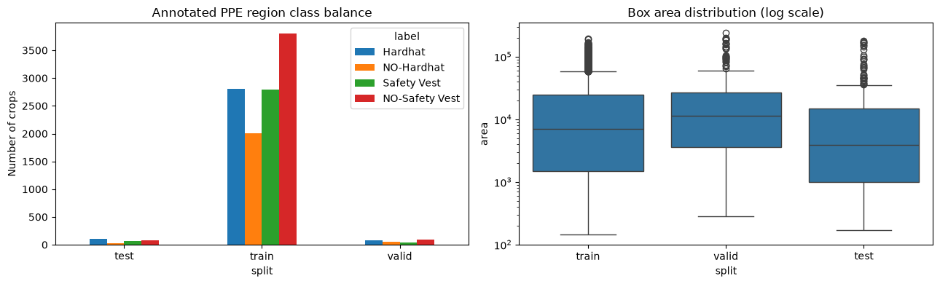
Figure 2. Validation accuracy across models
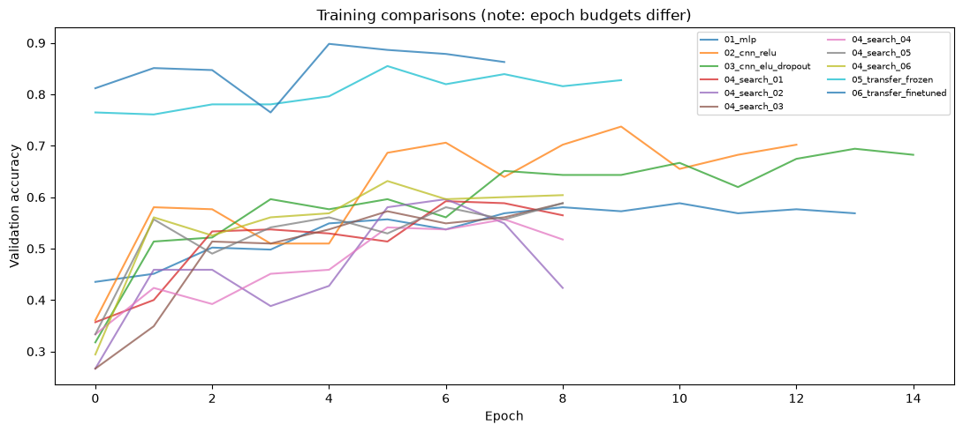
Figure 3. Test confusion matrix
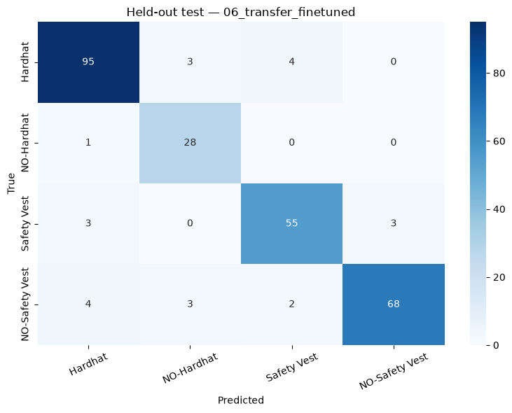
Figure 4. Misclassified test regions
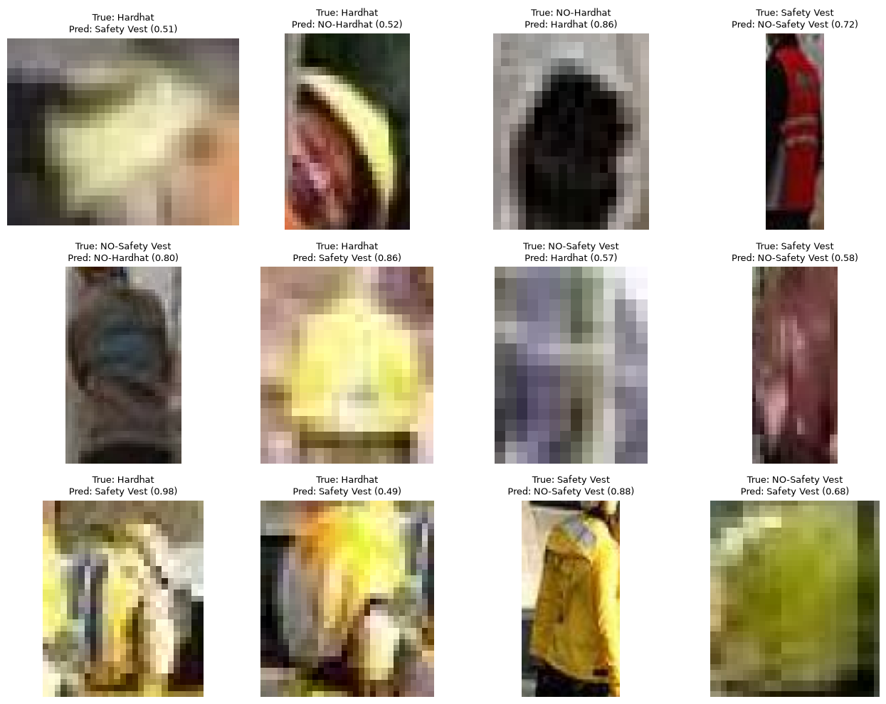
Provenance note: values and figures above were reconstructed from the uploaded notebook outputs. Original exported CSV/JSON artifact files were not separately supplied. Student/instructor/date placeholders remain for completion.

