Data Model Documentation Report

HR Analytics Project

1. Introduction
The purpose of this document is to describe the data model used in the HR Analytics Dashboard project. It explains the structure, tables, keys, and relationships in the snowflake schema.

2. Data Model Overview
The data model follows a Snowflake Schema consisting of one fact table and four dimension tables.

3. Fact Table – emp_fact
- Contains employee-level measurable metrics.
- Columns include: emp_id (FK), Age, Attrition, MonthlyIncome, DistanceFromHome, etc.
- Grain: One row per employee.

4. Dimension Table – dim_emp
- Contains unique employee attributes.
- Columns: emp_id (PK), job_id, dep_id, education_id.
- Maps employees to job, department, and education.

5. Dimension Table – dept_dim
- Contains department information.
- Columns: dep_id (PK), Department.

6. Dimension Table – dim_job
- Contains job role information.
- Columns: job_id (PK), JobRole.

7. Dimension Table – education_dim
- Contains education levels.
- Columns: education_id (PK), Education.

8. Relationships
emp_fact → dim_emp (Many to One)
dim_emp → dept_dim (Many to One)
dim_emp → dim_job (Many to One)
dim_emp → education_dim (Many to One)
All relationships have referential integrity where possible.

9. Cardinality and Joins
- Fact to Dimensions = Many-to-One.
- Tableau Relationships used instead of joins to avoid data duplication.

10. Data Dictionary
- emp_id: Unique employee identifier.
- dep_id: Department identifier.
- job_id: Job role identifier.
- education_id: Education level identifier.
- Attrition: Status of employee leaving.
- MonthlyIncome: Employee salary.

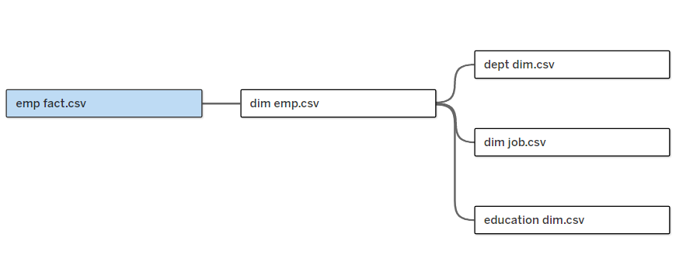

11. Summary
The data model is clean, normalized, and ideal for BI reporting in Tableau.

