**BE 1 Exercises by Mohammed Alammar**

URL: <https://unsplash.com/>

IP: 151.101.129.181:443

How many http(s) requests were made? 131 requests

What are the different types returned from all of the requests?

(bmp, text ,JavaScript ,png ,avif ,script ,and fetch)

What was the largest file returned? 74.9kB

How many ms did it take? 679ms

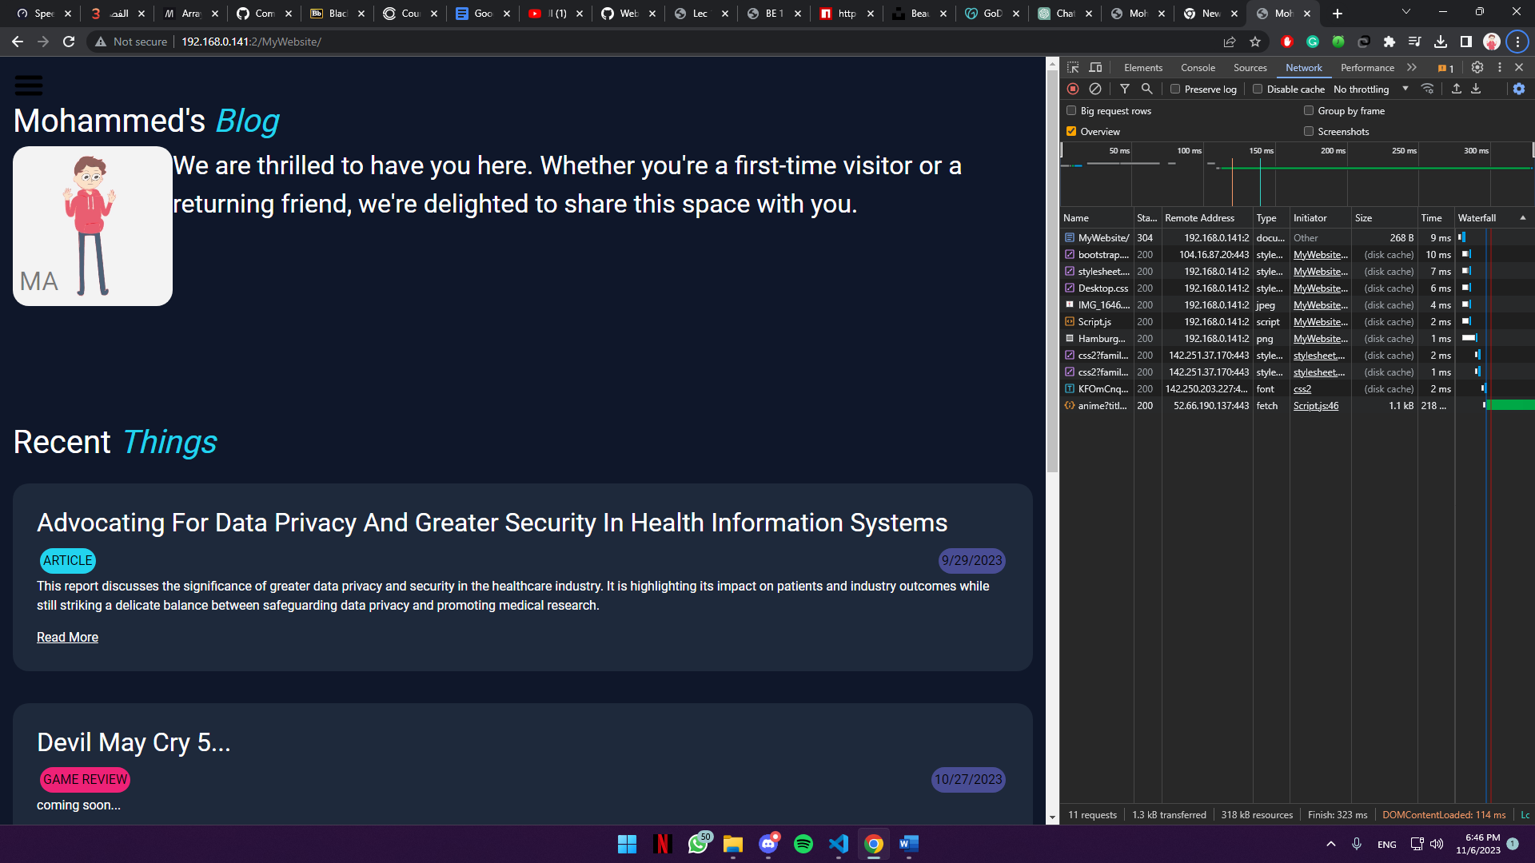

**Domain Name: domzi.me**