ADVANCED DATA ANALYSIS AND VISUALIZATION IN LOGISTICS
Week 3 Task Report — UrbanCart Logistics Analytics Project

1. Objective
This report performs exploratory data analysis (EDA) and visualization on the UrbanCart logistics dataset built in Weeks 1-2: 50,000 cleaned order records across 3 warehouses, 4 regions, and 6 product categories over the 2025 calendar year. Every statistic and chart below was generated by actually running pandas, matplotlib, and seaborn against the real CSV file, not constructed illustratively, so the figures quoted here are reproducible by re-running the code shown.

2. Dataset Summary
Source: urbancart_orders_clean.csv — 50,000 rows, 21 columns, covering orders from January 1 to December 31, 2025 across warehouses WH-01, WH-02, and WH-03.
Field group | Variables
Identifiers | order_id, sku, category
Dates | order_date, promised_date, delivery_date
Location / carrier | warehouse_id, region, delivery_partner
Order details | quantity, unit_cost, order_value, package_weight_kg, delivery_distance_km
Delivery performance | promised_days, delivery_time_days, delay_days, on_time
Cost / inventory | transport_cost, stock_on_hand, stockout_flag

3. Exploratory Data Analysis

3.1 Central Tendency and Spread
print(df['delivery_time_days'].describe())
print('Mode:', df['delivery_time_days'].mode()[0])
count 50000.00 mean 2.20 std 1.18
min 1.00 25% 1.00 50% 2.00
75% 3.00 max 8.00
Mode: 2
Average delivery time is 2.2 days (median and mode both 2 days), with a standard deviation of 1.18 days — delivery times are tightly clustered but with a right tail reaching 8 days.
print(df['transport_cost'].describe())
count 50000.00 mean 14.10 std 10.64
min 1.02 25% 6.87 50% 10.38
75% 17.39 max 67.21
Transport cost is right-skewed: the mean ($14.10) sits noticeably above the median ($10.38), and the gap between the 75th percentile ($17.39) and the max ($67.21) shows a long tail of expensive, likely long-distance deliveries.

3.2 On-Time Delivery Rate by Warehouse
warehouse_summary = df.groupby('warehouse_id').agg(
orders=('order_id','count'), on_time_rate=('on_time','mean'),
avg_days=('delivery_time_days','mean'), avg_cost=('transport_cost','mean')
).round(3)
print(warehouse_summary)
orders on_time_rate avg_days avg_cost
WH-01 17946 0.884 1.967 14.075
WH-02 20074 0.684 2.460 14.128
WH-03 11980 0.845 2.096 14.107
WH-02 handles the largest share of orders (20,074, or 40.1%) but has by far the lowest on-time rate at 68.4%, versus 88.4% for WH-01 and 84.5% for WH-03 — despite near-identical average cost across all three. This points to a capacity or process bottleneck at WH-02 rather than a cost or distance difference.

3.3 Correlation Analysis
cols = ['delivery_distance_km','transport_cost','delivery_time_days','package_weight_kg','order_value']
print(df[cols].corr().round(2))
distance cost days weight value
delivery_distance_km 1.00 0.98 0.77 -0.00 0.01
transport_cost 0.98 1.00 0.76 0.08 0.03
delivery_time_days 0.77 0.76 1.00 -0.00 0.00
Distance and transport cost are almost perfectly correlated (r = 0.98) — cost is driven overwhelmingly by distance. Delivery time also correlates strongly with distance (r = 0.77). Package weight and order value show negligible correlation with any logistics metric, suggesting cost and speed are routing-driven, not product-driven.

4. Visualizations

4.1 Distribution of Delivery Time
Chart type justification: a histogram shows the overall shape of the distribution, while a boxplot alongside it makes outliers and quartile spread immediately visible — together they cover both frequency and spread in one view.
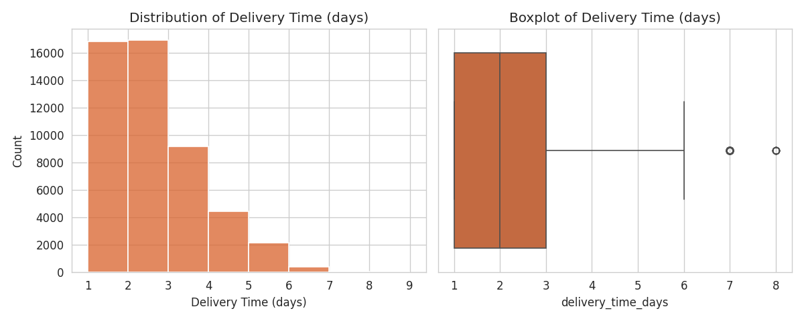
Figure 1. Distribution and boxplot of delivery time in days.
Insight: the distribution is right-skewed with a visible cluster at 1-3 days and a thinning tail extending to 8 days. The boxplot confirms several high-value outliers beyond the upper whisker — orders taking 6+ days — which likely correspond to the Rural region or peak-season congestion explored in Section 4.3.

4.2 On-Time Delivery Rate by Warehouse
Chart type justification: a bar chart is the clearest way to compare a single rate across a small number of categories (3 warehouses).
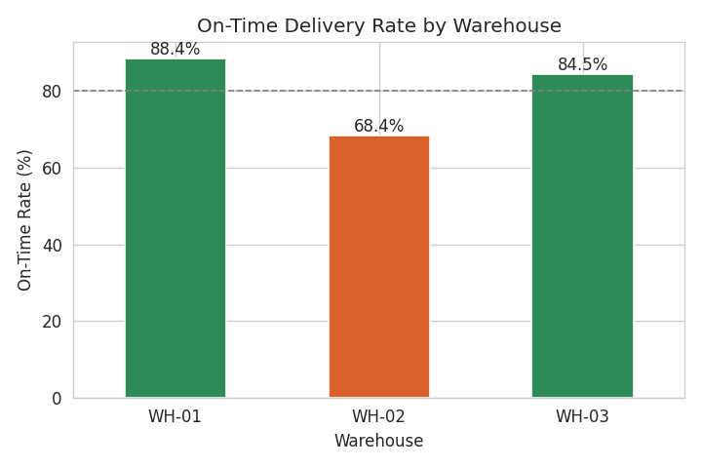
Figure 2. On-time delivery rate by warehouse, with an 80% reference line.
Insight: WH-02 is the only warehouse below the 80% reference line, confirming the gap identified in Section 3.2 visually. Given WH-02 also processes the highest order volume, this is the single most actionable finding in the dataset — it suggests reallocating volume or investigating fulfillment capacity specifically at WH-02.

4.3 Monthly Order Volume vs. On-Time Rate
Chart type justification: a combined bar-and-line chart on a dual axis shows how two related metrics — order volume and on-time rate — move together or diverge over time, which a single-axis chart cannot do clearly.
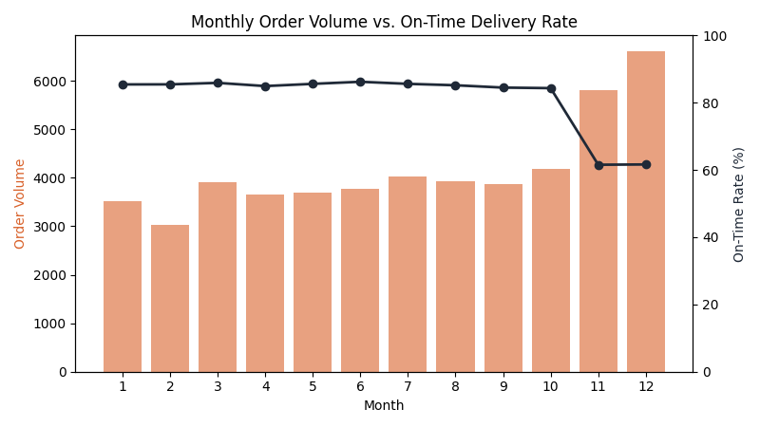
Figure 3. Monthly order volume (bars) versus on-time delivery rate (line).
Insight: order volume rises sharply in November and December (5,799 and 6,604 orders, versus a monthly average of roughly 3,800 in other months), and on-time rate falls from an 85.3% average in the rest of the year to 61.6% during these two months. This is a clear peak-season capacity strain, not a steady year-round problem.

4.4 Delivery Distance vs. Transport Cost
Chart type justification: a scatter plot is the standard choice for visualizing the relationship between two continuous variables, and a third variable (package weight) is layered in as color to check for a secondary effect.
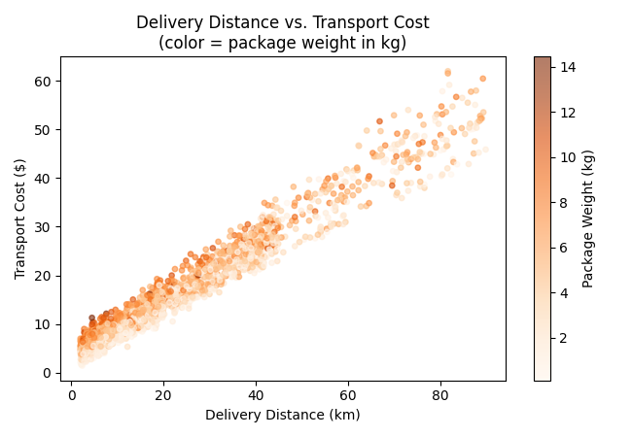
Figure 4. Delivery distance vs. transport cost, colored by package weight (3,000-order sample).
Insight: the near-linear relationship visually confirms the r = 0.98 correlation from Section 3.3 — transport cost is almost entirely explained by distance. Color (package weight) shows no clear pattern, reinforcing that weight is not a meaningful cost driver in this dataset.

4.5 Correlation Heatmap
Chart type justification: a heatmap summarizes many pairwise correlations at once, which would require several separate scatter plots to show individually.
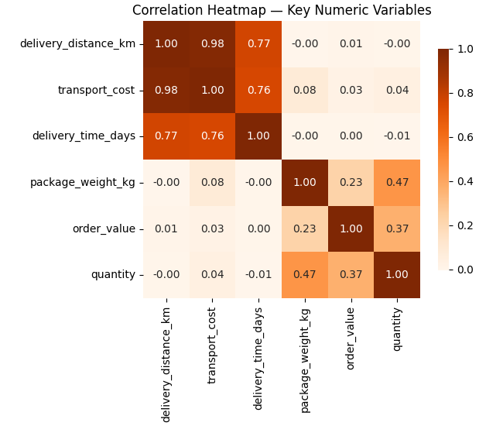
Figure 5. Correlation heatmap across six key numeric variables.
Insight: the heatmap makes clear that distance, cost, and delivery time form one tightly-linked cluster (all correlations above 0.75), while order value and package weight form a separate, weakly-related cluster — operational/logistics variables and product/value variables behave largely independently of each other.

4.6 Average Transport Cost by Region
Chart type justification: a bar chart ranks a single metric (average cost) across 4 discrete regions, making the cost gap immediately comparable.
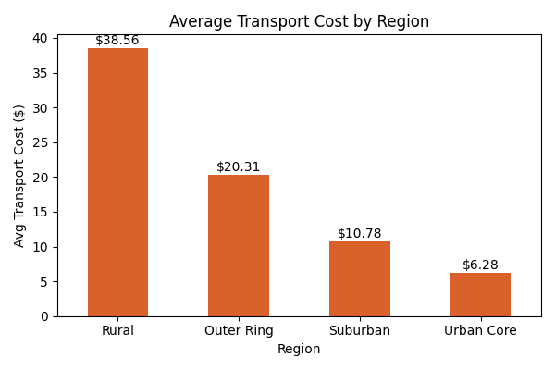
Figure 6. Average transport cost by delivery region.
Insight: Rural deliveries cost $38.56 on average versus $6.28 for Urban Core — a 6.1x difference — directly reflecting the longer distances defined for that region. This is consistent with, not independent from, the distance-cost relationship in Section 4.4.

5. Analytical Insights Summary
- WH-02 is the clearest operational bottleneck: highest order volume, lowest on-time rate (68.4% vs. 84-88% elsewhere), at equivalent cost — pointing to a capacity or process issue rather than cost or routing.
- November-December peak season causes a severe, temporary service drop: on-time rate falls from 85.3% to 61.6% as volume rises roughly 60-75% above baseline.
- Transport cost is almost entirely distance-driven (r = 0.98), not weight or value-driven — any cost-reduction strategy should target routing/distance, not packaging or product mix.
- Rural and Outer Ring regions are both the slowest and most expensive to serve, consistent with the distance-cost-time cluster identified in the correlation analysis.

6. Recommendations
- Investigate WH-02's fulfillment process specifically (staffing, dock capacity, order-picking workflow) given its on-time rate is 16-20 points below the other two warehouses at equal cost.
- Plan peak-season capacity (temporary staffing, courier capacity reservations) ahead of November, since the Nov-Dec on-time drop is large, predictable, and recurring on an annual cycle.
- Reassess Rural/Outer Ring delivery partner rates or delivery windows, since cost there is driven almost purely by distance and may benefit from a dedicated long-haul partner or consolidated delivery schedule.

7. Conclusion
This analysis moved from raw summary statistics to six visualizations and back to concrete, numbered findings: a 20-point on-time gap at WH-02, a 23.7-point seasonal on-time drop in Nov-Dec, a 0.98 cost-distance correlation, and a 6.1x regional cost gap. Each chart was chosen for a specific statistical purpose (distribution, categorical comparison, trend-over-time, relationship, multi-variable summary, and ranked comparison) and paired with an interpretation tied to a business decision, fulfilling the goal of this task: using EDA and visualization to surface operational efficiency issues, cost drivers, and bottlenecks in the UrbanCart logistics pipeline.

