Platelet-rich plasma versus hyaluronic acid injection for knee osteoarthritis: a randomized controlled trial
Randomised controlled trial · PRP group (n=30) and HA group (n=30) · significance level 0.05
Key findings
• Age, sex, BMI, diabetes and KL grade were insignificantly different between the groups.
• WOMAC at Baseline was insignificantly different between the two groups.
• VAS at Baseline was insignificantly different between the two groups.
• Complications and satisfaction were insignificantly different between the two groups.
• After adjustment for WOMAC at Baseline and age, WOMAC at M6 was significantly different between the two groups (P value < 0.001).
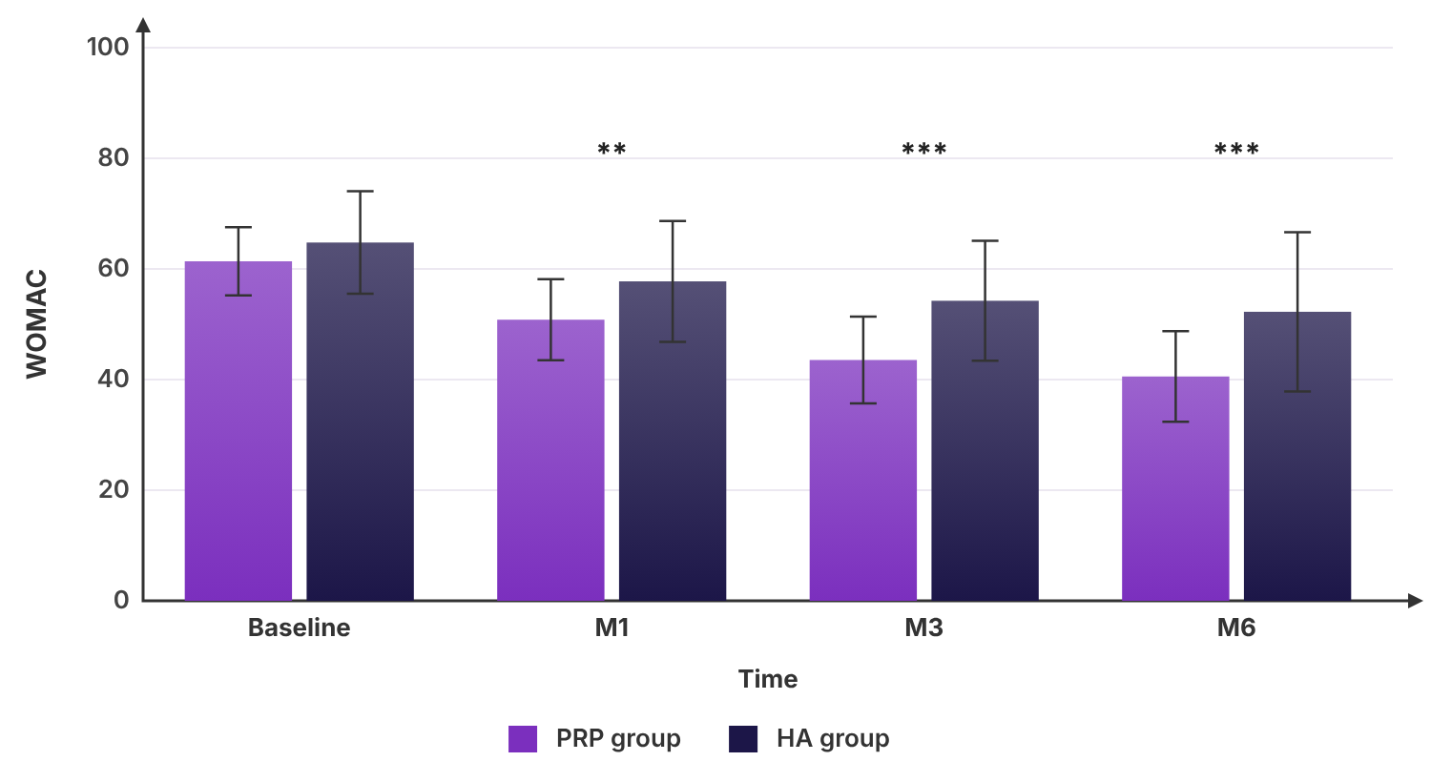
WOMAC of the studied groups
In plain words
We studied PRP group (n=30) and HA group (n=30). The main differences we found: WOMAC at (M1, M3 and M6) was clearly lower in PRP group than HA group, which was clinically relevant. VAS at (M1, M3 and M6) was clearly lower in PRP group than HA group. After adjustment for WOMAC at Baseline and age, WOMAC at M6 was clearly different between the two groups. These results come from one study and should be confirmed by others before they change care.

