Supplementary material

1. Age (years)
Report: parametric (from the normality test), independent t-test, P = 0.606.
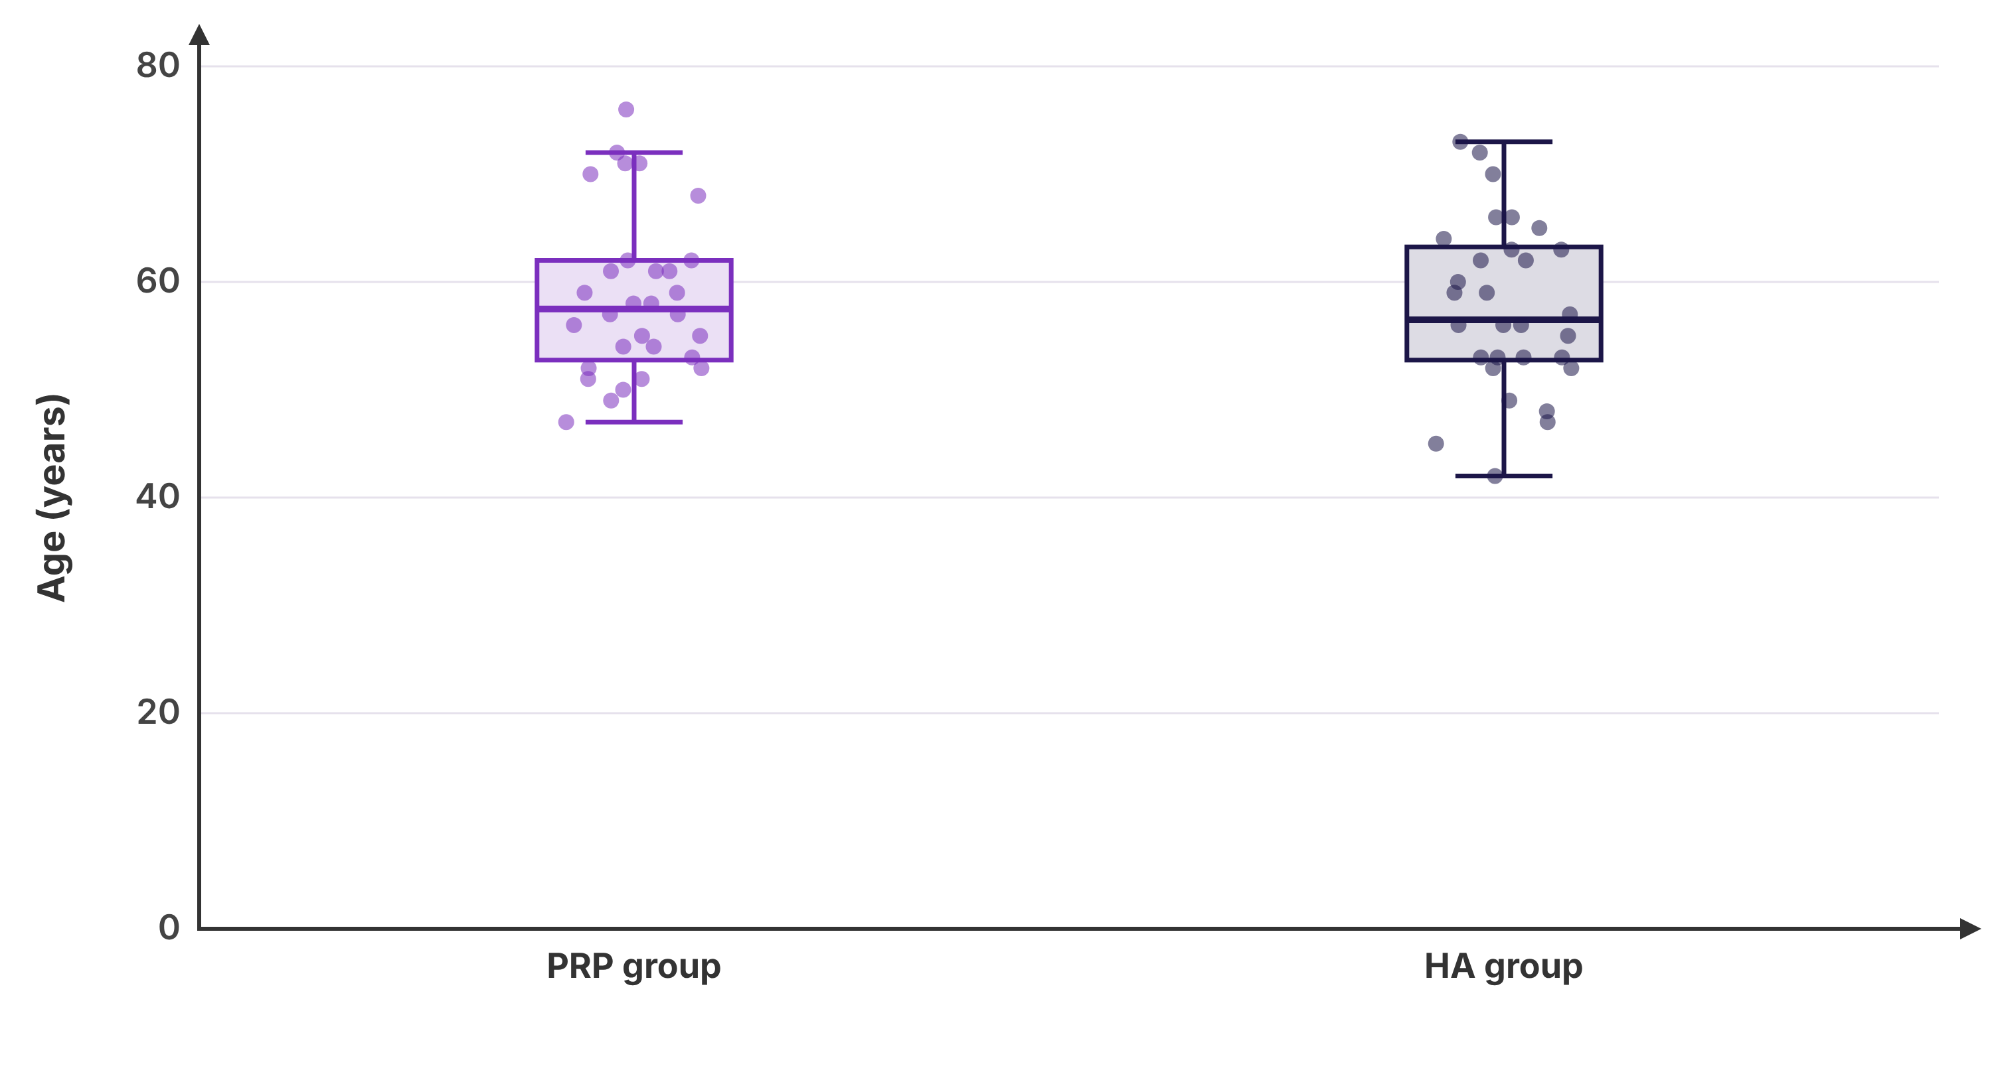
Descriptive statistics
 | n | Missing | Mean | SD | SE | 95% CI of the mean | Median | IQR | Min | Max | Shapiro-Wilk P
PRP group | 30 | 0 | 58.73 | 7.57 | 1.38 | 55.9 to 61.56 | 57.5 | 52.75 - 62 | 47 | 76 | 0.069 (normal)
HA group | 30 | 0 | 57.7 | 7.84 | 1.43 | 54.77 to 60.63 | 56.5 | 52.75 - 63.25 | 42 | 73 | 0.913 (normal)
All patients | 60 | 0 | 58.22 | 7.66 | 0.99 | 56.24 to 60.2 | 57 | 53 - 62.75 | 42 | 76 | 0.312 (normal)
Comparison between the groups
Test | Statistic | df | P value | Effect size (95% CI) | In the report
Levene's test (equal variances) |  |  | 0.697
Student's t-test | t = 0.52 | 58 | 0.606 | MD = 1.03 (-2.95 to 5.02) | ✓
Welch's t-test | t = 0.52 | 57.9 | 0.606 | MD = 1.03 (-2.95 to 5.02)
Mann-Whitney U test | U = 435.5, z = -0.21 |  | 0.830 | HL median difference = 1 (-3 to 5), r = 0.03
Yuen's trimmed-means t-test (20%) | t = -0.06 | 32.7 | 0.955 | trimmed-mean difference = -0.11
Bayes factor (JZS, r = 0.707) | BF₁₀ = 0.29 |  |  | evidence for no difference
Effect sizes |  |  |  | Hedges g = 0.13, Glass Δ = 0.13, Cliff's δ = 0.03

2. Sex
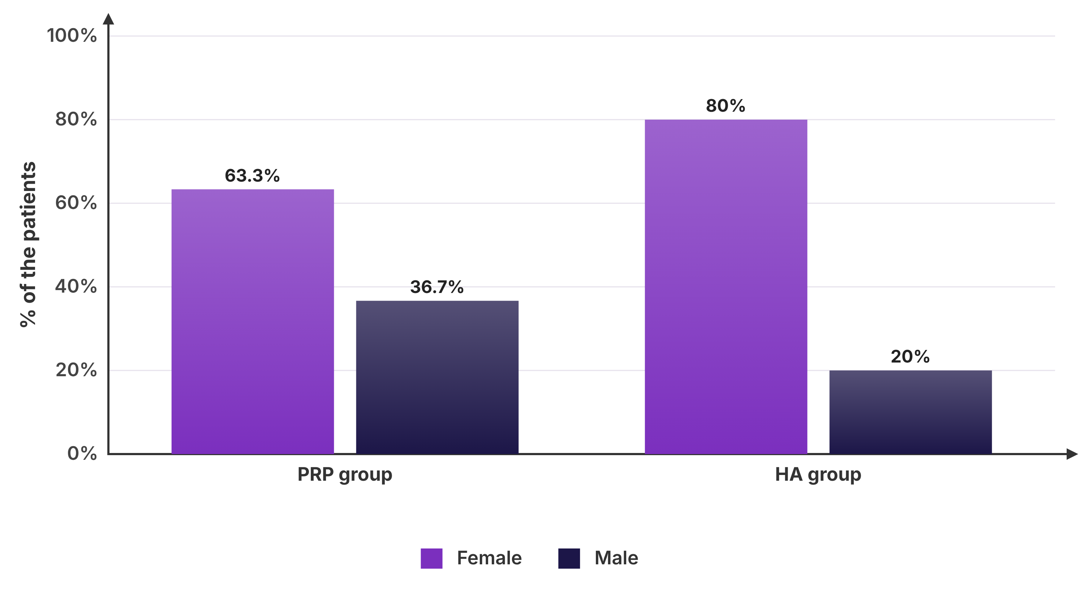
Frequencies
 | PRP group (n=30) | HA group (n=30) | Total (n=60)
Female | 19 (63.3%) | 24 (80%) | 43 (71.7%)
Male | 11 (36.7%) | 6 (20%) | 17 (28.3%)
Missing | 0 | 0 | 0
Comparison between the groups
Test | Statistic | df | P value | Note | In the report
Chi-square test | χ² = 2.05 | 1 | 0.152 | smallest expected count 8.5; 0% of cells < 5 | ✓
Fisher's exact test |  |  | 0.252
Effect of “Female”
Pair | Relative risk (95% CI) | Odds ratio (95% CI)
PRP group vs HA group | 0.79 (0.57 to 1.1) | 0.43 (0.14 to 1.38)

3. BMI (kg/m2)
Report: parametric (from the normality test), independent t-test, P = 0.664.
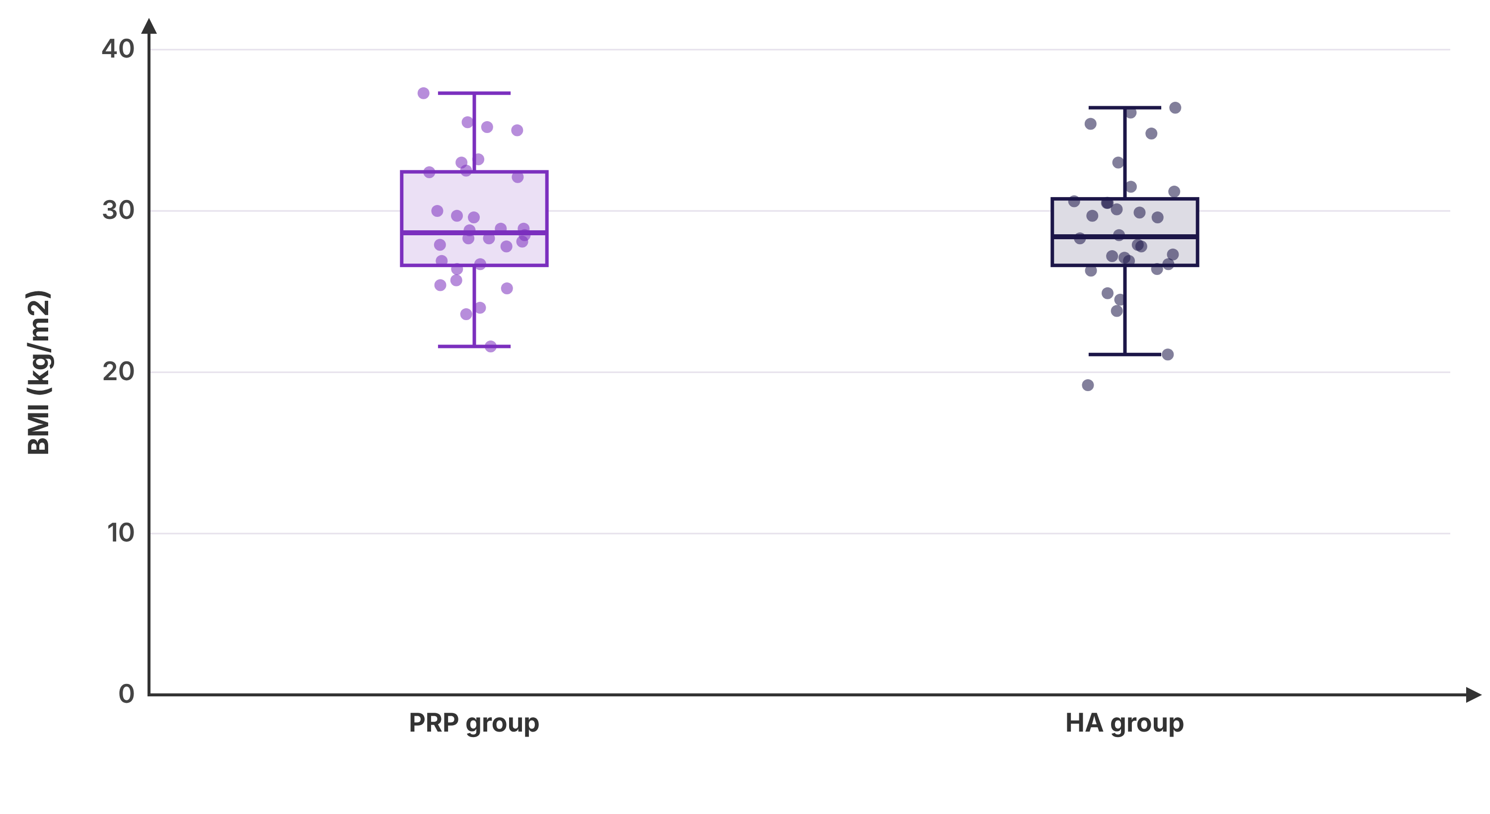
Descriptive statistics
 | n | Missing | Mean | SD | SE | 95% CI of the mean | Median | IQR | Min | Max | Shapiro-Wilk P
PRP group | 30 | 0 | 29.22 | 3.81 | 0.7 | 27.79 to 30.64 | 28.65 | 26.63 - 32.42 | 21.6 | 37.3 | 0.672 (normal)
HA group | 30 | 0 | 28.77 | 4.05 | 0.74 | 27.26 to 30.28 | 28.4 | 26.63 - 30.75 | 19.2 | 36.4 | 0.610 (normal)
All patients | 60 | 0 | 29 | 3.9 | 0.5 | 27.99 to 30 | 28.5 | 26.7 - 31.43 | 19.2 | 37.3 | 0.543 (normal)
Comparison between the groups
Test | Statistic | df | P value | Effect size (95% CI) | In the report
Levene's test (equal variances) |  |  | 0.867
Student's t-test | t = 0.44 | 58 | 0.664 | MD = 0.44 (-1.59 to 2.47) | ✓
Welch's t-test | t = 0.44 | 57.8 | 0.664 | MD = 0.44 (-1.59 to 2.48)
Mann-Whitney U test | U = 431.5, z = -0.27 |  | 0.784 | HL median difference = 0.3 (-1.7 to 2.2), r = 0.04
Yuen's trimmed-means t-test (20%) | t = 0.32 | 32.6 | 0.748 | trimmed-mean difference = 0.31
Bayes factor (JZS, r = 0.707) | BF₁₀ = 0.28 |  |  | evidence for no difference
Effect sizes |  |  |  | Hedges g = 0.11, Glass Δ = 0.11, Cliff's δ = 0.04

4. Diabetes
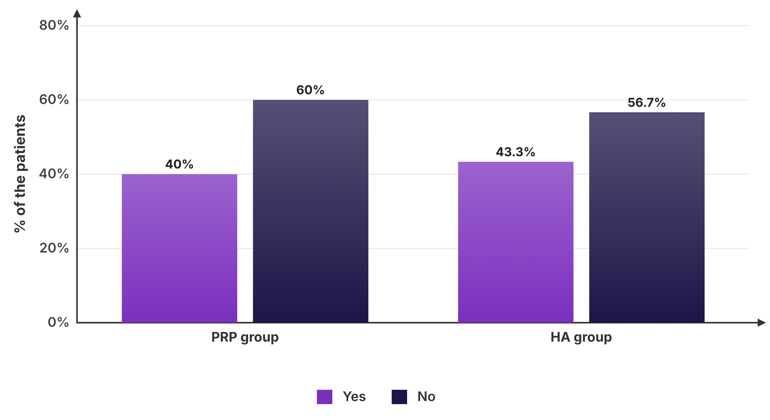
Frequencies
 | PRP group (n=30) | HA group (n=30) | Total (n=60)
Yes | 12 (40%) | 13 (43.3%) | 25 (41.7%)
No | 18 (60%) | 17 (56.7%) | 35 (58.3%)
Missing | 0 | 0 | 0
Comparison between the groups
Test | Statistic | df | P value | Note | In the report
Chi-square test | χ² = 0.07 | 1 | 0.793 | smallest expected count 12.5; 0% of cells < 5 | ✓
Fisher's exact test |  |  | 1.000
Effect of “Yes”
Pair | Relative risk (95% CI) | Odds ratio (95% CI)
PRP group vs HA group | 0.92 (0.51 to 1.68) | 0.87 (0.31 to 2.43)

5. KL grade
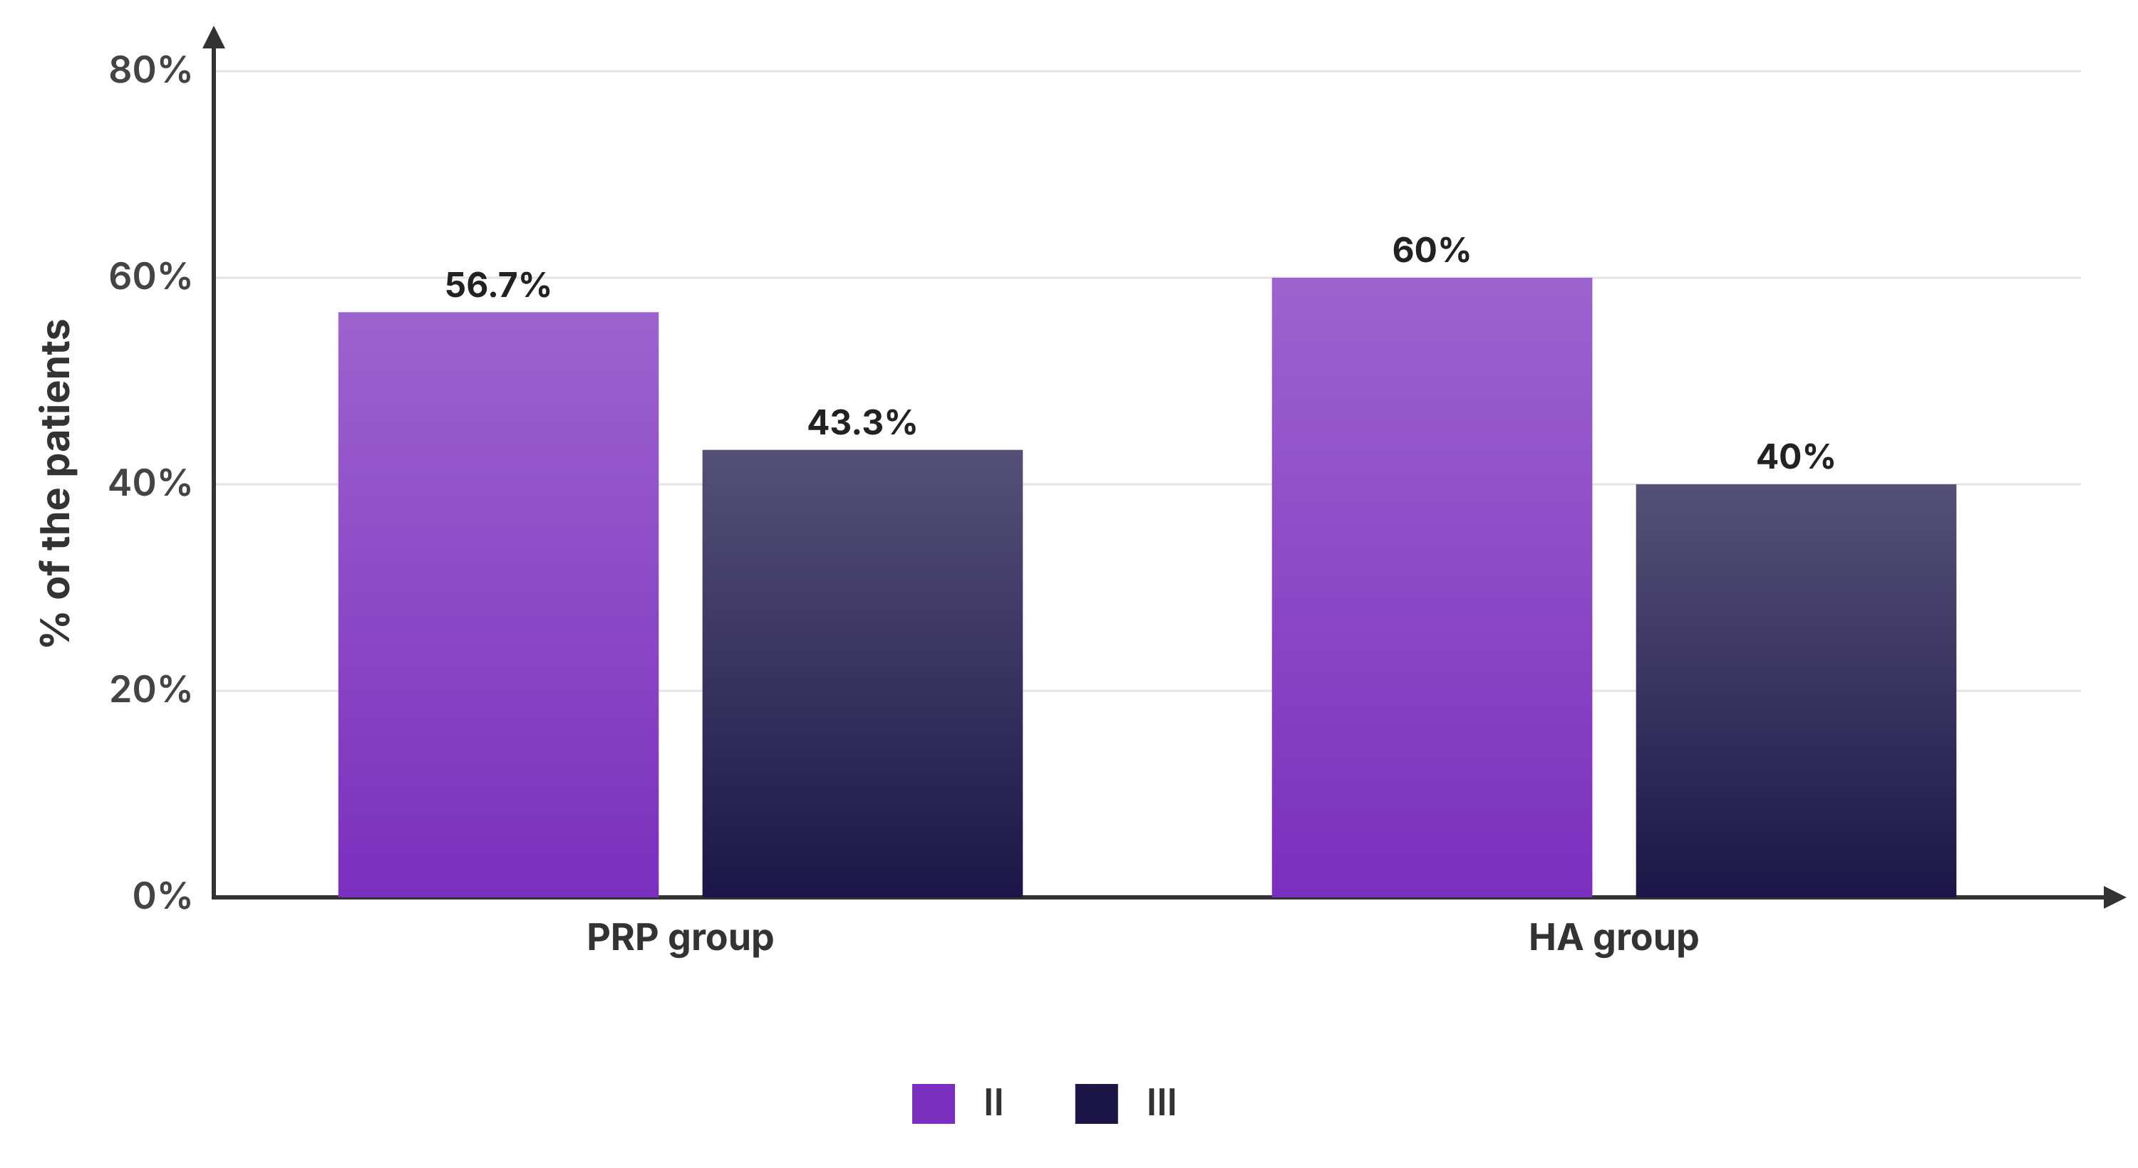
Frequencies
 | PRP group (n=30) | HA group (n=30) | Total (n=60)
II | 17 (56.7%) | 18 (60%) | 35 (58.3%)
III | 13 (43.3%) | 12 (40%) | 25 (41.7%)
Missing | 0 | 0 | 0
Comparison between the groups
Test | Statistic | df | P value | Note | In the report
Chi-square test | χ² = 0.07 | 1 | 0.793 | smallest expected count 12.5; 0% of cells < 5 | ✓
Fisher's exact test |  |  | 1.000
Effect of “II”
Pair | Relative risk (95% CI) | Odds ratio (95% CI)
PRP group vs HA group | 0.94 (0.62 to 1.45) | 0.87 (0.31 to 2.43)

6. WOMAC
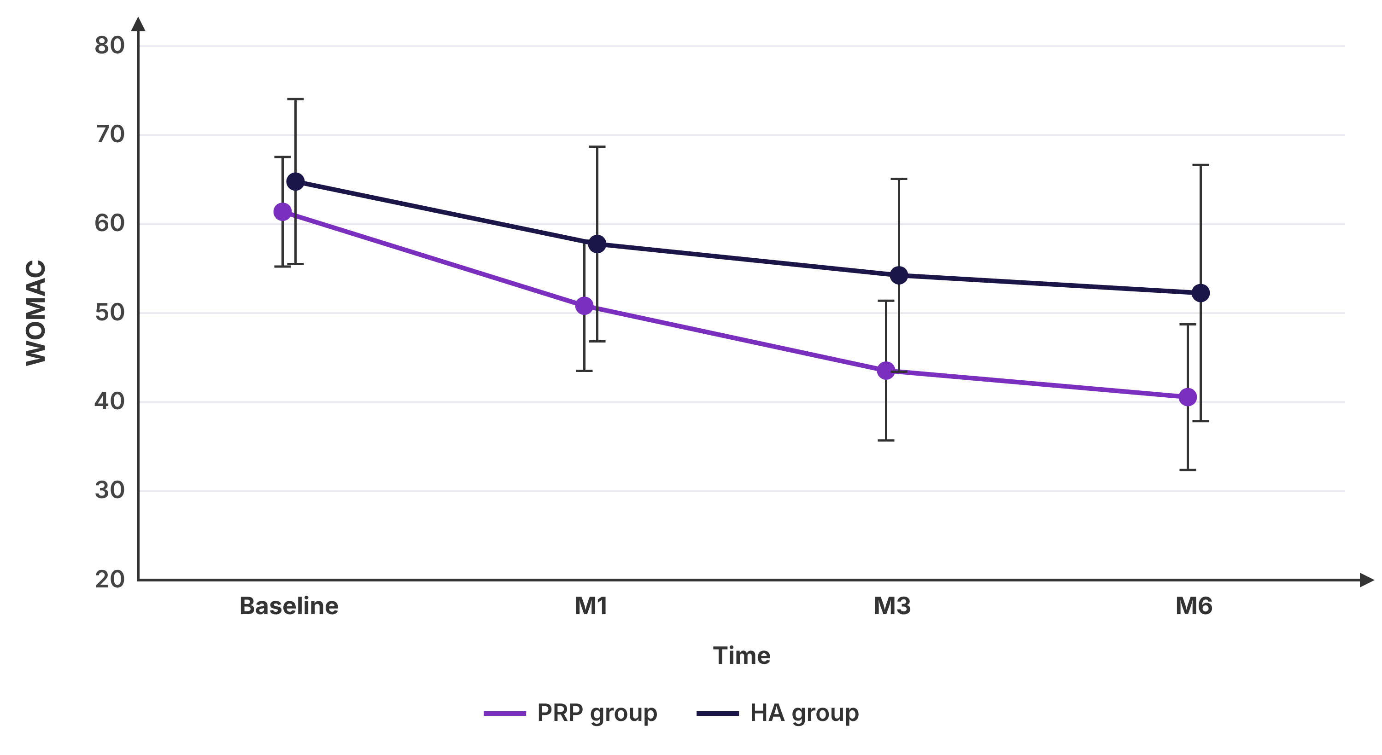
Descriptive statistics
Timepoint |  | n | Missing | Mean | SD | SE | 95% CI of the mean | Median | IQR | Min | Max | Shapiro-Wilk P
Baseline | PRP group | 30 | 0 | 61.38 | 6.15 | 1.12 | 59.08 to 63.68 | 61.05 | 57.55 - 66.08 | 48.6 | 75.1 | 0.975 (normal)
Baseline | HA group | 30 | 0 | 64.77 | 9.26 | 1.69 | 61.32 to 68.23 | 64.4 | 60.13 - 70.18 | 44.6 | 90.9 | 0.371 (normal)
M1 | PRP group | 30 | 0 | 50.82 | 7.31 | 1.33 | 48.09 to 53.55 | 50.5 | 47.05 - 55.65 | 35.5 | 70.3 | 0.808 (normal)
M1 | HA group | 30 | 0 | 57.75 | 10.93 | 2 | 53.67 to 61.83 | 55.55 | 50.38 - 67.48 | 31 | 77.5 | 0.570 (normal)
M3 | PRP group | 30 | 0 | 43.54 | 7.85 | 1.43 | 40.61 to 46.47 | 43.6 | 38.42 - 49.23 | 26.5 | 57.6 | 0.635 (normal)
M3 | HA group | 30 | 0 | 54.24 | 10.84 | 1.98 | 50.2 to 58.29 | 53.1 | 47.98 - 62.08 | 31.8 | 80.6 | 0.919 (normal)
M6 | PRP group | 28 | 2 | 40.56 | 8.18 | 1.55 | 37.39 to 43.73 | 39.05 | 34.8 - 46.1 | 28.5 | 57.9 | 0.068 (normal)
M6 | HA group | 30 | 0 | 52.25 | 14.39 | 2.63 | 46.88 to 57.63 | 51 | 43.28 - 62.8 | 22.3 | 77.4 | 0.828 (normal)
Between the groups at each timepoint
Timepoint | Student's t-test P | Mann-Whitney P | Mean difference (95% CI)
Baseline | 0.100 | 0.062 | -3.39 (-7.46 to 0.67)
M1 | 0.005* | 0.008* | -6.93 (-11.74 to -2.13)
M3 | <0.001* | <0.001* | -10.71 (-15.6 to -5.82)
M6 | <0.001* | <0.001* | -11.7 (-17.91 to -5.48)
Change over time within each group (patients with every measurement)
Group | n | Repeated-measures ANOVA | Friedman test
PRP group | 28 | F = 77.89; GG ε = 0.727, P < 0.001; HF ε = 0.794, P < 0.001; uncorrected P < 0.001 | χ² = 61.76, P < 0.001
HA group | 30 | F = 27.07; GG ε = 0.719, P < 0.001; HF ε = 0.778, P < 0.001; uncorrected P < 0.001 | χ² = 44.39, P < 0.001
Comparisons versus Baseline (Bonferroni-adjusted)
Group | Comparison | Paired t-test P | Wilcoxon P
PRP group | M1 vs Baseline | <0.001* | <0.001*
PRP group | M3 vs Baseline | <0.001* | <0.001*
PRP group | M6 vs Baseline | <0.001* | <0.001*
HA group | M1 vs Baseline | <0.001* | <0.001*
HA group | M3 vs Baseline | <0.001* | <0.001*
HA group | M6 vs Baseline | <0.001* | <0.001*
Mixed (split-plot) ANOVA
Effect | F | df | P value
Group | 14.69 | 1, 56 | <0.001*
Time (Greenhouse-Geisser) | 95.69 | 3, 168 | <0.001*
Group × time | 6.13 | 3, 168 | 0.002*

7. VAS
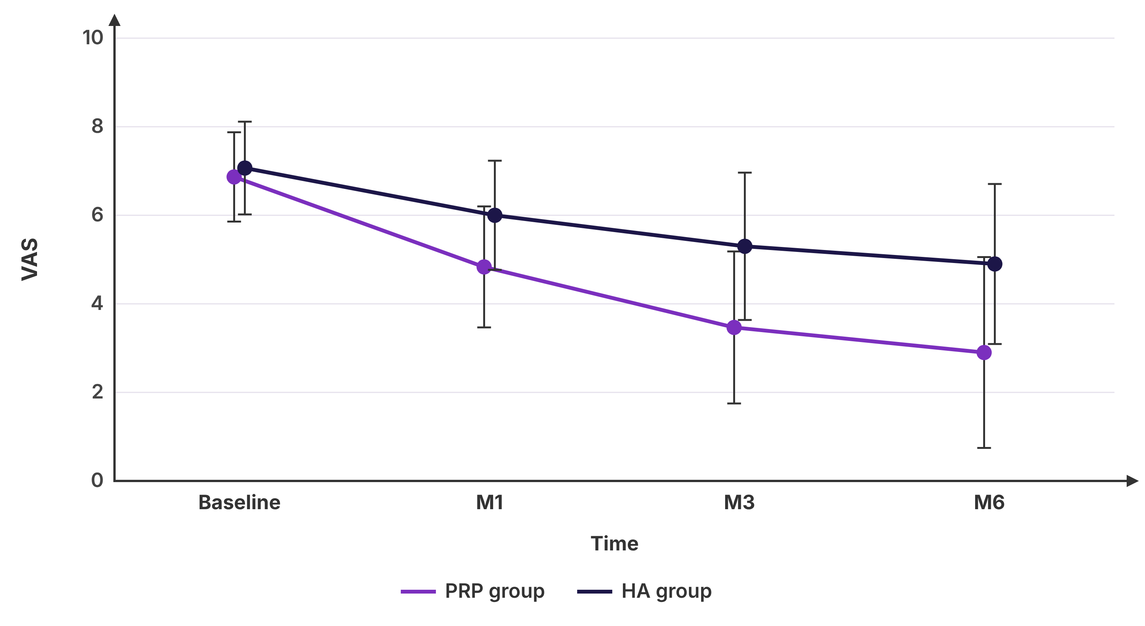
Descriptive statistics
Timepoint |  | n | Missing | Mean | SD | SE | 95% CI of the mean | Median | IQR | Min | Max | Shapiro-Wilk P
Baseline | PRP group | 30 | 0 | 6.87 | 1.01 | 0.18 | 6.49 to 7.24 | 7 | 6 - 8 | 5 | 8 | <0.001* (non-normal)
Baseline | HA group | 30 | 0 | 7.07 | 1.05 | 0.19 | 6.68 to 7.46 | 7 | 6 - 8 | 4 | 9 | 0.007* (non-normal)
M1 | PRP group | 30 | 0 | 4.83 | 1.37 | 0.25 | 4.32 to 5.34 | 5 | 4 - 6 | 2 | 7 | 0.060 (normal)
M1 | HA group | 30 | 0 | 6 | 1.23 | 0.22 | 5.54 to 6.46 | 6 | 5 - 7 | 3 | 8 | 0.063 (normal)
M3 | PRP group | 30 | 0 | 3.47 | 1.72 | 0.31 | 2.83 to 4.11 | 4 | 2 - 5 | 0 | 7 | 0.160 (normal)
M3 | HA group | 30 | 0 | 5.3 | 1.66 | 0.3 | 4.68 to 5.92 | 5.5 | 4.75 - 6 | 0 | 8 | 0.016* (non-normal)
M6 | PRP group | 30 | 0 | 2.9 | 2.16 | 0.39 | 2.1 to 3.7 | 2.5 | 1 - 5 | 0 | 7 | 0.011* (non-normal)
M6 | HA group | 30 | 0 | 4.9 | 1.81 | 0.33 | 4.23 to 5.57 | 5 | 3.75 - 6 | 1 | 9 | 0.605 (normal)
Between the groups at each timepoint
Timepoint | Student's t-test P | Mann-Whitney P | Mean difference (95% CI)
Baseline | 0.454 | 0.487 | -0.2 (-0.73 to 0.33)
M1 | <0.001* | 0.002* | -1.17 (-1.84 to -0.49)
M3 | <0.001* | <0.001* | -1.83 (-2.71 to -0.96)
M6 | <0.001* | <0.001* | -2 (-3.03 to -0.97)
Change over time within each group (patients with every measurement)
Group | n | Repeated-measures ANOVA | Friedman test
PRP group | 30 | F = 58.31; GG ε = 0.722, P < 0.001; HF ε = 0.782, P < 0.001; uncorrected P < 0.001 | χ² = 62.14, P < 0.001
HA group | 30 | F = 30.19; GG ε = 0.657, P < 0.001; HF ε = 0.704, P < 0.001; uncorrected P < 0.001 | χ² = 55.6, P < 0.001
Comparisons versus Baseline (Bonferroni-adjusted)
Group | Comparison | Paired t-test P | Wilcoxon P
PRP group | M1 vs Baseline | <0.001* | <0.001*
PRP group | M3 vs Baseline | <0.001* | <0.001*
PRP group | M6 vs Baseline | <0.001* | <0.001*
HA group | M1 vs Baseline | <0.001* | <0.001*
HA group | M3 vs Baseline | <0.001* | <0.001*
HA group | M6 vs Baseline | <0.001* | <0.001*
Mixed (split-plot) ANOVA
Effect | F | df | P value
Group | 17.43 | 1, 58 | <0.001*
Time (Greenhouse-Geisser) | 88.44 | 3, 174 | <0.001*
Group × time | 8.02 | 3, 174 | <0.001*

8. Complications
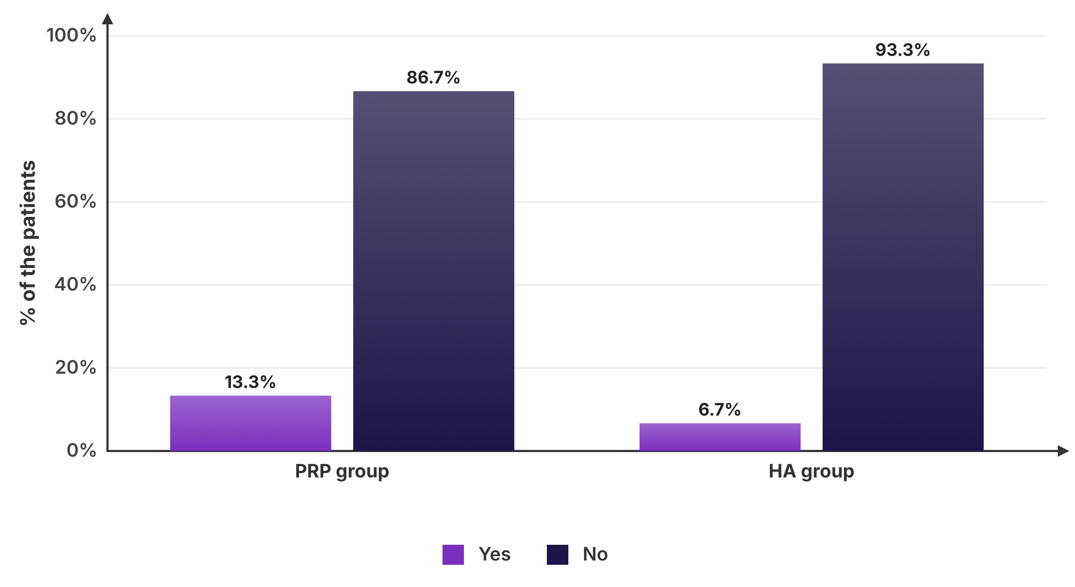
Frequencies
 | PRP group (n=30) | HA group (n=30) | Total (n=60)
Yes | 4 (13.3%) | 2 (6.7%) | 6 (10%)
No | 26 (86.7%) | 28 (93.3%) | 54 (90%)
Missing | 0 | 0 | 0
Comparison between the groups
Test | Statistic | df | P value | Note | In the report
Chi-square test | χ² = 0.74 | 1 | 0.389 | smallest expected count 3; 50% of cells < 5
Fisher's exact test |  |  | 0.671 |  | ✓
Effect of “Yes”
Pair | Relative risk (95% CI) | Odds ratio (95% CI)
PRP group vs HA group | 2 (0.4 to 10.11) | 2.15 (0.36 to 12.76)

9. Satisfaction
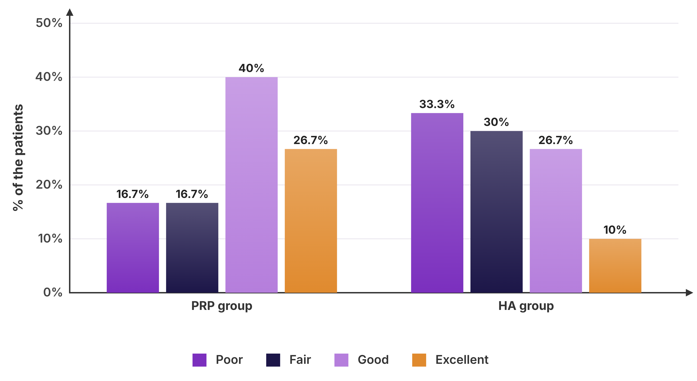
Frequencies
 | PRP group (n=30) | HA group (n=30) | Total (n=60)
Poor | 5 (16.7%) | 10 (33.3%) | 15 (25%)
Fair | 5 (16.7%) | 9 (30%) | 14 (23.3%)
Good | 12 (40%) | 8 (26.7%) | 20 (33.3%)
Excellent | 8 (26.7%) | 3 (10%) | 11 (18.3%)
Missing | 0 | 0 | 0
Comparison between the groups
Test | Statistic | df | P value | Note | In the report
Chi-square test | χ² = 5.88 | 3 | 0.117 | smallest expected count 5.5; 0% of cells < 5 | ✓

