Platelet-rich plasma versus hyaluronic acid injection for knee osteoarthritis: a randomized controlled trial

Acknowledgements
We thank the patients and staff.

Statistical Analysis
Statistical analysis was performed using IBM SPSS Statistics, version 28.0 (IBM Corp., Armonk, NY, USA). Shapiro-Wilk test and histograms were used to evaluate the normality of the distribution of data. Quantitative parametric data were presented as mean and standard deviation (SD) and were analyzed by unpaired Student's t-test (or Welch's t-test when Levene's test indicated unequal variances). Quantitative non-parametric data were presented as median and interquartile range (IQR) and were analyzed by Mann-Whitney test. Qualitative variables were presented as frequency and percentage (%) and were analyzed utilizing the Chi-square test or Fisher's exact test when appropriate. Effect estimates were reported as mean differences, Hodges-Lehmann median differences and relative risks (RR) with 95% confidence intervals (CI). Analysis of covariance (ANCOVA) was used to compare groups after adjustment for covariates, reporting adjusted (estimated marginal) means with 95% CI and Bonferroni-adjusted pairwise comparisons. A two tailed P value ≤ 0.05 was considered statistically significant.

Results
In this study, 83 patients were assessed for eligibility; 20 patients were excluded (not meeting inclusion criteria: 14; declined to participate: 6). The remaining 63 patients were randomly allocated into two groups (PRP group: 32, HA group: 31). In PRP group, 2 patients were lost to follow-up (Moved away (n=1), withdrew consent (n=1)). In HA group, 1 patient was lost to follow-up (Withdrew consent). Finally, 30 patients in PRP group, 30 patients in HA group were analyzed statistically.
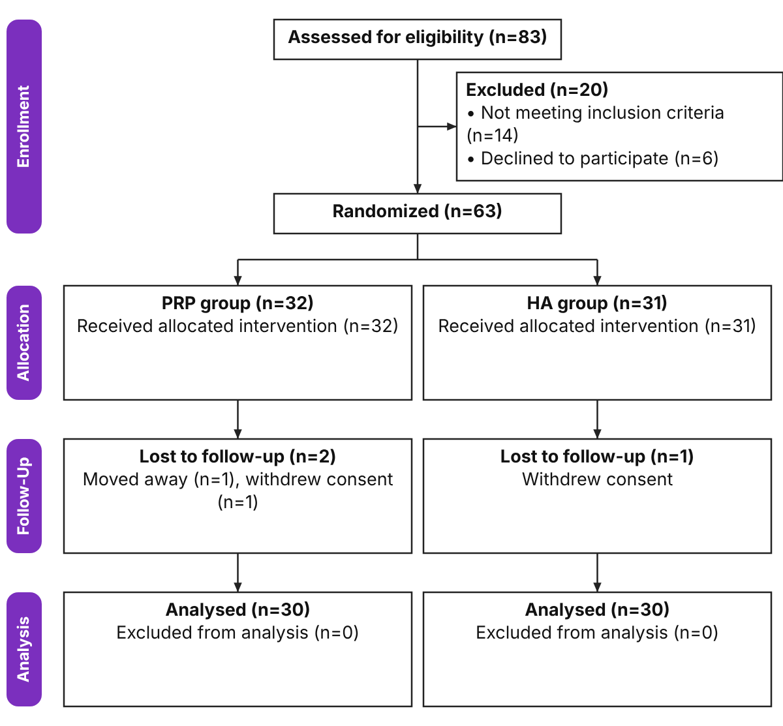
Figure 1: CONSORT flowchart of the enrolled patients
Table 1: Demographic and baseline data of the studied groups
 |  | PRP group (n=30) | HA group (n=30) | P value | MD/RR (95% CI)
Age (years) | Mean ± SD | 58.73 ± 7.57 | 57.7 ± 7.84 | 0.606 | 1.03 (-2.95:5.02)
Age (years) | Range | 47 - 76 | 42 - 73 | 0.606 | 1.03 (-2.95:5.02)
Sex | Female | 19 (63.3%) | 24 (80%) | 0.152 | 0.79 (0.57-1.1)
Sex | Male | 11 (36.7%) | 6 (20%) | 0.152 | 0.79 (0.57-1.1)
BMI (kg/m2) | Mean ± SD | 29.22 ± 3.81 | 28.77 ± 4.05 | 0.664 | 0.44 (-1.59:2.47)
BMI (kg/m2) | Range | 21.6 - 37.3 | 19.2 - 36.4 | 0.664 | 0.44 (-1.59:2.47)
Diabetes |  | 12 (40%) | 13 (43.3%) | 0.793 | 0.92 (0.51-1.68)
KL grade | II | 17 (56.7%) | 18 (60%) | 0.793 | 0.94 (0.62-1.45)
KL grade | III | 13 (43.3%) | 12 (40%) | 0.793 | 0.94 (0.62-1.45)
Data are presented as mean ± SD and frequency (%), MD: Mean difference, RR: Relative risk, CI: Confidence interval.
Age, sex, BMI, diabetes and KL grade were insignificantly different between the groups.
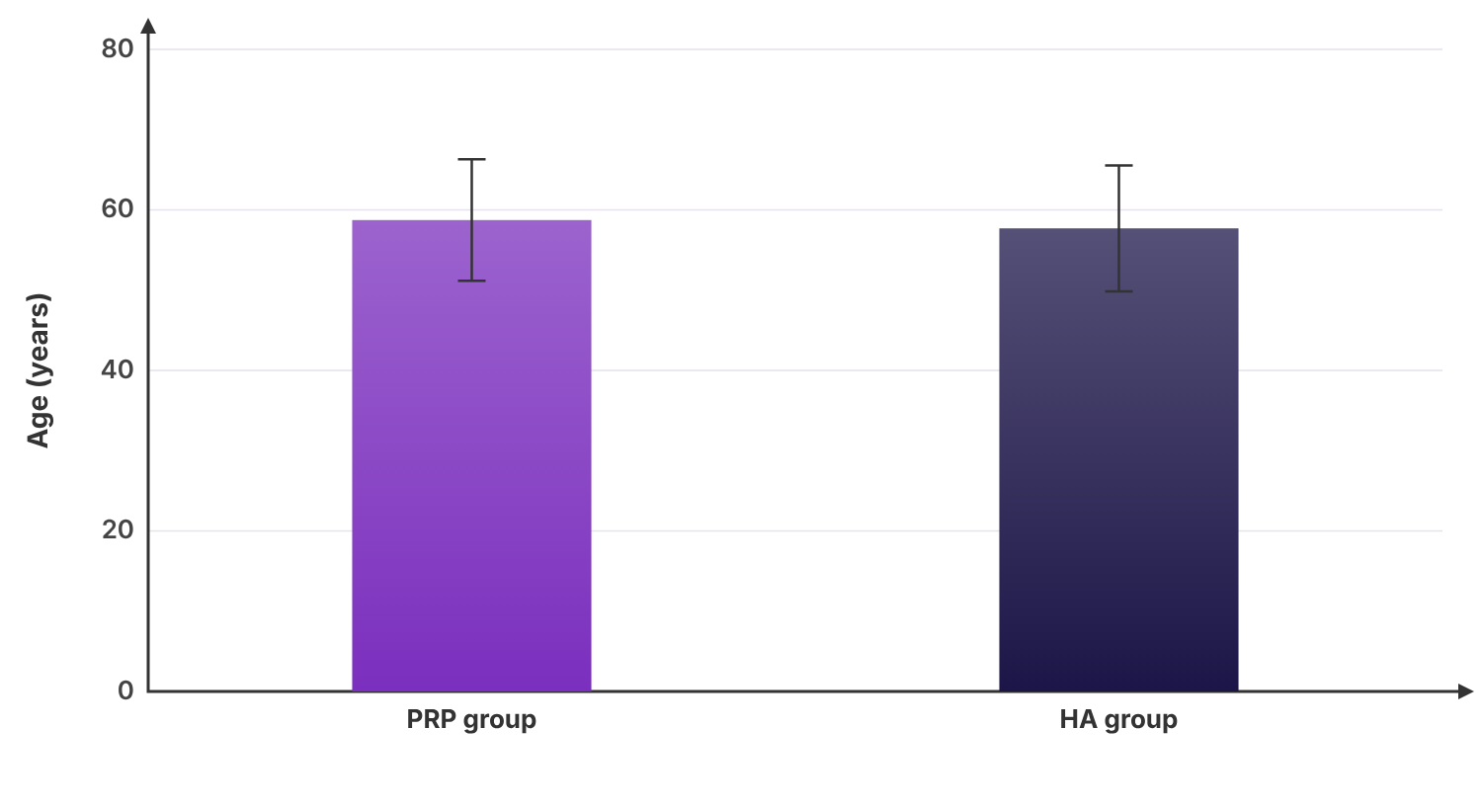
Figure 2: Age (years) of the studied groups. Bars show the mean; error bars show ±1 standard deviation (SD).
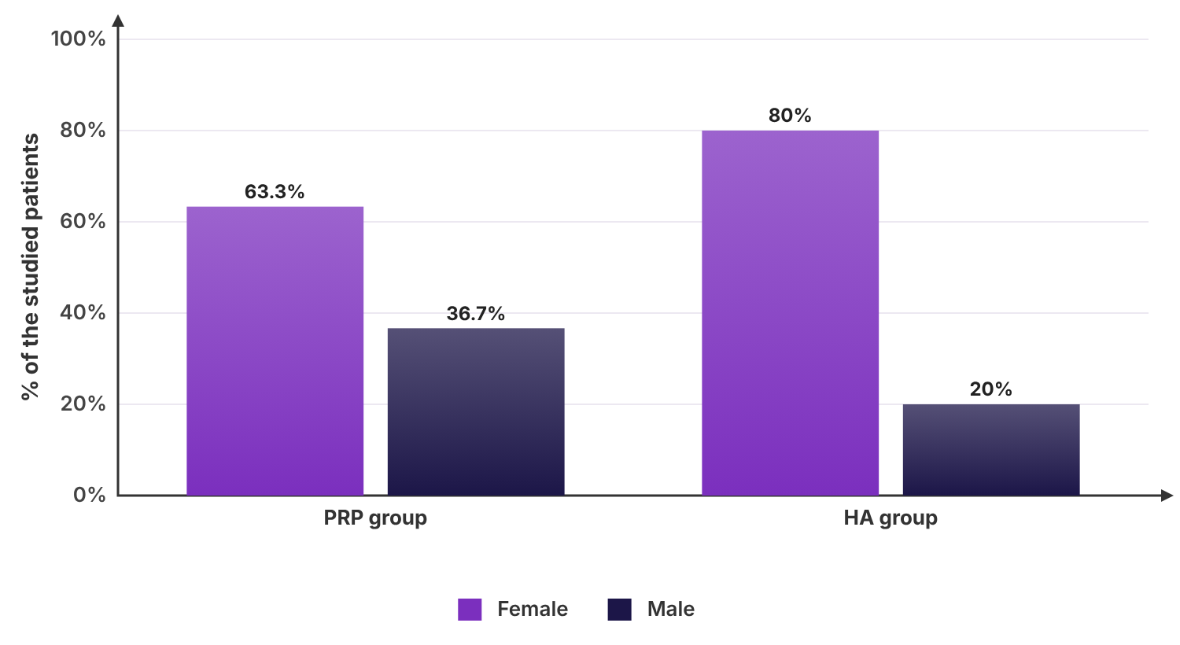
Figure 3: Sex of the studied groups
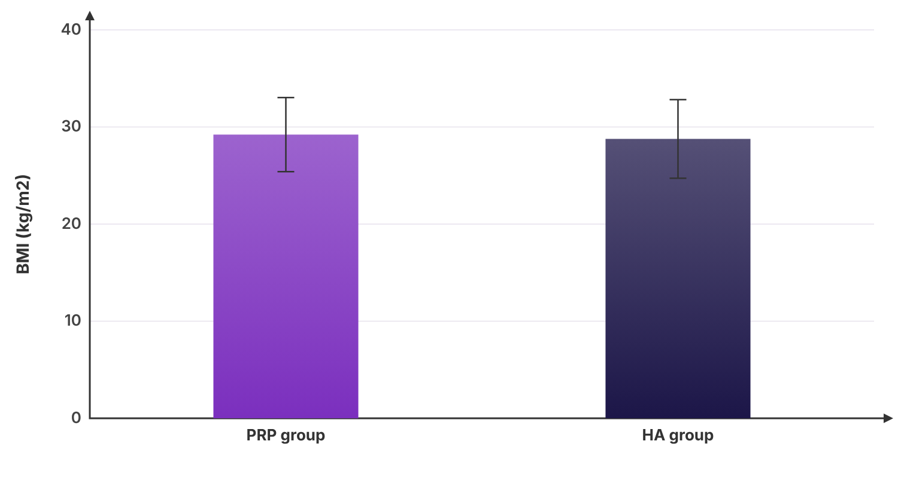
Figure 4: BMI (kg/m2) of the studied groups. Bars show the mean; error bars show ±1 standard deviation (SD).
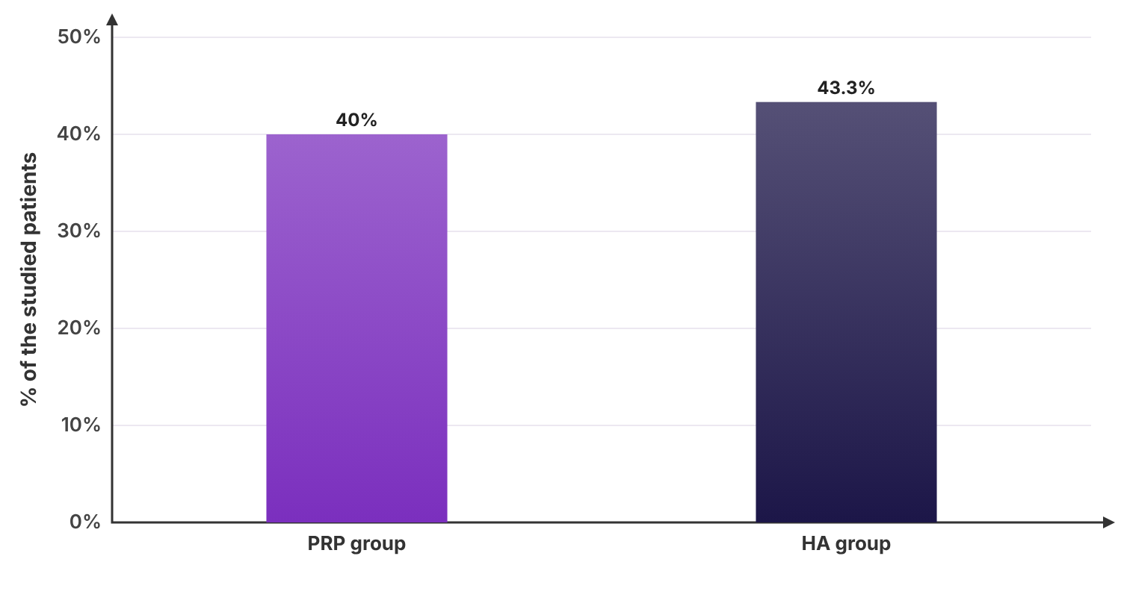
Figure 5: Diabetes of the studied groups
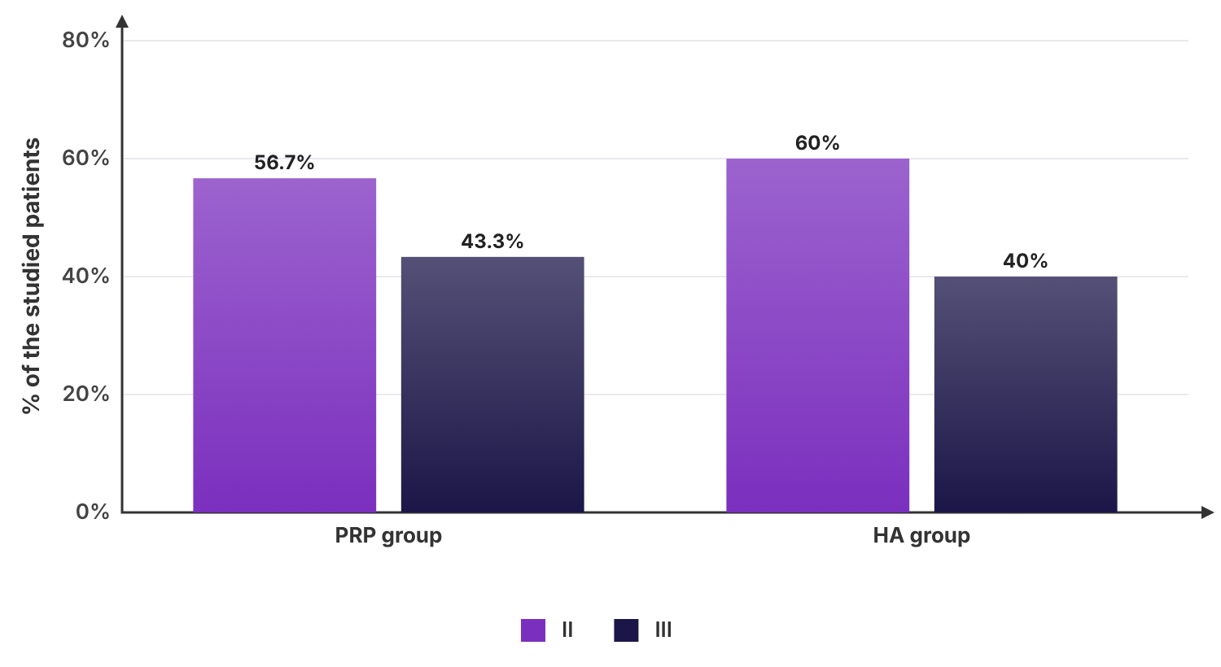
Figure 6: KL grade of the studied groups
Table 2: WOMAC of the studied groups
 | PRP group (n=30) | HA group (n=30) | P value | MD (95% CI)
Baseline | 61.38 ± 6.15 | 64.77 ± 9.26 | 0.100 | -3.39 (-7.46:0.67)
M1 | 50.82 ± 7.31 | 57.75 ± 10.93 | 0.006* | -6.93 (-11.75:-2.11)
M3 | 43.54 ± 7.85 | 54.24 ± 10.84 | <0.001* | -10.71 (-15.6:-5.82)
M6 | 40.56 ± 8.18 | 52.25 ± 14.39 | <0.001* | -11.7 (-17.83:-5.56)
*: Significant as P value ≤ 0.05, Data are presented as mean ± SD, MD: Mean difference, CI: Confidence interval.
WOMAC at Baseline was insignificantly different between the two groups. WOMAC at (M1, M3 and M6) was significantly lower in PRP group than HA group (P value = 0.006, < 0.001 and < 0.001 respectively), which was clinically relevant.
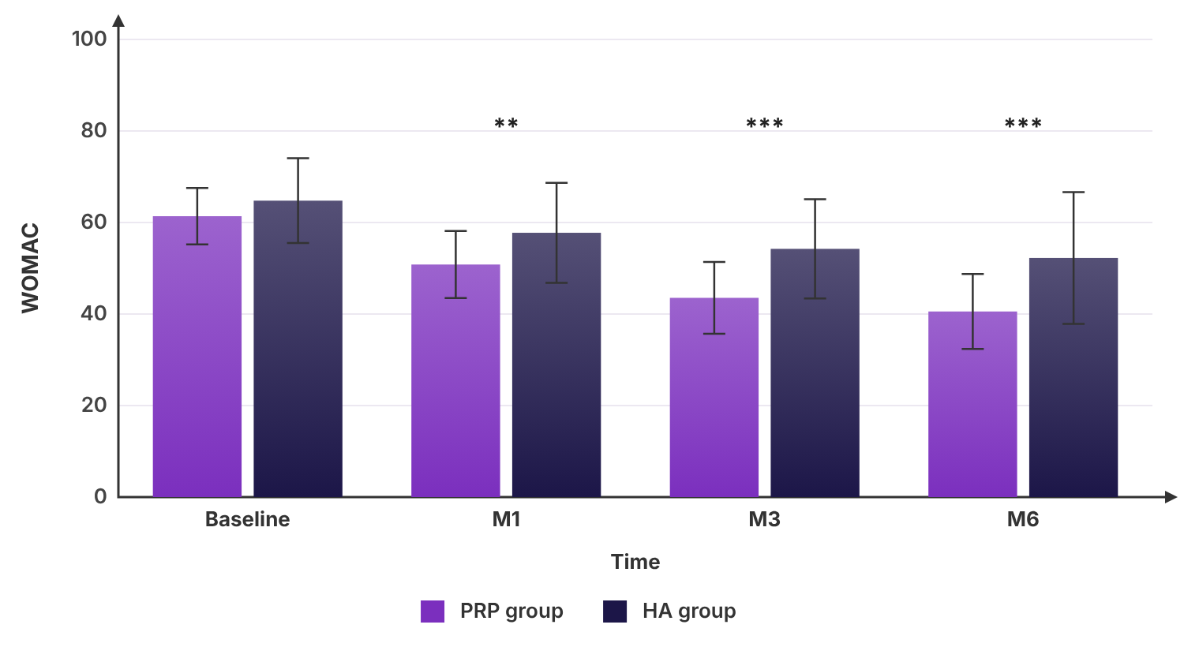
Figure 7: WOMAC of the studied groups. Bars show the mean; error bars show ±1 standard deviation (SD). *P ≤ 0.05, **P ≤ 0.01, ***P ≤ 0.001 (difference between the groups at that time).
Table 3: VAS of the studied groups
 | PRP group (n=30) | HA group (n=30) | P value | MD (95% CI)
Baseline | 7 (6 - 8) | 7 (6 - 8) | 0.487 | 0 (-1:0)
M1 | 5 (4 - 6) | 6 (5 - 7) | 0.002* | -1 (-2:0)
M3 | 4 (2 - 5) | 5.5 (4.75 - 6) | <0.001* | -2 (-3:-1)
M6 | 2.5 (1 - 5) | 5 (3.75 - 6) | <0.001* | -2 (-3:-1)
*: Significant as P value ≤ 0.05, Data are presented as median (IQR), MD: Median difference, CI: Confidence interval.
VAS at Baseline was insignificantly different between the two groups. VAS at (M1, M3 and M6) was significantly lower in PRP group than HA group (P value = 0.002, < 0.001 and < 0.001 respectively).
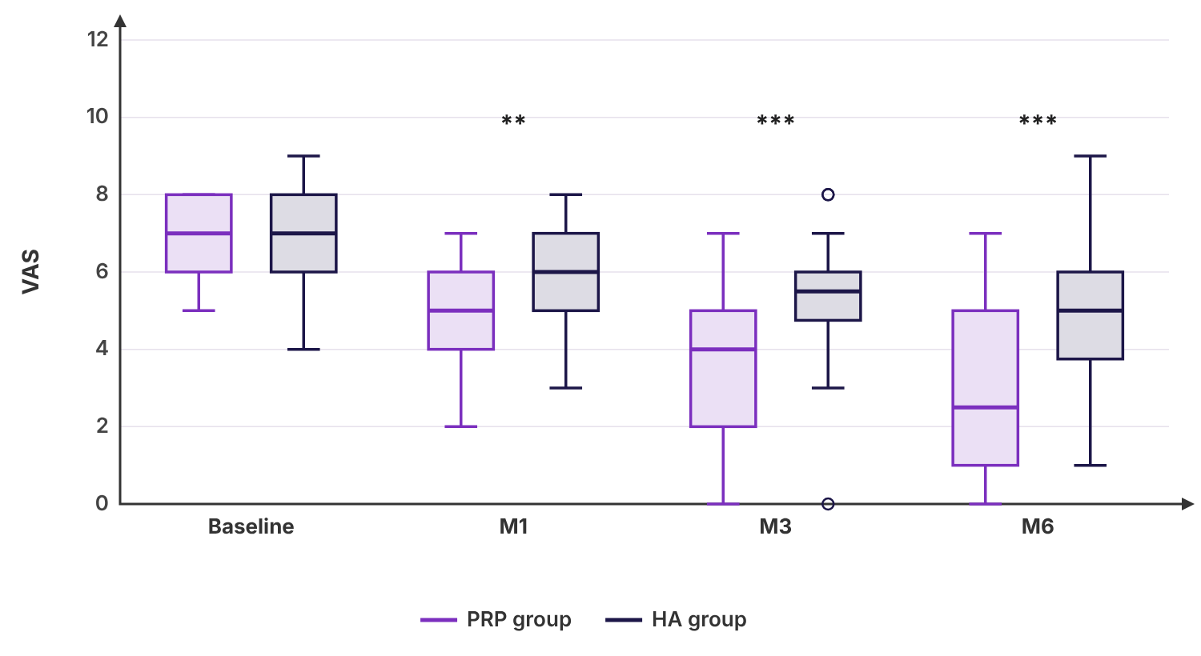
Figure 8: VAS of the studied groups. Boxes show the median and interquartile range (IQR); whiskers extend to the most extreme values within 1.5 × IQR, and points beyond them are outliers. *P ≤ 0.05, **P ≤ 0.01, ***P ≤ 0.001 (difference between the groups at that time).
Table 4: Other outcomes of the studied groups
 |  | PRP group (n=30) | HA group (n=30) | P value | RR (95% CI)
Complications |  | 4 (13.3%) | 2 (6.7%) | 0.671 | 2 (0.4-10.11)
Satisfaction | Poor | 5 (16.7%) | 10 (33.3%) | 0.117 | ---
Satisfaction | Fair | 5 (16.7%) | 9 (30%) | 0.117 | ---
Satisfaction | Good | 12 (40%) | 8 (26.7%) | 0.117 | ---
Satisfaction | Excellent | 8 (26.7%) | 3 (10%) | 0.117 | ---
Data are presented as frequency (%), RR: Relative risk, CI: Confidence interval.
Complications and satisfaction were insignificantly different between the two groups.
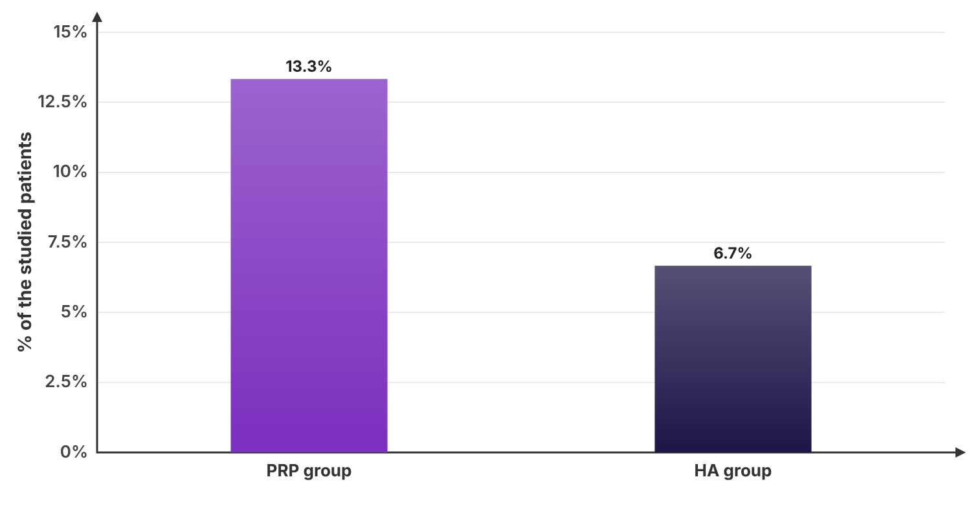
Figure 9: Complications of the studied groups
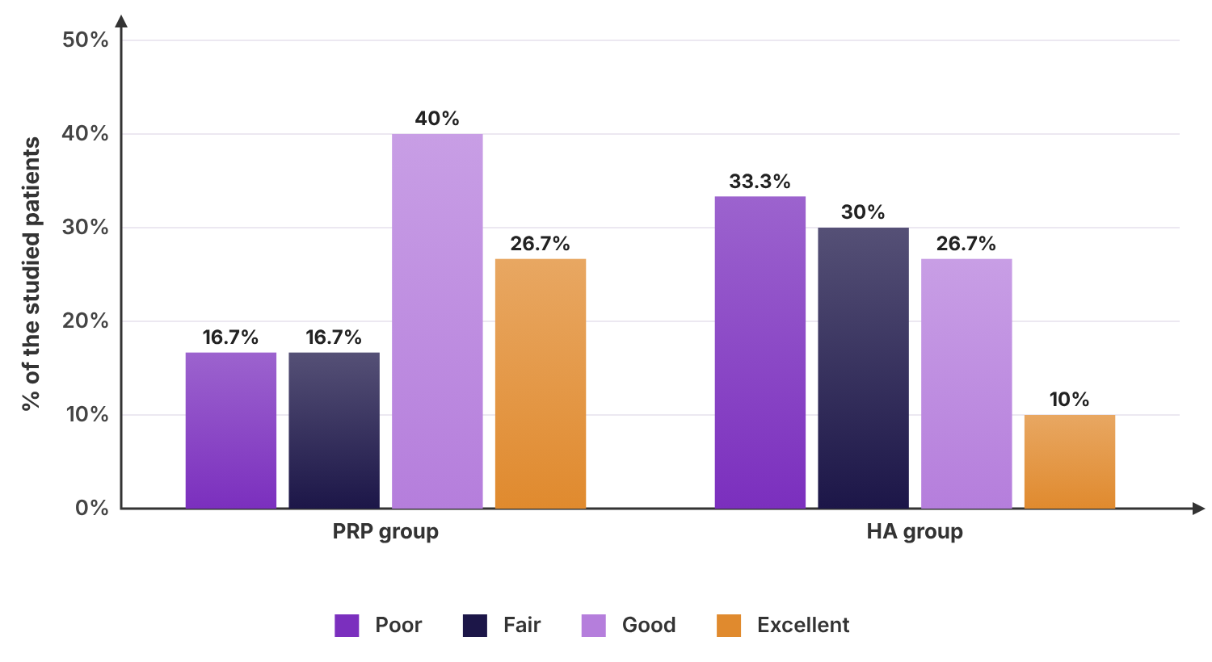
Figure 10: Satisfaction of the studied groups
Table 5: WOMAC at M6 of the studied groups adjusted for covariates (ANCOVA)
 | PRP group (n=28) | HA group (n=30) | P value
Mean ± SD (unadjusted) | 40.56 ± 8.18 | 52.25 ± 14.39 | <0.001*
Adjusted mean (95% CI) | 43.04 (40.3 to 45.78) | 49.94 (47.3 to 52.58) | <0.001*
Adjusted difference (95% CI) | PRP group vs HA group: -6.9 (-10.76 to -3.03)
*: Significant as P value ≤ 0.05, Adjusted for WOMAC at Baseline and age (covariates held at their mean values), ANCOVA: F(1, 54) = 12.8, partial η² = 0.192, WOMAC at Baseline: B = 1.21, P < 0.001*, Age (years): B = -0.02, P = 0.870.
After adjustment for WOMAC at Baseline and age, WOMAC at M6 was significantly different between the two groups (P value < 0.001). The adjusted mean was lower in PRP group than HA group by 6.9 (95% CI -10.76 to -3.03).

Discussion points
WOMAC at (M1, M3 and M6) was significantly lower in PRP group than HA group. The size of this difference over time should be judged against its minimal clinically important difference. VAS at (M1, M3 and M6) was significantly lower in PRP group than HA group. The size of this difference over time should be judged against its minimal clinically important difference.

Conclusion
In conclusion, WOMAC at (M1, M3 and M6) was significantly lower in PRP group than HA group.

Appendix

Data analysed
Group | ID | Age (years) | Sex | BMI (kg/m2) | Diabetes | KL grade | WOMAC at Baseline | WOMAC at M1 | WOMAC at M3 | WOMAC at M6 | VAS at Baseline | VAS at M1 | VAS at M3 | VAS at M6 | Complications | Satisfaction
PRP group | 1 | 62 | Male | 35 | No | III | 48.6 | 38.1 | 49.6 | 32.2 | 7 | 5 | 2 | 0 | No | Excellent
PRP group | 2 | 56 | Male | 32.4 | No | II | 70.9 | 58.8 | 56.5 |  | 5 | 5 | 0 | 1 | No | Poor
PRP group | 3 | 55 | Male | 26.7 | Yes | II | 61.3 | 51 | 42.1 | 40.1 | 8 | 6 | 4 | 6 | No | Good
PRP group | 4 | 72 | Female | 33 | Yes | II | 54.6 | 44.3 | 37.3 | 34.9 | 6 | 3 | 3 | 4 | Yes | Good
PRP group | 5 | 62 | Female | 28.8 | Yes | II | 52.9 | 35.5 | 31.8 | 31.4 | 7 | 3 | 3 | 3 | No | Excellent
PRP group | 6 | 58 | Female | 35.2 | No | II | 60.4 | 48.1 | 38.8 | 38.6 | 7 | 4 | 5 | 5 | No | Good
PRP group | 7 | 52 | Female | 25.4 | No | II | 67.2 | 52.7 | 46.7 | 55.4 | 7 | 4 | 2 | 2 | No | Excellent
PRP group | 8 | 61 | Male | 29.7 | No | III | 61.7 | 51 | 45.6 | 54.7 | 6 | 5 | 0 | 0 | No | Excellent
PRP group | 9 | 71 | Male | 33.2 | No | III | 60.3 | 42.2 | 27.7 | 36.5 | 7 | 5 | 2 | 2 | No | Good
PRP group | 10 | 68 | Female | 28.1 | No | III | 57.1 | 49.1 | 34.9 | 34.8 | 6 | 3 | 2 | 2 | No | Excellent
PRP group | 11 | 57 | Female | 25.2 | Yes | II | 63.4 | 56.1 | 49.7 | 47 | 5 | 3 | 2 | 0 | No | Fair
PRP group | 12 | 70 | Female | 26.9 | No | III | 59.5 | 47.2 | 33.3 | 42.5 | 8 | 6 | 7 | 4 | Yes | Poor
PRP group | 13 | 52 | Male | 28.5 | No | II | 65.7 | 49.3 | 47.7 | 44 | 7 | 5 | 5 | 3 | Yes | Excellent
PRP group | 14 | 59 | Male | 27.8 | No | III | 49.7 | 47.2 | 26.5 | 36.8 | 7 | 4 | 4 | 6 | Yes | Poor
PRP group | 15 | 76 | Female | 28.3 | No | II | 56.6 | 48 | 43.5 | 28.9 | 8 | 5 | 4 | 4 | No | Fair
PRP group | 16 | 53 | Female | 32.1 | Yes | II | 61.3 | 56.3 | 43.2 | 39.6 | 6 | 2 | 3 | 3 | No | Poor
PRP group | 17 | 71 | Male | 35.5 | Yes | II | 54.9 | 50.5 | 41.3 | 38.4 | 6 | 5 | 4 | 1 | No | Good
PRP group | 18 | 54 | Female | 28.3 | No | II | 62.6 | 59.2 | 47.2 | 39.5 | 8 | 6 | 4 | 7 | No | Fair
PRP group | 19 | 57 | Male | 25.7 | No | II | 57.7 | 45.3 | 49.1 | 33.3 | 5 | 5 | 1 | 1 | No | Good
PRP group | 20 | 61 | Female | 28.9 | No | III | 59.9 | 50.5 | 41.5 | 42.5 | 8 | 7 | 4 | 6 | No | Poor
PRP group | 21 | 51 | Female | 24 | Yes | III | 59.7 | 55.5 | 36.9 | 28.5 | 8 | 4 | 5 | 1 | No | Excellent
PRP group | 22 | 61 | Male | 21.6 | Yes | III | 62.6 | 48.8 | 50 | 34.8 | 8 | 7 | 5 | 5 | No | Good
PRP group | 23 | 50 | Female | 32.5 | Yes | III | 68.6 | 61.1 | 57.6 | 33.4 | 6 | 5 | 3 | 1 | No | Excellent
PRP group | 24 | 59 | Female | 30 | No | III | 65.6 | 54.8 | 43.7 | 46.8 | 8 | 5 | 4 | 1 | No | Good
PRP group | 25 | 49 | Female | 26.4 | Yes | II | 75.1 | 70.3 | 41.2 | 57.9 | 7 | 6 | 1 | 2 | No | Good
PRP group | 26 | 58 | Female | 29.6 | No | II | 57.7 | 51.1 | 56.6 | 38 | 8 | 7 | 6 | 6 | No | Good
PRP group | 27 | 47 | Female | 37.3 | No | II | 67.2 | 46.6 | 44.5 |  | 7 | 6 | 5 | 3 | No | Good
PRP group | 28 | 51 | Male | 27.9 | Yes | III | 60.8 | 51.7 | 47.1 | 39.6 | 6 | 4 | 5 | 1 | No | Good
PRP group | 29 | 54 | Female | 23.6 | No | III | 70.3 | 62.5 | 51.4 | 53.4 | 6 | 3 | 5 | 6 | No | Fair
PRP group | 30 | 55 | Female | 28.9 | Yes | II | 67.5 | 41.8 | 43.1 | 52.1 | 8 | 7 | 4 | 1 | No | Fair
HA group | 31 | 63 | Female | 21.1 | No | III | 70.1 | 65.8 | 57.8 | 57.8 | 8 | 7 | 7 | 7 | No | Fair
HA group | 32 | 64 | Female | 28.3 | Yes | II | 44.6 | 31 | 38.4 | 27.3 | 7 | 5 | 5 | 5 | No | Poor
HA group | 33 | 66 | Female | 31.5 | No | III | 63.6 | 54.3 | 52.4 | 56.7 | 6 | 4 | 4 | 4 | No | Excellent
HA group | 34 | 59 | Male | 27.2 | No | II | 59.6 | 52.7 | 59.4 | 39.5 | 7 | 7 | 3 | 3 | No | Poor
HA group | 35 | 53 | Male | 24.5 | No | II | 65.9 | 61.5 | 48.4 | 64.3 | 9 | 7 | 8 | 6 | No | Excellent
HA group | 36 | 56 | Female | 27.9 | No | II | 62.5 | 63.4 | 45.8 | 49.7 | 8 | 7 | 7 | 6 | Yes | Fair
HA group | 37 | 56 | Female | 26.3 | No | III | 66.5 | 67.4 | 40.5 | 62.3 | 6 | 5 | 4 | 1 | No | Good
HA group | 38 | 62 | Female | 24.9 | No | III | 63.7 | 55.4 | 57.8 | 59.7 | 7 | 5 | 5 | 6 | No | Good
HA group | 39 | 49 | Female | 26.9 | Yes | III | 76.4 | 70 | 64.4 | 66.4 | 4 | 3 | 0 | 2 | No | Poor
HA group | 40 | 55 | Female | 27.3 | No | II | 65.6 | 52.9 | 52.9 | 58.4 | 6 | 6 | 5 | 5 | No | Fair
HA group | 41 | 47 | Female | 29.6 | Yes | II | 58.3 | 51.2 | 52.8 | 44.8 | 7 | 6 | 6 | 4 | No | Fair
HA group | 42 | 73 | Female | 29.7 | Yes | II | 62 | 47.9 | 53.3 | 48.3 | 8 | 8 | 5 | 4 | No | Good
HA group | 43 | 52 | Female | 36.4 | Yes | III | 73.6 | 68.7 | 65 | 51.2 | 7 | 6 | 4 | 6 | No | Poor
HA group | 44 | 48 | Female | 26.4 | Yes | III | 79.2 | 70.4 | 72.8 | 71.8 | 7 | 7 | 6 | 5 | No | Poor
HA group | 45 | 66 | Female | 28.5 | No | II | 64.6 | 47.8 | 64.2 | 50.8 | 7 | 6 | 6 | 4 | No | Excellent
HA group | 46 | 53 | Female | 26.7 | No | II | 71.5 | 69.9 | 64.1 | 77.4 | 7 | 6 | 5 | 6 | No | Fair
HA group | 47 | 42 | Male | 33 | Yes | III | 65.3 | 54.1 | 58.3 | 54.6 | 6 | 5 | 6 | 3 | No | Fair
HA group | 48 | 53 | Male | 29.9 | No | II | 58.8 | 44.3 | 49.8 | 47.1 | 8 | 5 | 6 | 8 | No | Poor
HA group | 49 | 72 | Female | 30.5 | No | II | 68.3 | 67.2 | 60 | 43.8 | 6 | 4 | 3 | 4 | No | Poor
HA group | 50 | 65 | Female | 34.8 | Yes | III | 46.4 | 46.3 | 31.8 | 22.3 | 7 | 6 | 6 | 7 | No | Poor
HA group | 51 | 63 | Female | 36.1 | Yes | II | 60.3 | 55.7 | 49.2 | 33.4 | 6 | 5 | 5 | 5 | No | Good
HA group | 52 | 62 | Male | 27.8 | Yes | III | 68.9 | 60.8 | 61.4 | 64.4 | 8 | 7 | 7 | 5 | No | Fair
HA group | 53 | 70 | Female | 30.1 | No | II | 90.9 | 77.5 | 80.6 | 76.4 | 8 | 8 | 7 | 4 | No | Good
HA group | 54 | 59 | Female | 19.2 | No | III | 72.2 | 74.1 | 64.8 | 76.8 | 6 | 6 | 5 | 3 | No | Good
HA group | 55 | 53 | Female | 30.5 | Yes | II | 62.8 | 61.8 | 49.2 | 42.9 | 7 | 6 | 6 | 3 | No | Fair
HA group | 56 | 56 | Male | 27.1 | No | II | 70.4 | 67.7 | 57.4 | 57.7 | 8 | 7 | 6 | 7 | No | Good
HA group | 57 | 45 | Female | 30.6 | No | II | 61.4 | 53.4 | 50.4 | 39.6 | 8 | 7 | 6 | 6 | No | Poor
HA group | 58 | 60 | Female | 35.4 | Yes | II | 64.2 | 52.6 | 40.6 | 48.3 | 7 | 6 | 3 | 3 | No | Poor
HA group | 59 | 52 | Female | 23.8 | No | III | 52.1 | 42.2 | 46.7 | 30.5 | 9 | 8 | 8 | 9 | Yes | Fair
HA group | 60 | 57 | Female | 31.2 | Yes | II | 53.5 | 44.6 | 37.1 | 43.4 | 7 | 5 | 5 | 6 | No | Good
60 patients.

