Thesis Methodology & Baseline Report:
Deterministic TinyML Inference on ESP32-S3
Author: Mohan Pulugur Subramanya | Hardware: Heltec Wireless Tracker (ESP32-S3 @ 240 MHz) | Framework: ESP-IDF v5.3.1 (esp-tflite-micro v1.4.1)

1. Reference Papers & Problem Definition
Deploying deep neural networks on microcontroller units (MCUs) requires operating within strict SRAM (hundreds of kilobytes), Flash (megabytes), and power budgets without an operating system MMU. In streaming audio applications such as Keyword Spotting (KWS), the processor must execute inference on every 20 ms audio stride in real time. Reducing inference latency directly increases the fraction of time the MCU can spend in low-power sleep modes. However, standard embedded ML demo pipelines couple neural network execution with blocking hardware I/O (I2S microphone DMA waits) and RTOS task scheduling, obscuring true tensor execution time. This work establishes a hardware-decoupled, microsecond-accurate baseline on the ESP32-S3 to enable rigorous evaluation of model optimizations.
- MLPerf Tiny Benchmark (Banbury et al., NeurIPS 2021, https://arxiv.org/abs/2106.07597): Defines standardized benchmarking rules for ultralow-power TinyML workloads, establishing Keyword Spotting (KWS) as a primary audio benchmark for microcontrollers.
- TensorFlow Lite Micro (David et al., MLSys 2021, https://arxiv.org/abs/2010.08678): Introduces the interpreter-based embedded inference engine using a contiguous static tensor_arena to eliminate dynamic heap fragmentation on bare-metal and RTOS targets.
- MCUNet (Lin et al., NeurIPS 2020, https://arxiv.org/abs/2007.10319): Demonstrates system-algorithm co-design to jointly optimize neural network latency and SRAM footprint on microcontrollers.

2. Experimental Setup & Methodology
Target Platform: Heltec Wireless Tracker featuring an Espressif ESP32-S3 (Dual-core Xtensa 32-bit LX7, revision v0.2) running at 240 MHz, 8 MB Quad-SPI Flash (80 MHz QIO mode), and 320 KB internal SRAM (~256 KB dynamic heap free at boot, 16 KB I-Cache, 32 KB D-Cache). External PSRAM is disabled, and the board has no onboard I2S microphone.
Software Stack & Workload: Built using ESP-IDF v5.3.1 (xtensa-esp-elf-gcc 13.2.0, -O2 performance optimization) with managed components espressif/esp-tflite-micro (v1.4.1) and espressif/esp-nn (v1.4.1). The baseline workload is Espressif's micro_speech example (TinyConv 4-op graph: DepthwiseConv2D, FullyConnected, Softmax, Reshape) with a 30 KB static tensor_arena.
Latency Isolation Method: To eliminate I2S peripheral deadlocks and Native USB starvation, three core modifications were made:
1. Dummy Audio Provider (audio_provider.cc): Removed physical I2S drivers and ring-buffer tasks; injected deterministic zeroed PCM buffers (silence) while advancing the virtual timestamp by +20 ms per cycle and yielding via vTaskDelay(pdMS_TO_TICKS(20)).
2. Unconditional Responder (command_responder.cc): Removed duplicate-command suppression.
3. Precision Hardware Stopwatch (main_functions.cc): Wrapped esp_timer_get_time() (1-us hardware counter) strictly around interpreter->Invoke().

3. Chronological Debugging & Engineering Solutions
Symptom / Error Log | Root Cause | Engineering Fix
WSL Make build failed (tflite folder missing) | Upstream TFLM repository restructured | Migrated to ESP-IDF v5.3.1 managed component workflow
CMake: Failed to resolve component espressif__esp-tflite-micro | Project cloned inside ESP-IDF framework root directory | Created clean workspace C:\esp_projects\micro_speech via create-project-from-example
Serial flash semaphore timeout / write timeout | Flashing targeted ghost COM3/COM4 ports instead of active Native USB | Identified COM7 via python -m serial.tools.list_ports plug/unplug test
Monitor stuck at waiting for download / ClearCommError | ESP32-S3 Native USB reset enumeration behavior | Used --no-reset flag and proper RTS reset sequencing
Hang after 'Audio Recording started' & USB disconnect | i2s_readsamples blocked infinitely on missing mic; unthrottled loop starved CPU0 Native USB stack | Engineered Dummy Audio Provider with +20 ms stride and vTaskDelay(20 ms)
Compile error: 'error_reporter' was not declared in this scope | TF_LITE_REPORT_ERROR macro deprecated in esp-tflite-micro v1.4.1 | Replaced with MicroPrintf() and ESP_LOGW()

4. Baseline Experimental Results & Hardware Analysis
Metric | Measured Value | Hardware / Architectural Interpretation
Cold-Start Inference (Run #1) | 3,761 us (3.76 ms) | Includes SPI Flash (DROM) -> 32 KB SRAM Data Cache weight fetch penalty
Steady-State Inference (Runs #2..1244) | 3,121.43 us (3.12 ms) | Weights cached in SRAM; deterministic band of 3,119 - 3,124 us (std = 1.59 us)
Cache Warm-Up Penalty | +639.57 us (+20.49%) | Extra latency incurred on first invocation due to SPI Flash bus stalls
Real-Time Duty Cycle (20 ms stride) | 15.61% Active / 84.39% Slack | 3.121 ms compute per 20 ms audio window; 16.88 ms available for sleep/peripherals
Compiled Binary Footprint | 436,160 bytes (0x6A7C0 / ~426 KB) | Occupies 22% of OTA partition (78% / 0x175840 bytes free)
Configured Tensor Arena | 30,720 bytes (30 KB) | Static allocation in internal SRAM (peak arena_used_bytes() to be logged in Phase 2)

5. Limitations & Roadmap for Optimization
1. Model Scope: The current baseline runs Espressif's micro_speech (TinyConv 4-op graph), not the larger official MLPerf Tiny DS-CNN model.
2. Pre-Enabled SIMD: sdkconfig enables CONFIG_NN_OPTIMIZED=y by default (linking esp-nn Xtensa S3 assembly). Phase 2 will benchmark CONFIG_NN_ANSI_C=y to quantify exact SIMD speedup.
3. Pre-Processing Timer & Peak RAM: Phase 2 will add a timer around feature_provider->PopulateFeatureData() and log interpreter->arena_used_bytes().
4. Optimization Targets: Phase 3 & 4 will evaluate the official MLPerf Tiny DS-CNN model, test accuracy on real PCM samples (yes/no), and benchmark Confidence-Gated Early-Exit and Mixed-Precision Quantization.

6. Visual Telemetry & Experimental Plots
Figure 1: Raw ESP-IDF v5.3.1 Serial Monitor Output showing 240 MHz clock, RAM map, Cold-Start (3761 us), and Steady-State (3119-3124 us) inference telemetry.
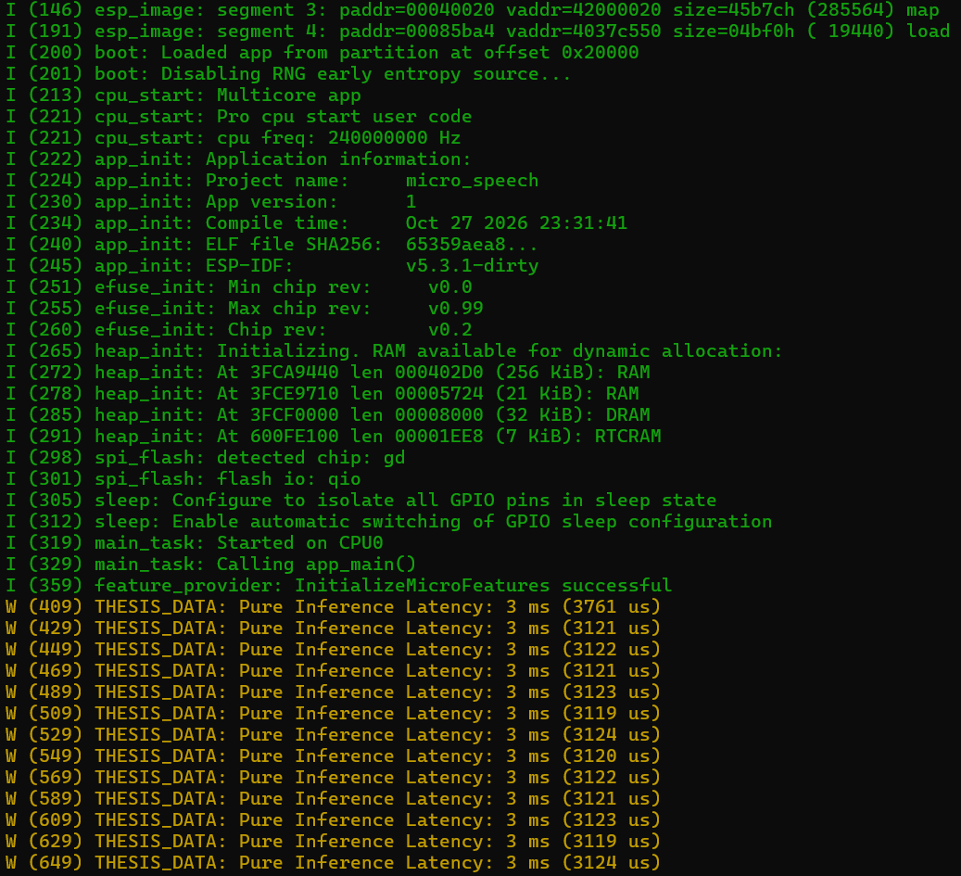
Figure 2: (A) Cold-Start Cache Miss (3,761 us) vs. Steady-State Execution (3,121.4 us) and (B) Microsecond Stability Band (+/-2.5 us jitter, sigma = 1.59 us).
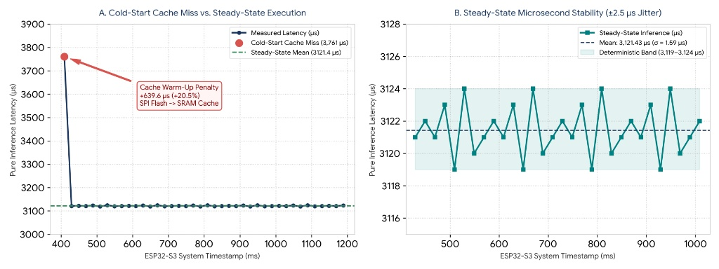
Figure 3: Detailed Callout of the +639.6 us (+20.5%) SPI Flash to SRAM Data Cache Warm-Up Penalty.
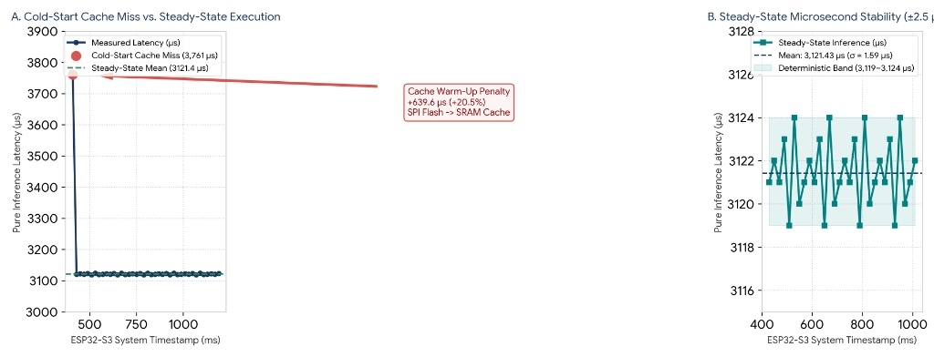
Figure 4: (A) 20 ms Real-Time Audio Frame Duty Cycle Budget (15.61% Active vs. 84.39% Slack) and (B) Baseline vs. Architectural Optimization Targets.


