DeepDiabetic: An Identification System of Diabetic Eye Diseases Using Deep Neural Networks
Diabetic retinopathy (DR) is an eye condition that damages the blood vessels in the retina. It's a complication of diabetes that can lead to vision loss or blindness. Diabetes is a significant public health concern, and diabetic eye disease will be the leading cause of vision loss across the globe.
To combat against such disease author of propose paper employing deep learning algorithms for early and accurate diagnosis of DR diseases. In propose paper author has first collected different DR images from 6 different datasets and then trained with 5 different DL algorithms such as EfficientNetB0, VGG16, ResNet152V2, ResNet152V2 + GRU and ResNet152V2 + BIGRU. Each algorithm performance is evaluated in terms of accuracy, precision, recall and FCSORE. Among all algorithms EfficinetNetB0 outperform all algorithms with an accuracy of 98%.
In propose paper author has collected Eye Diseases images such as Cataract, DR, DME and Glaucoma. All this images are augmented to increased dataset size and then trained with above algorithms. In the past many Eye disease DL algorithms was developed but all those algorithms were not collected images from 6 different dataset and not utilized EfficinetNetB0 so they detection accuracy was below 98%.
To implement this project we have designed following modules
- New User Sign up: using this module user can sign up with the application
- User Login: user can login to system
- Upload DR Dataset: using this module will upload DR dataset to application
- Processed Dataset: this module will extract features from all images and then perform augmentation and then normalize all pixels values. All processed images will be split into train and test where application using 80% dataset for training and 20% for testing
- Run DL Algorithms: 80% training data will be input to all DL algorithms to train a model and this model will be applied on 20% test data to calculate prediction accuracy
- Predict Diabetic Eye Disease: using this module user can upload test image and then EfficientNetB0 model will analyse image features to predict type of eye disease.
SCREEN SHOTS
To run project double click on ‘run.bat’ file to start python web server and then will get below page
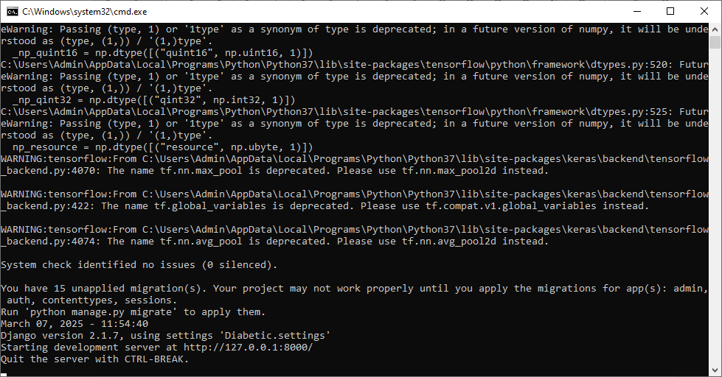
In above screen python server started and now open browser and enter URL as http://127.0.0.1:8000/index.html and then press enter key to get below page
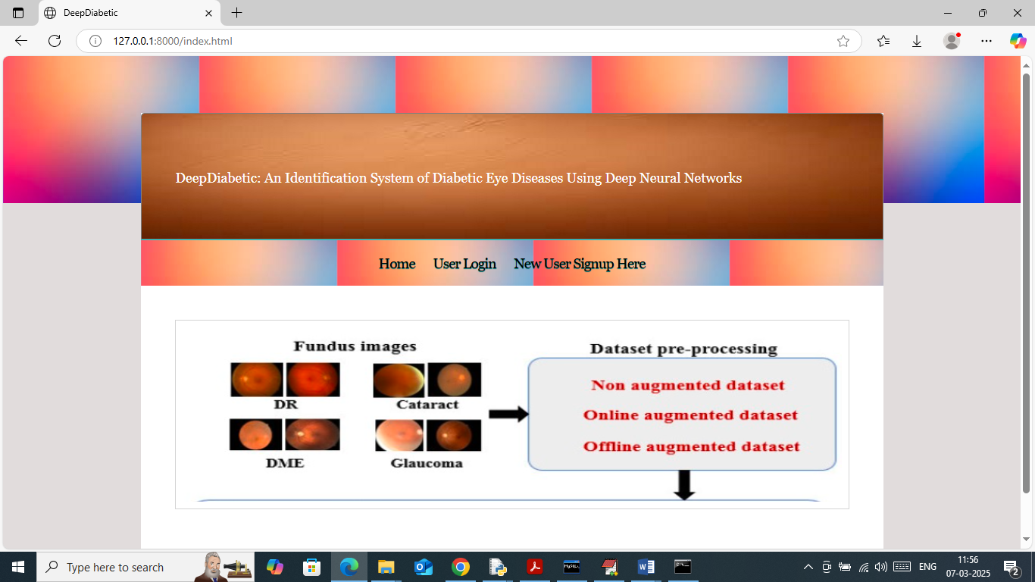
In above screen click on ‘New User Sign up’ link to get below page
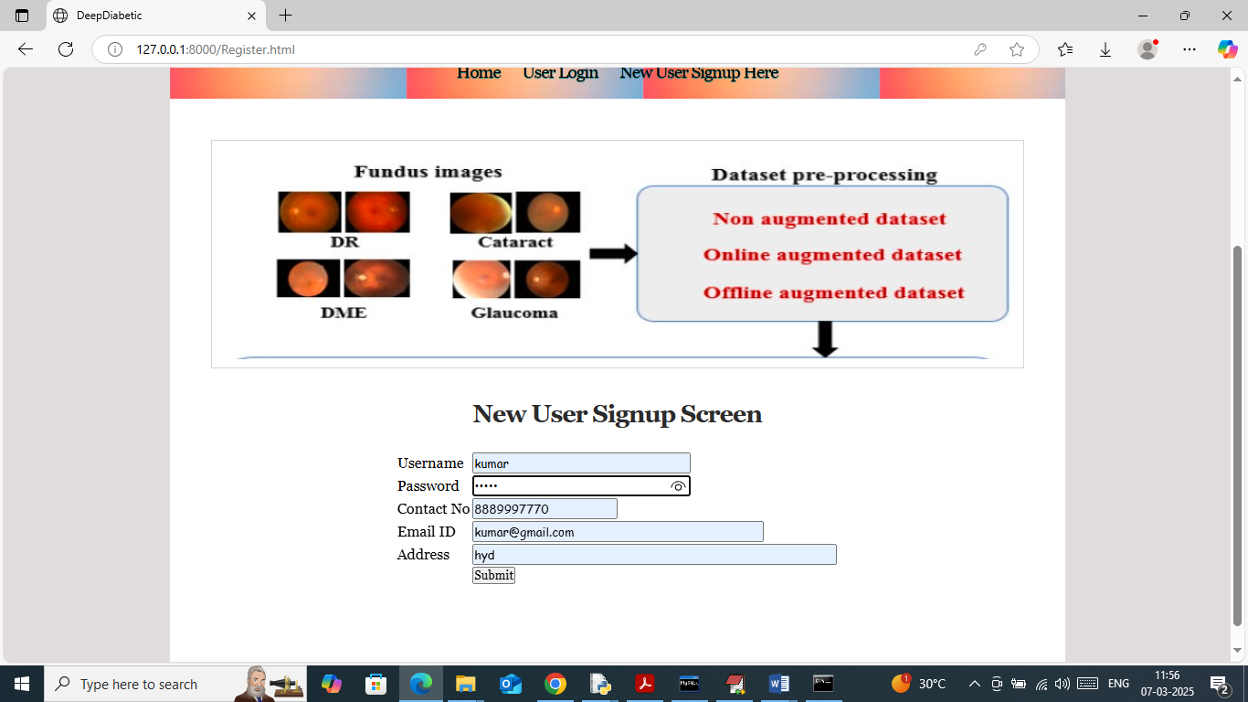
In above screen user is entering sign up details and then press button to get below page
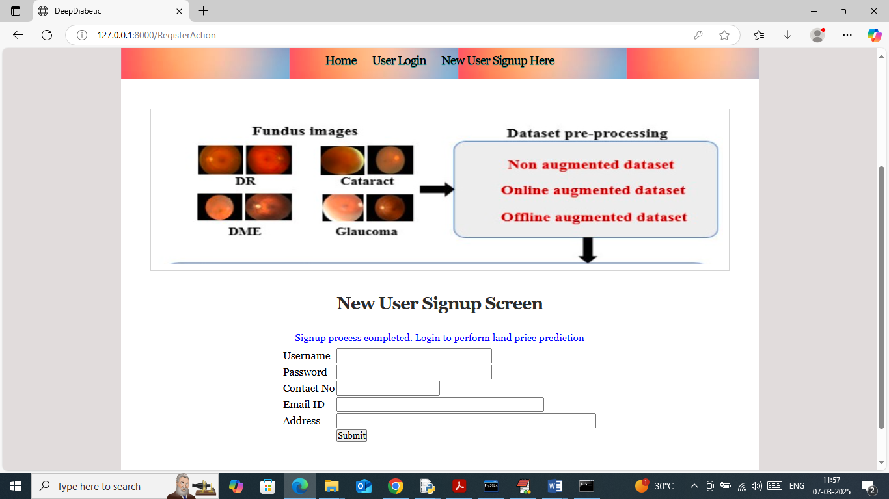
In above screen sign up process completed and now click on ‘User Login’ link to get below page
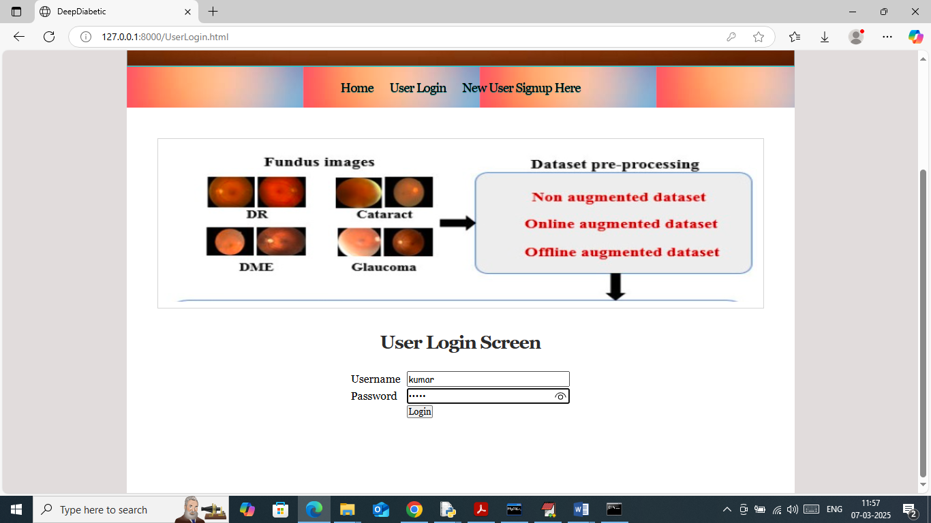
In above screen user is login and after login will get below page
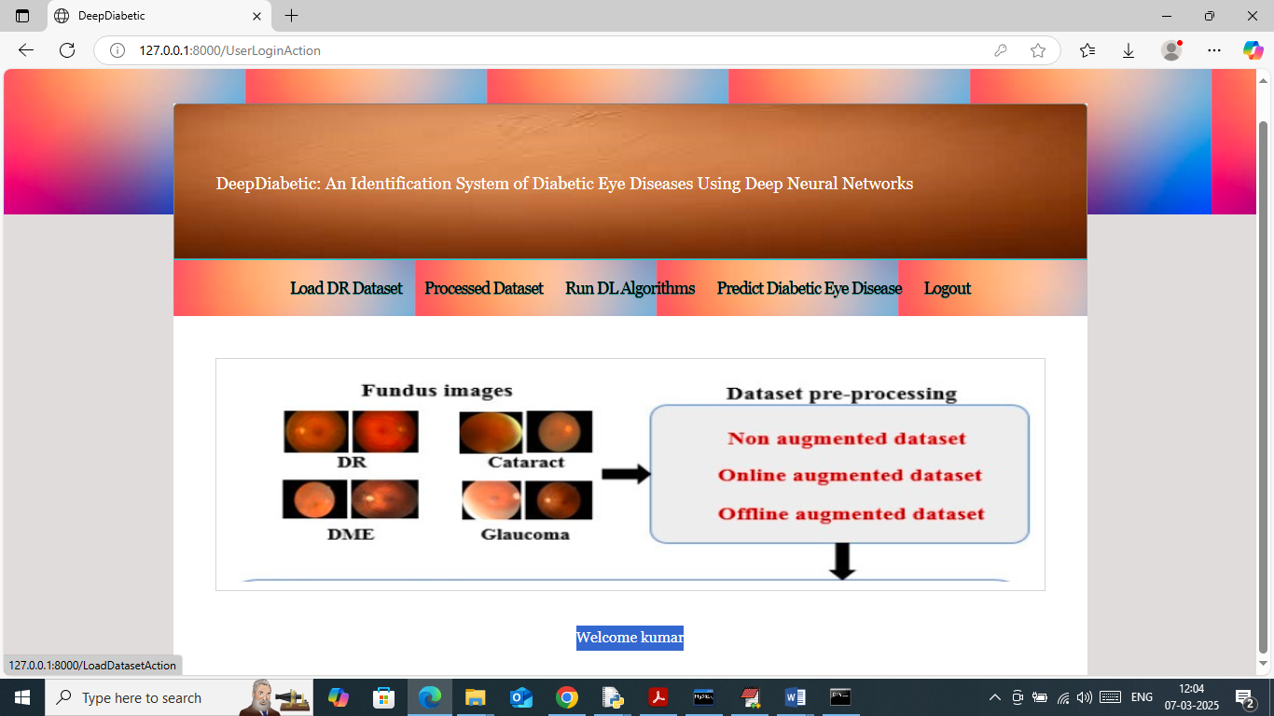
In above screen click on ‘Load DR Dataset’ button to load dataset and then will get below page
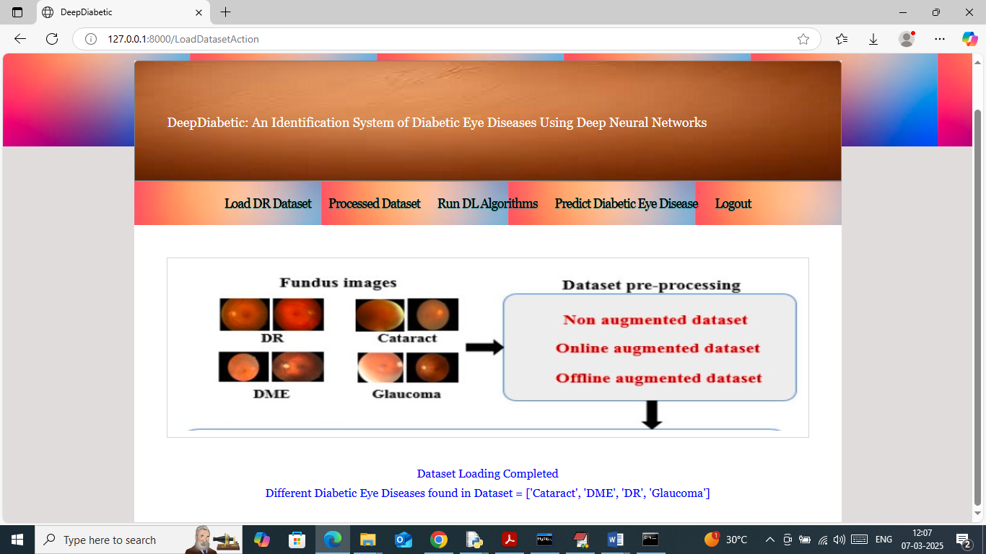
In above screen dataset loaded and can see different eye disease labels found in dataset and now click on ‘Processed Dataset’ link to process dataset and then will get below page
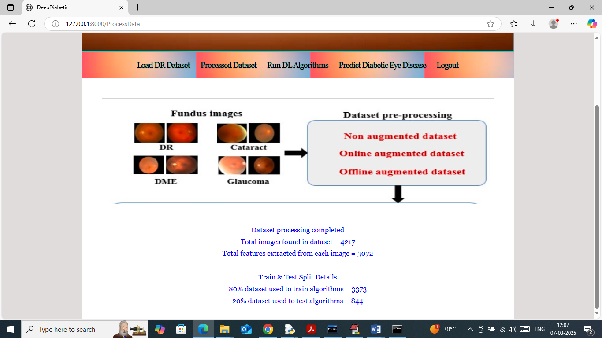
In above screen can see number of images processed and total features extracted from each image and then can see train and test size. Now click on ‘Run DL Algorithms’ link to train algorithms and then will get below page
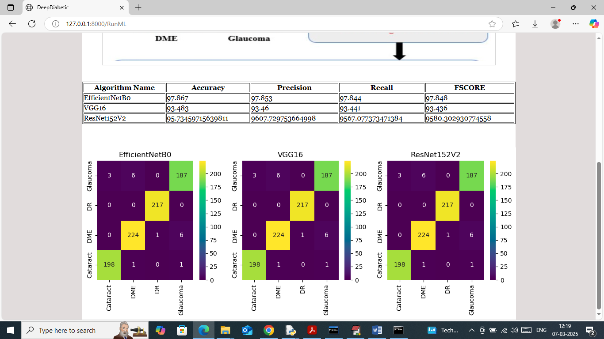
In above screen in table format can see performance of each algorithm where EfficientNetB0 got highest accuracy as 97% and VGG as 93 and Resnet152V2 got 95% accuracy. In below each algorithms classification confusion matrix graph x-axis represents Predicted Labels and y-axis represents True Labels and then all different colour boxes in diagonal represents correct prediction count and remaining blue boxes represents incorrect prediction count which are very few.
Note: training and testing all 5 algorithms taking hours of time so we trained and tested with above 3 best algorithms. Now click on ‘Predict Diabetic Eye Disease’ link to get below page
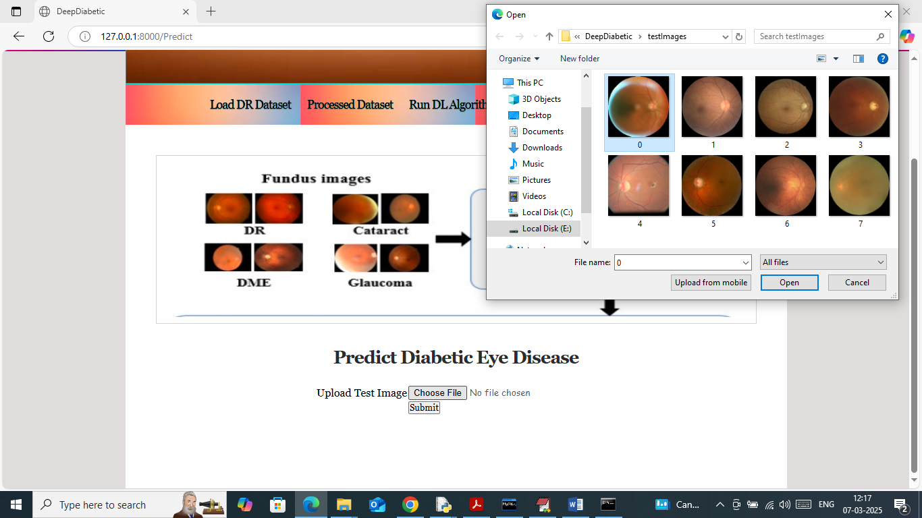
In above screen selecting and uploading test image and then click on buttons to get below prediction result and this images you can upload from ‘test Images’ folder available inside code folder
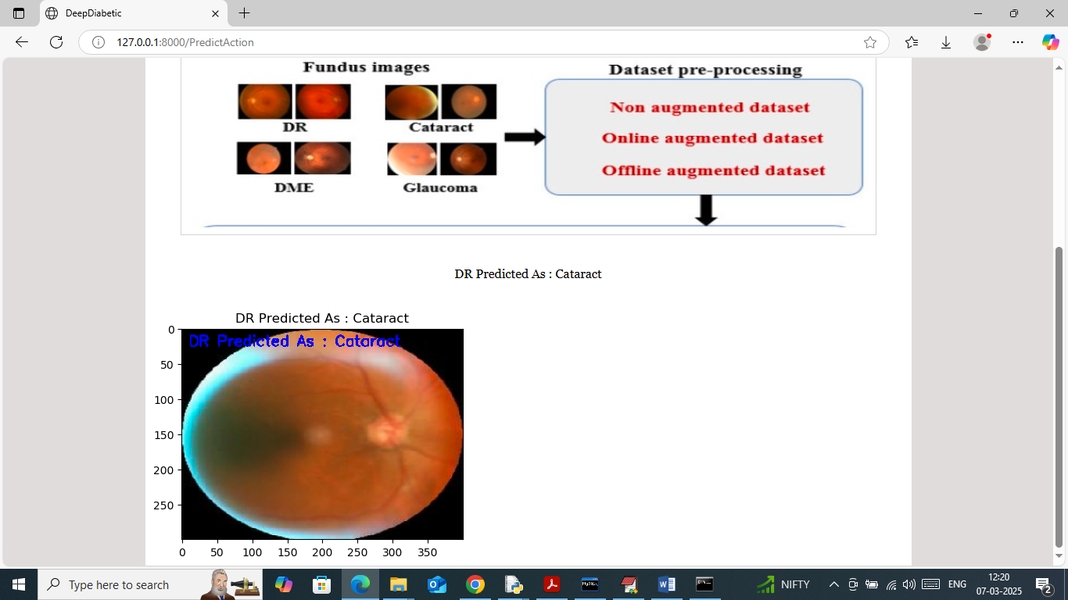
In above screen uploaded image predicted as ‘Cataract’ diabetic eye disease and similarly you can upload and test other images
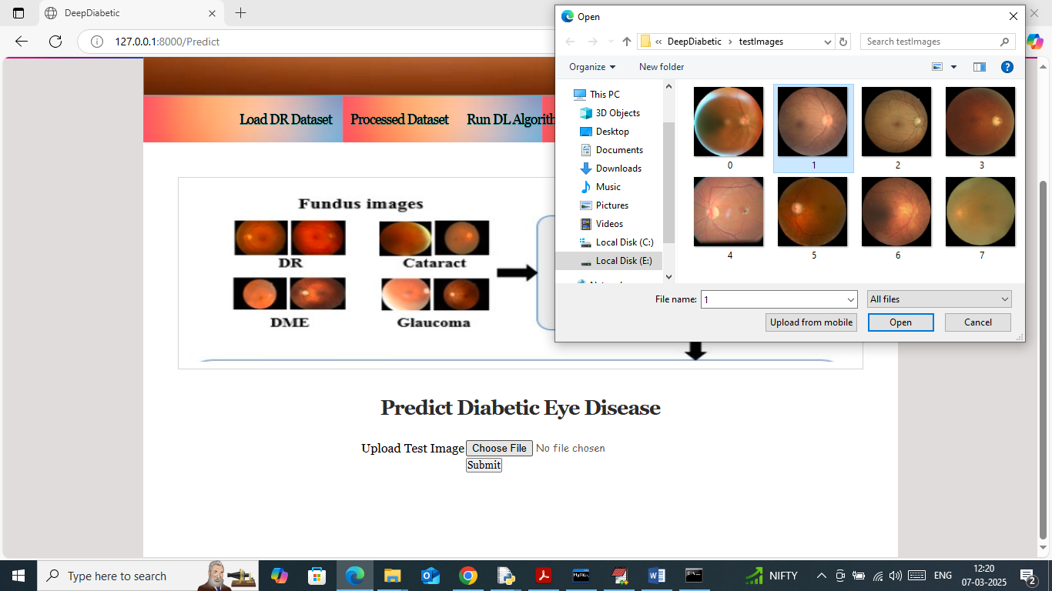
In above screen uploading another image
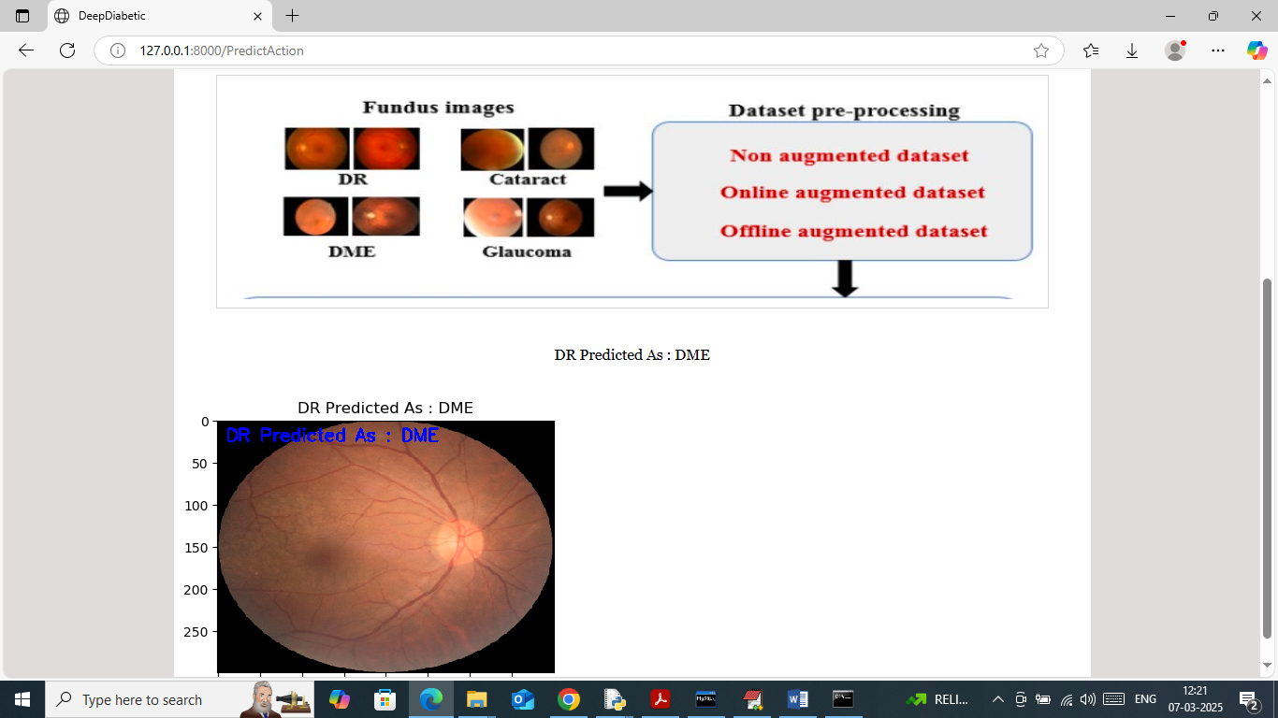
Above image detected as DME
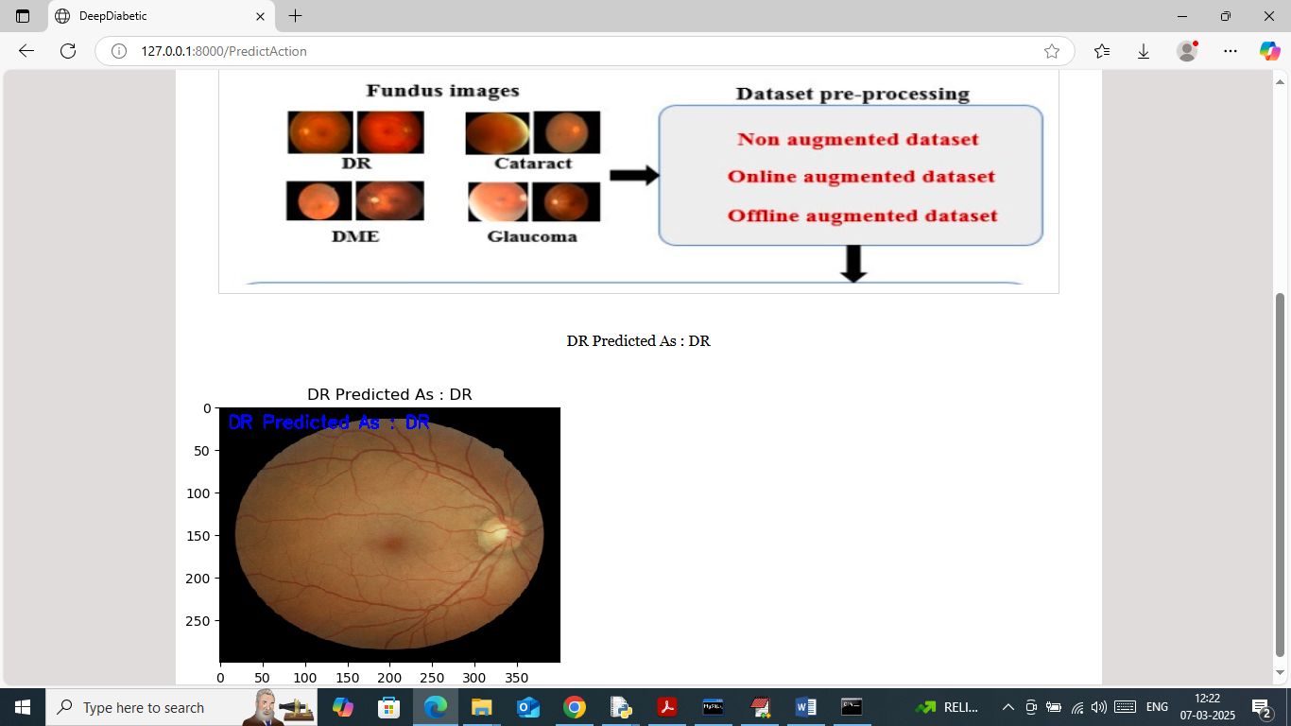
Above image detected as DR.
Similarly you can upload and test other images

