Phishing Email Analysis Report
Project Name: FUTURE_CS_02
Task: Phishing Email Detection & Awareness System
Organization: Future Interns

1. Email Analysis
Email Subject:
Urgent: Verify Your Account
Sender:
security-update@paypa1-verification.com
Indicators Identified:
• SPF authentication failed
• DKIM authentication failed
• Suspicious sender domain
• Unknown server detected
• Urgent language used
Risk Classification:
PHISHING (High Risk)
Explanation:
The analyzed email was classified as a phishing email because SPF and DKIM authentication failed. The sender domain appeared suspicious and the message used urgent language to pressure the user into verifying the account immediately.
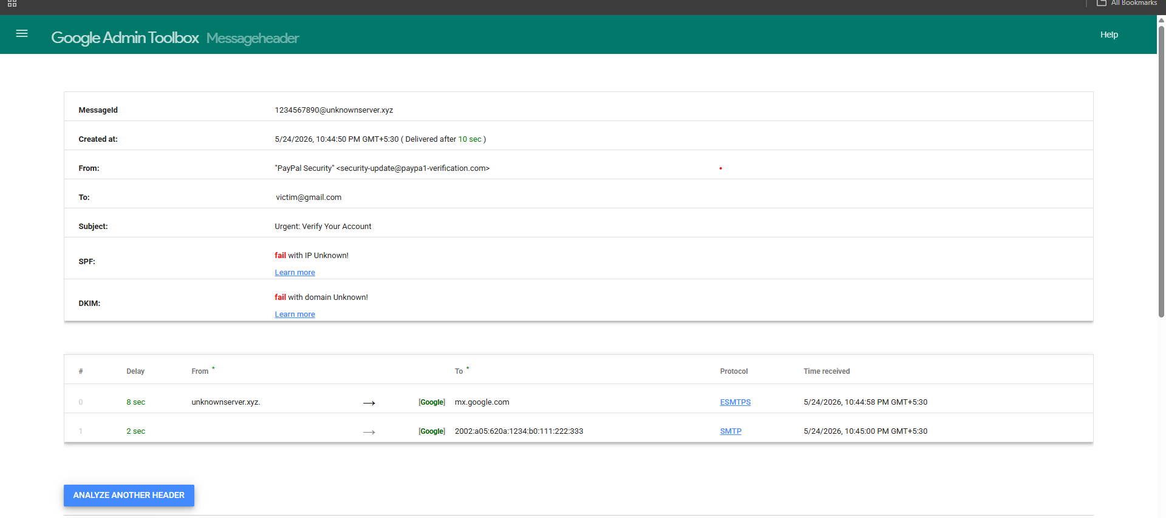

2. Prevention Tips
- Verify sender email addresses before responding.
- Avoid clicking suspicious links.
- Do not download unknown attachments.
- Enable multi-factor authentication (MFA).
- Report suspicious emails immediately.

3. Employee Do's and Don'ts
- DO's
- Verify sender details carefully.
- Hover over links before clicking.
- Use strong passwords.
- Report suspicious emails.
- DON'Ts
- Do not share OTPs or passwords.
- Do not click random links.
- Do not trust urgent emails blindly.
- Do not open suspicious attachments.

4. Conclusion
Phishing attacks continue to grow rapidly across organizations. User awareness and proper email analysis are essential to prevent data breaches and cyber attacks.

