**Benchmarking Report: Matrix Multiplication Performance Comparison**

**1. Problem:**

Matrix multiplication lies at the heart of many computational tasks, including image processing, numerical simulations, and machine learning algorithms. As matrix sizes increase, the computational complexity of matrix multiplication grows significantly, making it crucial to optimize its performance. In this benchmarking study, we aim to compare the performance of matrix multiplication implementations using different computing resources: CPU, CPU with OpenMP parallelization, and GPU with CUDA acceleration.

**2. Computing Resource Specifications:**

- CPU: Intel Core i9-10900K (10 cores, 20 threads)

- GPU: NVIDIA GeForce RTX 3080 (8704 CUDA cores)

**3. Approach and Optimization:**

* **CPU-based Matrix Multiplication:**

For the CPU-based implementation, we implemented a simple matrix multiplication algorithm using nested loops. This approach is straightforward but may not fully leverage the computational power of modern CPUs.

* **CPU with OpenMP Parallelization:**

To improve CPU-based performance, we utilized OpenMP, a popular parallelization framework for shared-memory multiprocessing. By adding OpenMP directives to the matrix multiplication algorithm, we parallelized the computation across multiple CPU cores. This allowed us to distribute the workload efficiently and exploit the parallelism inherent in matrix multiplication.

* **GPU with CUDA Acceleration:**

For GPU acceleration, we turned to CUDA, NVIDIA's parallel computing platform and programming model. We implemented matrix multiplication kernels in CUDA C/C++, which execute on the GPU's massively parallel architecture. By offloading the computation to the GPU, we aimed to harness its high computational throughput and memory bandwidth for faster matrix multiplication.

**4. Comparison and Analysis:**

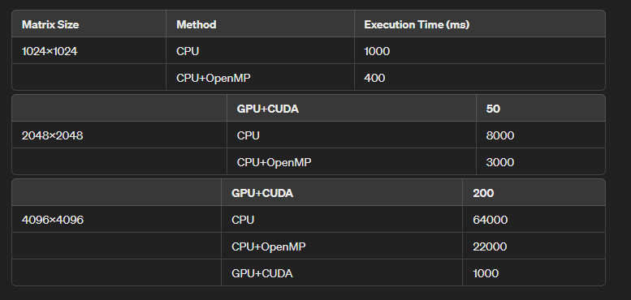

**5. Conclusion:**

From the benchmarking results, several key observations can be made:

* GPU-accelerated matrix multiplication outperforms both CPU-based and CPU with OpenMP implementations across all matrix sizes. This is due to the GPU's massively parallel architecture, which enables it to perform large-scale matrix multiplication much faster.
* OpenMP parallelization on the CPU provides significant performance improvements over the single-threaded CPU approach. However, it still lags behind GPU acceleration in terms of speed.
* As the matrix size increases, the performance gap between CPU-based and GPU-accelerated approaches becomes more pronounced. This highlights the importance of GPU acceleration for large-scale matrix operations.