SYNOPSIS

- Introduction

In the modern digital era, healthcare organizations generate vast amounts of data from multiple sources such as electronic health records (EHRs), laboratory systems, pharmacy databases, diagnostic imaging, wearable devices, and patient monitoring equipment. This data, if utilized effectively, can significantly improve patient care, hospital management, and medical research. However, traditional transactional databases are designed for daily operations like storing patient details or processing bills, and they lack the ability to support large-scale analysis and long-term decision-making. A Healthcare Data Warehouse (HDW) provides a solution by integrating heterogeneous data into a centralized and structured repository. Unlike conventional databases, an HDW is optimized for querying, reporting, and analytics. It allows healthcare professionals to analyze disease patterns, evaluate treatment outcomes, predict risks, and support evidence-based decision-making. For administrators, it helps improve efficiency, resource allocation, and cost control. With the adoption of modern cloud platforms such as Snowflake and Google BigQuery, healthcare institutions can achieve scalable, secure, and real-time analytics. These platforms ensure compliance with strict healthcare data privacy regulations while enabling faster and more reliable processing of large datasets. Thus, implementing a Healthcare Data Warehouse is a transformative step toward building a more efficient, data-driven, and patient - centered healthcare ecosystem.

- Project Statement

The main objective of this project is to design and implement a Healthcare Data Warehouse that can integrate data from multiple healthcare sources into a unified system. By consolidating diverse datasets, the warehouse aims to provide clean, consistent, and well structured information that supports advanced analytics and effective decision-making. This centralized approach will enable healthcare organizations to gain valuable data-driven insights into patient care, treatment effectiveness, and overall operational efficiency.
Furthermore, the project emphasizes the importance of Extract, Transform, Load (ETL) pipelines and business intelligence tools, which play a vital role in processing raw data into meaningful information and presenting it in a way that supports healthcare professionals, administrators, and researchers in making informed, evidence-based decisions.

- Objectives of the Project

- Design and implement a centralized healthcare data warehouse using a simple Star or Snowflake schema, along with basic ETL processes to extract, clean, and load data into the system.
- Enable analytics and visualization by generating dashboards and reports (using tools like Tableau, Power BI, or Looker) to analyze disease trends, patient readmission rates, and resource utilization.

5. Methodology
The methodology for designing a healthcare data warehouse follows a structured

Data Sources
- Collect healthcare data from multiple systems such as electronic health records (EHRs), laboratory results, pharmacy data, medical imaging, and patient monitoring devices.
- These heterogeneous datasets form the foundation of the warehouse.

ETL Pipeline (Extract, Transform, Load)
- Extract raw data from different sources.
- Transform and clean the data by removing duplicates, handling missing values, and normalizing formats.
- Load the processed data into the warehouse for analysis.

Centralized Data Warehouse
- Store structured and integrated data in a healthcare data warehouse.
- Use cloud platforms such as Snowflake or Google BigQuery to ensure scalability, secure storage, and efficient querying.

Business Intelligence (BI) Tools
- Connect BI tools like Tableau or Power BI with the data warehouse.
- Design dashboards and reports to present insights in a user-friendly way.

Healthcare Analytics Dashboards
- Develop dashboards to monitor disease trends, patient readmission rates, and resource utilization.
- Provide actionable insights to support decision-making, improve patient care, and optimize operations.

- Block Diagram

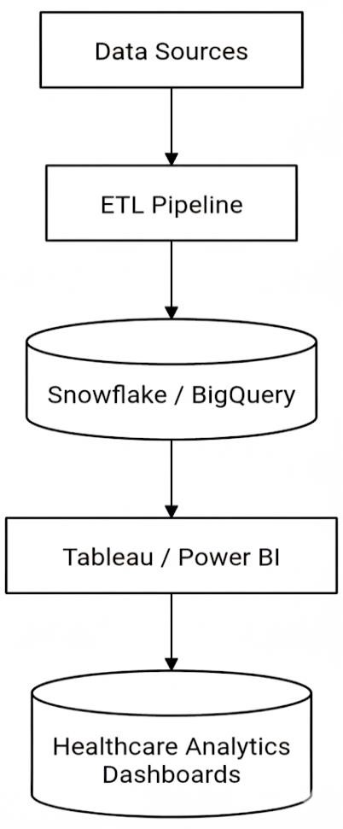

7. Expected Outcomes
- Organized and Clean Data : All healthcare data from different sources will be combined into one system. The data will be cleaned and structured so it can be used easily for analysis.
- Useful Dashboards and Reports : Visual dashboards and reports will show important information like disease trends, patient readmission, and hospital resource use. This helps doctors and managers make better decisions.

