SPOTIFY SONGS' GENRE SEGMENTATION
AND RECOMMENDATION SYSTEM
Major Project Report
Machine Learning / Data Analytics Project
Dataset: Spotify playlist tracks supplied for the project

1. Abstract
This project develops an automated music analysis and recommendation pipeline using Spotify playlist track data. The system performs data preprocessing, exploratory data analysis, correlation analysis, unsupervised K-Means segmentation, supervised genre prediction and nearest-neighbor recommendation. Audio characteristics such as danceability, energy, loudness, speechiness, acousticness, instrumentalness, liveness, valence, tempo, duration and popularity are used to represent songs numerically. The final system creates six interpretable music segments and provides a recommendation engine that retrieves acoustically similar tracks. A Random Forest baseline is also trained to predict the playlist genre from audio features.

2. Introduction
Music streaming platforms contain large collections of songs described by metadata and numerical audio characteristics. A recommendation system must identify similarities between tracks and understand user-oriented groupings such as genres, moods and playlist styles. This project applies machine learning to transform raw Spotify playlist data into meaningful song segments and a simple recommendation system.

3. Problem Statement
Manual organization of thousands of songs into meaningful groups is time-consuming and subjective. The objective is to create an automated system that analyzes song attributes, discovers groups of similar tracks, identifies genre patterns and produces recommendations based on audio-feature similarity.

4. Objectives
- Perform data preprocessing and quality checks.
- Analyze distributions and relationships among song/audio features.
- Generate a numerical correlation matrix.
- Study playlist genres, subgenres and playlist names.
- Segment songs using K-Means clustering.
- Evaluate candidate cluster counts using silhouette, Calinski-Harabasz and Davies-Bouldin measures.
- Build a genre prediction baseline using Random Forest.
- Build a nearest-neighbor recommendation component.

5. Dataset Description
The supplied CSV contains 32,833 rows and 23 columns. After preprocessing, 32,833 rows remained. The dataset contains 6 playlist genres, 24 playlist subgenres and 10,693 unique artists. Important variables include track metadata, playlist metadata and audio features such as danceability, energy, loudness, speechiness, acousticness, instrumentalness, liveness, valence and tempo. The mentor-provided Kaggle reference is https://www.kaggle.com/datasets/maharshipandya/-spotify-tracks-dataset/code.'

6. Data Preprocessing
The pipeline removes exact duplicate rows, fills missing text metadata with “Unknown”, converts numerical columns to numeric types, removes rows missing essential modeling fields, converts duration from milliseconds to minutes, clips bounded audio features to valid ranges, and restricts popularity to 0–100. The cleaned dataset is saved as outputs/cleaned_spotify_tracks.csv.

7. Exploratory Data Analysis
The analysis includes popularity distribution, genre and subgenre counts, audio-feature distributions, correlation matrix, energy-versus-danceability scatter analysis, average popularity by genre, genre feature heatmap, duration distribution and popularity distribution by genre. These plots help identify the structure of the catalogue before machine learning.

8. Methodology
The numerical audio features are standardized using StandardScaler. Candidate K values from 2 through 10 are evaluated on a representative sample. K-Means is then fitted to the complete standardized dataset. PCA is used only for two-dimensional visualization. A Random Forest classifier is trained as a supervised baseline for playlist genre prediction. Finally, a Nearest Neighbors model provides song recommendations from the learned audio-feature space.

9. Cluster Selection and Segmentation
Silhouette evaluation produced the strongest purely unsupervised score at K=2. However, the project requirement emphasizes playlist genre segmentation and the supplied data contains six playlist genres. Therefore, K=6 was selected for the final practical segmentation because it provides a richer and more interpretable recommendation space. The final K=6 silhouette score is 0.1252; Calinski-Harabasz is 544.62; Davies-Bouldin is 1.877. This trade-off is explicitly documented rather than presenting K=6 as the mathematically optimal silhouette solution.

10. Supervised Genre Prediction
A Random Forest classifier was trained on the same standardized audio-feature representation to predict the six playlist genres. On a stratified 20% test split, the model achieved an accuracy of 55.98%. The detailed precision, recall and F1 scores are stored in outputs/classification_report.txt. This model can act as a genre-aware layer before recommendations are presented.

11. Recommendation System
The recommendation engine represents every track as a standardized feature vector. For a selected or newly specified song profile, the vector is transformed with the saved scaler and compared with the stored track vectors using Euclidean nearest-neighbor search. The system predicts a playlist genre, identifies the learned segment and returns acoustically similar songs. This is a content-based recommender and does not claim to reproduce Spotify’s proprietary production recommendation algorithm.

12. Results
The pipeline successfully processed 32,833 tracks. The final segmentation contains six clusters with distinct audio profiles. The largest segment contains 10,899 tracks and is dominated by Latin playlists; another segment is dominated by EDM and has very high instrumentalness; another is dominated by R&B with higher acousticness and lower energy; and a rap-dominant segment shows relatively high speechiness. The complete cluster profile table is included in the outputs folder.

13. Limitations
The supplied data represents playlist/track snapshots rather than a live user-history system. Playlist genre is a label attached to the source data and may not perfectly correspond to the acoustic characteristics of every song. K-Means assumes spherical cluster structure and Euclidean distance may not represent every musical similarity. The Random Forest accuracy is a baseline, not a production-grade genre classifier. Recommendations are based on audio similarity and do not use collaborative listening history.

14. Future Enhancements
Future versions can incorporate user listening history, collaborative filtering, hybrid content-plus-collaborative recommendation, neural embeddings, automatic mood detection, artist/album embeddings, Spotify API integration, a feedback loop, personalized playlists and online model monitoring.

15. Conclusion
The project demonstrates a complete machine-learning workflow from raw Spotify playlist data to an operational recommendation prototype. Data preprocessing and EDA establish the dataset structure, K-Means creates interpretable song segments, Random Forest provides a genre prediction baseline, and nearest-neighbor search converts the learned representation into recommendations. The result is suitable as an academic major project foundation and can be extended into a more personalized recommendation platform.

16. Key Visualizations
Figure 1: 01 Popularity Distribution
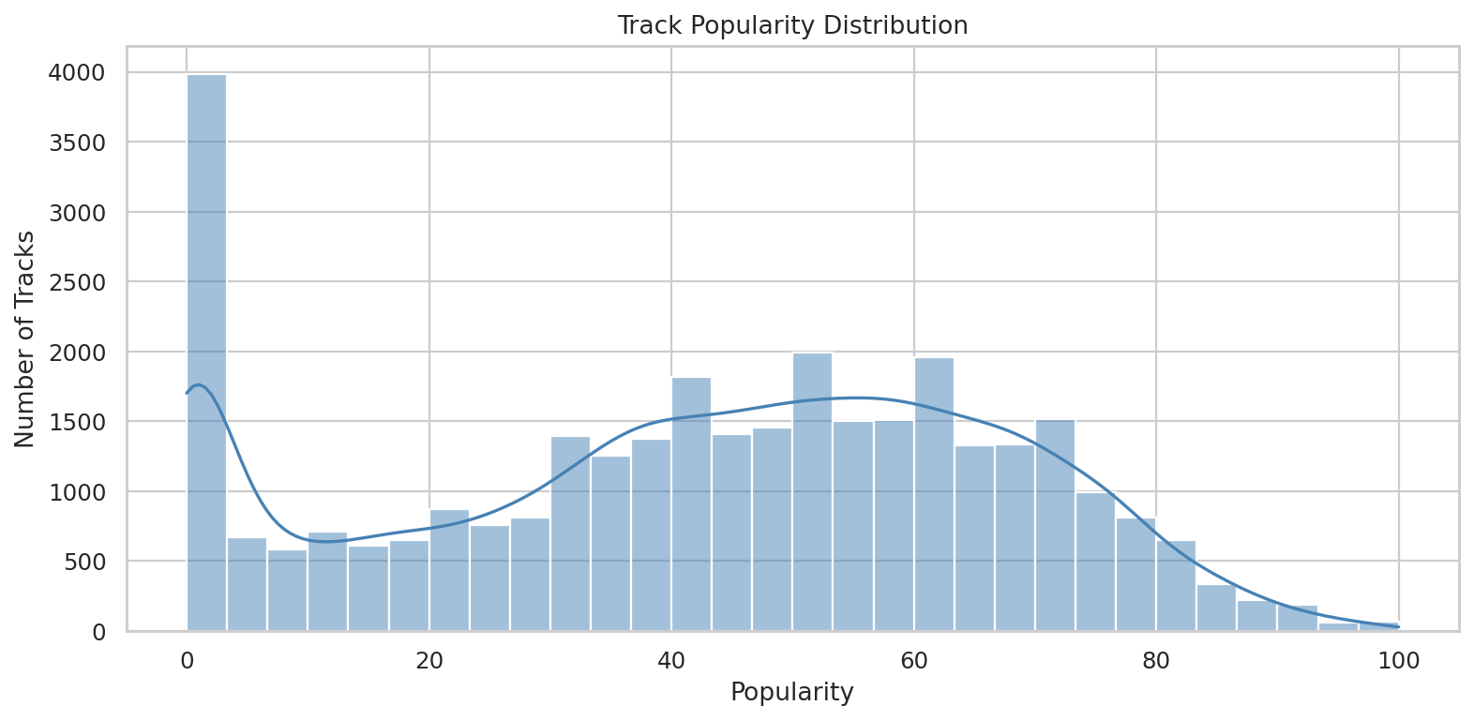
Figure 2: 02 Top Genres Count
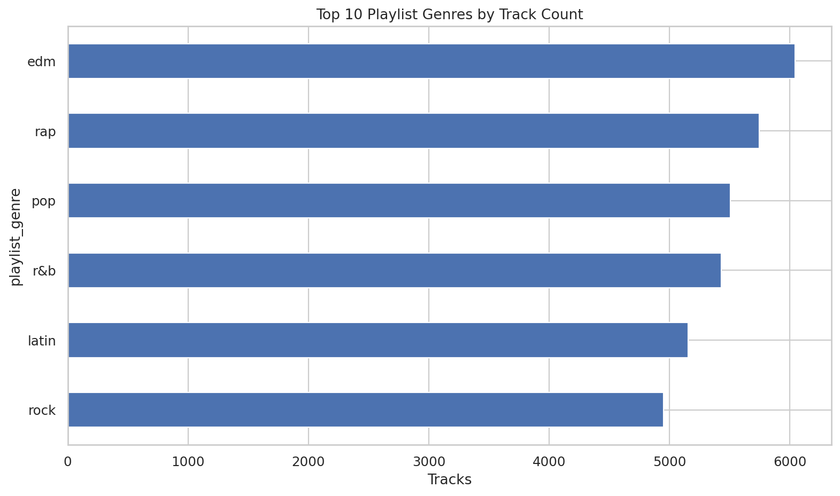
Figure 3: 03 Top Subgenres Count
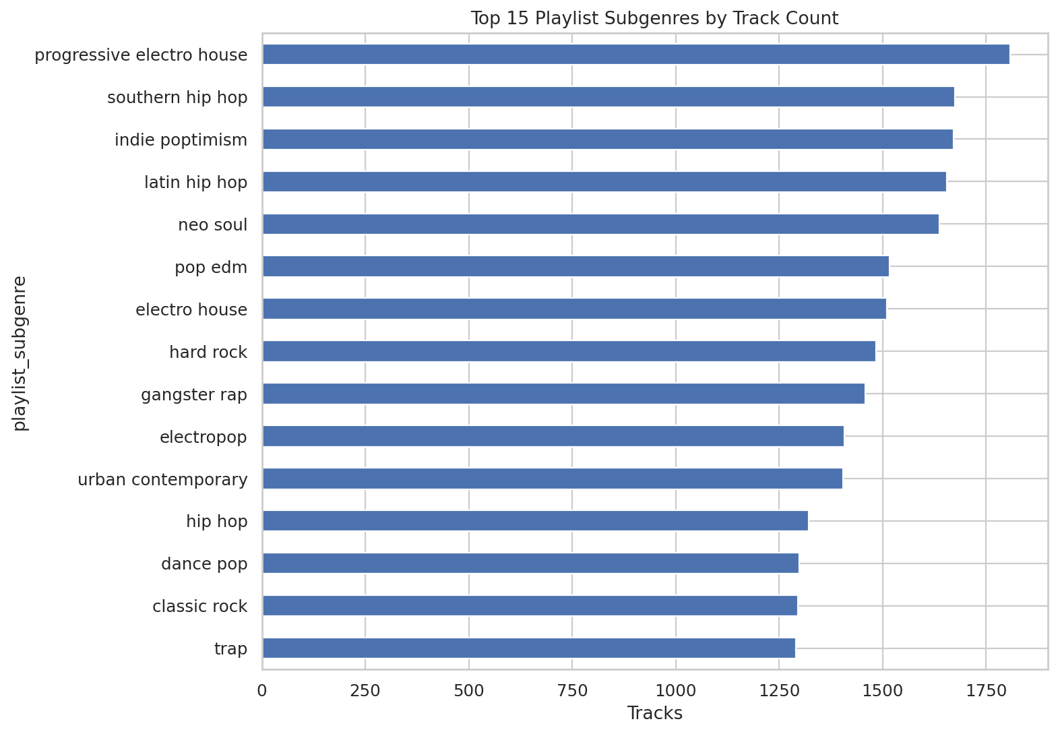
Figure 4: 04 Audio Feature Distributions
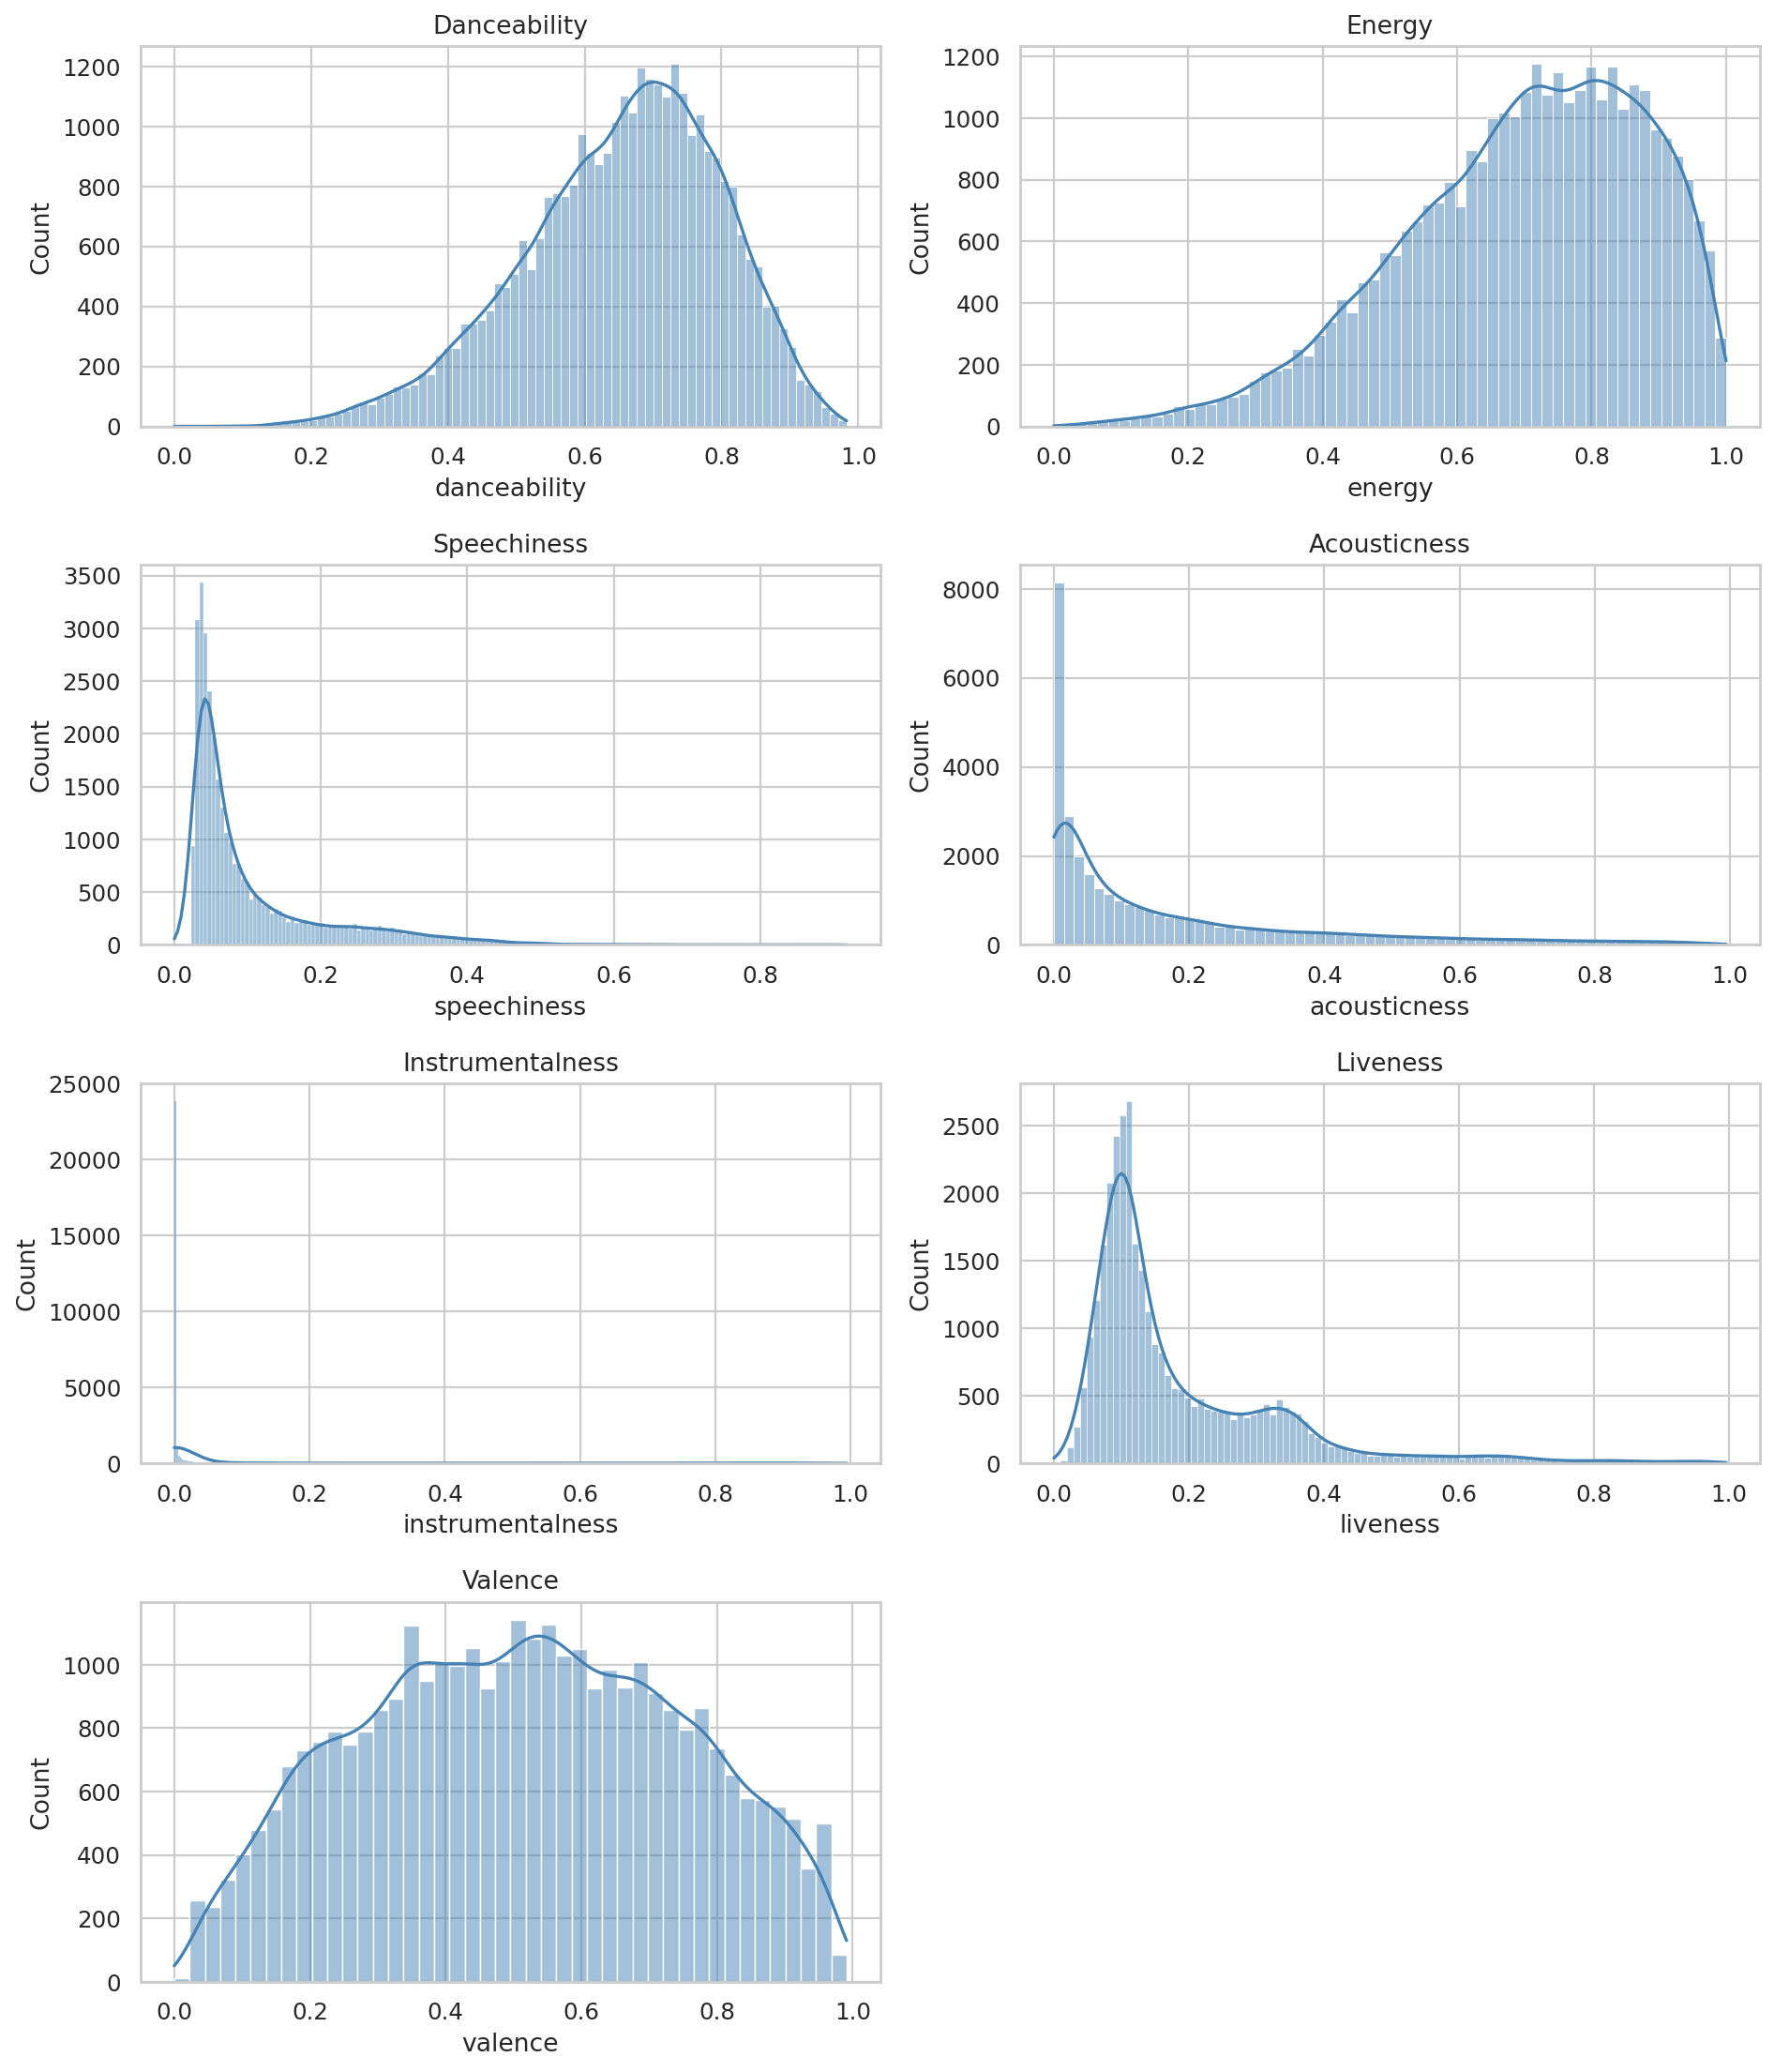
Figure 5: 05 Correlation Matrix
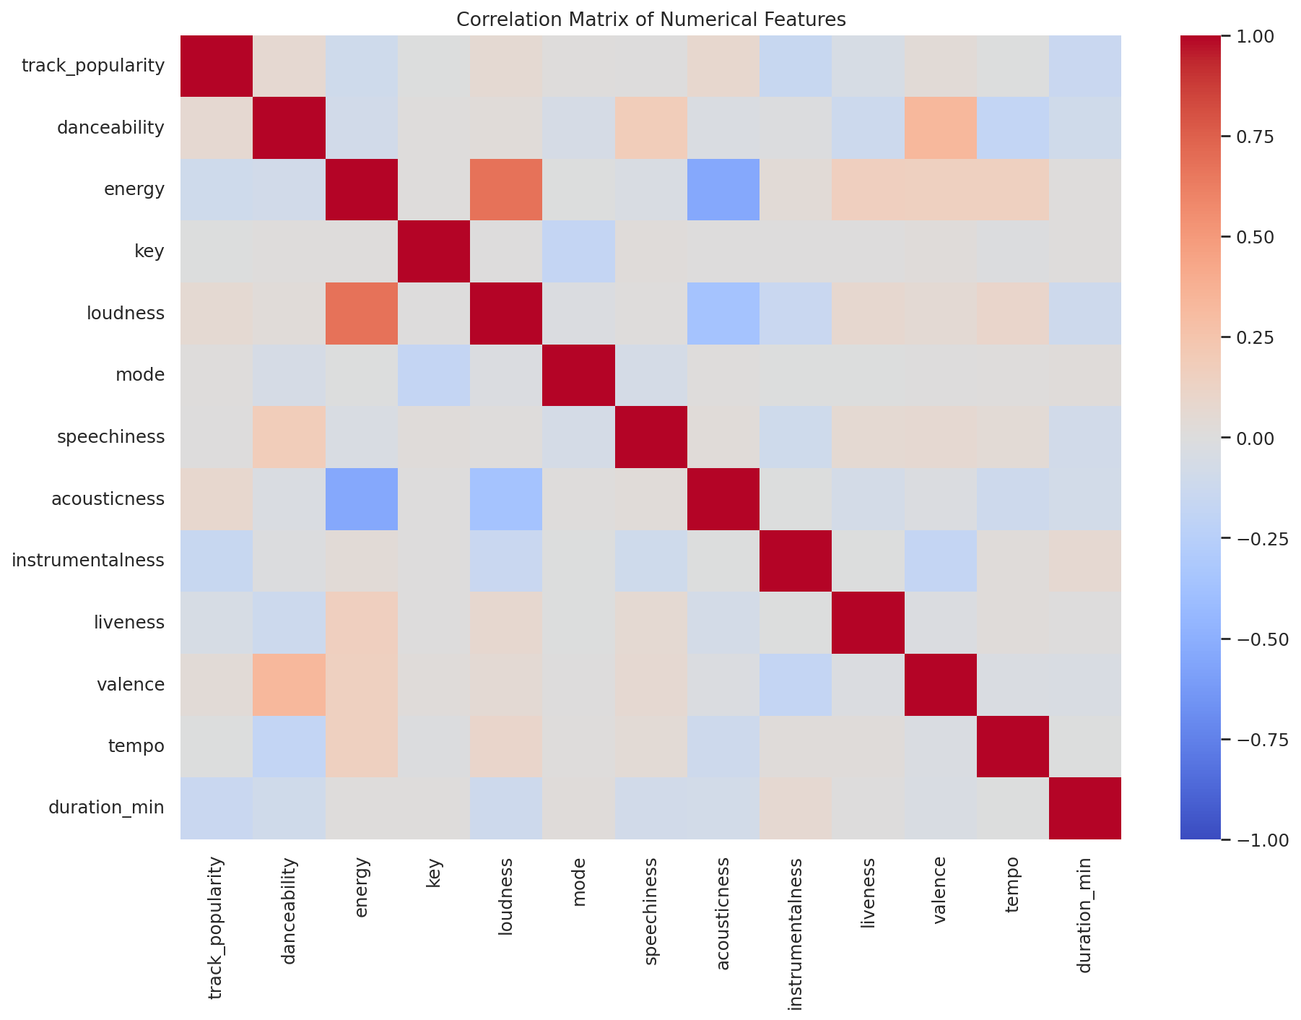
Figure 6: 06 Energy Vs Danceability
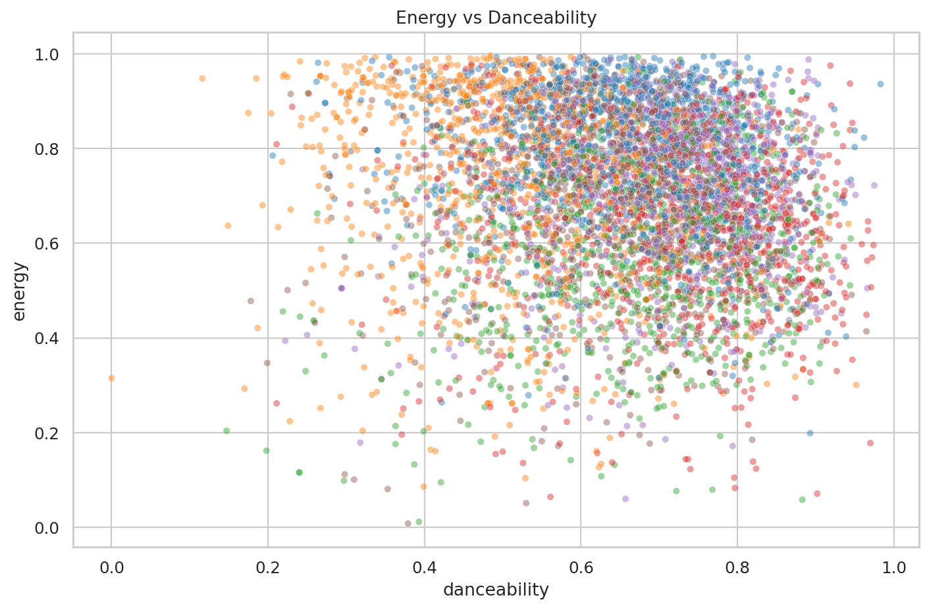
Figure 7: 07 Avg Popularity Genre
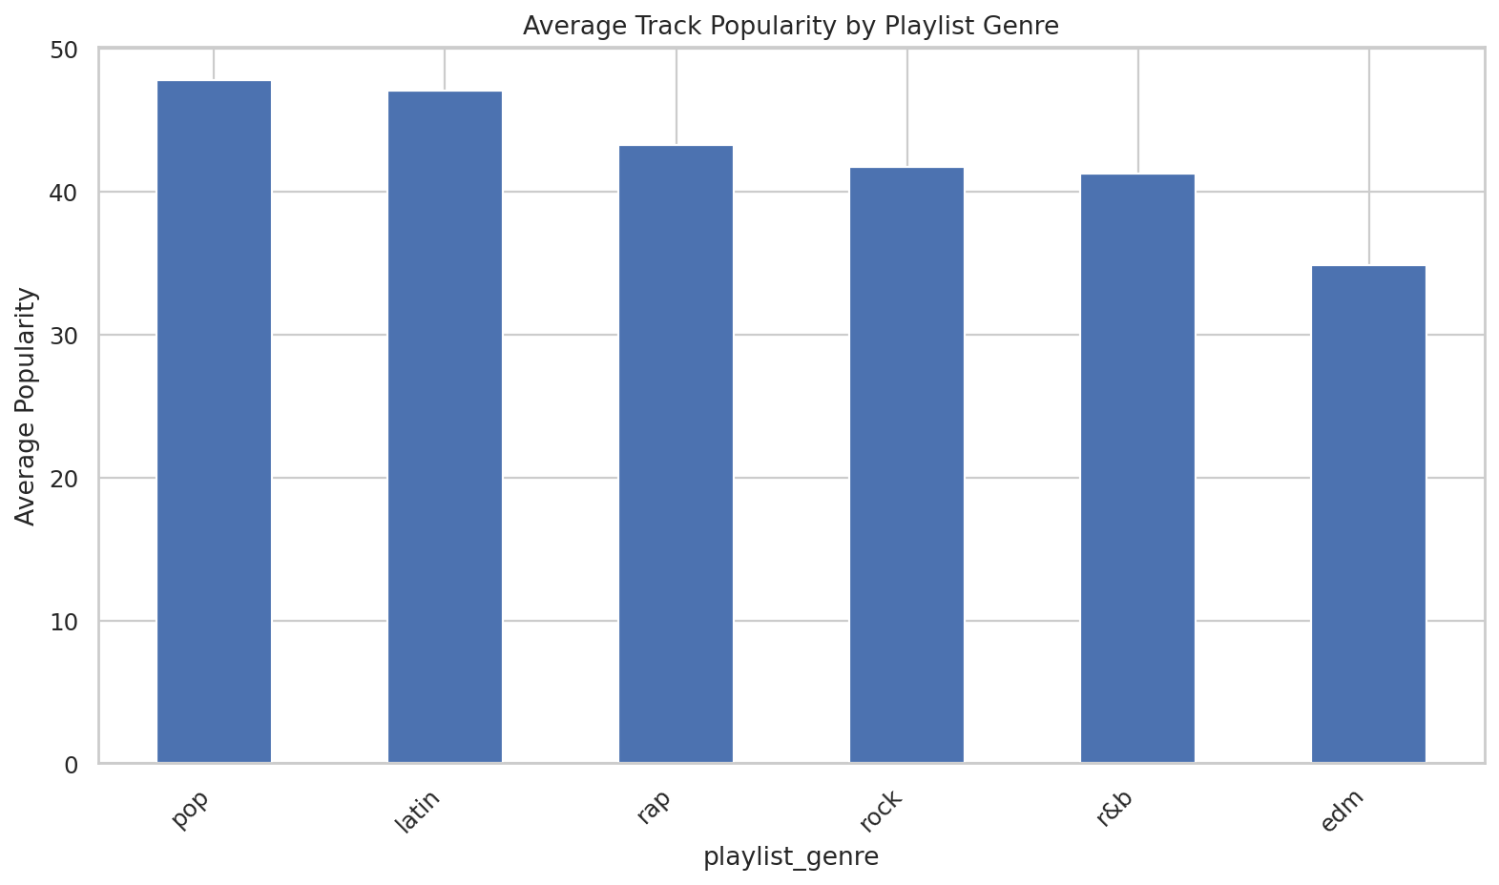
Figure 8: 08 Genre Feature Heatmap
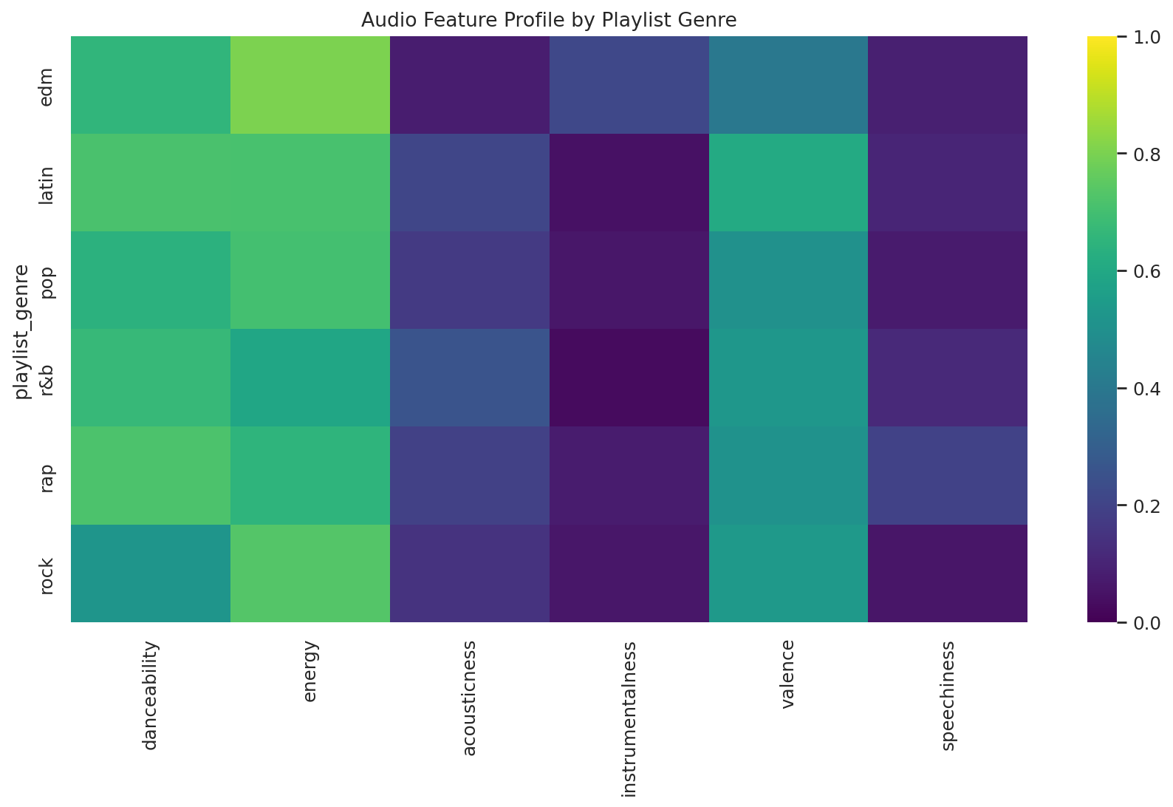
Figure 9: 09 Duration Distribution
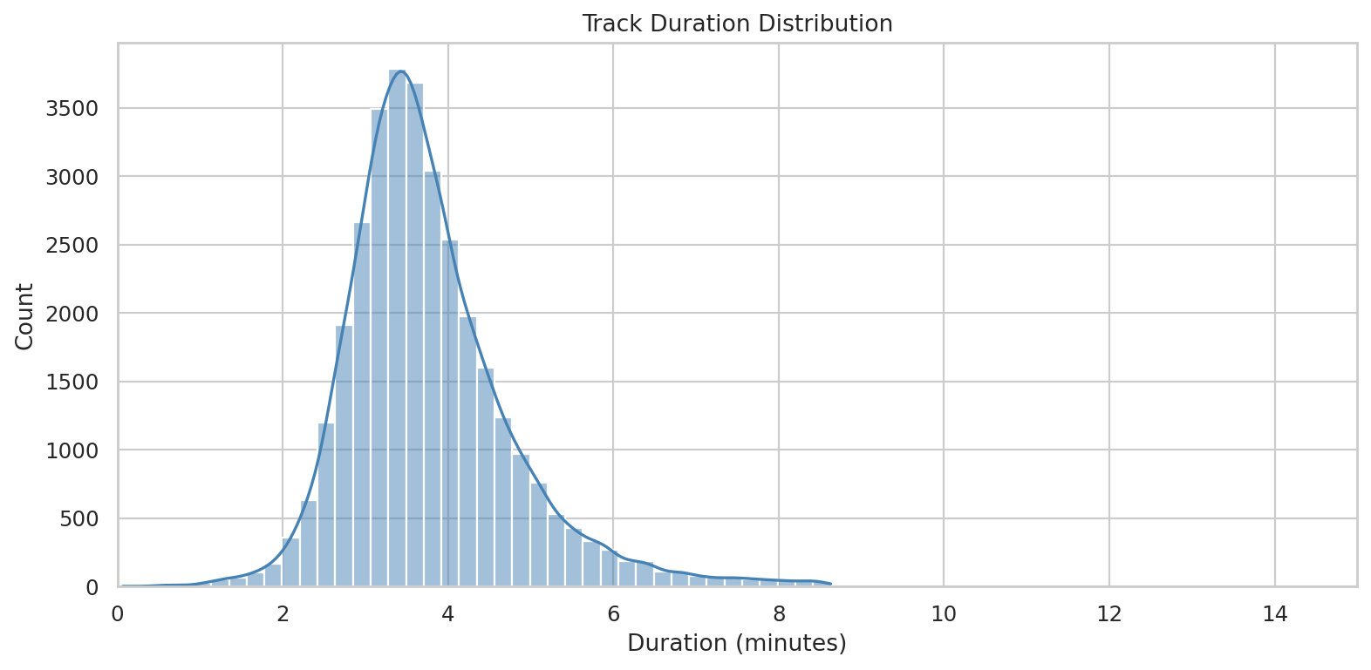
Figure 10: 10 Popularity By Genre Boxplot
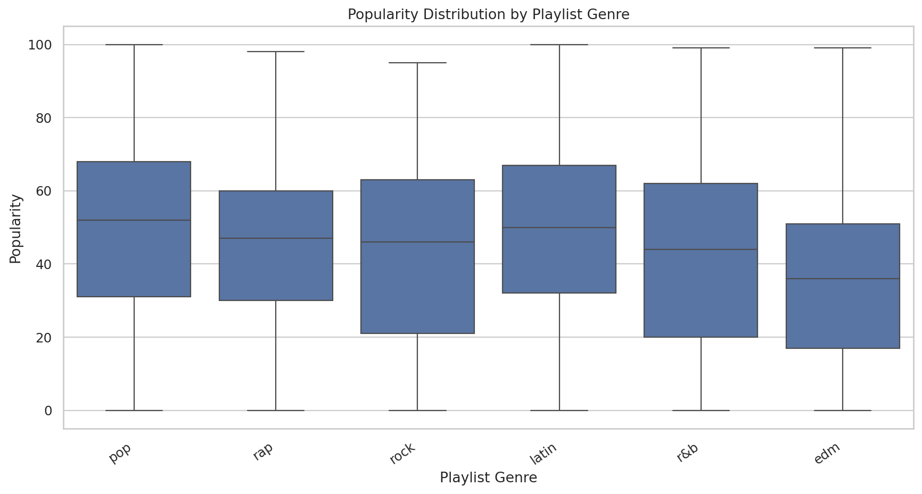
Figure 11: 11 Silhouette Scores
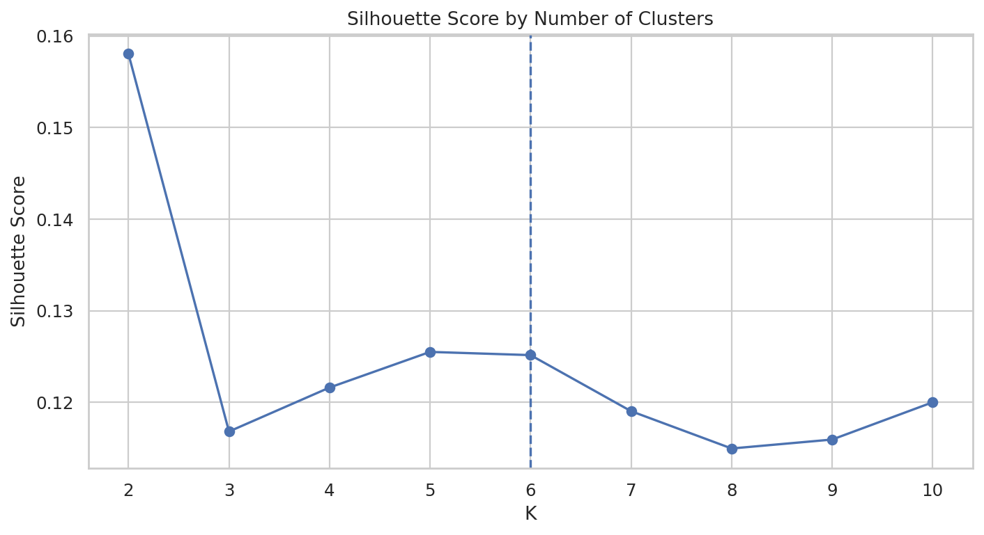
Figure 12: 12 Pca Clusters
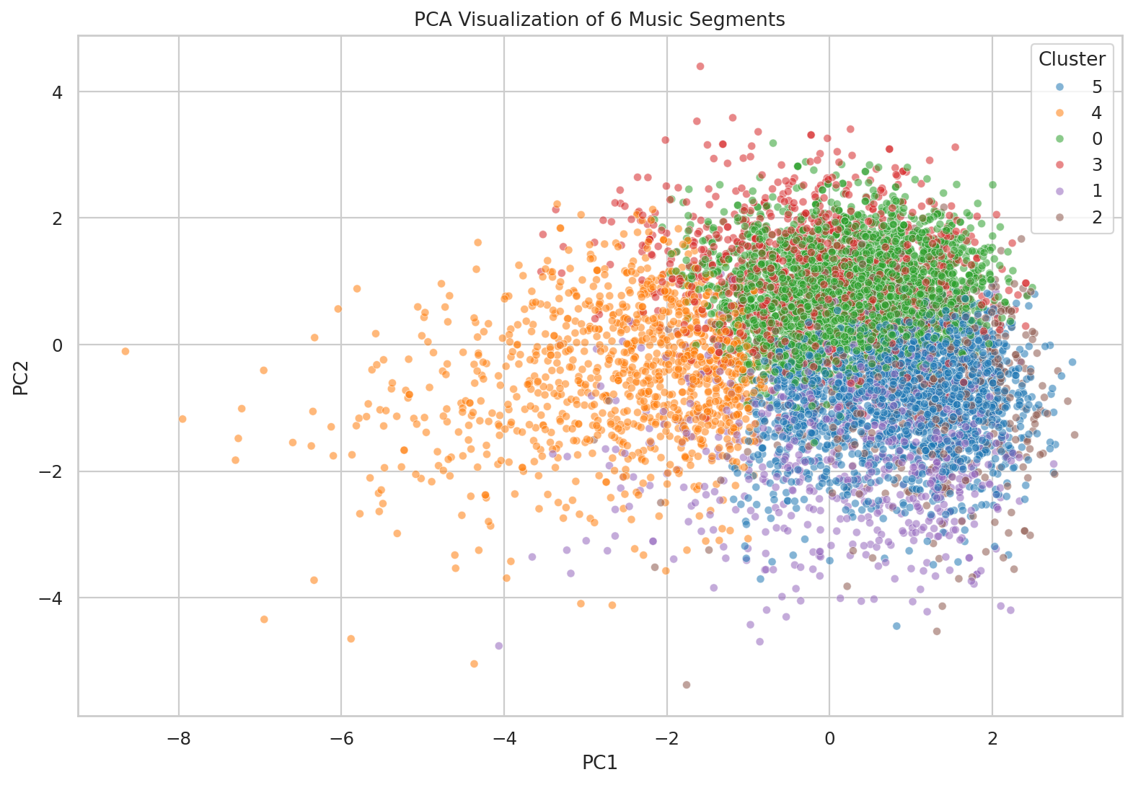
Figure 13: 13 Cluster Sizes
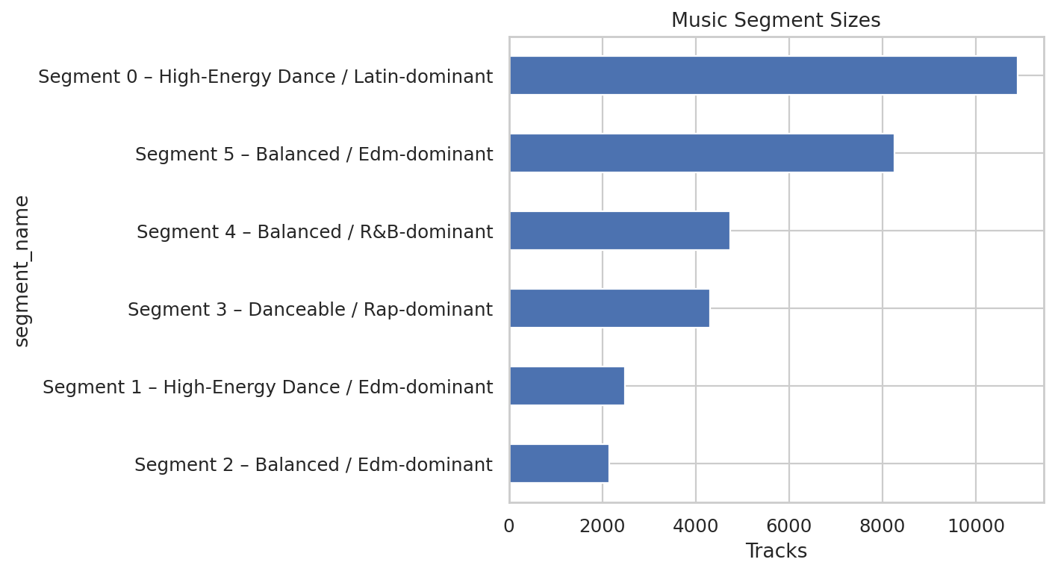
Figure 14: 14 Genre Classification Confusion Matrix
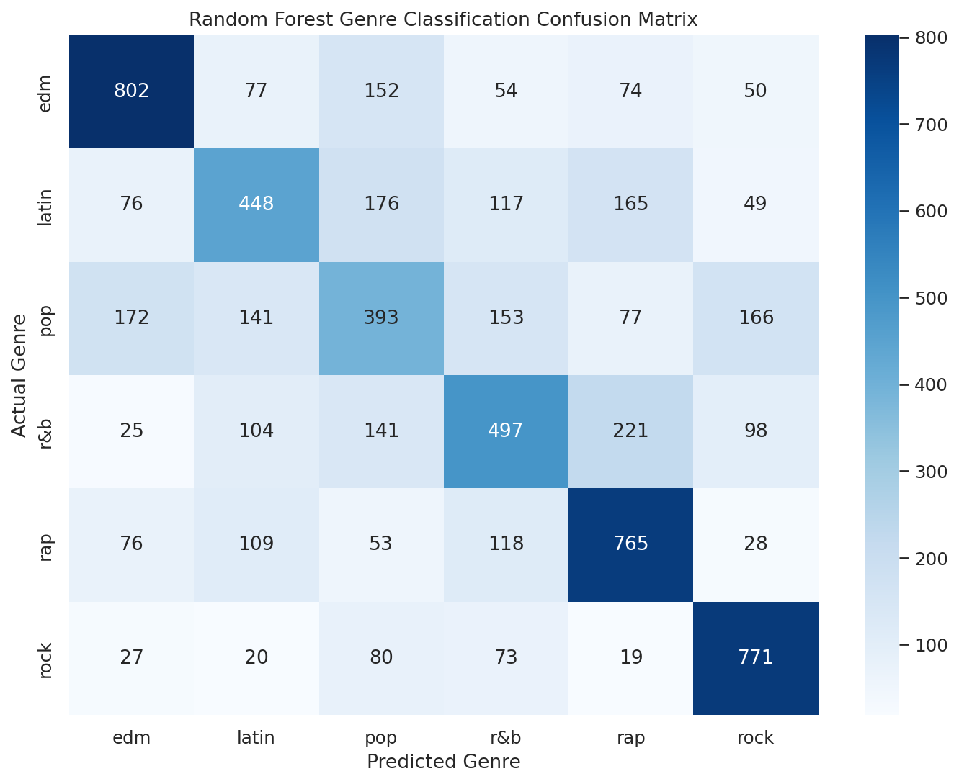
Figure 15: 15 Feature Importance
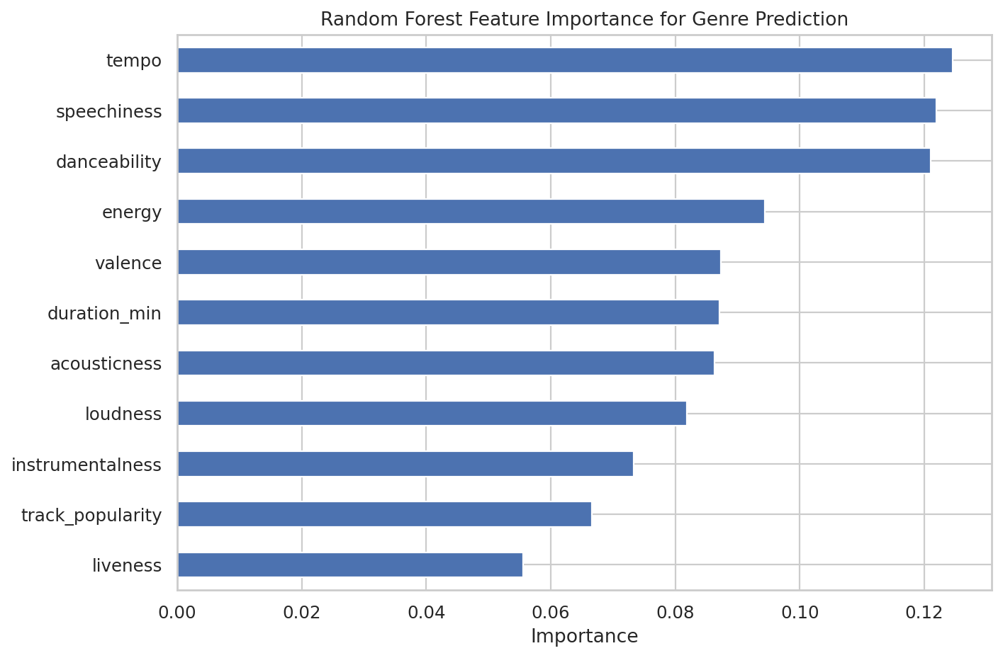

17. Final Cluster Profiles
Cluster | Tracks | Dominant Genre | Energy | Danceability | Popularity
0 | 10899 | latin | 0.725 | 0.739 | 48.7
1 | 2488 | edm | 0.784 | 0.665 | 28.8
2 | 2153 | edm | 0.780 | 0.611 | 37.5
3 | 4309 | rap | 0.661 | 0.727 | 43.4
4 | 4732 | r&b | 0.426 | 0.606 | 44.1
5 | 8252 | edm | 0.793 | 0.543 | 38.2

18. Sample Recommendations
Track | Artist | Genre | Subgenre | Segment
I Don't Care (with Justin Bieber) - Loud Luxury Remix | Ed Sheeran | pop | dance pop | Segment 0 – High-Energy Dance / Latin-dominant
Todavia | La Factoria | latin | reggaeton | Segment 0 – High-Energy Dance / Latin-dominant
TTM (feat. Wiz Khalifa & NGHTMRE) | PnB Rock | r&b | urban contemporary | Segment 0 – High-Energy Dance / Latin-dominant
Glad You Came | The Wanted | pop | post-teen pop | Segment 0 – High-Energy Dance / Latin-dominant
Not Ok - Frank Walker Remix | Kygo | edm | electro house | Segment 0 – High-Energy Dance / Latin-dominant
Not Ok - Frank Walker Remix | Kygo | pop | dance pop | Segment 0 – High-Energy Dance / Latin-dominant
Not Ok - Frank Walker Remix | Kygo | edm | big room | Segment 0 – High-Energy Dance / Latin-dominant
Love Me | Felix Cartal | pop | indie poptimism | Segment 0 – High-Energy Dance / Latin-dominant

