
RECORD OF EXPERIMENTS
Register Number: 231801093
Academic Year 2025 – 2026
List of Experiments
- Private Cloud using OpenStack
- PaaS in Public Cloud Using Render
- Setting Up Hybrid Cloud Connectivity Using Cisco Packet Tracer
- Virtual Private Server (VPS) Provisioning and Configuration
- Cloud Backup and Migration using Google Drive
- CDN Service Selection and Configuration

Ex: 1 | Private Cloud using OpenStack
Date:24/06/2026

Aim
To create a private cloud environment by installing and configuring OpenStack (MicroStack) on a single Ubuntu system, and to learn how core cloud resources such as virtual machines, networking, and storage are managed within a private cloud.

What is OpenStack?
OpenStack is an open-source cloud platform used to build and manage cloud infrastructure. It is mainly used to provide Infrastructure-as-a-Service (IaaS), allowing users to create and control virtual machines on demand, along with compute, networking, and storage services.

What is MicroStack?
MicroStack is a lightweight, single-node distribution of OpenStack. It requires minimal configuration and is well suited for learning, testing, and small-scale development, making it an ideal choice for understanding how OpenStack works.

Procedure
- Create a new Ubuntu virtual machine in Oracle VirtualBox with the following configuration: 8 GB RAM, 4 CPU cores, and 20 GB of virtual disk storage.
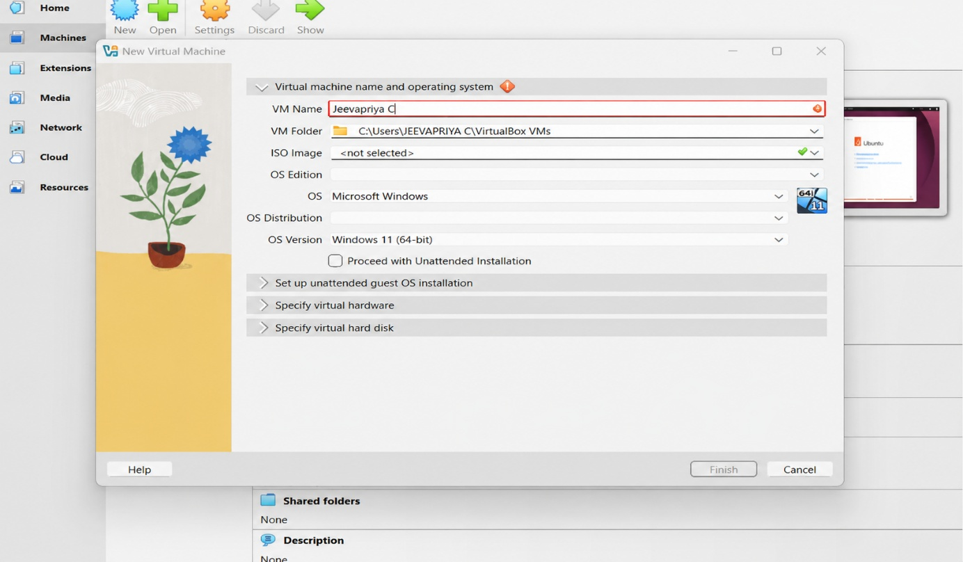
Figure 1.1: Configuring the new Ubuntu virtual machine in VirtualBox.
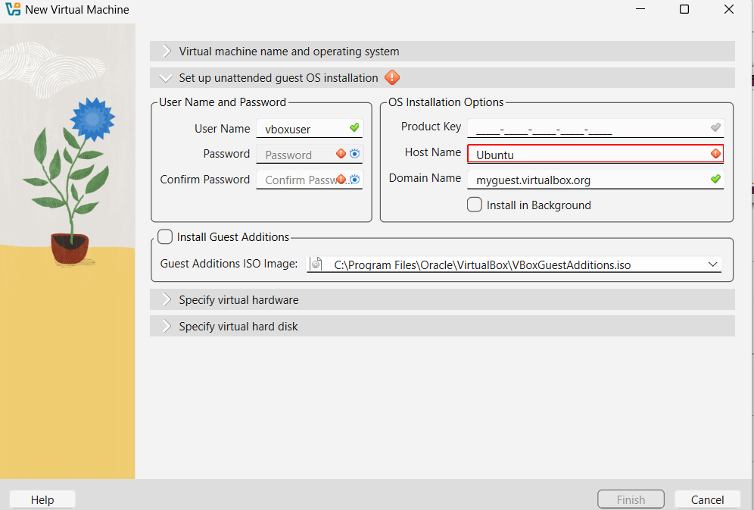
Figure 1.2: Reviewing the virtual machine settings before creation.
- Install the Ubuntu operating system and log in using the username and password created during installation.
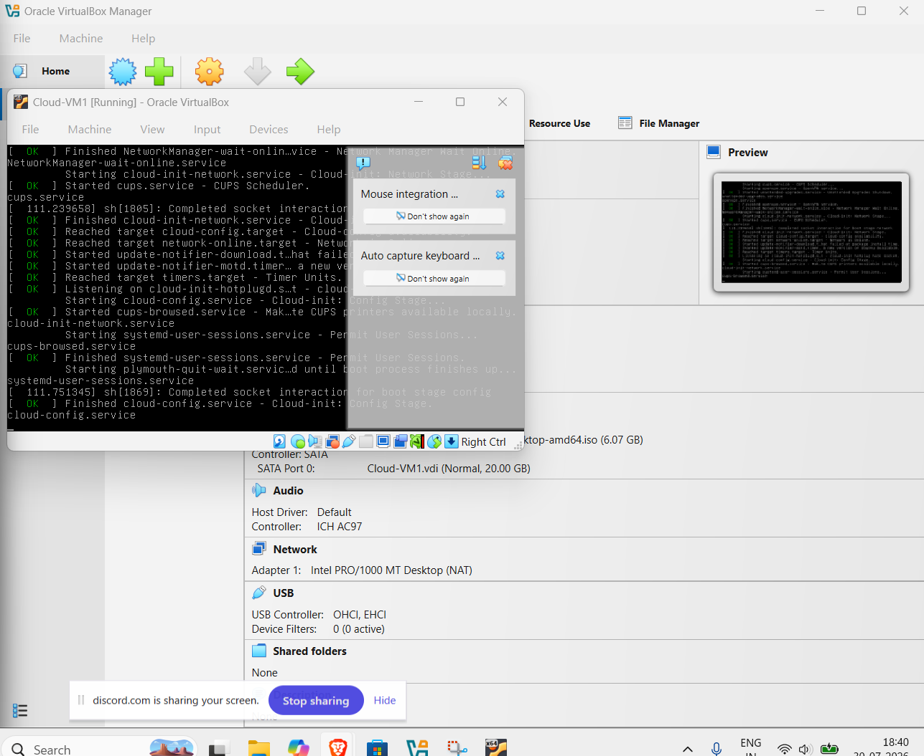
Figure 1.3: Ubuntu installation completed and first login.
- Update the Ubuntu package repository: sudo apt update, followed by sudo apt upgrade.

- Install MicroStack from the beta channel: sudo snap install microstack --beta.

- Verify that MicroStack was installed successfully: snap list microstack.

- Initialise the OpenStack services automatically: sudo microstack init --auto --control.
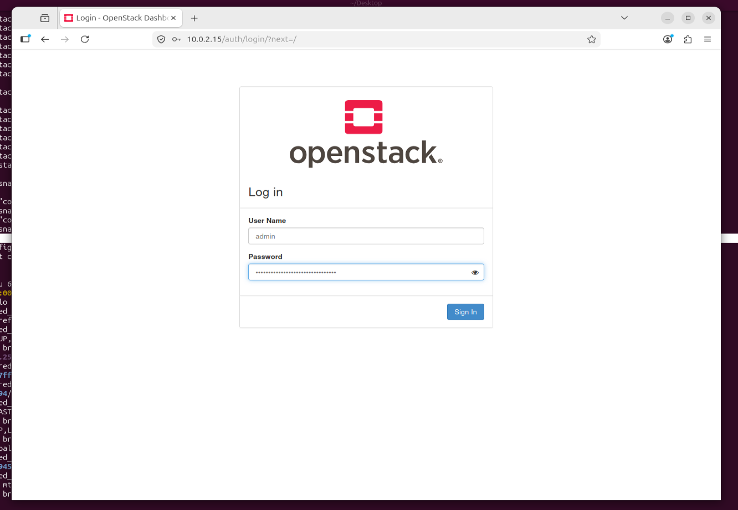
Figure 1.4: MicroStack initialisation completing successfully.
- Verify the installed OpenStack version: microstack.openstack --version.

- Retrieve the Keystone administrator password: sudo snap get microstack config.credentials.keystone-password.

- Open the OpenStack Horizon Dashboard in a web browser using the IP address shown after initialisation, and log in with username admin and the retrieved password.
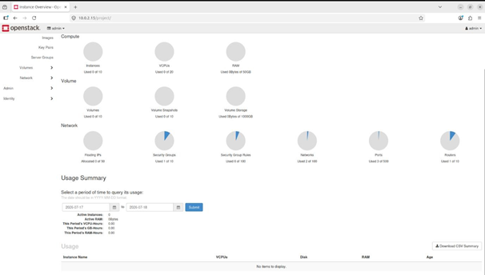
Figure 1.5: OpenStack Horizon Dashboard accessed successfully.

Conclusion
OpenStack (MicroStack) was successfully installed and configured on Ubuntu, and the Horizon Dashboard was accessed, confirming a functional single-node private cloud environment.

