
RECORD OF EXPERIMENTS
Register Number: 231801093
Academic Year 2025 – 2026
List of Experiments
- Private Cloud using OpenStack
- PaaS in Public Cloud Using Render
- Setting Up Hybrid Cloud Connectivity Using Cisco Packet Tracer
- Virtual Private Server (VPS) Provisioning and Configuration
- Cloud Backup and Migration using Google Drive
- CDN Service Selection and Configuration

Ex: 5 | Cloud Backup and Migration using Google Drive
Date:14/08/2026

Aim
To create a cloud backup and migration system by storing important files in Google Drive, enabling automatic synchronisation for a local folder, and verifying that changes made locally are correctly reflected in the cloud copy.

Cloud Backup and Cloud Migration
Cloud backup means storing a copy of important files on cloud servers instead of keeping them only on a local computer, so the data survives even if the local device fails. Cloud migration means moving files, applications, or data from a local computer to a cloud service.

Procedure

Part A – Preparing Local Data
- Create a folder named OfficeData on the desktop and add three sample files inside it: Student.txt, Attendance.txt, and Marks.txt, each populated with example data.
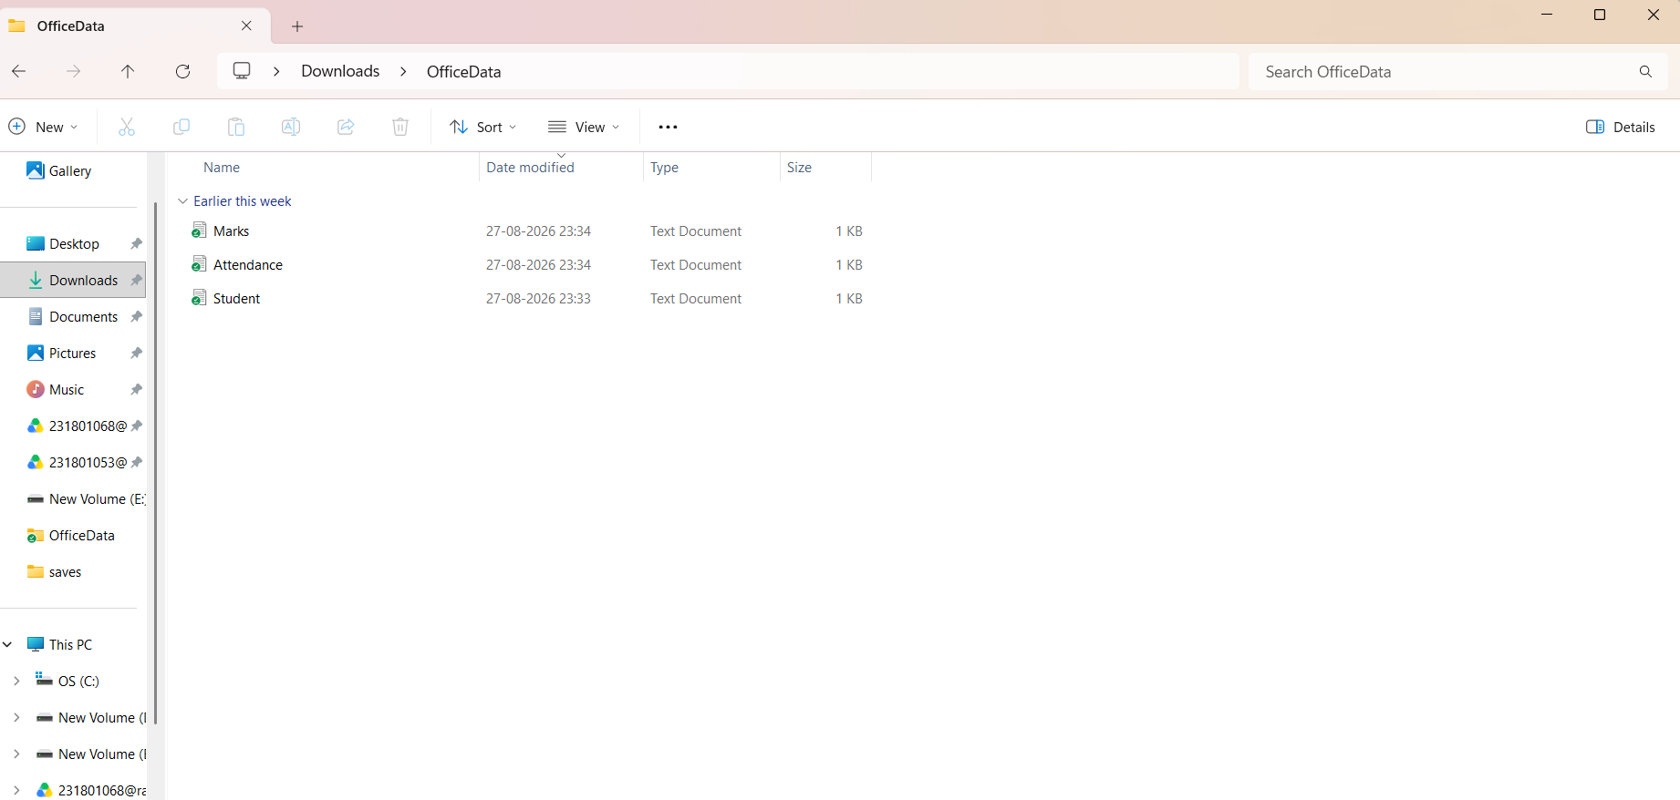

Part B – Uploading to Google Drive
- Sign in to Google Drive and create a new folder named CloudBackup.

- Upload the three sample files into the CloudBackup folder, completing an initial cloud migration.

Part C – Enabling Automatic Synchronisation
- Download and install Google Drive for Desktop, then sign in using the same Google account.

- In the Drive for Desktop settings, add the local OfficeData folder and enable synchronisation with Google Drive.
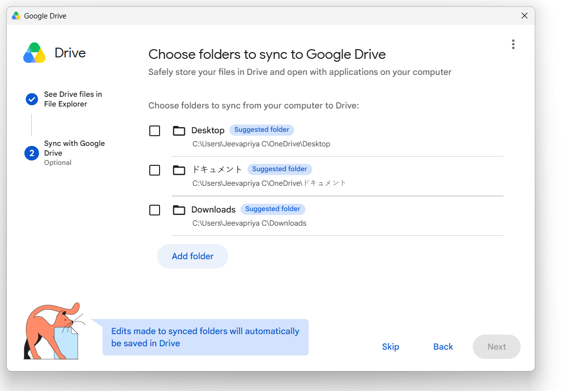
Figure 5.1: Selecting the OfficeData folder for synchronisation.
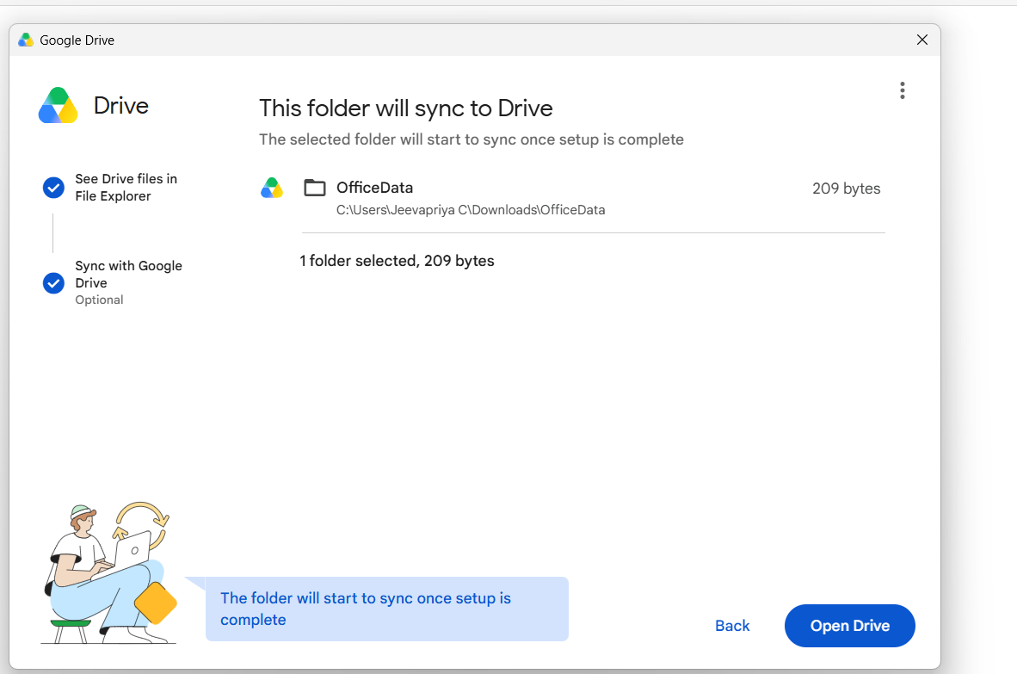
Figure 5.2: Confirming the folder for sync.

- Verify that the local OfficeData folder now appears fully synced within the Drive for Desktop application.

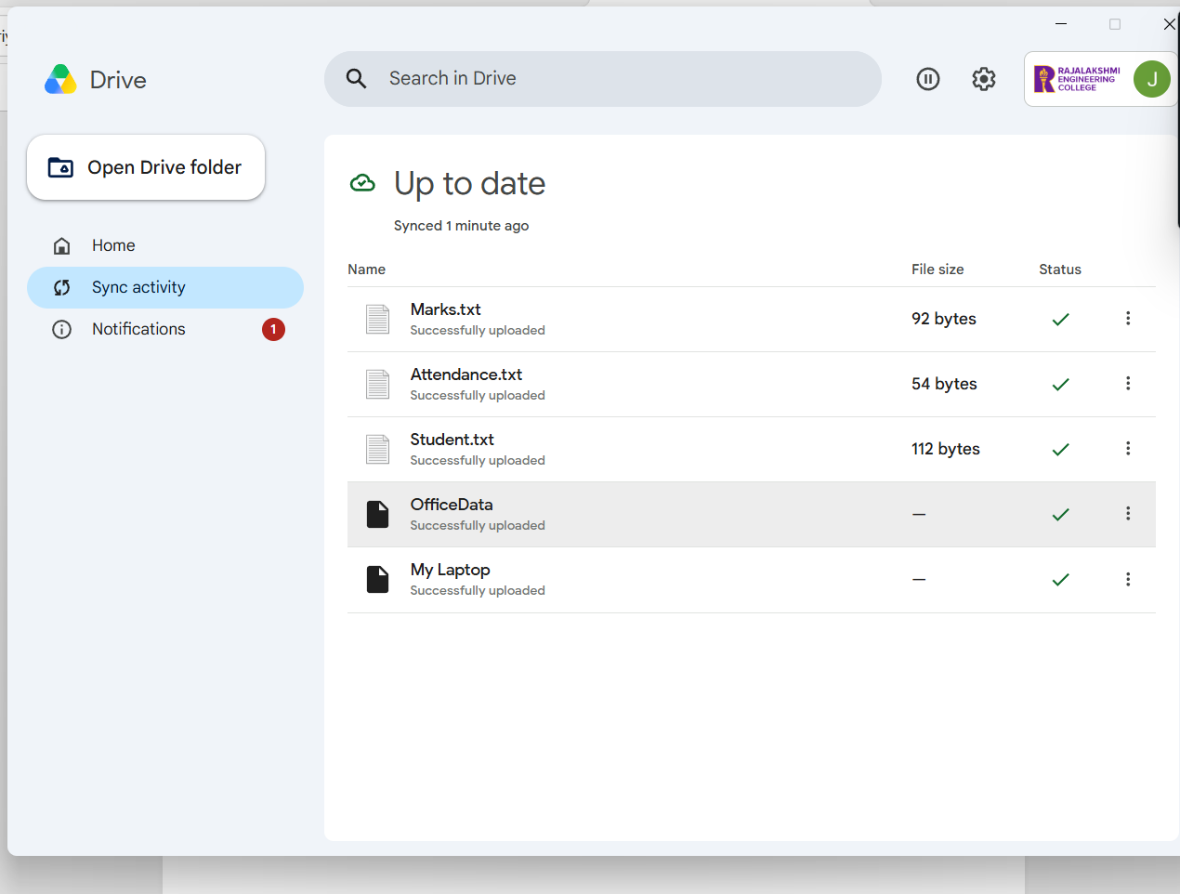
Figure 5.3: Google Drive Desktop showing all files successfully uploaded.

Part D – Testing Automatic Backup
- Confirm the synchronised files are visible in Google Drive on the web.
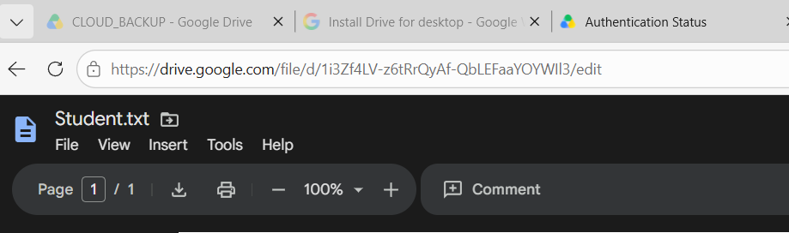
Figure 5.4: Synchronised OfficeData files visible in Google Drive on the web.
- Open Student.txt locally and append the line "Cloud Backup Test - Successfully Synchronized", then save the file.
- Wait briefly and check that Google Drive Desktop shows the file status as "Up to date".
- Refresh Google Drive on the web and reopen Student.txt to confirm the new line appears in the cloud copy.
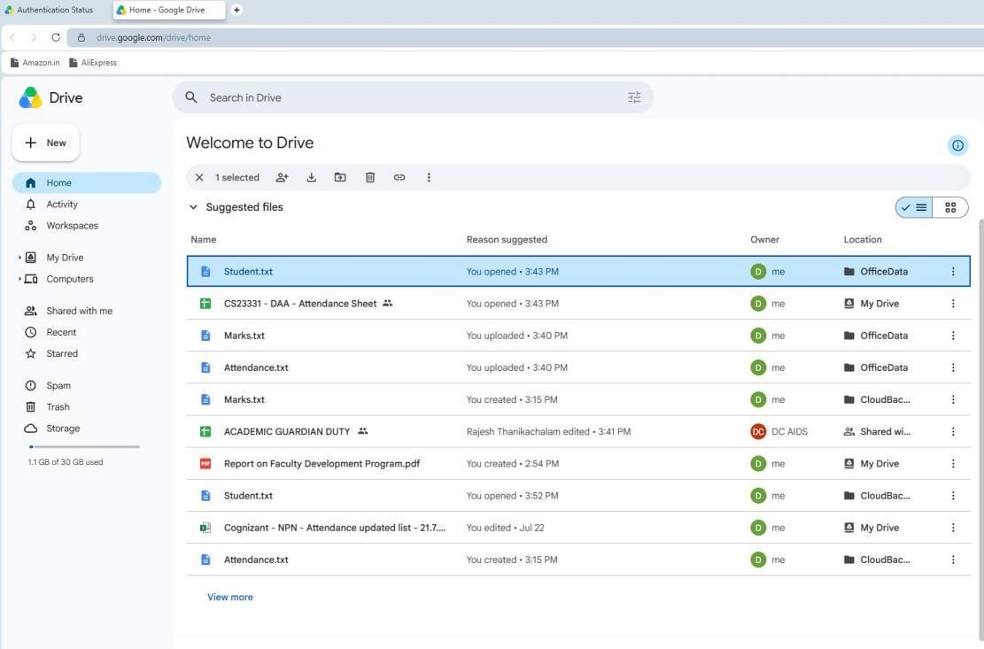
Figure 5.5: Student.txt shown with a recent update on Google Drive web.
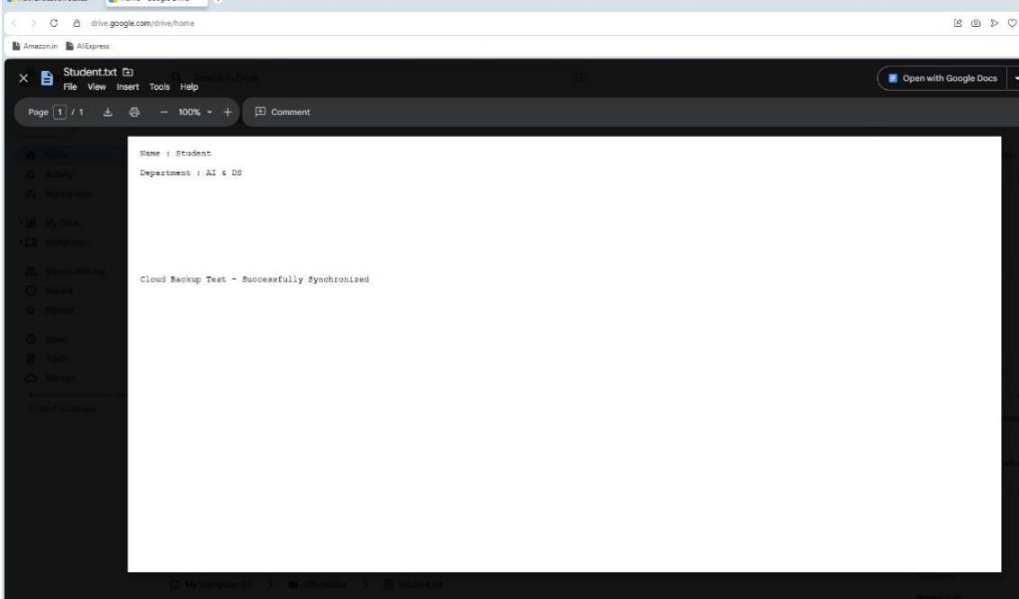
Figure 5.6: Contents of Student.txt confirming the synchronised test line.

Conclusion
A cloud backup and migration workflow was successfully implemented using Google Drive. Local files were migrated to cloud storage, automatic synchronisation was enabled, and an update made to a local file was verified to be reflected in the cloud copy, demonstrating a reliable cloud-based backup mechanism.

