1.HashToTree:
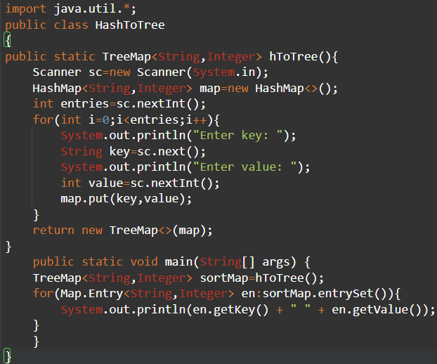
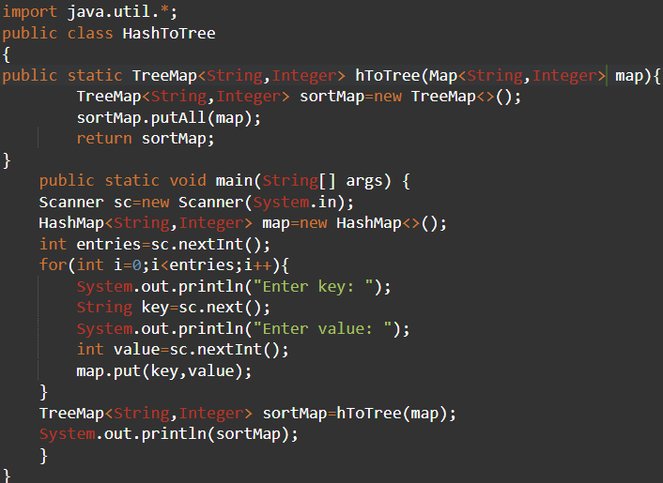
2.HashSet-LinkedHashSet-TreeSet
3.Distributing items when a person cannot take more than 2 times of same type.
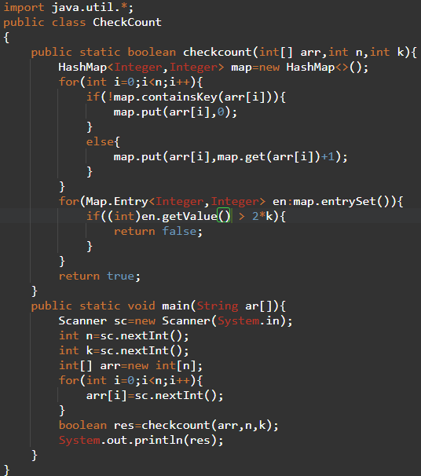

4.Fibonacci:
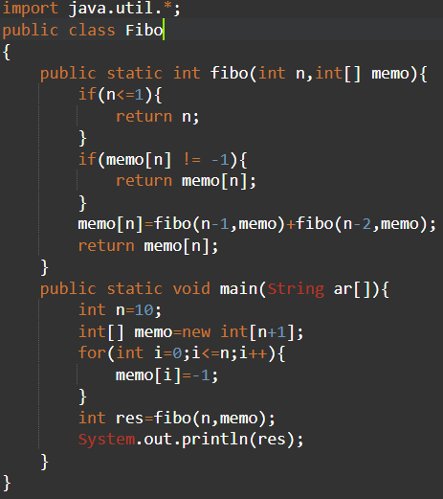
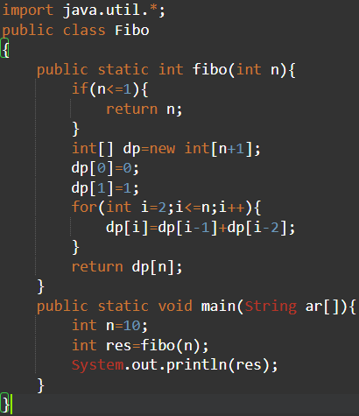
5.Longest Common Subsequence:(DP)
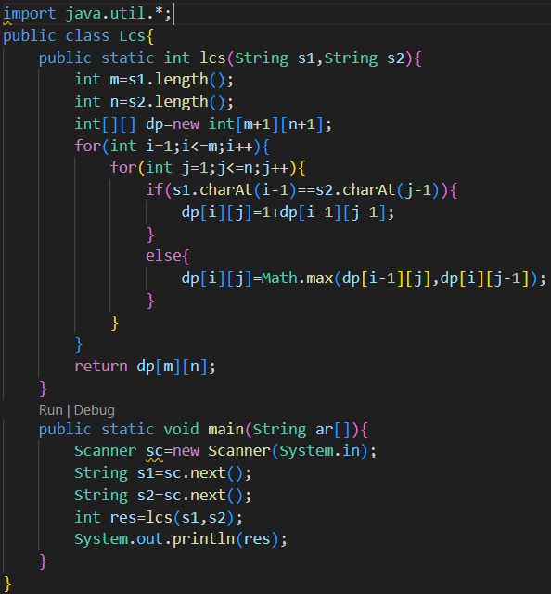
6.Longest Increasing Subsequence:(Recursion)
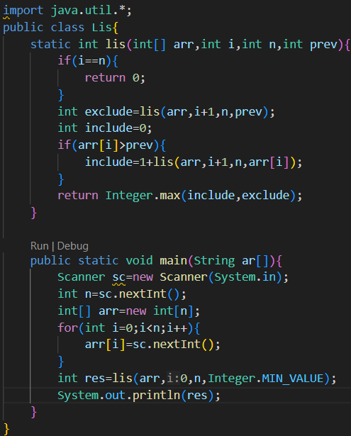

7.Longest Palindromic subsequence:(Recursion)

