Que 1 Which command is used to count words and line in a text file attach a screenshot which displaying the word and line count.

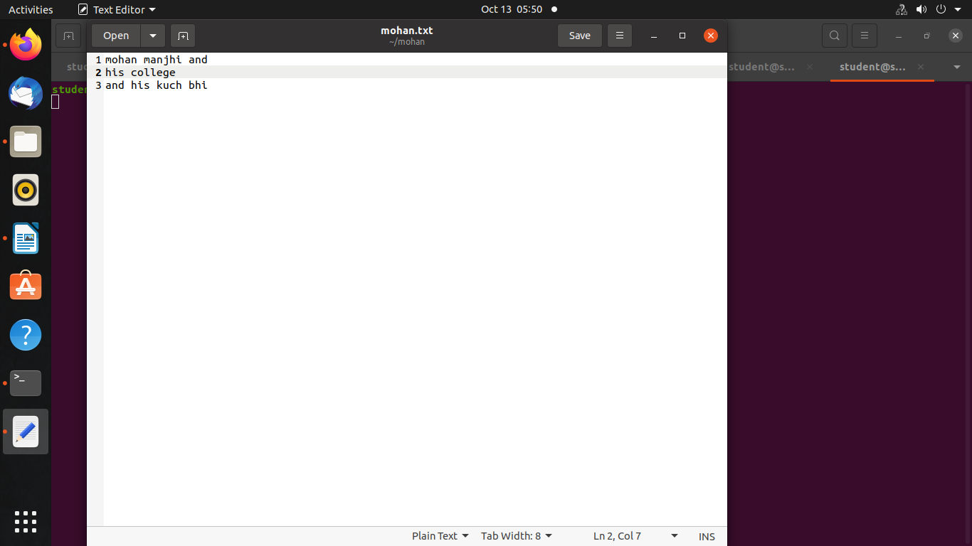

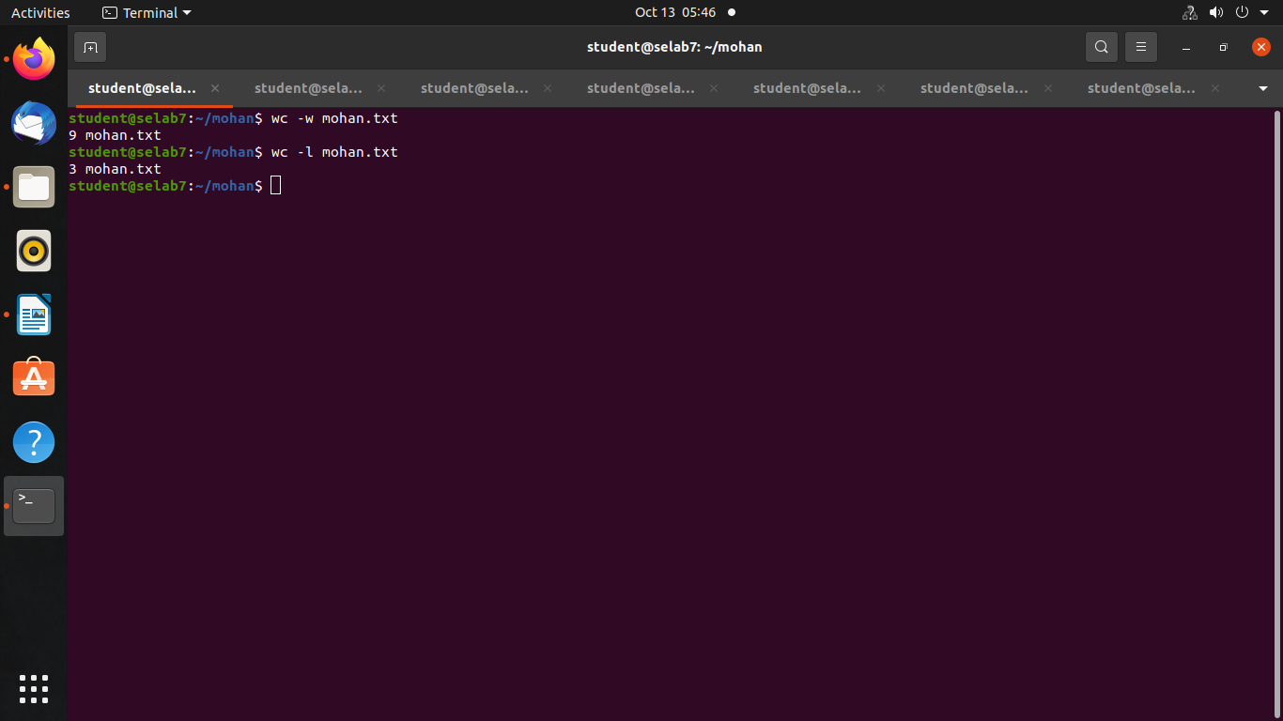

Que 2 Which command is used to search for specific text within a file includes a screenshot showing the result of the search.

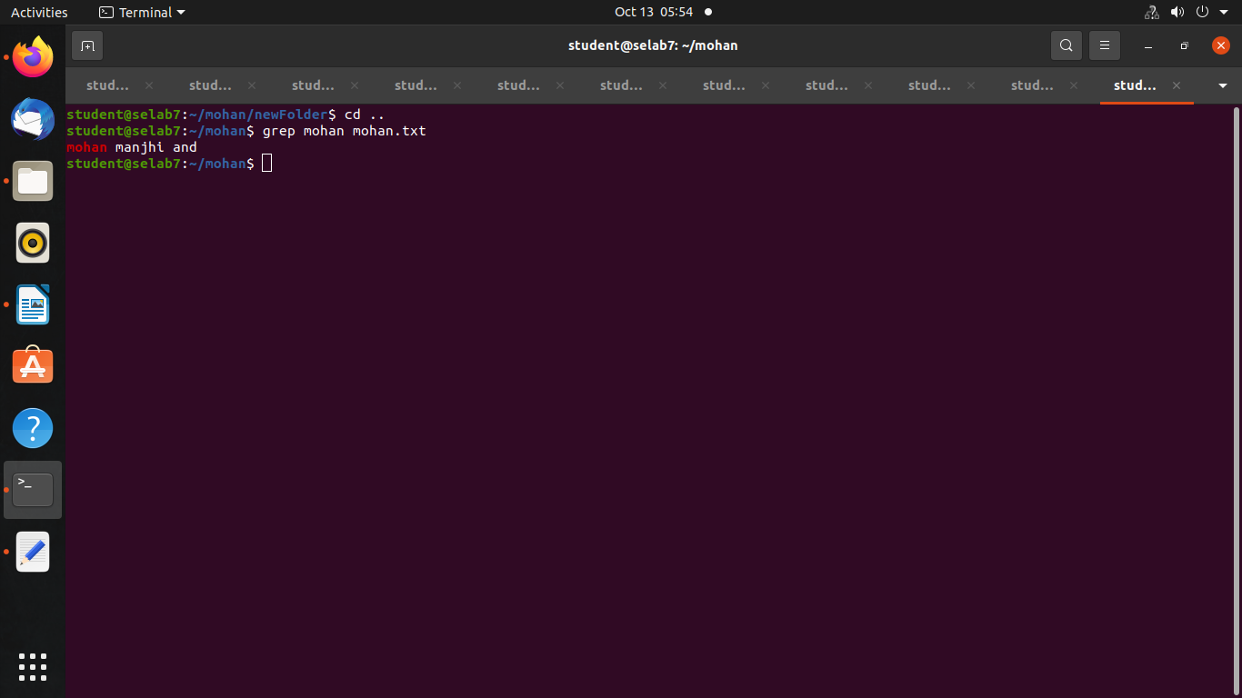

Que 3 Create a new empty file using command and capture a screenshot showing the successful creation of a file.

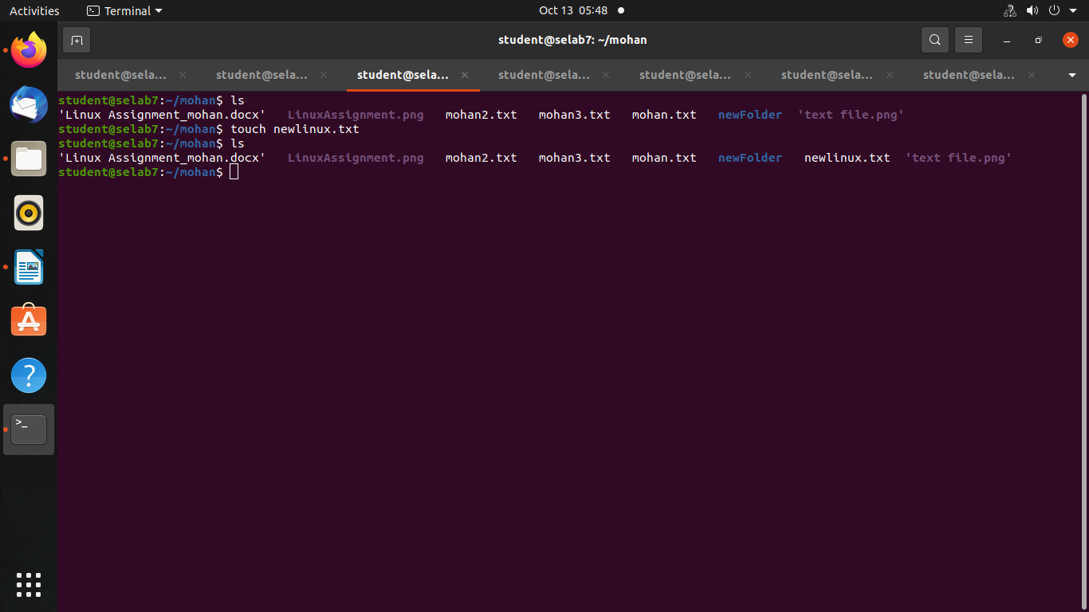

Que 4 Delete a file and remove a directory include screenshots for both actions.

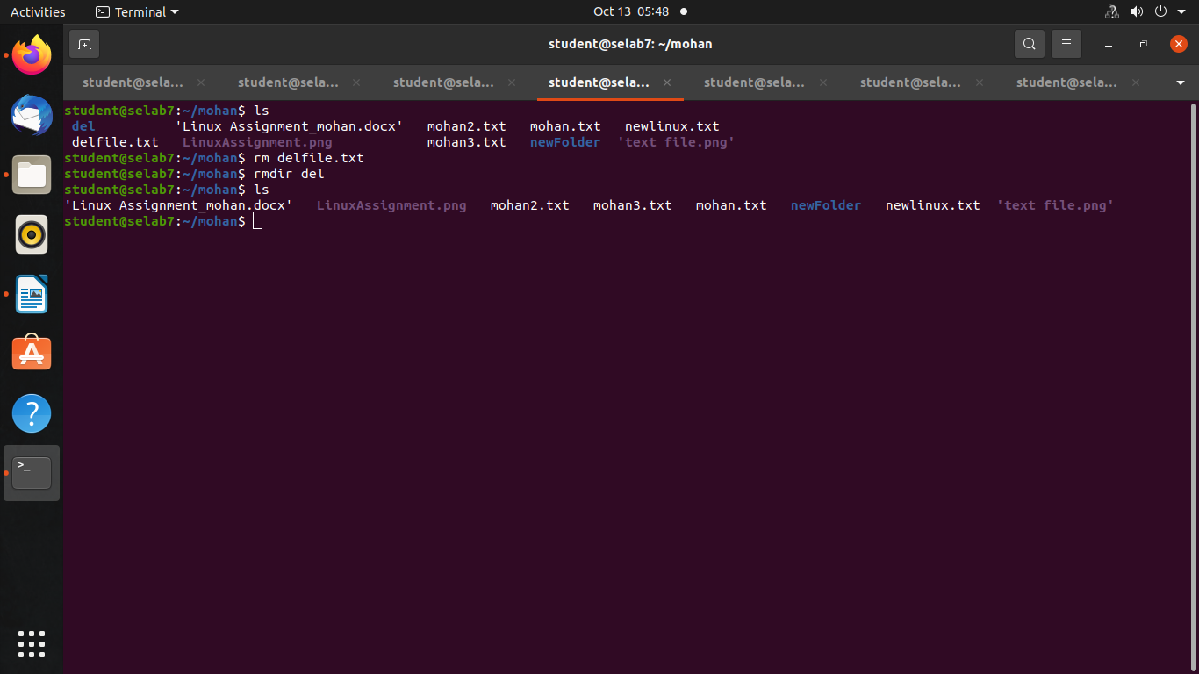

Que 5 Execute the command which display the contents of a file captures a screenshot showing the text.

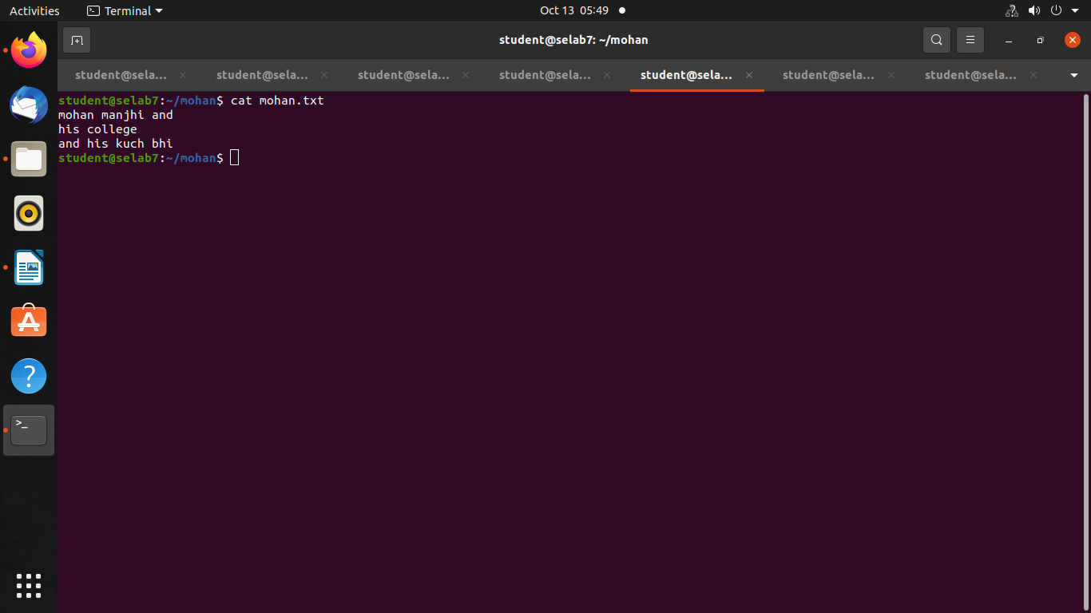

Que 6 Execute the command to navigate to a directory of your choice and take a screenshot of the terminal.

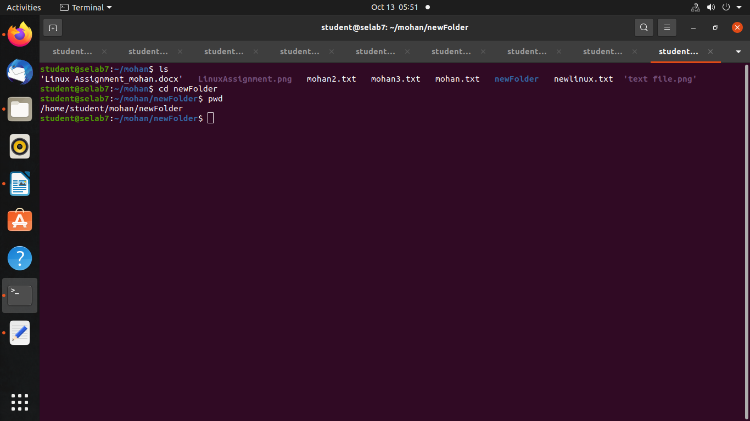

Que 7 Execute the command in your terminal displaying the list of files and d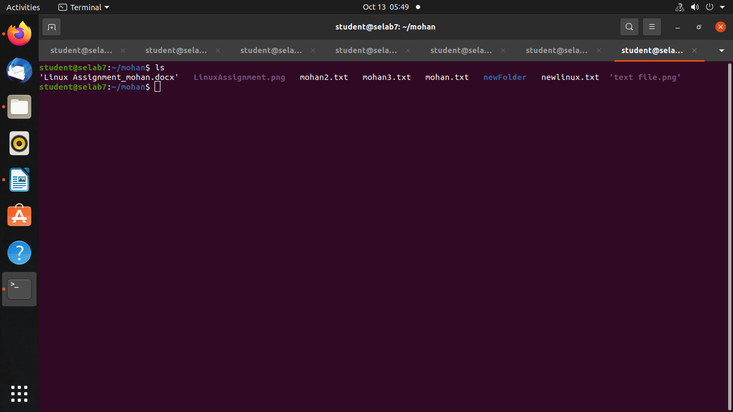irectories in your current location.