TCP Provenance Flow Guide
How signed evidence moves from user activity to verified decisions
Purpose. This guide explains the Tiered Compute Platform provenance workflow from the first recorded query through signing, chained verification, Detector decisions, dashboard review, and integrity-failure handling. It is written for readers who need both the security meaning and enough implementation detail to trace the code path.
Main conclusion. Provenance does not decide whether behavior is suspicious. Detector makes that decision. Provenance proves that the decision used signed, unchanged evidence from the expected components. A normal pass, a behavioral alert, and an integrity failure are three different outcomes.
Outcome | Meaning | Stored result
Behavioral pass | The verified queries are sufficiently consistent with the available research baseline. | Signed Detector no_warning receipt
Behavioral alert | The verified queries diverge from every available comparison baseline. | Signed UserWarning row and Detector receipt
Integrity failure | Evidence is unsigned, changed, missing, incorrectly signed, revoked, or incorrectly linked. | HTTP 409 and integrity_failure audit event

What provenance guarantees
- Attribution. A receipt identifies the configured component key that signed it.
- Integrity. Changes to signed inputs, outputs, receipt contents, parent references, current rows, or saved Clusterer artifacts can be detected.
- Traceability. A downstream receipt records the exact parent receipts on which its result depends.

What provenance does not guarantee
- Truth. A valid signature does not prove that ORCID, a user claim, or an analytical conclusion is factually correct.
- Completeness. The SQLite database does not prevent an administrator from deleting receipts or rolling the entire database back.
- Component isolation. The current monolithic backend can access all four private keys; separate identities provide attribution, not process-level isolation.

Components and their evidence responsibilities
Four producers sign evidence, while the verifier, trust registry, dashboard, and audit log control how that evidence is accepted and used.
Component | Inputs | Outputs
Logger | Successful chat result; user ID; query text; tool calls; response summary; dataset access | Signed query_history and data_access_log snapshots
Profiler | User ORCID ID; public ORCID works response; cached profile | Signed publication snapshots and a versioned signed profile
Detector | Up to 100 verified queries; declared interest; optional verified profile; thresholds | Signed insufficient_queries, no_warning, or UserWarning result
Clusterer | All verified query rows; observed user metadata; analysis settings | Signed run result and optional hashes for CSV and JSON artifacts
Trust registry | Component name and key ID | Trusted public key, component binding, and active, retired, or revoked status
Receipt database | Signed receipt envelopes and indexed subject metadata | Historical evidence graph stored in provenance_receipts
Verifier | Receipt ID or live row; registry; saved artifacts when applicable | Verified envelope/result or IntegrityError
Dashboard | Restricted user request; warning or Clusterer run | Verified display and review action, unsigned read-only warning, or blocked use
Audit log | IntegrityError reason, subject, and request path | Persistent integrity_failure audit event

Overall architecture
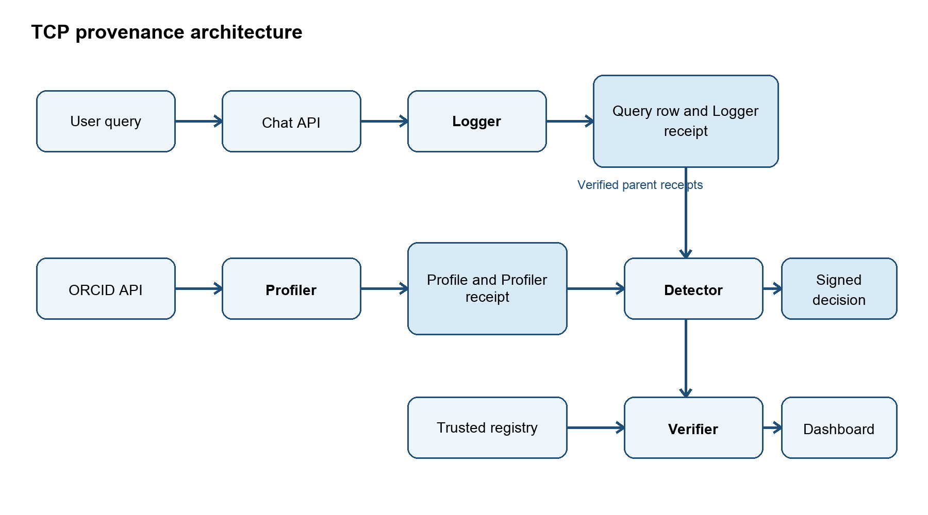
Figure 1 Overall provenance architecture

How a receipt is constructed
The protocol creates deterministic bytes before hashing or signing. Dates are normalized to UTC microsecond timestamps, enum values become strings, dictionary keys are sorted, unnecessary JSON whitespace is removed, Unicode remains unescaped, and non-finite numbers are rejected. This canonical UTF-8 representation ensures that the same supported value produces the same bytes.
1. Snapshot the material. For a database-backed output, the signer captures the row after it has an ID. Warning review fields status, reviewed_by, and reviewed_at are excluded because they are mutable workflow metadata.
2. Hash inputs and output. SHA-256 is calculated independently over canonical inputs and canonical output.
3. Record processing context. The receipt stores the operation, protocol version, thresholds, limits, source classification, and other selected parameters.
4. Reference parents. Each parent entry contains a receipt ID and the SHA-256 hash of the complete parent envelope, including its signature.
5. Sign the payload. The component signs canonical payload bytes using its configured Ed25519 private key.
6. Verify before persistence. The new envelope is immediately checked against the trusted registry so key or registry misconfiguration fails before the transaction commits.

Simplified Detector receipt
{
"payload": {
"schema": "tcp-receipt-v1",
"receipt_id": "6bd6...",
"component": "detector",
"key_id": "detector-2026",
"subject_type": "user_warnings",
"subject_id": "42",
"inputs": {
"user_id": 7,
"interest_score": 0.00,
"publication_score": 0.00,
"profile_evidence_status": "available"
},
"input_hash": "sha256...",
"output": {"id": 42, "severity": "high", "detail": "..."},
"output_hash": "sha256...",
"parents": [{"receipt_id": "logger...", "receipt_hash": "sha256..."}],
"processing": {"operation": "research_divergence", "version": 1}
},
"signature": "base64 Ed25519 signature..."
}
Field | Purpose
schema | Protocol interpretation rules.
receipt_id | Unique receipt identifier used by parent references and APIs.
component and key_id | Claimed producer and trusted public key used for verification.
subject_type and subject_id | Database row or analysis run represented by the receipt.
inputs and input_hash | Observed inputs and their canonical SHA-256 digest.
output and output_hash | Signed result snapshot and its canonical SHA-256 digest.
parents | Receipt IDs and complete-envelope hashes for dependencies.
processing | Operation version, thresholds, limits, source metadata, and parameters.
signature | Base64 Ed25519 signature over the canonical payload.

End to end flow
The following sequence begins only after the chat request succeeds. If the model request fails, the query is not recorded as signed analytical evidence.
1. User submits a query. The authenticated user sends a message through the chat API.
2. Chat completes successfully. The backend receives the assistant response, tool calls, and token usage.
3. Logger records evidence. The query row is flushed to obtain an ID, snapshotted, signed, and stored with its receipt in the same transaction.
4. Profiler builds research context. When triggered by a restricted user, Profiler fetches public ORCID works, signs parsed publications, builds a topic summary, and signs the profile with publication receipts as parents.
5. Detector verifies before analysis. It checks each Logger query and any Profiler profile it uses. With fewer than five queries, it signs insufficient_queries and stops.
6. Detector records the decision. It signs no_warning when a comparison passes or creates and signs a UserWarning when every available comparison indicates divergence.
7. Dashboard verifies before use. It checks the Detector receipt, every historical parent, and the current warning snapshot before allowing display or review.

Example subject
Property | Example value
User | Alice, user ID 7
Declared interest | Immunology and vaccine development
Observed ORCID topics | Immunology, vaccines, antibodies, viral infection
Minimum verified queries | 5
Interest threshold | 0.15
Publication threshold | 0.15 when verified publication topics are available

Decision flow
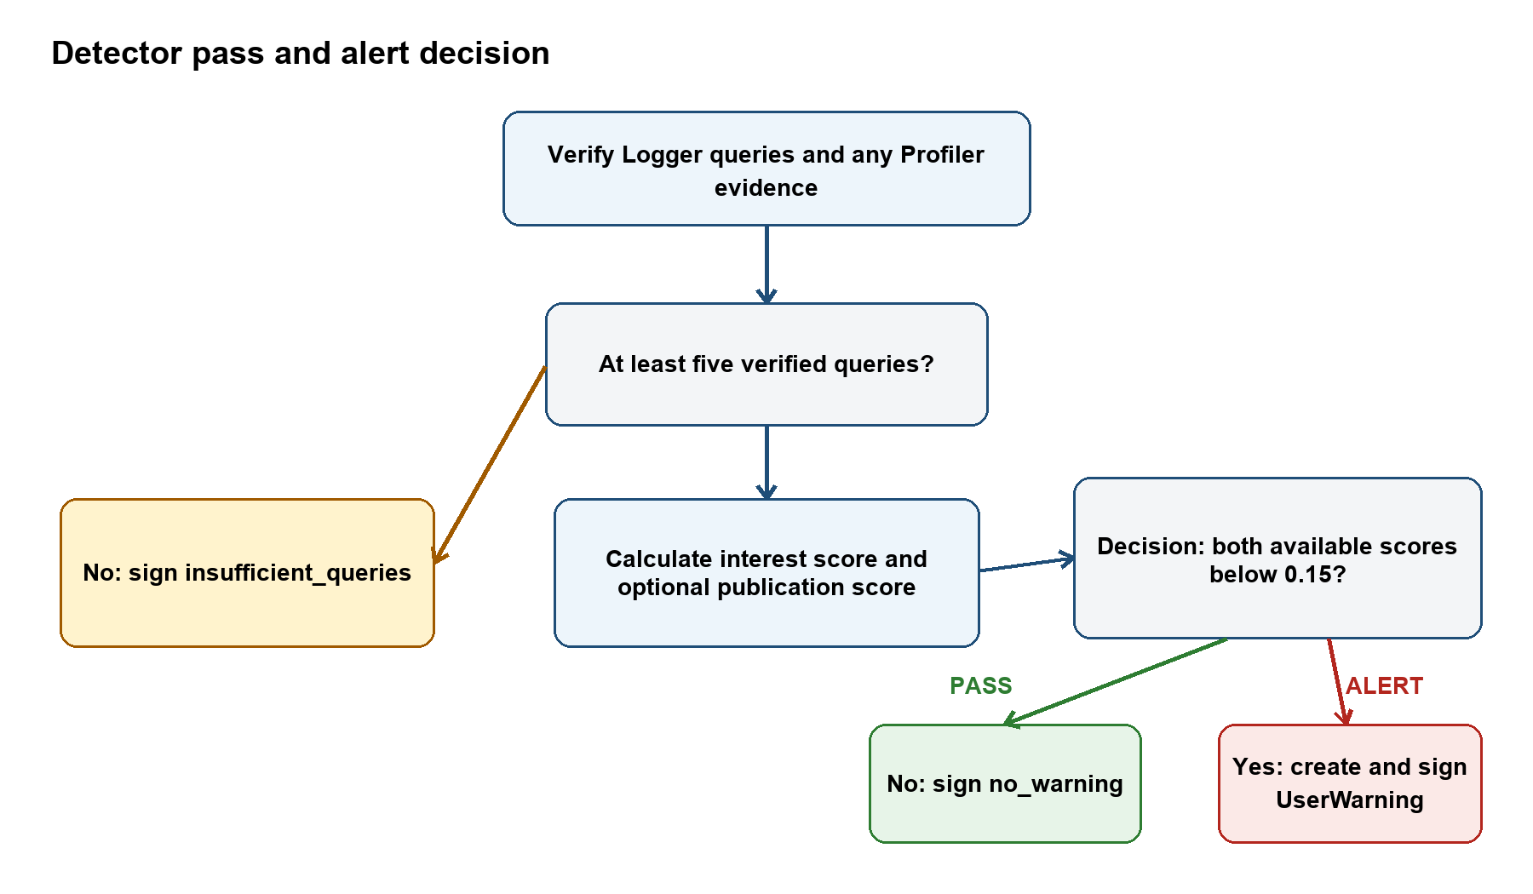
Figure 2 Detector pass and alert decision flow

Pass case matching research activity
Alice asks five questions that align with both her declared interest and the verified ORCID-derived topic summary.
- How do mRNA vaccines generate immunity?
- Explain antibody neutralization.
- What are vaccine adjuvants?
- How do viral vector vaccines work?
- Explain the adaptive immune response.

What Detector verifies
- Logger evidence. Every query has a valid Logger receipt, expected signer, intact parent chain, and live row matching the signed snapshot.
- Profiler evidence. The current profile has a valid Profiler receipt and its ORCID ID matches Alice’s current user record.
- Evidence provenance. The signed Detector inputs record query source kinds and whether profile evidence is available, unavailable, or contains no public works.

Example scores and result
Measure | Value | Interpretation
Interest score | 0.67 | Above 0.15
Publication score | 0.80 | Above 0.15
Decision | no_warning | At least one available comparison passes
Result. Detector persists a signed detector_scan receipt whose output is {"outcome": "no_warning"}. The receipt references all verified query receipts and the verified profile receipt. No UserWarning row is created.

Why signing a pass matters
A system that signs only alerts cannot later demonstrate that a user was evaluated and passed. TCP therefore signs the no-warning decision, the scores and evidence status it observed, the thresholds it applied, and the exact parent receipts it relied on.
Pass evidence chain
Logger query receipts 101-105
+
Profiler profile receipt and publication parents
-> Detector detector_scan receipt
-> output: no_warning

Interest only variation
If Alice has no fetched profile or the fetched profile has no public works, Detector does not invent a publication baseline. It records profile_evidence_status as not_fetched or no_public_works, sets publication_score to null, and uses the verified queries and declared interest alone. The resulting decision remains signed.

Alert case divergent research activity
Now assume Alice’s five most recent signed queries concern astronomy and aerospace topics rather than immunology.
- How do satellite navigation systems work?
- Explain galaxy formation.
- How are rocket engines designed?
- What is dark matter?
- Explain orbital mechanics.

Example scores and severity
Measure | Value | Interpretation
Interest score | 0.00 | Below 0.15
Publication score | 0.00 | Below 0.15
Average used for severity | 0.00 | Below 0.05, therefore high severity
Decision | UserWarning | Every available comparison indicates divergence

Warning output
Detector creates a UserWarning containing the warning type, severity, pending status, creation time, scores, evidence-source metadata, up to five divergent queries, query count, and recommended action. It then signs the warning snapshot with a Detector receipt.
{
"warning_type": "research_divergence",
"severity": "high",
"status": "pending",
"detail": {
"interest_score": 0.0,
"publication_score": 0.0,
"flagged_queries": ["satellite navigation...", "galaxy formation..."],
"recommended_action": "Review user activity and consider restricting access"
}
}

Evidence chain and review
1. Detector receipt. References the five Logger receipts and the Profiler profile receipt used during the scan.
2. Dashboard check. Calls live-record verification before presenting the warning for review.
3. Reviewer action. Marks the warning reviewed or dismissed only after verification succeeds.
4. Mutable workflow metadata. Changing status, reviewed_by, or reviewed_at does not invalidate the original finding because those fields are deliberately excluded from the signed snapshot.

Integrity failure case modified evidence
A behavioral alert is a Detector conclusion. An integrity alert is different: it means the application cannot trust the evidence enough to continue. Consider a direct database edit intended to make a suspicious query look harmless.
Version | Query text
Signed Logger snapshot | How do satellite navigation systems work?
Modified live row | How do vaccine delivery systems work?

Verification sequence
1. Load the warning receipt. Resolve its key ID in the trusted registry and verify the Detector signature.
2. Walk every parent. Load each Logger and Profiler receipt, verify its signature and hashes, and compare its complete envelope hash with the child’s parent reference.
3. Compare live material. Recalculate the canonical hash of the current query row and compare it with the signed output hash.
4. Reject the mismatch. The changed query produces live_record_mismatch. Detector, Clusterer, or the dashboard must not use that evidence.
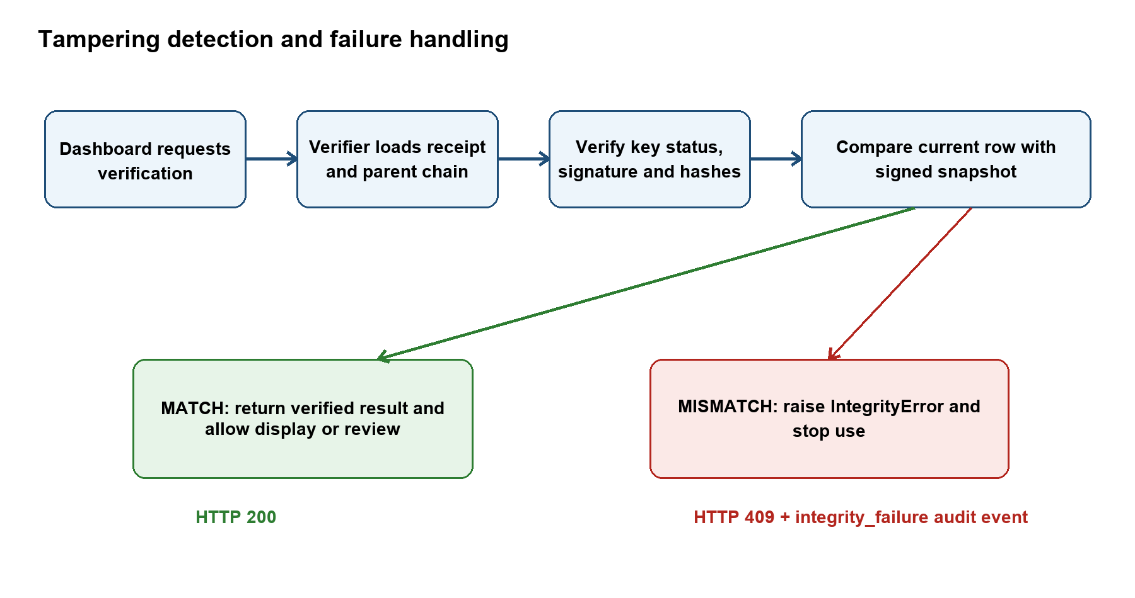
Figure 3 Tampering detection and HTTP 409 failure handling

IntegrityError response and audit event
HTTP 409
{
"detail": "Provenance verification failed",
"reason": "live_record_mismatch",
"subject": "query_history/101"
}
Audit action: integrity_failure
Audit detail: reason, subject, and request path

Verification interfaces
Endpoint | Input | Output and purpose
GET /api/v1/admin/provenance/receipts | subject_type and subject_id query parameters | Lists receipt versions and producing components for a subject.
GET /api/v1/admin/provenance/receipts/{receipt_id}/verify | Receipt UUID | Recursively verifies historical snapshots and returns the full cached evidence chain.
GET /api/v1/admin/provenance/records/{subject_type}/{subject_id}/verify | Supported live record type and integer ID | Verifies history and confirms the current row matches its newest signed snapshot.
GET /api/v1/admin/provenance/runs/{run_id}/verify | Clusterer run UUID | Verifies the receipt chain, receipt.json, allowlisted artifact names, and exact saved-file hashes.

Key lifecycle
Status | Behavior
Active | Can sign new receipts and verify existing receipts.
Retired | Cannot sign new receipts but can verify older receipts.
Revoked | Cannot sign or verify; receipts using the key fail verification, including historical receipts.

Common verification failures
Reason | Meaning
unsigned_input or missing_receipt | No receipt exists for the live row, or a referenced receipt is absent.
invalid_signature_or_receipt, wrong_signer, or revoked_key | Receipt structure, signature, signer identity, or key status is unacceptable.
receipt_binding_mismatch or parent_hash_mismatch | Indexed metadata or a parent envelope differs from the signed reference.
live_record_mismatch | Current database content differs from the signed snapshot.
artifact_mismatch | A saved Clusterer file or receipt.json is absent or changed.
cyclic_or_excessive_chain | A cycle is detected or the chain reaches the 32-level limit.

Security boundaries and operating guidance
- Protect trust material. Keep private PEM files outside source control and images, mount them as secrets, and deploy the public registry read-only from trusted configuration.
- Retain verifiable history. Keep retired public keys and historical receipts. Treat unsigned legacy warnings as read-only because their origin cannot be verified.
- Add isolation when required. Separate processes, per-service secret mounts, or managed signing services are needed for compromise isolation.
- Add external checkpoints when required. SQLite cannot reveal deletion or full-database rollback; an external append-only checkpoint is needed for that threat.

