ITECH 7415

MASTER’S PROJECT

Team Component Report

team Details:

Aarzoo (30430393)

Vikas (30425517)

Mohan (30423782)

yashika (30422543)

Table of Contents

Introduction 2

Sprint Details 2

Team Members and Hours Worked 2

Sprint Backlogs 2

Evidence of Work 6

Clint And Supervisor Feedback 11

Changes in the Next Sprint 12

Conclusion 12

|  |  |  |
| --- | --- | --- |
| Student Name | Individual Video Link | Group Video Link |
| Aarzoo Gaur |  |  |
| Vikas |  |
| Mohan |  |
| Yashika |  |

# Introduction

This report covers details of the sprints that have happened however the walkthrough demonstration of the product and the event summary has been included. In addition to that we talk about the feedbacks that were provided by clients, supervisors and in the next versions we are planning to have those corrections in place.

# Sprint Details

Sprint Duration: 05/08/2024 to 05/09/2024

## Team Members and Hours Worked

|  |  |
| --- | --- |
| Team Members | Hours Worked |
| Aarzoo Gaur |  |
| Vikas |  |
| Mohan |  |
| Yashika |  |

# Sprint Backlogs

|  |  |  |  |
| --- | --- | --- | --- |
| User/Team | Task Description | Acceptance Criteria | Completion Status |
| Product Owner | Learning wireframe design in Figma through YouTube tutorials. |  | Completed |
| Create wireframes for donor interfaces (registration, login, profile, donation requests, donation schedules, donation history, support contact). |  | Completed |
| Design wireframe for donor Registration form and Login Page. |  | Completed |
| Prepare some documents on User Stories, Acceptance criteria, Project requirements, Vision Statement, Project Roadmap and Technologies |  | Completed |
| Research about Web interface (Hospital) wireframes and design. |  | Completed |
| Testing Mobile App (signup and sign in), User Authentication and Validation. |  | Not Started |
| Scrum Master | Upskilling programming languages, tools and frameworks. |  | Completed |
| Learning PostgreSQL by watching videos and visiting websites |  | Completed |
| Creating ERD diagrams for database tables and their relationships. |  | Completed |
| Setup the PostgreSQL database and tables |  | Completed |
| Donor signup and login |  | Completed |
| Delivery Staff signup and login |  | Completed |
| Hospital Web Interface Signup and Login |  | In Progress |
| Create a wireframe for Delivery staff mobile app. |  | Completed |
| Research and design for hospital web interface. |  | Completed |
| Scrum Team Member | Paper work and learning of Wireframes for Hospital Web interface. |  | Completed |
| Create wireframes for hospital management interfaces. |  | Completed |
| Learn React Native and JavaScript |  | In Progress |

# Evidence of Work

**Blood donor app- Registration &login wireframes**

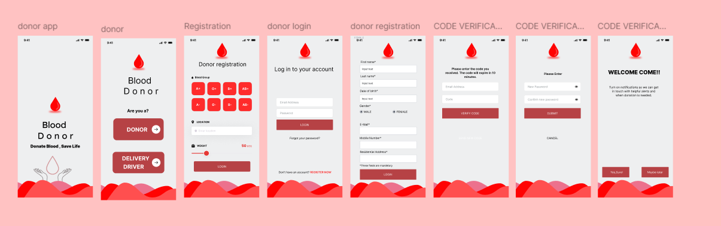

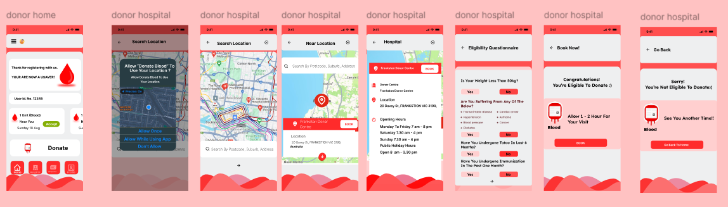

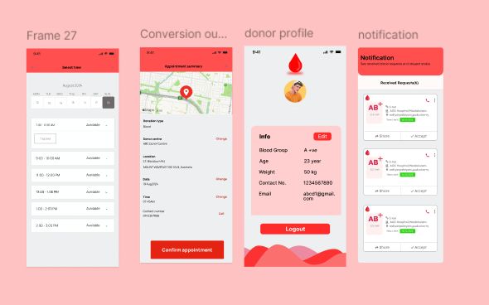

**Blood delivery app wireframes**

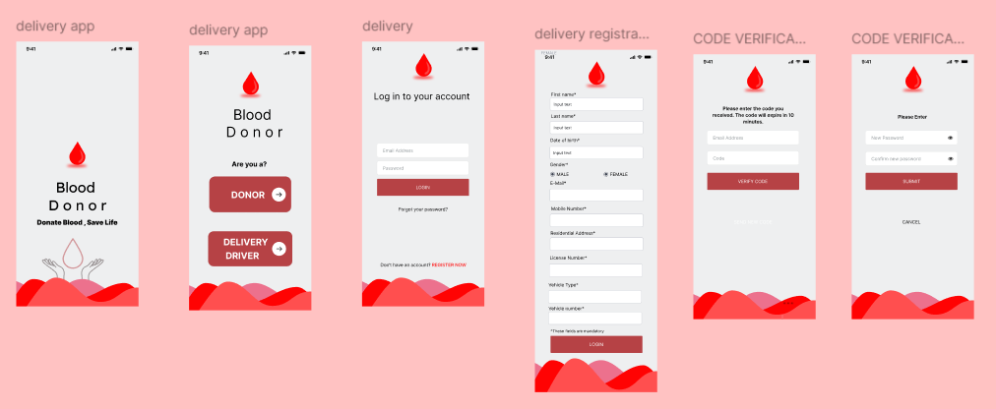

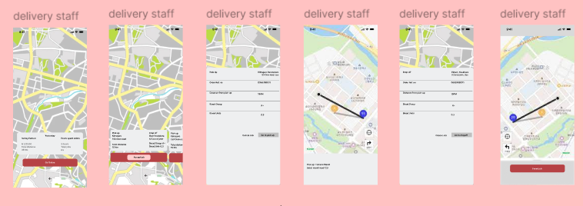

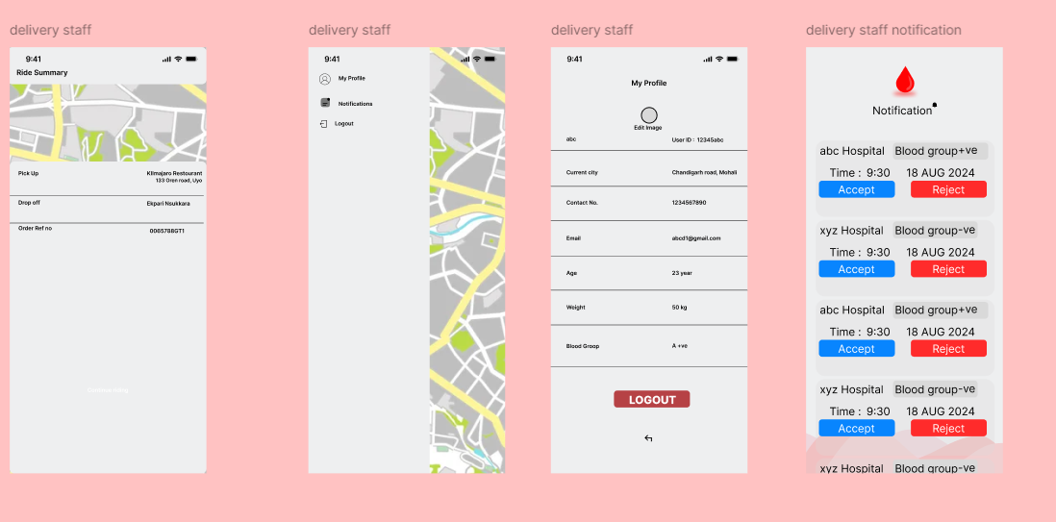

**Hospital web interface wireframes**

**JIRA Board backlog screenshots**

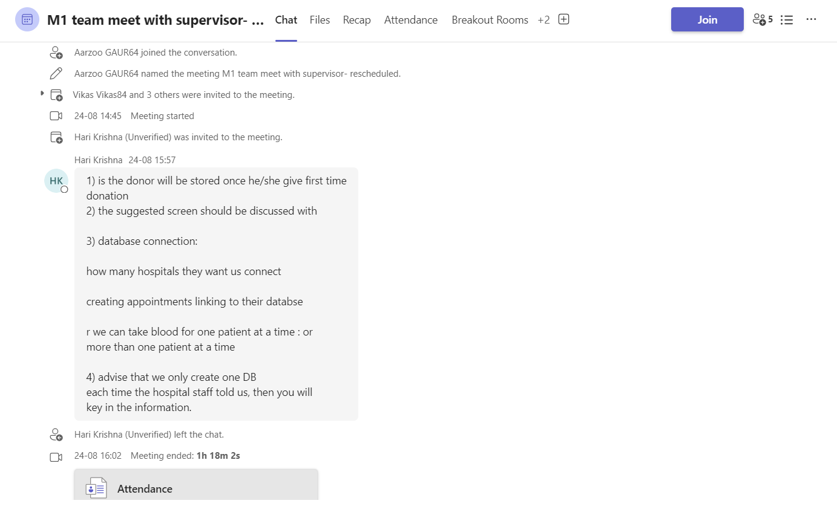

Clienjdjf

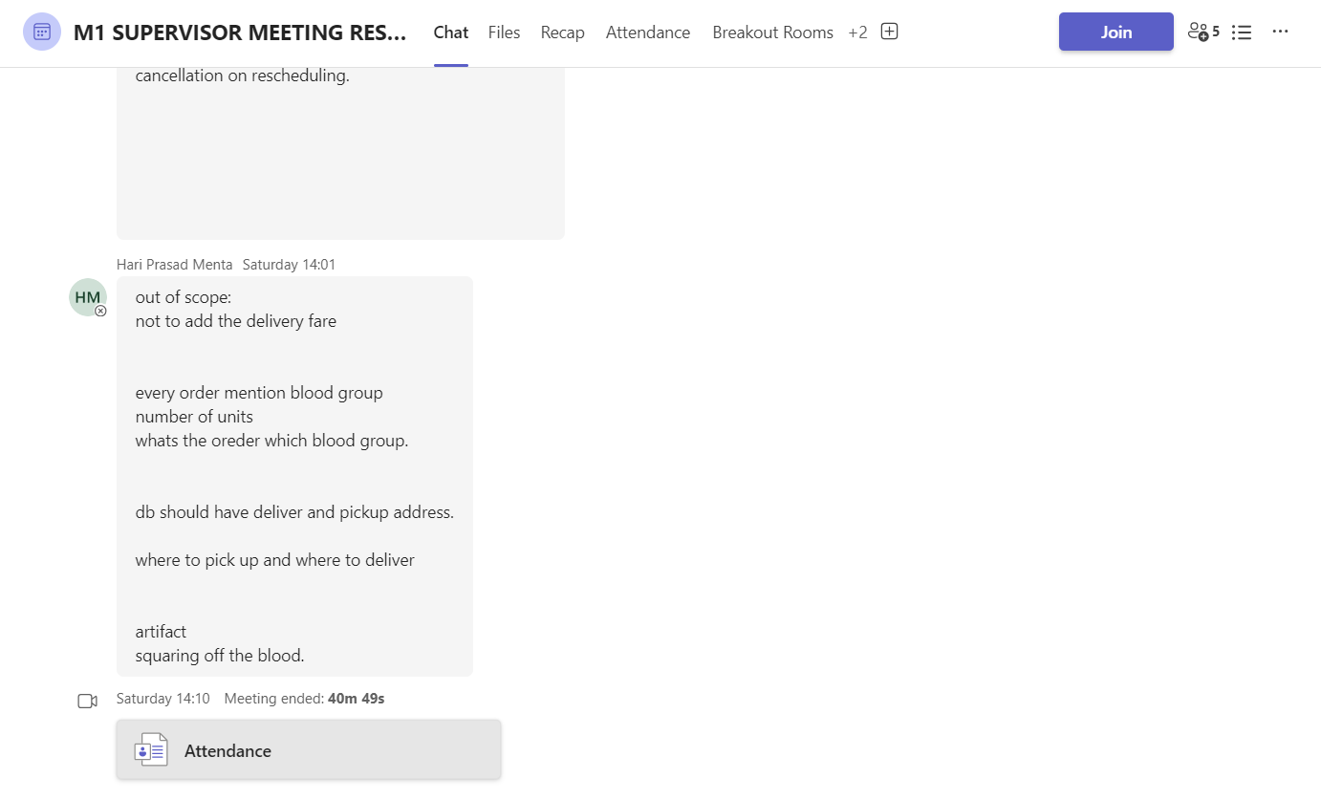

Client meeting-1

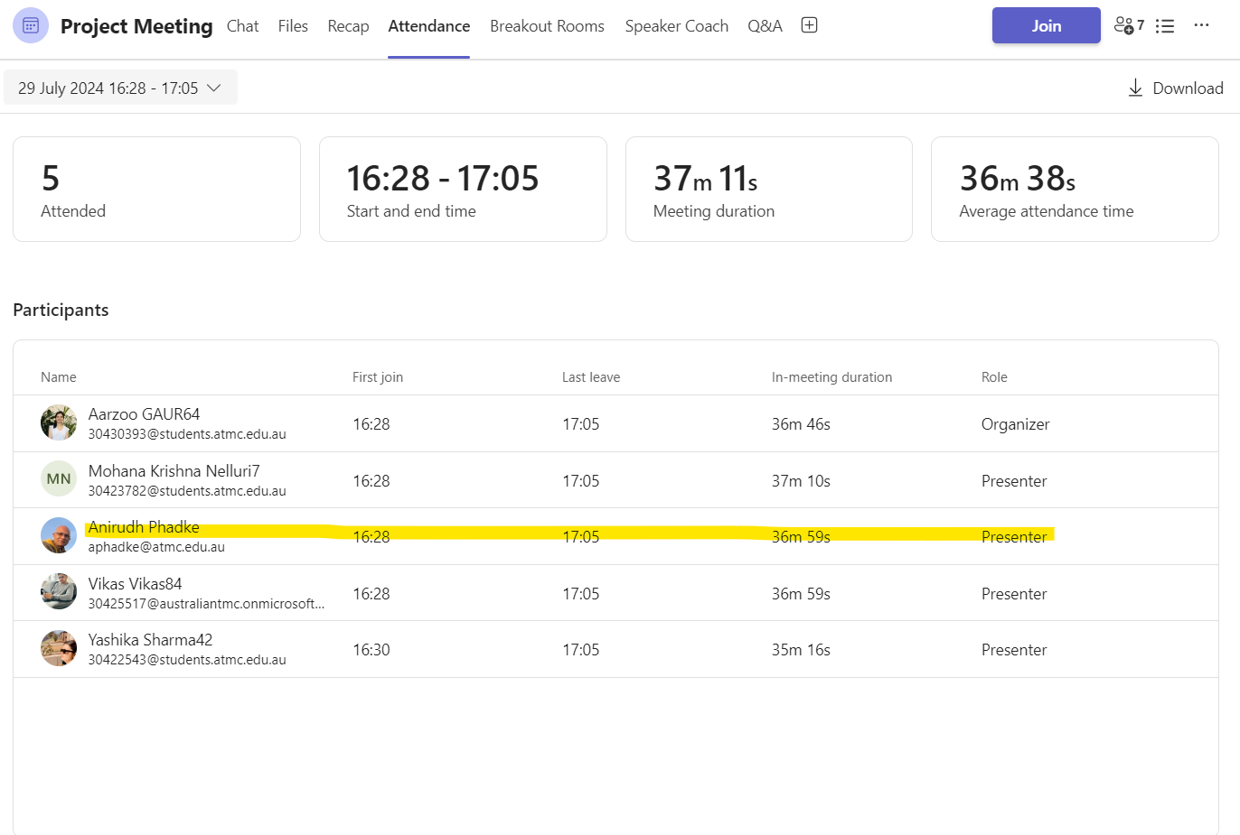

Client Meeting-2

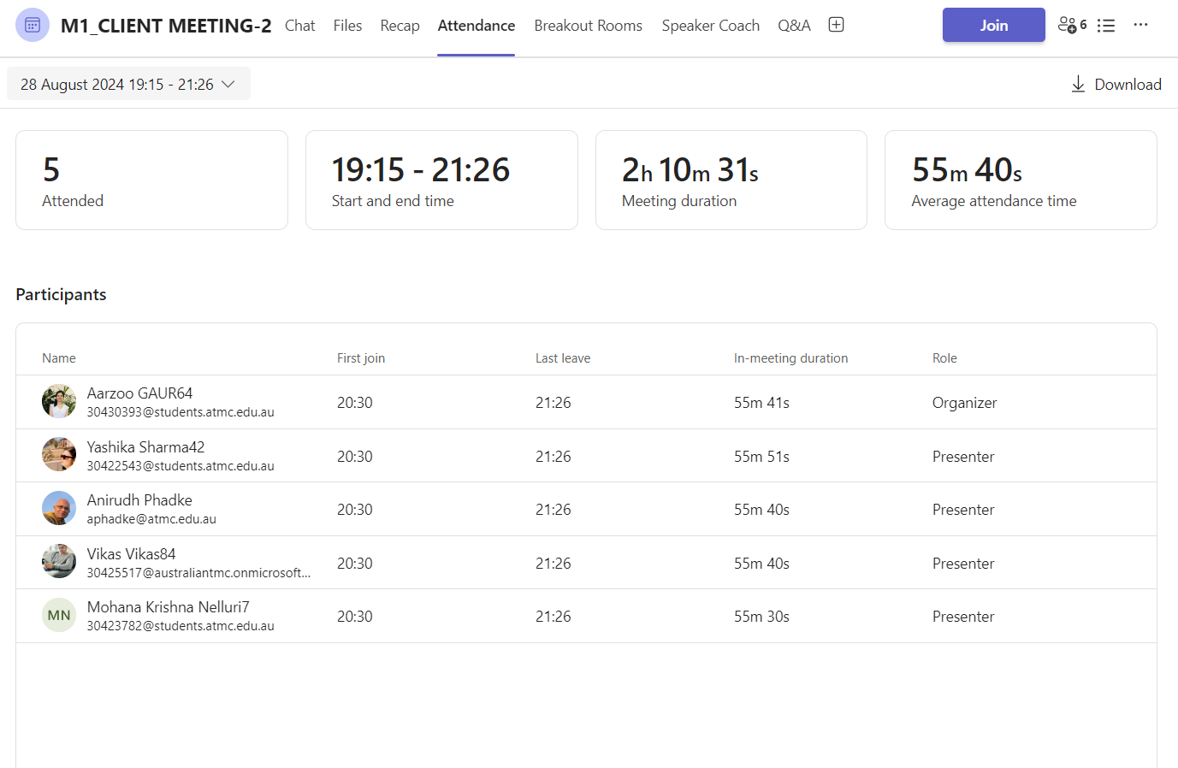

# Client And Supervisor Feedback

Self Reflection-Aarzoo Gaur(30430393)

Self Reflection- VIKAS (30425517)

Self Reflection MOHAN (30423782)

Self Reflection YASHIKA (30422543)