**VISVESVARAYA TECHNOLOGICAL UNIVERSITY**

**Jnana Sangama, Belagavi - 590018**



**Mini Project Synopsis**

**(18ECMP68) On**

**“SOLAR BOAT FOR WATER QUALITY ”**

**By**

**SHAMNAZ 4MT20EC068**

**R SURAJ 4MT20EC054**

**GANESH CHANDRASHEKAR BAILUR 4MT20EC032**

**MOHAN RAGHAVENDRA INAMADAR 4MT20EC043**

**Guide:**

**Dr. Ganesh V N**

**Associate Professor**



**DEPARTMENT OF ELECTRONICS & COMMUNICATION ENGINEERING**

***(Accredited by NBA)***

**MANGALORE INSTITUTE OF TECHNOLOGY & ENGINEERING**

*Accredited by NAAC with A+ Grade, An ISO 9001: 2015 Certified Institution*

(*A Unit of Rajalaxmi Education Trust®, Mangalore - 575001*)

Affiliated to VTU, Belagavi, Approved by AICTE, New Delhi

Badaga Mijar, Moodabidri-574225, Karnataka

**2022-23**

# ABSTRACT

Water quality refers to the presence or absence of various pollutants in saltwater, such as oil, sedimentation, sewage, nutrients, heavy metals, and thermal pollution. The process of measuring the saltwater's temperature, salinity, density, light transmission, and amount of dissolved oxygen is known as water quality monitoring. This article presents this work, which focuses on an autonomous system that uses a solar-powered water boat to assess the quality of saltwater. The boat has sensors that can measure temperature, conductivity, pH, and water turbidity, this cutting-edge boat provides quick and accurate testing of saltwater quality. The evaluation emphasizes the importance of designing a system that is not only affordable but also secure and dependable, harnessing the benefits of solar energy for long-term operation.

# INTRODUCTION

Monitoring and modelling studies are useful and suitable tools for assessing the environmental pollution. In particular, the sea water quality evaluation is an important issue concerning people’s well-being as well as economical activities which depend on it. The growing anthropogenic pressure on marine ecosystem, in terms of both resources exploiting and pollutants discharged in it, make it necessary to develop systems capable of providing real-time measurements and to collect and manage large amounts of data for further analysis.Nowadays all vehicles used by humans are powered by fossil fuels. In another field, electricity producers are dominated by fossilfuelled generators, either oil or coal. Ironically, scientists classify that fossil fuel is non-renewable energy resources therefore; traditional energy supplies should be shifted to renewable sources of energy and new technologies must be developed. In all the renewable energy sources, solar power takes more attention as a greatest promising option to be applied in the system. Solar energy is available in large quantities, cost less and pure which does not make any noise or any kind of pollution to the environment. The objective of the paper is to implement a Solar powered water boat which measures sea water quality. It is more accurate, most economical, and robust /compact construction and safe way of surveying the water. Nevertheless, it will still have a battery as a backup in case the boat goes into shadow or if it needs to sail during the night.

# LITERATURE SURVEY

**Adi Kurniawan [1]** The study claims that more recent research studies have been done that concentrate on the utilization of renewable energy. Researchers are investigating and advancing the use of renewable energy sources as alternatives for fossil fuel-based technology in a number of industries due to the possibility of future petroleum depletion. According to the study, solar energy is the most suitable type of renewable energy source to replace current ship fuels.

The study introduces an approach for creating a solar-powered boat as a way to determine the appropriate size of the photovoltaic (PV) system while controlling costs.

**Ahmad Nasirudin et.al [2]** The study introduces an approach for creating a solar-powered boat as a way to determine the appropriate size of the photovoltaic (PV) system while controlling costs.

**Prof. Paval K. L et.al [3]** The study demonstrates the benefits of renewable energy, energy efficiency, minimizing climate change, and generating economic rewards. This paper describes an autonomous system that measures the quantity and quality of water using a solar-powered water boat.

**Shinde D Tukaram et.al [4]** In this paper, research directed towards solar energy as a potential renewable energy source. By replacing traditional fuels, solar energy cuts fuel prices while simultaneously lowering water pollution. This alternative energy source provides a workable way to lessen reliance on non-renewable resources and the ensuing environmental issues.

**A. Kozyra et.al [5]** The use of a remote-controlled boat equipped with an automatic calibrator to measure several water quality indicators is discussed in this work. The factors considered in this study include temperature, conductance, pH, oxygen (O2), nitrate (NO3-), and ammonium (NH4+) content. The experiment's catamaran was designed expressly for this purpose. The measurements are wirelessly and automatically taken from a control station that is powered by a personal computer (PC) while the boat is moving. The data is subsequently stored in a unique database for future study.

**Hongda Liu et.al [6]** The maritime transportation industry recently indicated interest in employing solar energy and power reservetechnology to decrease carbon and nitrous oxide emissions and enhance energy efficiency. But the frequent tilting at sea that ships experience on account of weather and navigational factors—increases uncertainty and hastens the degeneration of solar power system batteries.

**Varsha Lakshmikantha et.al [7]** This paper offers a thorough analysis of recent advancements in intelligent water pollution monitoring systems. An IoT-based smart water quality monitoring system is suggested as a treatment because it is efficient and affordable. To support continuing water quality monitoring, it continuously measures a range of quality indices. Three separate water samples are used to evaluate the established model, and the results are uploaded to cloud for further evaluation and action. In order to enable real-time monitoring, data collecting, and analysis and allow stakeholders to act promptly on the information obtained, the system leverages IoT technology. This proactive strategy aids in preserving the water quality and effectively addressing pollution problems.

**Farmanullah Jan et.al [8]**  This review paper focuses on how Internet of Things (IoT) technologies are being used to develop smart water quality monitoring systems (IoT-WQMS) that are predominantly designed for residential use. It examines the limitations on access to clean drinking water associated with traditional water quality measurement criteria. Additionally, it covers the usage of intelligent sensors in IoT-WQMS and offers a critical assessment and validation of current systems.

**Moez ul Hassan et.al [9]** With the aid of a wireless, multi-sensor network and a cost-effective, real-time monitoring system is designed. This gadget gives speedy findings by measuring a number of physiochemical properties of water, in contrast to conventional approaches, which rely on sample and laboratory analysis. The contributing factors are temperature, pH, turbidity, electrical conductivity, and total dissolved solids (TDS). The procedure is especially made for assessing rivers, lakes, and reservoirs when the water quality ranges from one site to another. The answer to this issue is to originate a remote-controlled boat that can float and steer across water.

**S. Geetha et.al [10]** This study provides a comprehensive examination of recent research in the discipline of intelligent water quality monitoring. Additionally, it offers an Internet of Things (IoT)-based method for water quality monitoring within pipe that is straightforward and power-efficient.

# METHODOLOGY

The problem with water pollution monitoring is the manual effort of taking a boat through a lake or reservoir each time to monitor pollution throughout the water body.

A solar-powered boat designed for water quality monitoring can assess important elements including temperature, pH, and turbidity using sensor technology and renewable energy. The boat is powered by solar energy, which is collected by solar panels. The boat is equipped with sensors for temperature, pH, and turbidity, allowing it to collect data as it moves across the body of water. The sensor data is acquired by an Arduino microcontroller, which then processes it and outputs the results on an LCD display. This display allows operators or researchers to simply monitor the measured parameters while on the boat. Due to the system's utilization of solar energy and motor power, it operates sustainably and has little negative influence on the environment. The combination of sensors, Arduino, and LCD display offers a practical and user-friendly solution for water quality monitoring. This makes it possible to manage water resources quickly and make quick decisions.

**BLOCK DIAGRAM**

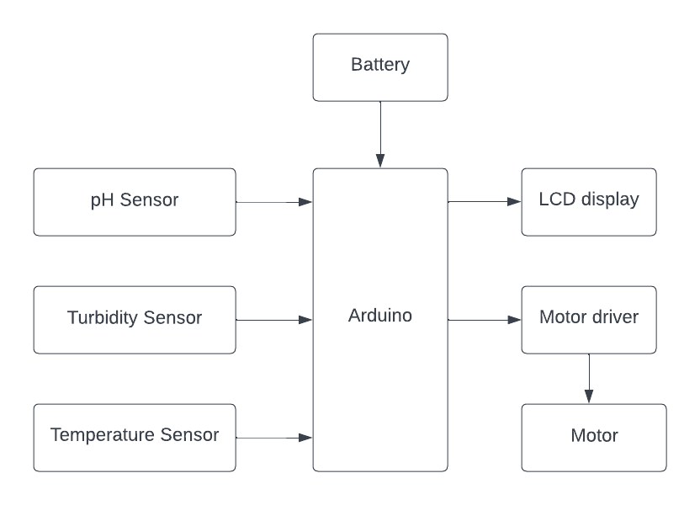

**Circuit Diagram**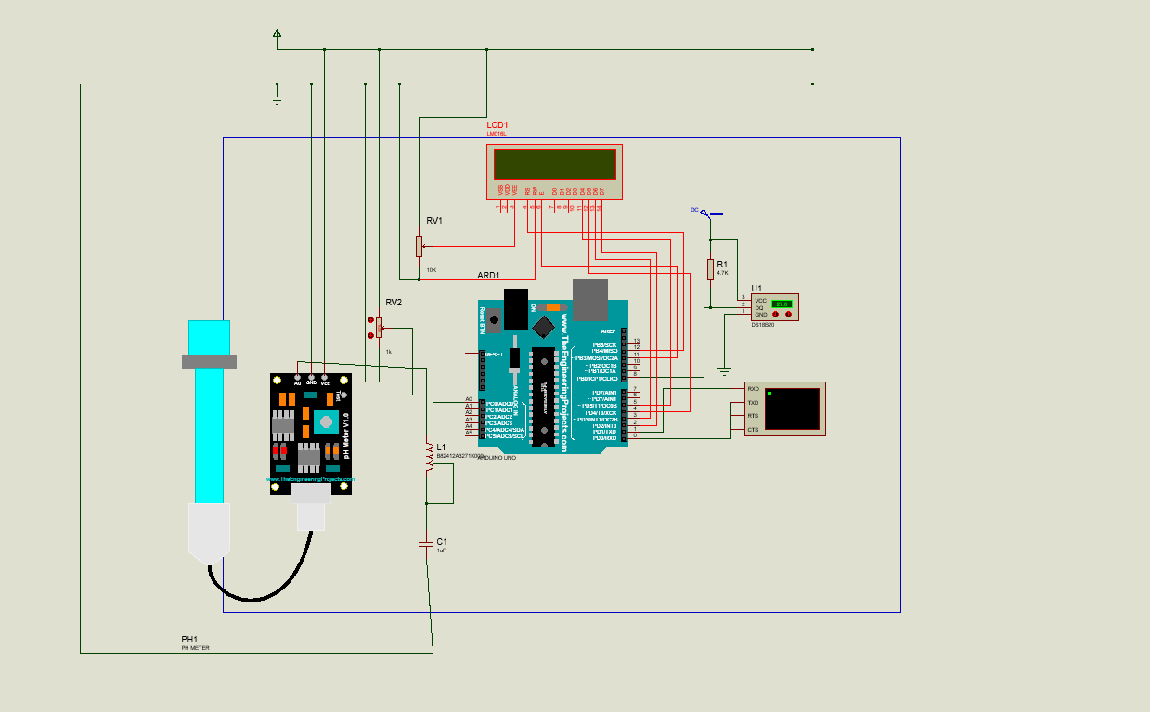

## TIME SCHEDULE OF PROJECT

|  |  |
| --- | --- |
| April | Research on IEEE paper and case study on the project review papers |
| May | Design and implementation of solar boat project |
| June | Completion of the project with respect to hardware and software |

**BUDGET ESTIMATION**

|  |  |
| --- | --- |
| Aurdino nano,Aurdino uno | 3150 /- |
| Temperature sensor,ph sensor, turbidity sensor | 100 /- |
| GPS Module | 650 /- |
| NRF24101 Transceiver | 60 /- |
| Dc motor | 200 /- |
| Servo motor | 150 /- |
| Radder, battery,wires | 250 /- |
| Bread board | 60 /- |
| TOTAL | 4620 /- |

# REFERENCES

1. Adi Kurniawan: A Review of Solar-Powered Boat Development: April 2016
2. Ahmad Nasirudin, Ru-Min Chaoa, I Ketut Aria PriaUtamab: Solar Powered Boat Design Optimization: 2017
3. Prof. Paval K. L, Pandurang Sonne, Namdev Shinde, Sandip Sonawane: Design of Solar Powered Water Boat for Water Quality and Quantity Measurement: A Review: 2019
4. Shinde Dnyaneshwar Tukaram, Shende Rahul Uttam, Raut Sujit Shivaji, Narkhedkar Rohit Ankush, Prof. Kare K.M: Design and fabrication of a solar boat.
5. A. Kozyra, K. Skrzypczyk, K. Stebel, A. Rolnik, P. Rolnik, M. Kucma: Remote controlled water craft for water measurement.
6. Hongda Liu, Qing Zhang, Xiaoxia Qi, Yang Han: Estimation of PV output power in moving and rocking hybrid energy marine ships.
7. Varsha Lakshmikantha, Anjitha Hiriyannagowda, Akshay Manjunath, Aruna Patted, Jagadeesh Basavaiah, Audre Arlene Anthony: IoT based smart water quality monitoring system
8. Farmanullah Jan, Nasro Min-Allah, Dilek Düştegör : IoT Based Smart Water Quality Monitoring: Recent Techniques, Trends and Challenges for Domestic Applications
9. Moez ul Hassan, Sanjay Kumar, Hitesh Kumar, Kabir Kumar, Sarmad Hameed, Kiran Fatima: Real time water quality monitoring boat: 2018.
10. S. Geetha, S. Gouthami: Internet of Things enabled real time water quality monitoring system, July 2017.