**SYNOPSIS**

**PHARMACY MANAGEMENT SYSTEM USING PYTHON**

**NAME: Mohan S**

**Reg. No: P18CD22S126046**

# INTRODUCTION

The modern generation is going to be defendable on a computer and through the computer, we use the software. Hence, we are learning Python that’s why we creating an application for managing pharmacy systems. By using this, we can serve patients, doctors, pharmacy clerks & pharmacists. Even managing drug stocks. Keeping their appropriate data to hold them the right drugs to save their life & soul. Mainly this application is used by pharmacy administration.

## Aim

Pharmacy is essential in the progress of the urgent need for drugs. In Bangladesh, senior citizens are now not too stable due to some basis of problems like high blood pressure, blackout, joint pain, gastric, etc. In most the equivalent case a smart solution can handle these kinds of circumstances. For smart development, we take a serious smart approach to reduce this kind of harm.

Our project has some basic goals which are pointed out below:

* Developing a system that reduces online & offline boring complexity
  + Standing on the serial line
  + Waiting for the next call
  + Come up with children or a short-tempered person
* Strong database with easy-to-use functional interactivity
* Give reliable filter ability
* Avoid disrupting waiting for drugs
* Ecosystem approach to reach out to any doctor or pharmacist at any time
* Make sure a 24/7 service with modest communicator
* Eco-friendly UI to have a huge experience that makes sense to be own

## Motivation

The aim of this project is the smart development of a pharmacy system where we revolutionize the pharmacy management system. We digitalize the whole system so that the consistency between online and offline can be measured in such a way therefore from children to grand every can easily access it.

# COMPONENTS OR TECHNOLOGIES

To keep the whole system within thumb we are approaching high-level and latest component technology which helps this system to be more optimistic and lightweight. Whatever a pharmacy is large or small within our ecosystem any patient finds it as a basis-based pharmacy to have desired instruction. Following elaborate on the actual purpose of using technology:

## Client-side

ReactJS, React-Bootstrap, React-Font-Awesome, React-Router, React-Leaflet, NPM for internal packages, React-helmet, React-day-picker, Date-fns & React-PDF.

## Server-side

Node.js, Express.js, Next.js, MongoDB, Mongo Atlas, Mongo CRUD, NodeMon, JWT, SQLite3 (final conversion).

## Offline display

Using a Python module called ManagePy as a phaser which simply turns the ReactJS application into a Django project. Which contains a parent server file known as *manage.py.* There showing offline can give the same experience as online giving which replace the original repo. Finally, convert the MongoDB database to the SQLite3 database.

**Use-case diagram of pharmacy management system:**

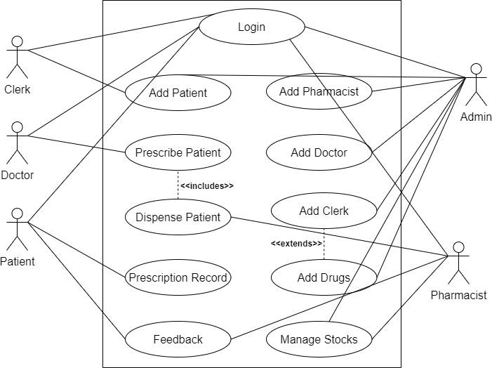

Fig. 4.1: use-case diagram of Pharmacy Management System

**CONTEXT DIAGRAM OF PHARMACY MANAGEMENT SYSTEM:**

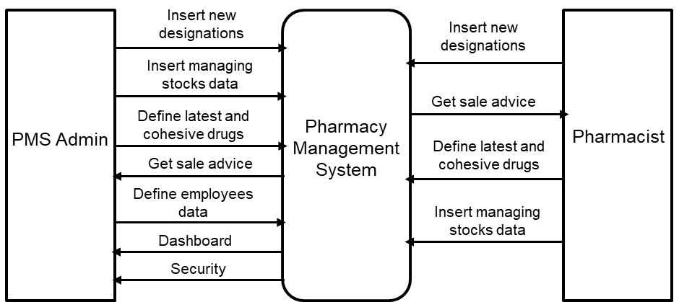

Fig. 4.2: context diagram of Pharmacy Management System

**LEVEL-1 DIAGRAM OF PHARMACY MANAGEMENT SYSTEM:**

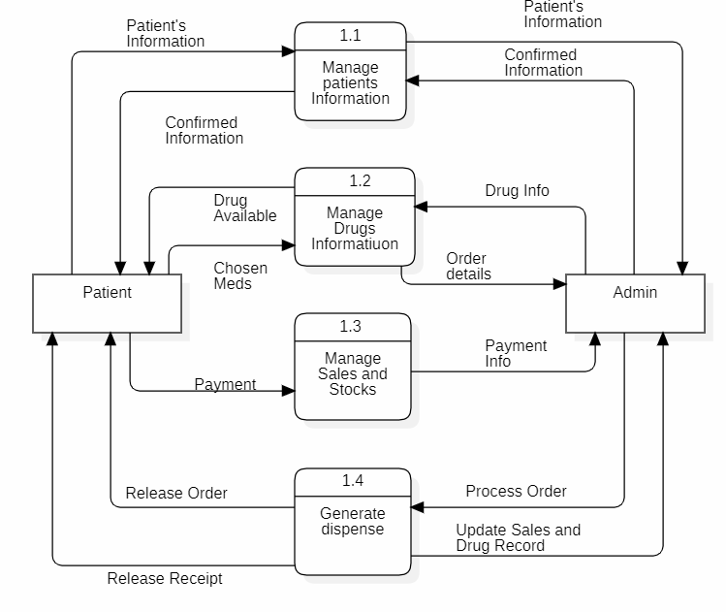

Fig. 4.2: level-1 diagram of Pharmacy Management System

Pharmacist

# CONCLUSION

This is a multi-time easy-to-use eco-friendly project from children to grand can access like nothing to anything. Each user has their own potential. Separate functionality with easy UI each portion can serve multiplication. As a doctor can prescribe a patient, the clerk can add new patients and manage their serial numbers, a patient can have their prescription seen and ability to give feedback, a pharmacist can have the ability to dispense through the prescription provided to a patient, and finally, come to the admin who has the full right to access and manage anything like CRUD operation else feedback.

### FUTURE ENHANCEMENT

The following things can be done in the future.

* + - The users could subscribe for dispensary alerts which would enable them to receive messages when doctor prescribe some medicines.
    - The current system can be extended to add new category for medicines.
    - Provide real-time dispensary information to patients, so they know if a particular item is in stock or not. This can help reduce frustration and increase transparency.
    - Provide Option for Forgot Password and can again change their password using mail id or username.