RESULTS
Date : 29 JUNE 2026
Team ID:
Project Name: Plugging-into-the-Future-An-Exploration-of-Electricity-Consumption-Patterns

Dashboard – 1: PLUGGING INTO THE FUTURE: AN EXPLORATION OF ELECTRICITY CONSUMPTION PATTERNS
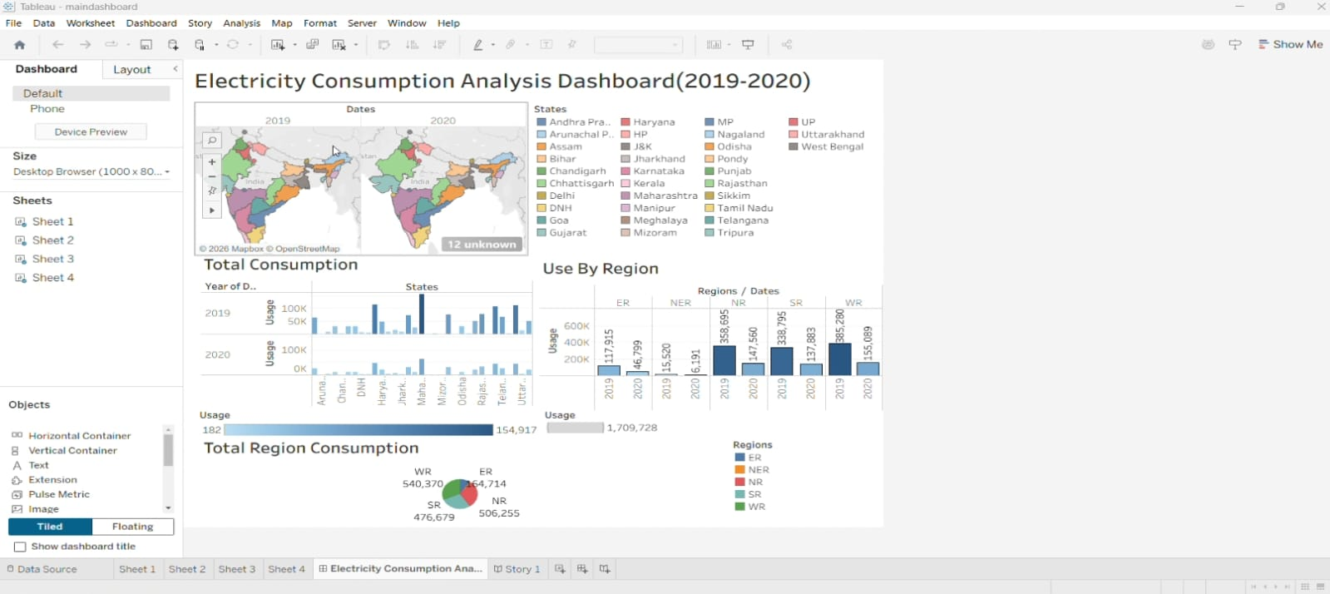

Dashboard – 2: TOTAL ELECTRICITY CONSUMPTION

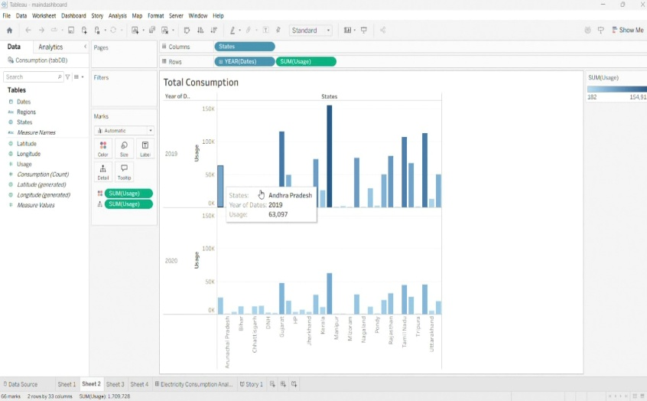

Story:
