

major project

ML-MAJOR-AUGUST-ML-08-ML01



*LOAN APPROVAL CLASSIFICATION USING ML*

JUPYTER_NOTEBOOK:

import pandas as pd #Importing the essential modules that we need  
import numpy as np  
import matplotlib.pyplot as plt  
from sklearn.preprocessing import LabelEncoder,StandardScaler #LabelEncoder is used for encoding categorical variables into numerical values, and StandardScaler is used for standardizing features by removing the mean and scaling to unit variance.  
from sklearn.model_selection import train_test_split #This imports a function from scikit-learn that allows you to split a dataset into training and testing sets. This is crucial for evaluating the performance of a machine learning model.  
from sklearn.metrics import accuracy_score,f1_score,confusion_matrix,classification_report #imports various metrics from scikit-learn that are commonly used for evaluating classification models. accuracy_score, f1_score, confusion_matrix, and classification_report provide different ways to assess model performance.  
import seaborn as sns  
%matplotlib inline  
#to display matplotlib plots inline within the notebook.

dataset=pd.read_excel("/content/loan-predictionUC.csv.xlsx")  
dataset.head() #first few rows of the dataset

Loan_ID Gender Married Dependents Education Self_Employed \  
0 LP001002 Male No 0 Graduate No   
1 LP001003 Male Yes 1 Graduate No   
2 LP001005 Male Yes 0 Graduate Yes   
3 LP001006 Male Yes 0 Not Graduate No   
4 LP001008 Male No 0 Graduate No   
  
 ApplicantIncome CoapplicantIncome LoanAmount Loan_Amount_Term \  
0 5849 0.0 NaN 360.0   
1 4583 1508.0 128.0 360.0   
2 3000 0.0 66.0 360.0   
3 2583 2358.0 120.0 360.0   
4 6000 0.0 141.0 360.0   
  
 Credit_History Property_Area Loan_Status   
0 1.0 Urban Y   
1 1.0 Rural N   
2 1.0 Urban Y   
3 1.0 Urban Y   
4 1.0 Urban Y

df=sns.pairplot(dataset,hue="Loan_Status") #pairplotting so as to study the relation between any 2 cells

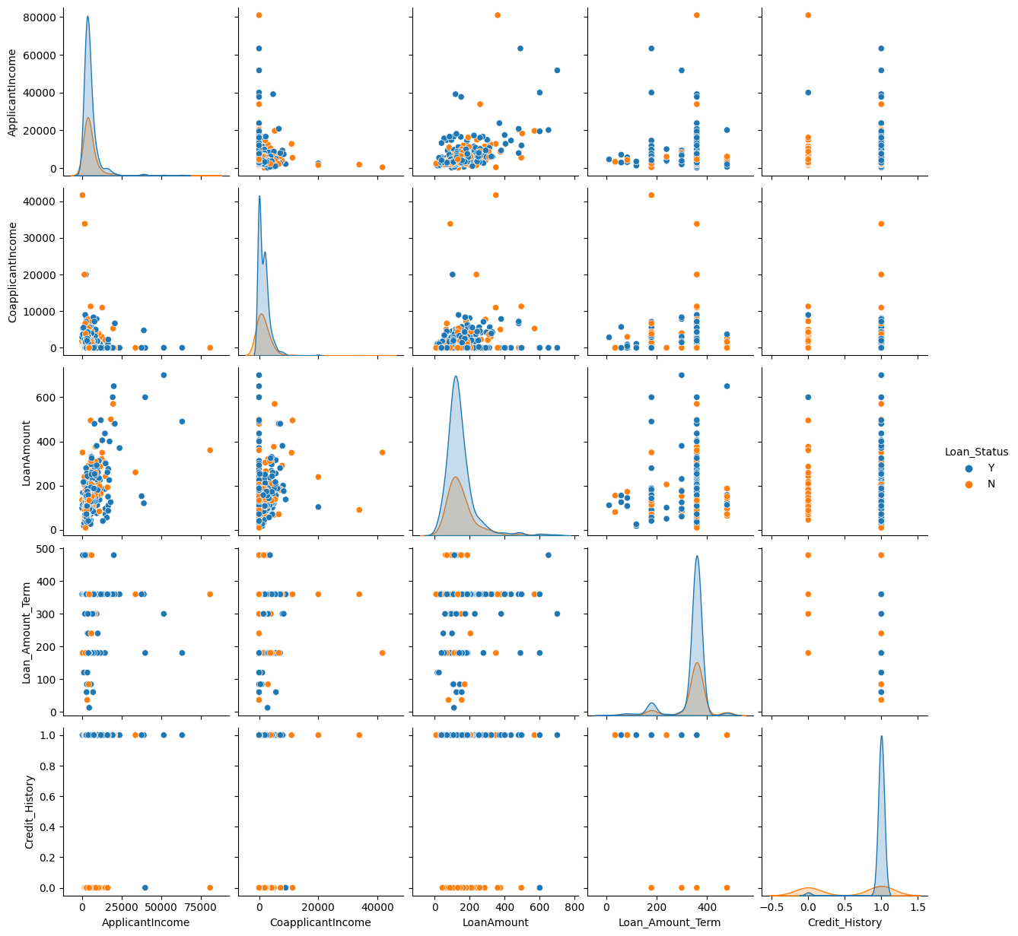

dataset.shape #It returns a tuple representing the number of rows and columns in your dataset.

(614, 13)

dataset.describe() #It provides a summary of the basic statistical measures of the dataset. This can include things like mean, standard deviation, minimum, maximum, and quartiles for numerical columns.

ApplicantIncome CoapplicantIncome LoanAmount Loan_Amount_Term \  
count 614.000000 614.000000 592.000000 600.00000   
mean 5403.459283 1621.245798 146.412162 342.00000   
std 6109.041673 2926.248369 85.587325 65.12041   
min 150.000000 0.000000 9.000000 12.00000   
25% 2877.500000 0.000000 100.000000 360.00000   
50% 3812.500000 1188.500000 128.000000 360.00000   
75% 5795.000000 2297.250000 168.000000 360.00000   
max 81000.000000 41667.000000 700.000000 480.00000

Credit_History   
count 564.000000   
mean 0.842199   
std 0.364878   
min 0.000000   
25% 1.000000   
50% 1.000000   
75% 1.000000   
max 1.000000

dataset.info()

<class 'pandas.core.frame.DataFrame'>  
RangeIndex: 614 entries, 0 to 613  
Data columns (total 13 columns):  
 # Column Non-Null Count Dtype   
--- ------ -------------- -----   
 0 Loan_ID 614 non-null object   
 1 Gender 601 non-null object   
 2 Married 611 non-null object   
 3 Dependents 599 non-null object   
 4 Education 614 non-null object   
 5 Self_Employed 582 non-null object   
 6 ApplicantIncome 614 non-null int64   
 7 CoapplicantIncome 614 non-null float64  
 8 LoanAmount 592 non-null float64  
 9 Loan_Amount_Term 600 non-null float64  
 10 Credit_History 564 non-null float64  
 11 Property_Area 614 non-null object   
 12 Loan_Status 614 non-null object   
dtypes: float64(4), int64(1), object(8)  
memory usage: 62.5+ KB

for i,j in enumerate(("Gender","Married","Education","Self_Employed","Property_Area","ApplicantIncome","CoapplicantIncome","LoanAmount","Loan_Amount_Term","Credit_History","Loan_Status")):  
 plt.subplot(3,4,i+1)  
 dataset[j].hist(bins=20) #enumerate returns 2 values index and value

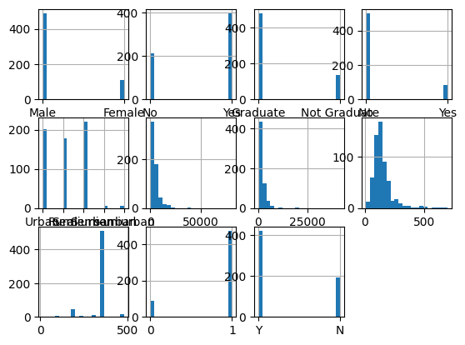

for i,x in enumerate(dataset):  
 if dataset[x].dtype=="object":  
 plt.subplot(4,5,i+1)  
 sns.countplot(data=dataset,x=x,hue="Loan_Status")  
 else:  
 sns.displot(data=dataset,x=x,hue="Loan_Status",kde=True)  
 plt.show()

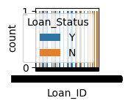

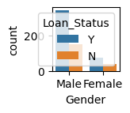

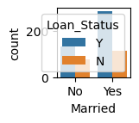

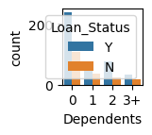

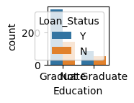

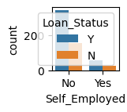

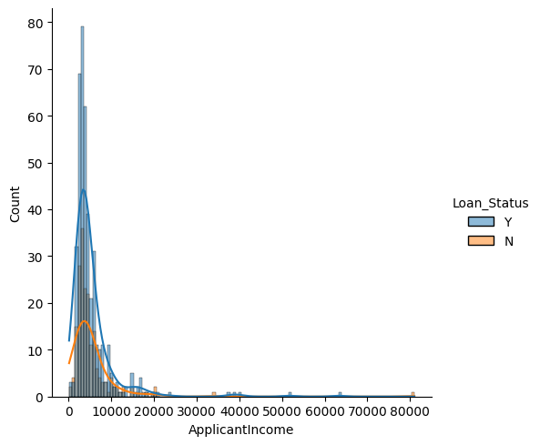

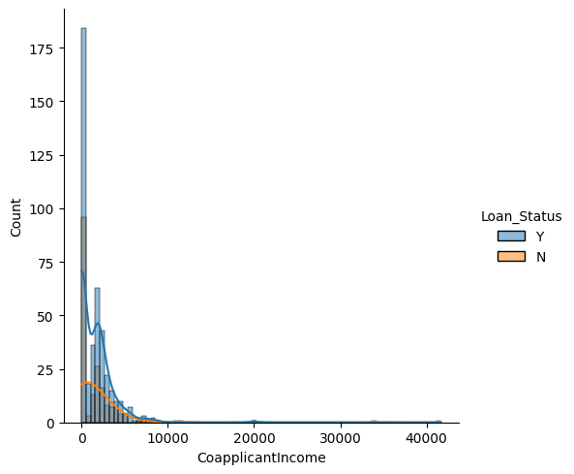

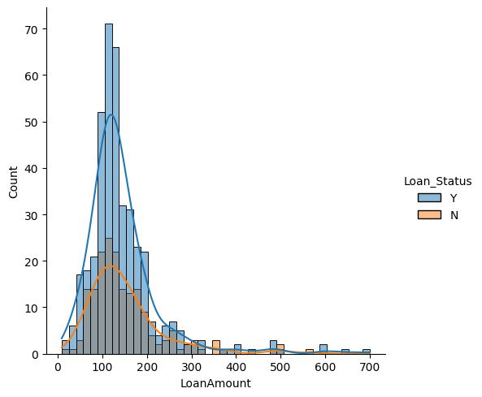

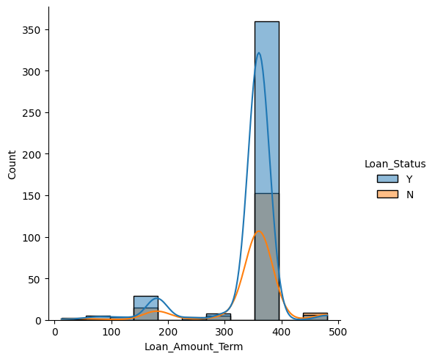

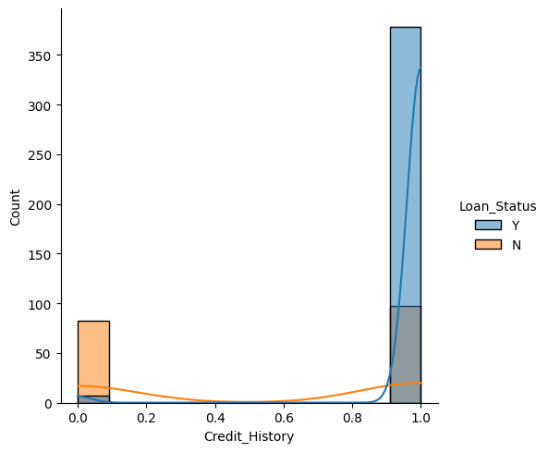

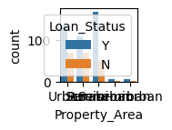

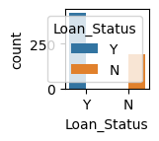

dataset.isna().sum() #checking how many values aren't present in each column and taking summation of missing

Loan_ID 0  
Gender 13  
Married 3  
Dependents 15  
Education 0  
Self_Employed 32  
ApplicantIncome 0  
CoapplicantIncome 0  
LoanAmount 22  
Loan_Amount_Term 14  
Credit_History 50  
Property_Area 0  
Loan_Status 0  
dtype: int64

dataset["LoanAmount_log"]=np.log(dataset["LoanAmount"])

dataset["Gender"].fillna(dataset["Gender"].mode()[0],inplace=True) #This method fills the missing values in dataset with mode values in that column  
dataset["Married"].fillna(dataset["Married"].mode()[0],inplace=True)  
dataset["Dependents"].fillna(dataset["Dependents"].mode()[0],inplace=True)  
dataset["Self_Employed"].fillna(dataset["Self_Employed"].mode()[0],inplace=True)  
dataset["Credit_History"].fillna(dataset["Credit_History"].mode()[0],inplace=True)  
dataset["LoanAmount"].fillna(dataset["LoanAmount"].mean(),inplace=True)  
dataset["LoanAmount_log"].fillna(dataset["LoanAmount_log"].mean(),inplace=True)  
dataset["Loan_Amount_Term"].fillna(dataset["Loan_Amount_Term"].mode()[0],inplace=True)

dataset.isna().sum() #These methods return a DataFrame of the same shape as dataset but with True in places where the original DataFrame has missing values and False where it does not to check whether we have a completely filled dataset or not

Loan_ID 0  
Gender 0  
Married 0  
Dependents 0  
Education 0  
Self_Employed 0  
ApplicantIncome 0  
CoapplicantIncome 0  
LoanAmount 0  
Loan_Amount_Term 0  
Credit_History 0  
Property_Area 0  
Loan_Status 0  
LoanAmount_log 0  
dtype: int64

dataset["Total_Income"]=dataset["ApplicantIncome"]+dataset["CoapplicantIncome"]  
dataset["Total_Income_log"]=np.log(dataset["Total_Income"])

dataset["Dependents"]=dataset["Dependents"].astype(str)  
X=dataset.iloc[:,np.r_[1:5,9:11,13:15]].values  
y=dataset.iloc[:,12].values

X_train,X_test,y_train,y_test=train_test_split(X,y,test_size=0.2,random_state=0)

labelencoder_x=LabelEncoder()  
labelencoder_y=LabelEncoder()

for i in range(5):  
 X_train[:,i]=labelencoder_x.fit_transform(X_train[:,i])  
X_train[:,7]=labelencoder_x.fit_transform(X_train[:,7])

y_train=labelencoder_y.fit_transform(y_train)

labelencoder_x=LabelEncoder()  
labelencoder_y=LabelEncoder()

for i in range(5):  
 X_test[:,i]=labelencoder_x.fit_transform(X_test[:,i])  
X_test[:,7]=labelencoder_x.fit_transform(X_test[:,7])  
y_test=labelencoder_y.fit_transform(y_test)

ss=StandardScaler() #The StandardScaler is a preprocessing technique in machine learning used to standardize the features of a dataset. Standardization involves transforming the features so that they have a mean of 0 and a standard deviation of 1.  
X_train=ss.fit_transform(X_train)  
X_test=ss.fit_transform(X_test)

from sklearn.naive_bayes import GaussianNB #It is a variant of the Naive Bayes algorithm that is well-suited for classification tasks when the features are continuous and assumed to have a Gaussian (normal) distribution. It's particularly useful for numerical data.

nbc=GaussianNB() #It is a variant of the Naive Bayes algorithm that is well-suited for classification tasks when the features are continuous and assumed to have a Gaussian (normal) distribution. It's particularly useful for numerical data.  
nbc.fit(X_train,y_train)

GaussianNB()

y_pred_train=nbc.predict(X_train)# fit the model to your training data and then use the predict method to make predictions on new, unseen data.  
y_pred_test=nbc.predict(X_test)# fit the model to your testing data and then use the predict method to make predictions on new, unseen data.  
print("Accuracy on Train data :",accuracy_score(y_train,y_pred_train)*100)  
print("Accuracy on Test data :",accuracy_score(y_test,y_pred_test)*100)

Accuracy on Train data : 80.44806517311609  
Accuracy on Test data : 82.92682926829268

con_mat_train=confusion_matrix(y_train,y_pred_train) #TO analyse and predict how much a model is correct or comparison b/w y_pred_train and y_train  
con_mat_test=confusion_matrix(y_test,y_pred_test) #TO analyse and predict how much a model is correct or comparison b/w y_pred_test and y_test

sns.heatmap(con_mat_train) #display the confusion matrix

<Axes: >

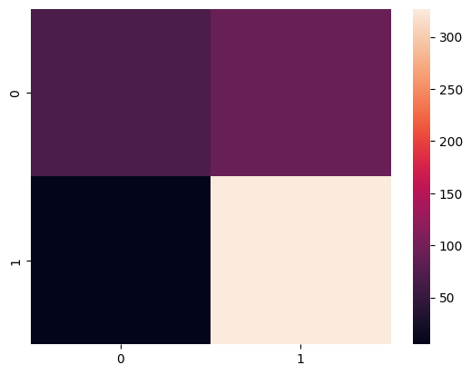

sns.heatmap(con_mat_test)

<Axes: >

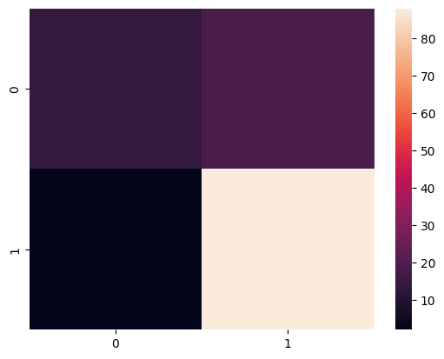

The dataset contains information about loan applicants and whether their loan applications were approved or not. The goal is to build a machine learning model to predict whether a loan application will be approved or denied based on the applicant's information. Unique identification number for each loan application. Gender of the applicant (Male/Female). Marital status of the applicant (Yes/No). Number of dependents of the applicant. Education level of the applicant (Graduate/Not Graduate). Whether the applicant is self-employed (Yes/No). Income of the applicant (in dollars). Income of the co-applicant (if any) (in dollars). The loan amount requested (in dollars). Term of the loan (in months). Credit history of the applicant (1.0: Good credit history, 0.0: Poor credit history). Area type of the property (Urban/Rural/Semi Urban). Loan approval status (Y: Approved, N: Not Approved).

* This dataset has various columns like Loan_Id, Gender, Dependents, Education, Self-Employed, ApplicantIncome, CoApplicantIncome, LoanAmount, Loan_Amount_Term, Credit_History, Property_area, Loan_Status.
* From the dataset after visualization the loan status is depending more on credit history than any other column.
* A person with Credit History = 1 will have more chance of getting approved for the loan.
* Loan status is depending very less on LoanAmount, Loan_Amount_Term.
* After that loan status is barely depending on other columns like Applicant_Income, CoApplicant_Income.
* The loan status dependency on the columns like Gender, Married, Self_Employed is negligible.

The loan status has no dependency on loan_id.

CONCLUSION:

This dataset provides valuable insights into the factors that influence loan approval decisions. By building a machine learning model, the financial institution can automate the loan approval process and make more informed lending decisions.

* This dataset has various columns like Loan_Id, Gender, Dependents, Education, Self-Employed, ApplicantIncome, CoApplicantIncome, LoanAmount, Loan_Amount_Term, Credit_History, Property_area, Loan_Status.
* From the dataset after visualization the loan status is depending more on credit history than any other column.
* A person with Credit History = 1 will have more chance of getting approved for the loan.
* Loan status is depending very less on LoanAmount, Loan_Amount_Term.
* After that loan status is barely depending on other columns like Applicant_Income, CoApplicant_Income.
* The loan status dependency on the columns like Gender, Married, Self_Employed is negligible.
* The loan status has no dependency on loan_id.