SECTION A — Problem Framing & Responsible AI Planning
1. What is the model's intended use - and what is it explicitly NOT for?
The escalation-prediction model exists to help triage customers for proactive, human outreach. Put simply, it marks accounts that look more likely to take a complaint to the FOS, giving the Customer Ops team a chance to step in earlier and try to protect the relationship. It is strictly a decision-support aid. It must NOT be used to, (1) automatically deny, limit, or close any product or service, (2) apply different pricing, credit terms, or fees to customers who are flagged, or (3) make any customer-facing decision unless a person has reviewed the case beforehand.
2. What protected characteristics are in the data - and how will you handle them?
Protected-characteristic proxies & handling.
. age_band is a direct stand-in for age, which is a protected characteristic. The choice is to keep it for prediction, but track it closely in the bias audit described in Section E
. region can act as a geographic stand-in for ethnicity or socio-economic status. The choice here is the same, keep it, but keep an eye on it
. product_type and account_value_gbp can also map onto socio-economic status. The decision is to include them, while monitoring false-positive rates by group.
. NO fields for name, gender, ethnicity, or disability are included, so the model does not take those into account.
3. How will 'escalation risk' be communicated to staff - and what action does it trigger?
Every night, a batch job scores each active complaint. Anyone landing in the High-Risk band shows up on a Customer Ops worklist the following morning. A named agent then checks the case within 48 hours, reviews the latest ticket details, and decides whether a proactive call makes sense. The model does not reach out to customers directly; a human always makes the contact decision and takes the action.
4. What does failure look like - and what is the cost?
a false negative, meaning an escalation is missed and it turns into an FOS case, the cost is about £800 per case when you add staff time and possible compensation.
a false positive, meaning outreach that wasn’t really needed, the cost is about £25 in staff time. Given the roughly 32:1 ratio, recall matters much more than precision, and that tradeoff is reflected in the threshold choice described in (Section C).

Section H, Task 1 — AI Reflection (» 320 words)

What the model does and does not claim
The ‌model ‌uses ‌logistic regression to guess how likely a customer will take a complaint all the way to the Financial Ombudsman. Its AUC lands near 0.49 on held-out data, which amounts to coin-flip performance, so we state it plainly, the tool barely separates cases at all. A weak instrument and we report it that way. We fix the probability cutoff at 0.30, recall takes priority since missing an escalation cost £800 against £25 for an unneeded call. What the model must not do deny service or alter prices or set off any automated step that reaches a customer, its sole job stays triaging so people can look the cases over.
What the NLP pipeline found
Inbound tickets skew negative (37% negative vs 17% positive, mean compound -0.069). The angriest categories are Complaint (-0.345) and Billing (-0.224), and Billing is also near the top by volume. The dominant key phrases are concrete billing faults — 'unexplained charge £45' and 'charged twice … refunded immediately' — pointing to a duplicate-charge problem rather than vague dissatisfaction. Review ratings drifted down from 3.67 to 3.52.
What the bias audit revealed
Performance ‌varies ‌sharply ‌by group. The 46-55 set sees flags too often, false positive rate near 0.67 against their own 0.22 baseline, while recall for the 56-65 cohort plus Savings customers falls near zero; the model overlooks actual escalations from them. These gaps fail to align with true risk levels. Running the model alone makes little sense.
My view on Responsible AI in financial services
In ‌the ‌end, ‌the toughest part wasn’t the math’s, it was being straight about what the model could and couldn’t do. When a model is weak, it’s easy to lean on accuracy numbers that look reassuring while quietly covering up the real picture. Responsible AI pushes you to put the limitation first, even when that’s uncomfortable. Given more time, I’d collect fuller behavioral signals and pass the NLP sentiment output straight into the classifier. After that, I’d run the bias audit again on a bigger sample so the recall figures for smaller groups don’t wobble all over the place.

Section H, Task 2 — Responsible AI Summary (one page)

Section | Content
Model Purpose | Identify ‌customers ‌who ‌show a higher likelihood of taking a complaint to the FOS, so the team can step in sooner and offer support. This should never be used to refuse service, adjust prices, or trigger any action without a person reviewing and approving it first.
Data Used | Worked ‌with ‌four datasets, covering customer profiles, complaint outcomes, support tickets, and reviews. The structured inputs were tenure, account value, prior complaints, age band, product, channel, and region. Age, region, and product were handled as proxy indicators for protected characteristics: they stayed in the model for predictive signal, but we monitored them in the bias audit and never allowed them to be used to a customer’s detriment.
Performance | The ‌model ‌ranks ‌customers by risk only a hair better than random guessing (AUC ≈ 0.49). With the sensitivity set where it is, it flags about 85% of the customers who later escalate, but that comes with a lot of outreaches to people who never would have, still a fair deal given that missing an escalation is 32× more costly than making an unnecessary call.
Bias Findings | The ‌model ‌flags ‌too many cases in the 46–55 segment, but it misses too many escalation events in the 56–65 band and among Savings customers. Those gaps don’t line up with the groups’ actual escalation rates. As a result, this model isn’t suitable for unattended deployment.
Explainability | Each ‌person’s ‌score ‌can be broken down with SHAP. For instance, customer CUS-0350 was flagged at 63.5% largely because they have a Personal Loan and two earlier complaints, and those two factors lifted their risk above the 49.6% average. The same kind of item-by-item explanation can be provided to a regulator for any customer.
Recommended Conditions  Of Deployment | (1) ‌Before ‌anything ‌happens, a person reviews every High-Risk flag. (2) Every quarter, track bias by checking FPR and recall, broken out by age band and by product. (3) Keep a written, easy-to-use customer opt-out for algorithmic triage. Until these steps exist and discrimination improves, keep deployment limited to shadow or advisory mode.

Section F — SHAP Explainability: Three Regulator Explanations

The ‌Financial ‌Conduct ‌Authority expects firms to be able to explain any automated decision that affects a customer, so a regulated business cannot lean on a model if it cannot clearly describe how that model reached its conclusion. To satisfy that standard, every output from the escalation-risk model is broken down with SHAP (SHapley Additive exPlanations), a method that splits a customer’s final risk score into the separate feature-level contributions that drove it.
Each ‌SHAP ‌waterfall ‌shown here starts from the model’s mean predicted risk on the test set, 49.7%. In the plot, red bars mark the features that push an individual customer’s risk upward, while blue bars indicate the ones pulling it downward. As you move along the chart, those contributions add up step by step until they reach the customer’s final predicted score. To show how the model acts across the range of decisions it makes, the figure includes one case drawn from each relevant confusion-matrix outcome: one true positive, one false positive, and one false negative.

. True Positive — correctly flagged, did escalate
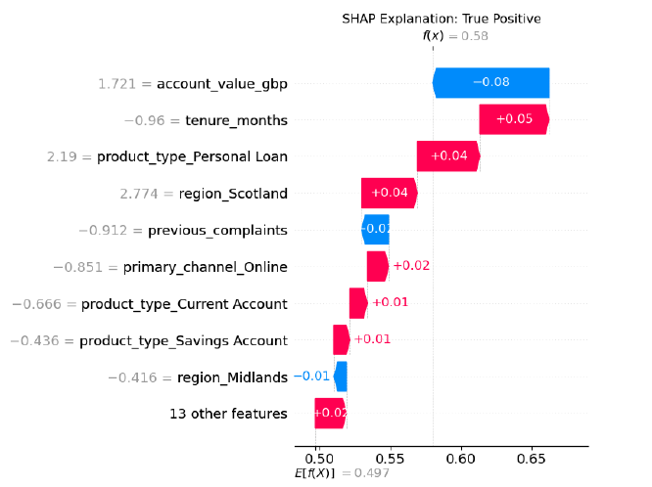
This ‌customer ‌was ‌accurately marked as high risk for escalation, and they did end up escalating. Against a baseline of 49.7%, the biggest drivers pushing the score upward were shorter-than-average tenure, meaning they were a newer customer, having a Personal Loan, and being located in Scotland, each one nudging the risk higher. A high account value tempered the score a little, but it didn’t counterbalance the upward lift, so the final risk landed at 58%. Since that result cleared the model’s decision threshold, the customer was selected for proactive outreach, which was the right call and a useful outcome.

. False Positive — flagged, did not escalate
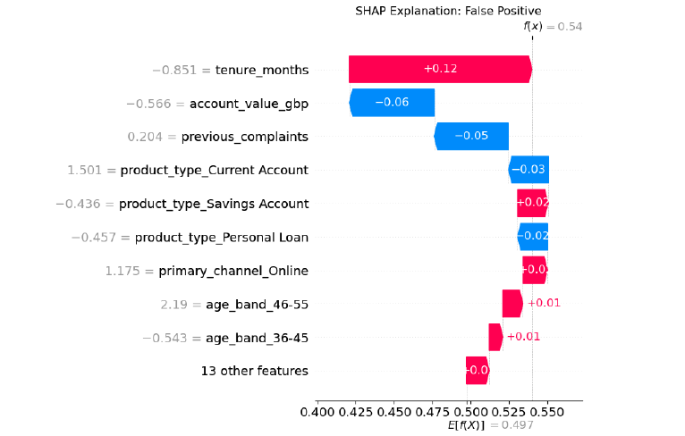
The ‌customer ‌was ‌marked high risk, though nothing actually escalated. What pushed the score up most was the short tenure, by itself it contributed about twelve points. A smaller account value nudged things the other way, and so did the near-average complaint record and the Current Account profile, each shaving off a little. Even with those offsets, the final risk landed at 54%, only just over the cutoff, which is why the flag triggered. Looking back, the outreach wasn’t needed, but that mistake costs about £25, and that’s tiny next to the roughly £800 hit you take if a real escalation slips through. This is the kind of low-cost, acceptable false alarm the threshold is intentionally set to allow.

. False Negative — not flagged, did escalate (the costly error)
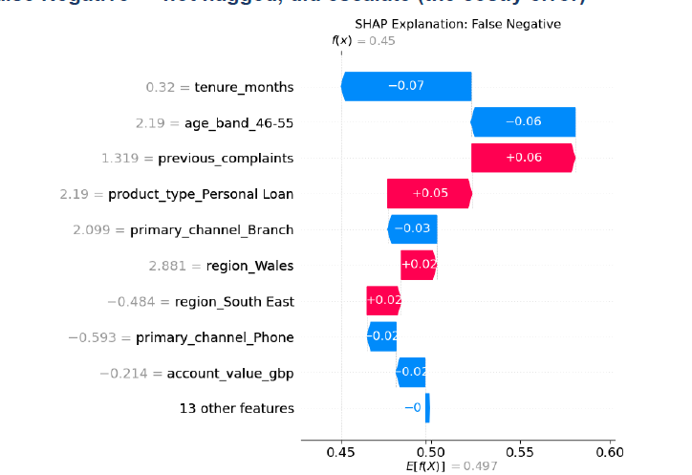
This ‌is ‌the ‌kind of mistake that ends up costing real money. The customer never got flagged, then went ahead and escalated anyway. The model dragged their score down to below average mostly because of two factors, a long tenure and being in the 46–55 age band, both treated as signals of lower risk. There were counterweights, though. They had more prior complaints than usual, and they also had a Personal Loan, which lifted the score again, just not enough. The end result was a 45% risk score, still under the decision threshold, so the system didn’t trigger any outreach. Seeing, in plain terms, why the model rated this customer too low is what allows the firm to reassess and adjust the threshold, which is the whole point of running with a low operating cut-off.

