**Victoria University**



**Assignment 2**

Advanced Object-Oriented Programming

NIT5150

**Submitted By:**

Sapana Poudel

Jeny Maharjan

# TABLE OF CONTENTS

TABLE OF CONTENTS II

LIST OF FIGURES III

LIST OF ABBREVIATION IV

1. BACKGROUND 1

1.1. Objective 1

1.2 Targeted User 1

2. SYSTEM ANALYSIS 2

2.1 Requirement Collection 2

2.2 Requirement Analysis 2

2.2.1 Functional Requirement 2

2.3 Data Modeling 2

2.3.1 Class Diagram 2

3 USER MANUAL 4

3.1 Homepage 4

3.2 Logo 4

3.3 Create 5

3.4 Edit 5

3.5 Delete 6

3.6 Details 6

4 TEST INSTRUCTION 8

5 REFERENCES 9

# LIST OF FIGURES

Figure 1Class Diagram 3

Figure 2Home page 4

Figure 3Apta Website 4

Figure 4Create Option for Organiser 5

Figure 5Edit Option for Organiser 5

Figure 6Delete Option for Organiser A 6

Figure 7Details Section of Organiser 6

Figure 8 Avoids Text Input In Number fields 8

Figure 9EMail Address Validation 9

# LIST OF ABBREVIATION

.NET Network Enabled Technology

APTA Asia Pacific Tourism Association

ASP Active Server Page

MVC Model View Controller

# BACKGROUND

Conference and events are great way of exchanging statistics, concepts and are beneficial for students and researchers. Many of the company throughout the globe, organize such conferences and events to facilitate and also gain some ideas and information to uplift their own companies. So, organizing conferences and events is fundamental task.

So, many tasks should be done while organizing and conducting events and conferences properly. Many parties work simultaneously and makes difficulties for the organizer to manage them. Recording the information related to conference / event details, organizer details, attendees’ details as well as the process of registration is itself a complex task. To overcome the problems and simplify these complex tasks, conference management system in very helpful. This structure helps in recording details related to conference like organizer details, Student/attendees’ details as well as helps in registration process too. When a conference is going to be held, interested participants can register through this system. We can track the information of organizer, conferences, events in conferences and even students taking part in the conferences.

The Asia Pacific Tourism Association (APTA) is a globally praised association in the arena of tourism, hospitality and Global Utilization. A session is whispered annually and a SSCI registered journal (Asia Pacific Journal of Tourism Research, [APJTR](http://apta.asia/wp/?page_id=98)) is printed.

The goals of APTA are to simplify value tourism and hospitality investigation, especially, in Asia-Pacific area, to stake exploration successes and to discuss ideas between academician and their complements in the business world. (APTA, n.d.)

The developed application is coded in ASP.NET platform to fulfill the course requirement. Further MVC pattern using Code First approach in Entity Framework. For database, local database is used. (Microsoft, n.d.)

The IDE used is visual studio 2012.

## Objective

The main objective of this work is:

* To track the Conference/Events and Attendees’ Registration
* To help organizer organize conference using this system more easily.

## Targeted User

As the main task is to solve the registered details, the targeted user of APTA could be:

1. Conference/Event Organizer
2. Admin panel from APTA
3. Attendee

# SYSTEM ANALYSIS

The technical analysis of the project including requirement analysis is explained in this chapter.

## Requirement Collection

APTA needs to design and develop a management system for tacking the details of conferences. The program needs to track the organizer details who will host the conference and register the events in every single conference. The viewer or students need to see the organizer details and conferences details and register the conference.

Further, certain technical limitations are provided where the logo is to appeared in every single webpage. The detail page should contain the requirement and different relational database approach are to be followed.

## Requirement Analysis

## Functional Requirement

The functional requirement analyzed during the requirement collection phases are:

1. Registration

* Description:
* Before creating the conference and events, organizer should be registered first
* Student should register themselves selecting the conference name.
* Input:

Organizer and Student Details

* Output:

List of Registration

* Processing

Organization details are validated before input and stored in database.

1. Creating the Conference and Events

* Description: After the organization is registered, the organizer can post the conference details and associated events
* Input:

Conference and event details

* Output:

List of Conference and events

* Processing

Only the registered organization can post the valid information of conference and events.

## Data Modeling

## Class Diagram

The following figure shows the class

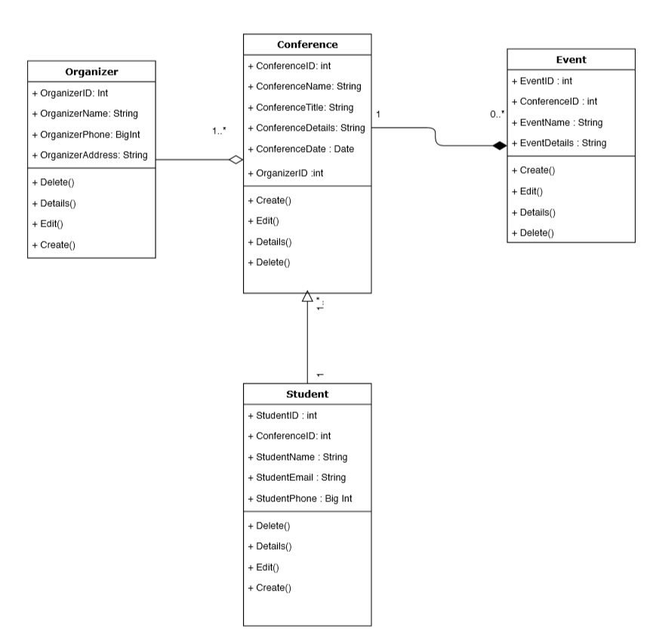

Figure Class Diagram

To solve the overall workflow the following tables are created

1. Organizer
2. Conference
3. Event
4. Student

The arrow between the classes shows the relationship between them and the multiplicity. A single organizer can post multiple conference (One-to-many relationship). Likewise, many conferences may or may not have events (many-to-many relationship) where as a single student can register multiple conference.

# USER MANUAL

This chapter includes the way of using the application. The following topics along with the screenshot explain the overall process.

First of all, the organizer should register themselves and can only appoint them as organizer in conference section.

After registering the Organizer, one can post the conference details and in event section the associated event details in certain conference can be done.

Finally, the student or attendee can select the required conference.

## Homepage

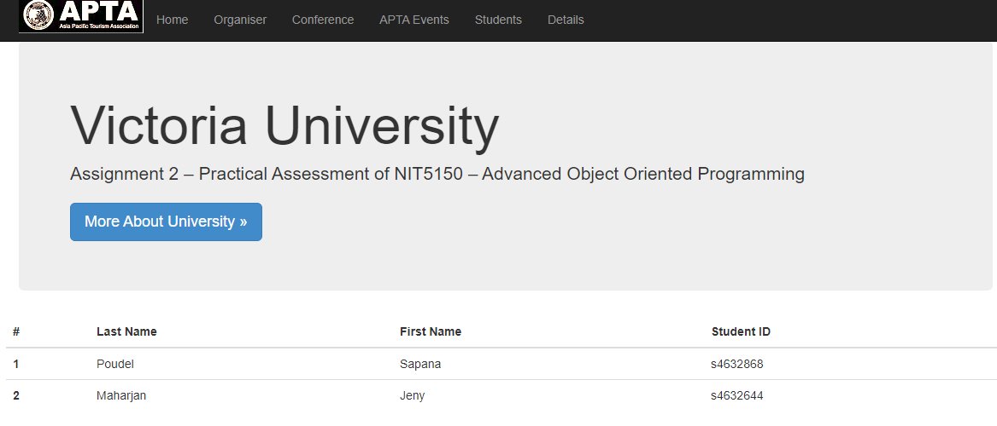

Figure Home page

## Logo

Logo appears in every webpage and redirects to official APTA page.

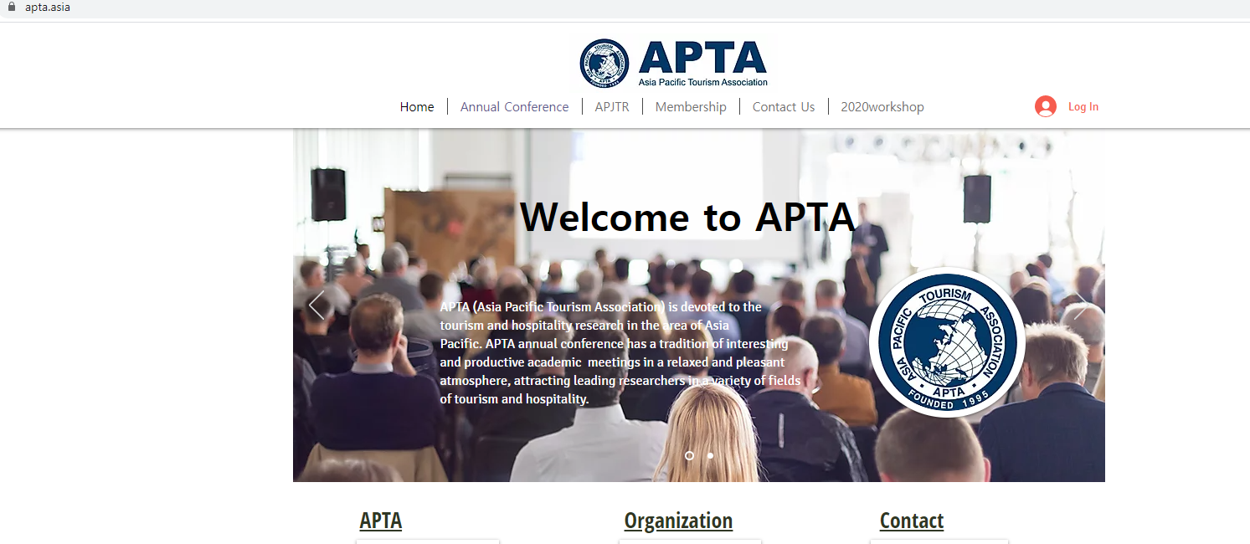

Figure Apta Website

## Create

Organizer and Attendee can create the information easily. The following figure shows the create option for organizer.

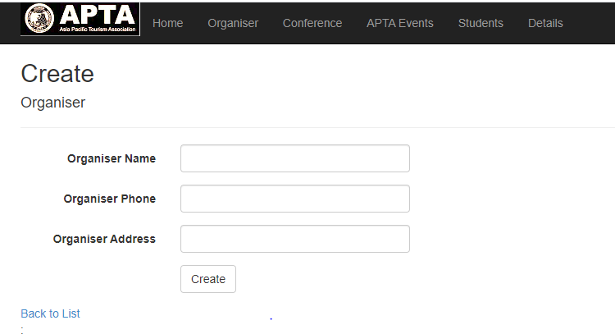

Figure Create Option for Organizer

## Edit

Organizer and Attendee can Edit the information easily. The following figure shows the Edit option for organizer.

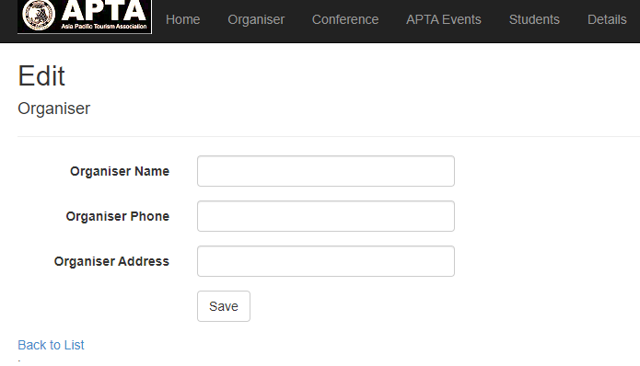

Figure Edit Option for Organizer

## Delete

Organizer and Attendee can create the information easily. The following figure shows the Delete option for organizer.

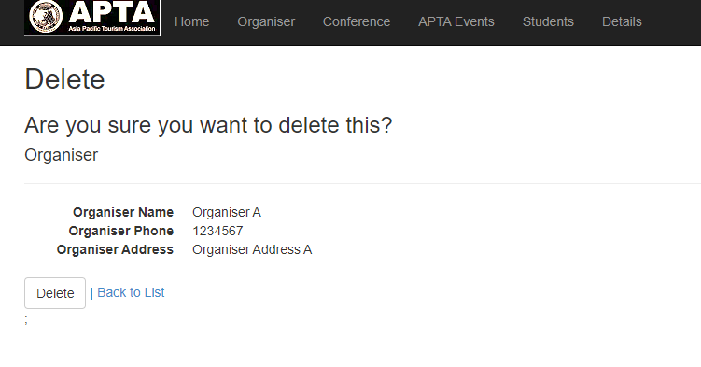

Figure Delete Option for Organizer A

## Details

Organizer and Attendee can create the information easily. The following figure shows the Details option for organizer.

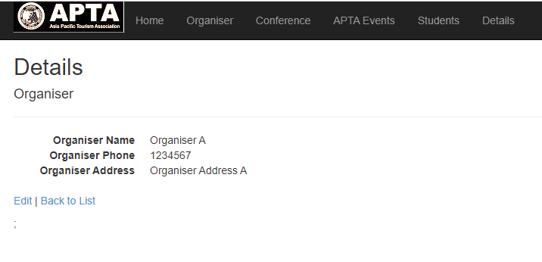

Figure Details Section of Organizer

# TEST INSTRUCTION

Data validation is done in basic required fields. For example, phone number validations and email address validation.

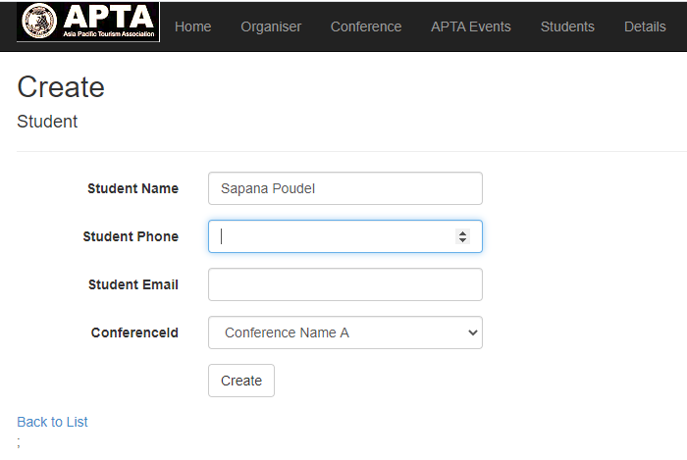

Figure Avoids Text Input In Number fields

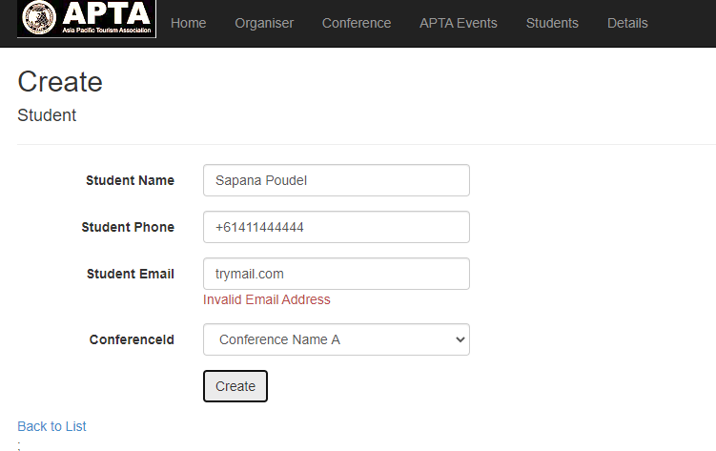

Figure EMail Address Validation

# REFERENCES

APTA. (n.d.). Retrieved from Asian Pacific Tourism Association: http://www.apta.asia

Microsoft. (n.d.). *Microsoft.com*. Retrieved from https://docs.microsoft.com/en-us/ef/