KUBERNETES 2

.After preparing the Kubernetes cluster we configured our andisble and jenkins server using putty.
And developed a password less connection between the ansible server and the Controller- Machine.

.NOTE:- We used to controller-machine despite of the Master Node of the Kubernetes cluster because the Master Node is already linked with the controller machine.

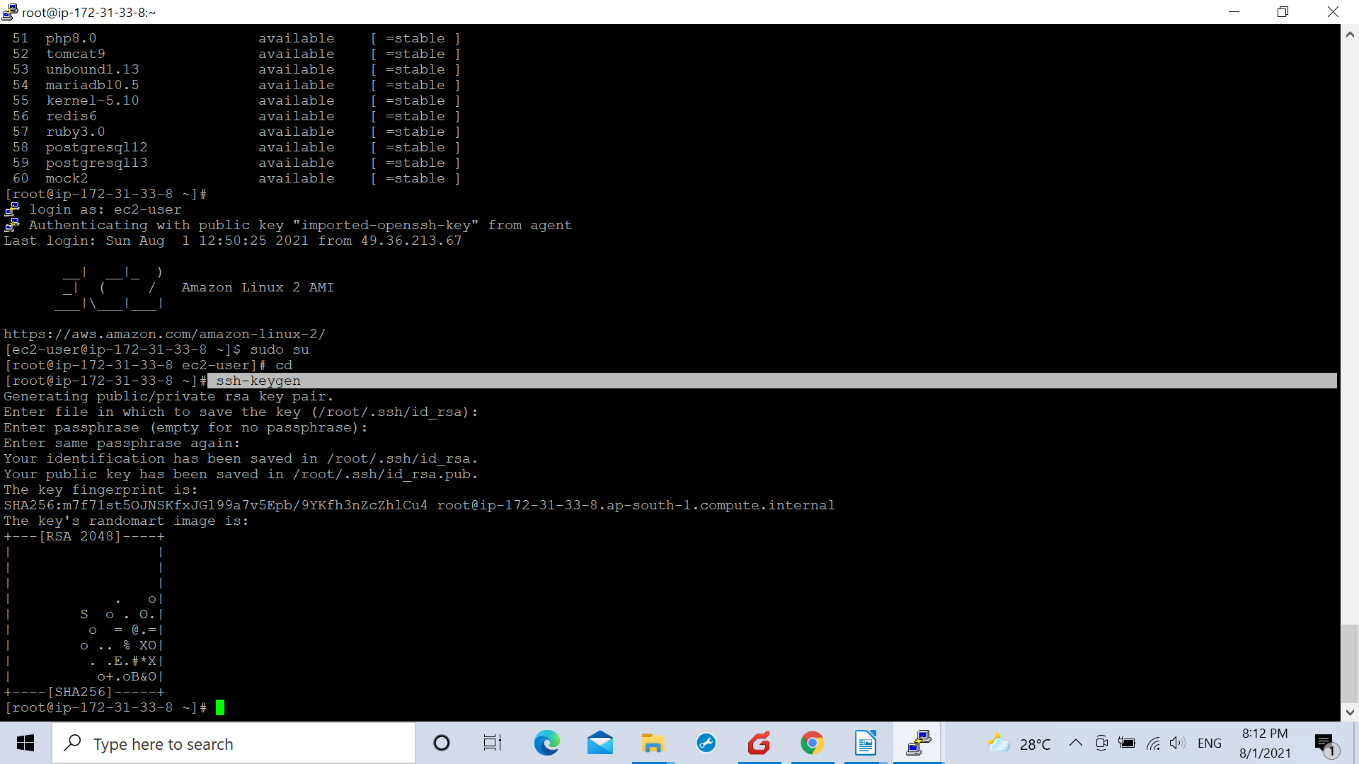

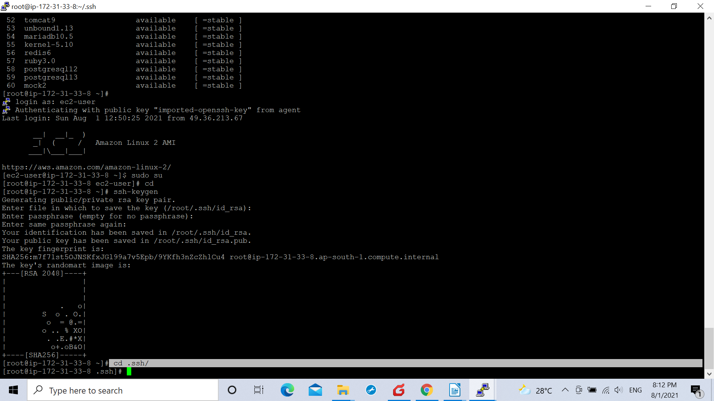
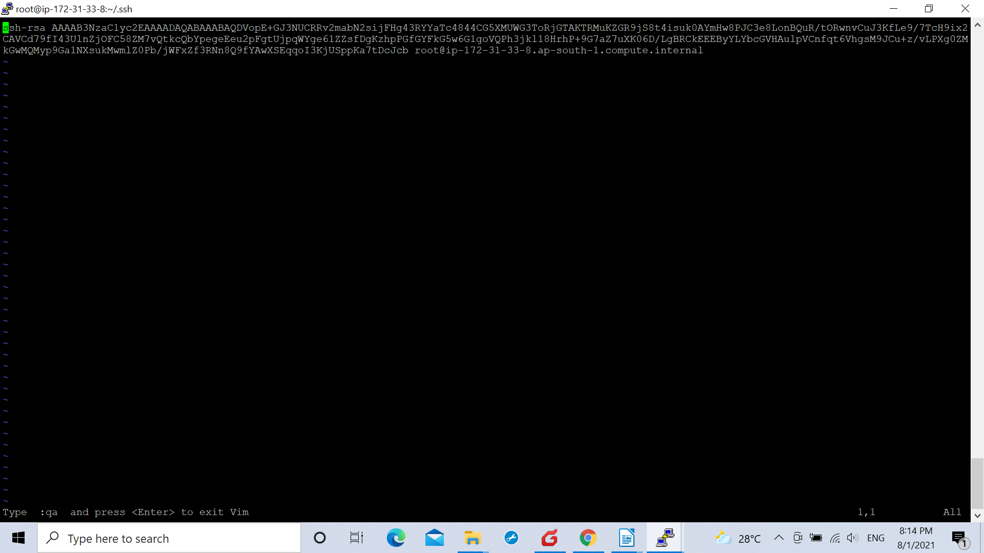
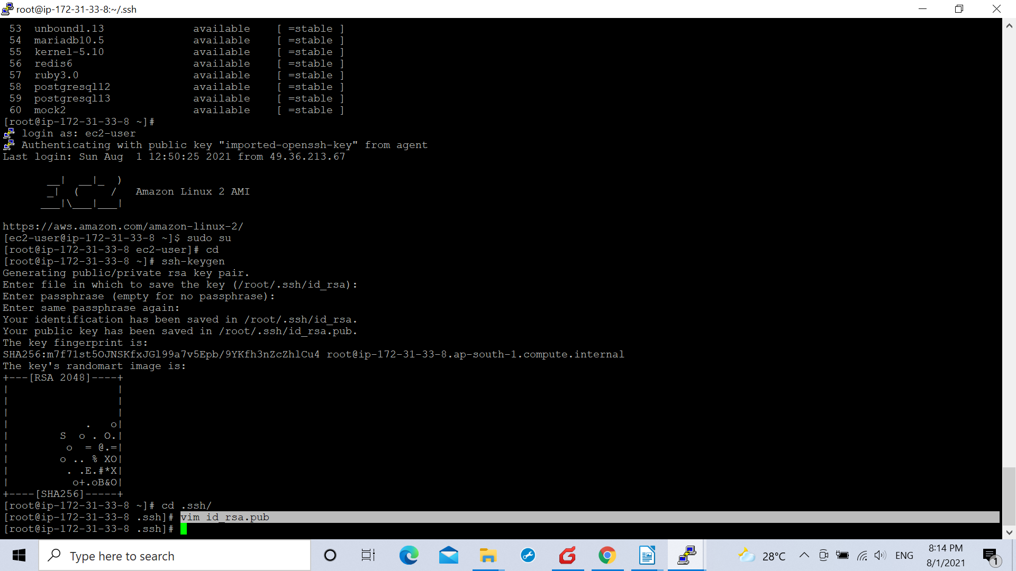

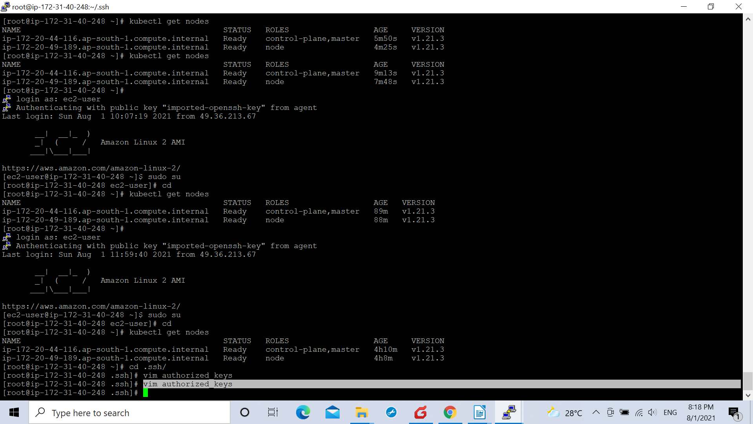

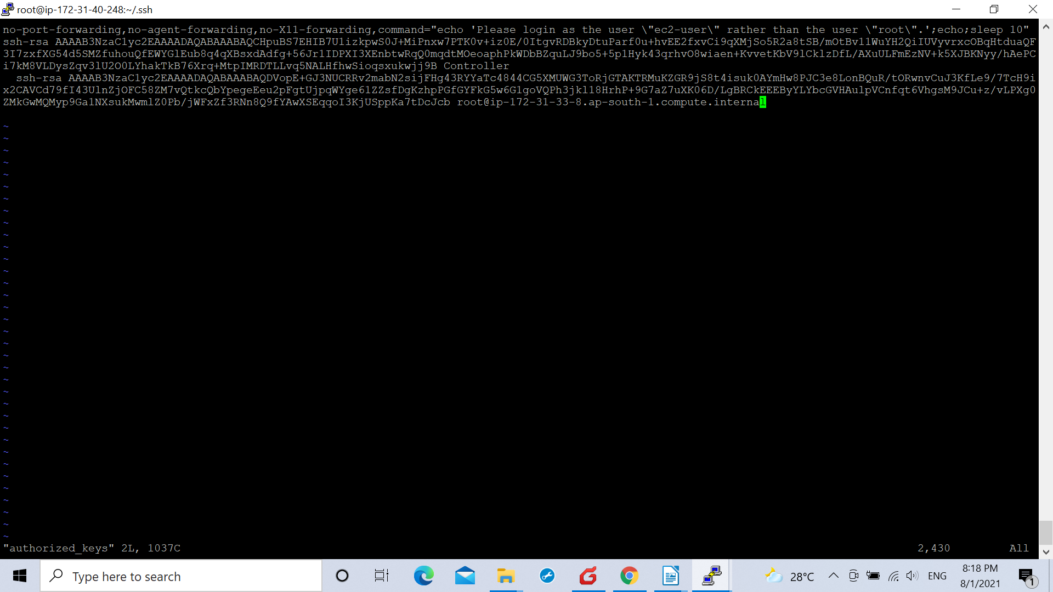

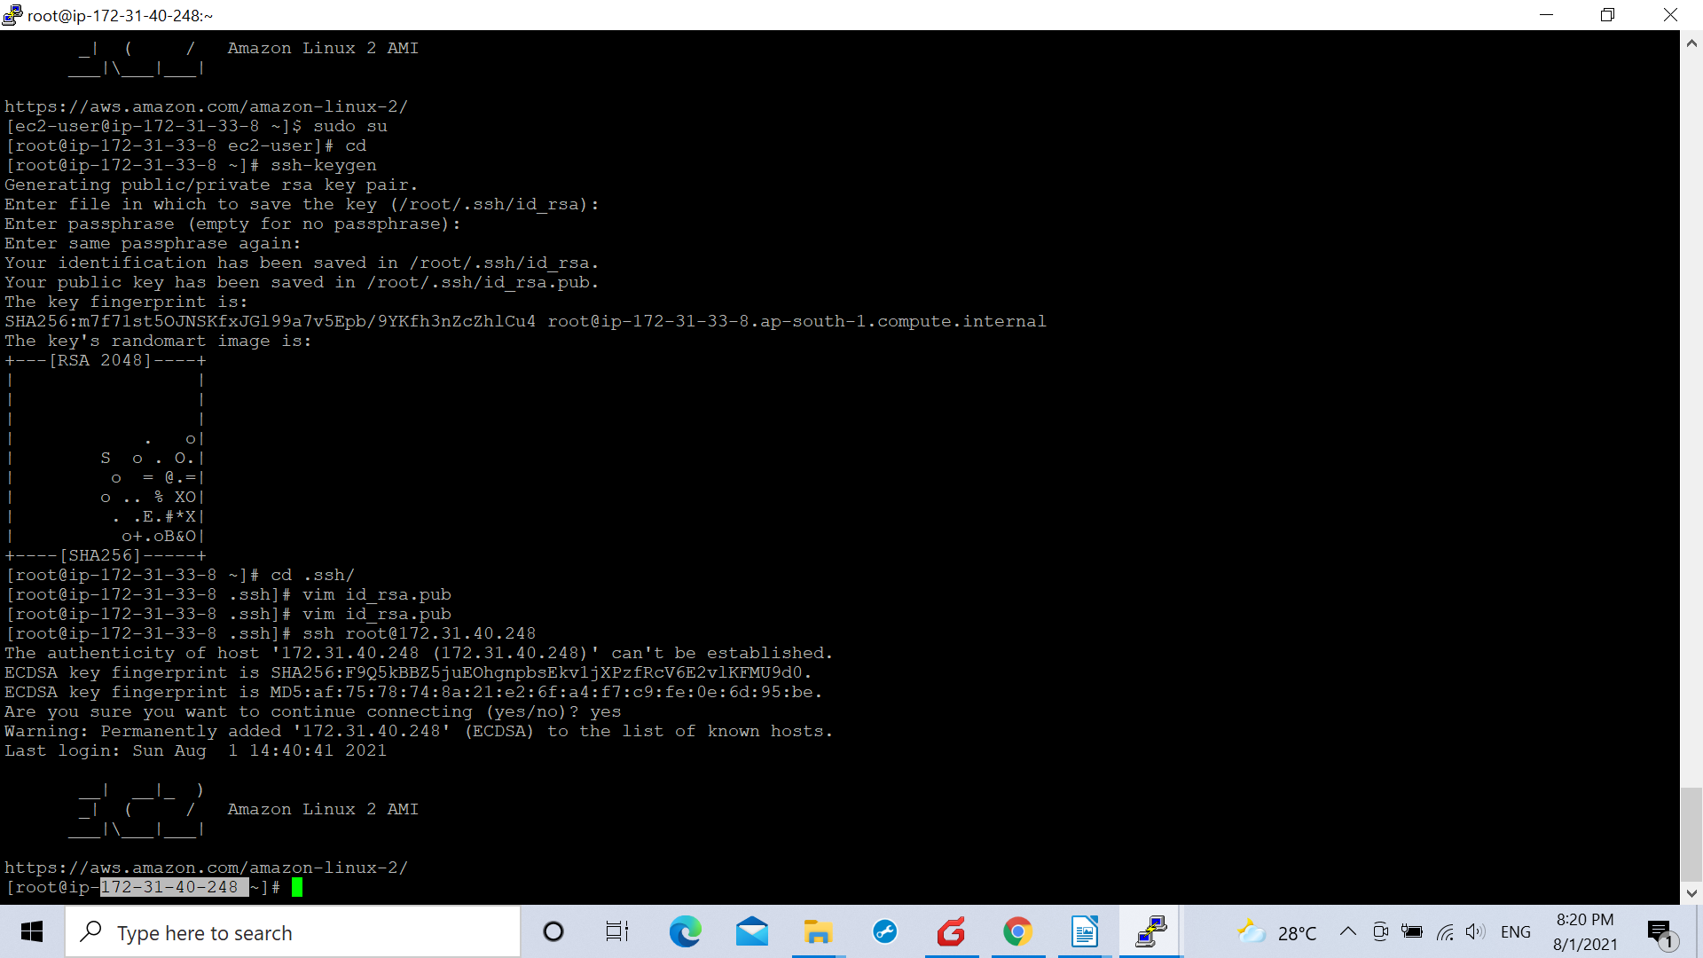
.Hence we made a password-less communication between ansible and controller-machine.

.We created a deployment.yml file on the controller-machine and defined it.

ApiVersion: apps/v1
kind: Deployment
metadata:
name: mohandave
spec:
selector:
matchLabels:
app: mohandave
replicas: 2
strategy:
type: RollingUpdate
rollingUpdate:
maxSurge: 1
maxUnavailable: 1
template:
metadata:
labels:
app: mohandave
spec:
containers:
- name: mohandave
image: mohan1809/ci
imagePulPolicy: Always
ports:
- containerPort: 80

. After that we created a service.yml file in the controller-container opt file

apiVersion: v1
kind: Service
metadata :
name: mohandave
labels:
app: mohandave
type: LoadBalancer
ports:
- port: 8080
targetPort : 80
nodePort: 31200

.The docker image was saved on the docker hub repository from where the conroller machine took it and sent it to the masternode of the kubernetes cluster

.It started appearing on the Kubernetes cluster .

.Hence this completed our pipeline and could be seen by copying the IP of any node and pasting it on the browser with the port number appearing on the kubernetes cluster that could be seen using the command

kubectl get nodes

.Hence pasting the port number of any node with its IP on the browser will show us the url from the docker image.


The port number was 31200 in our case and the IP of a worker node was 13.233.116.185
(FINAL DEPLOYMENT ON KUBERNETES CLUSTER WORKER NODE IN OUR PIPELINE)

This was our docker image file on the GITHUB repository provided by the developer.

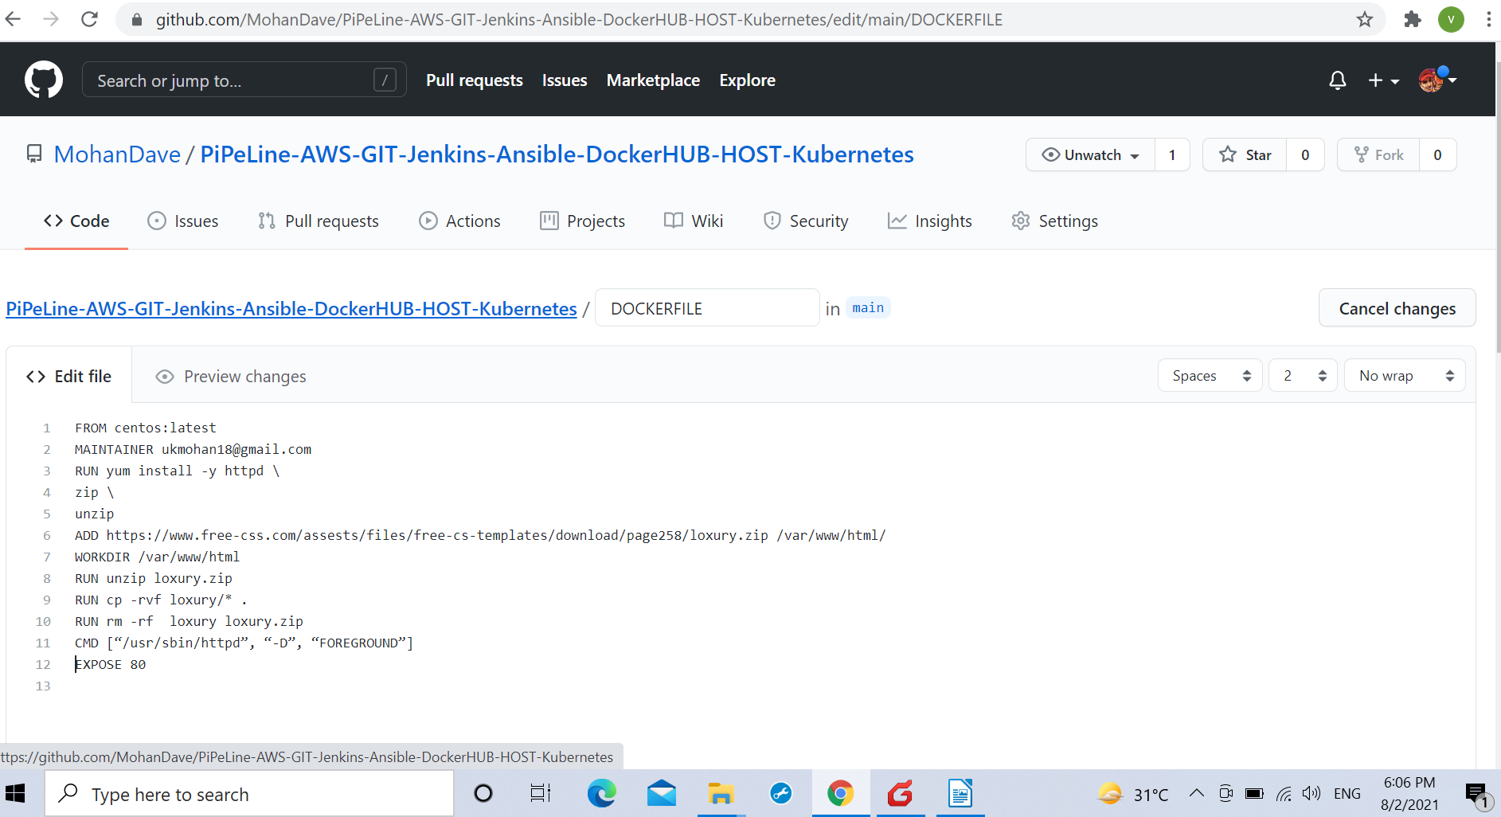
(INITIAL POINT OF OUR PIPELINE THE DOCKER FILE BY THE DEVELOPER ON THE GITHUB REPOSITORY)

