ANSIBLE
. Our ansible server is configured and a docker container is created within it. This was designed to store the built docker image that it got from the jenkins server and saved it in its playbook.yml file which was sent to the deployment point , the Kubernetes cluster node where the deplyment and service was created.

.The ansible server was configured on a Amazon Linux 2 (AMI) machine on our AWS console using the putty software.

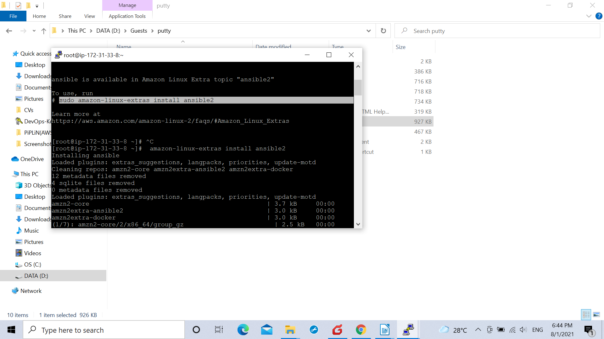

.The root password was set on the ansible server after installing the ansible packet on it using
amazon-linux-extras install ansible2
command and root login was enabled along with password authentication
post which it was added on the jenkins server.

.After preparing the Kubernetes cluster we configured our andisble and jenkins server using putty.
And developed a password less connection between the ansible server and the Controller- Machine.

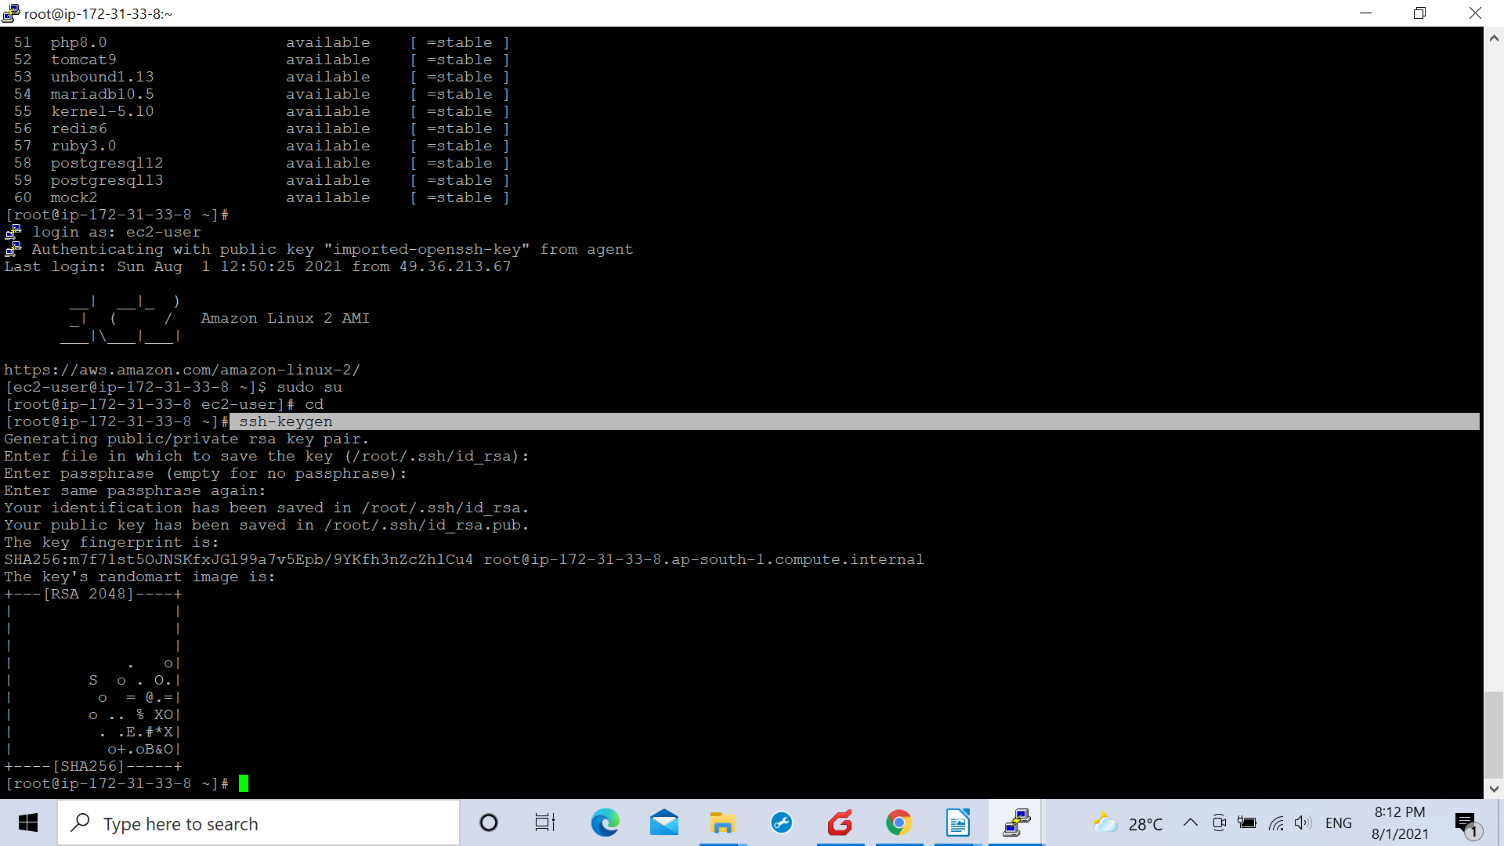

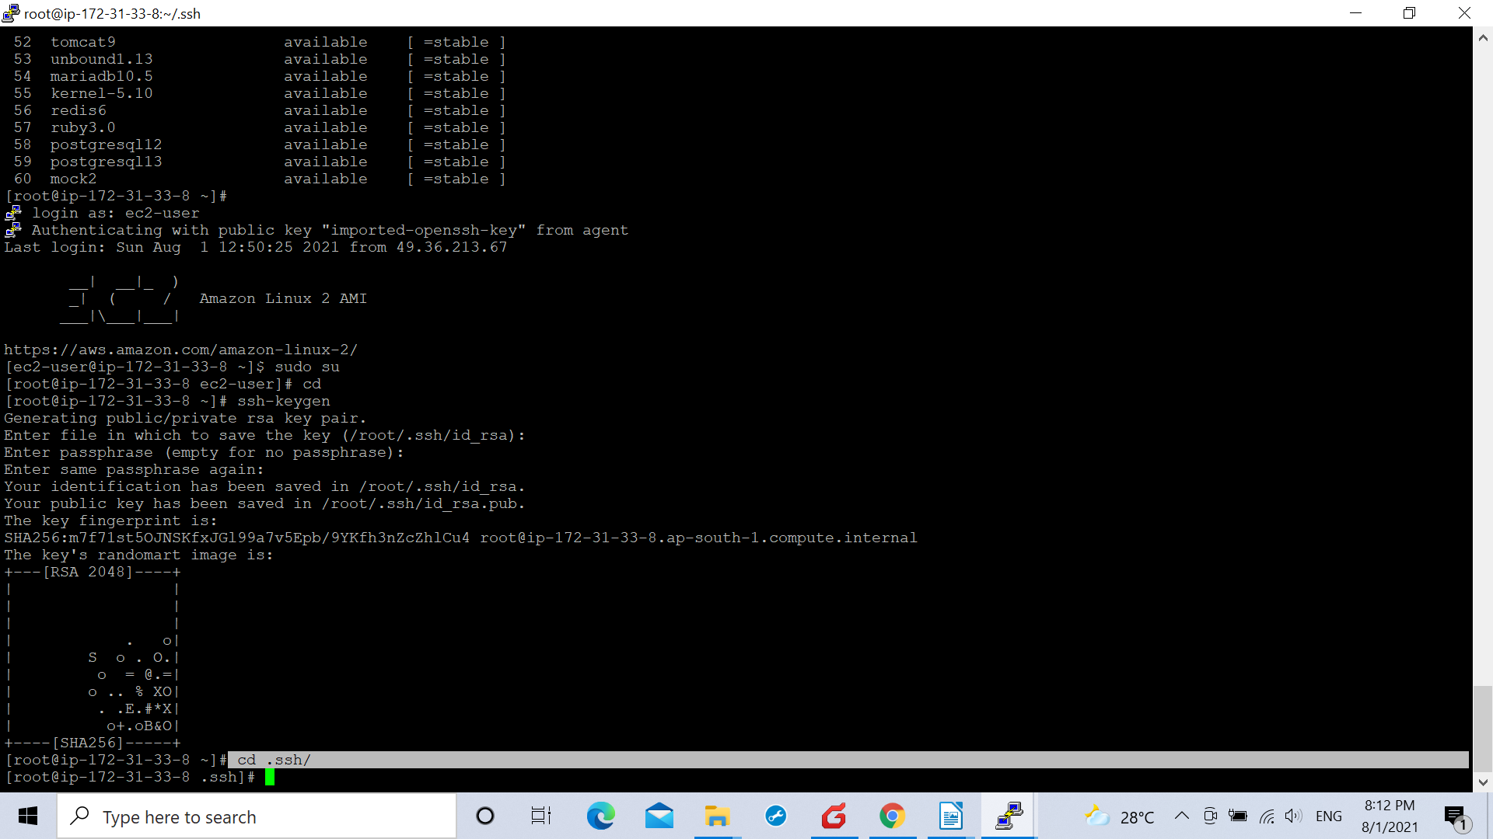
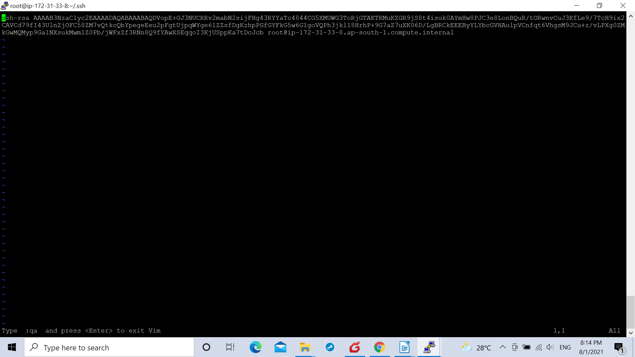
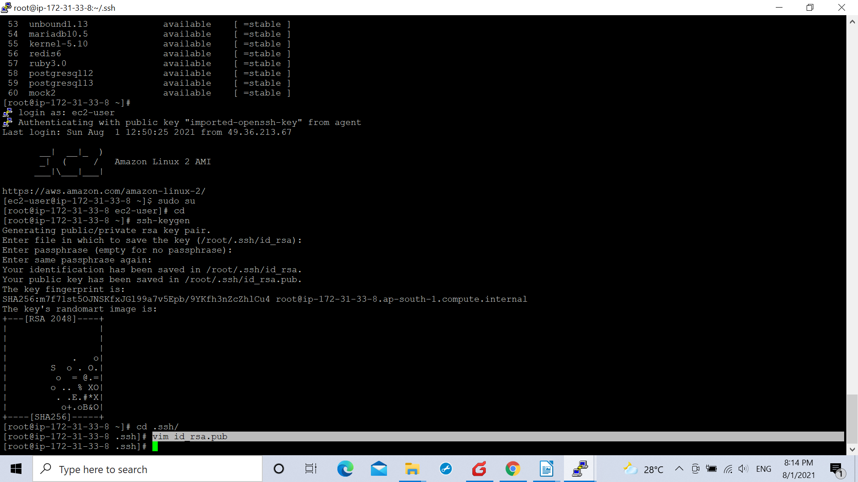

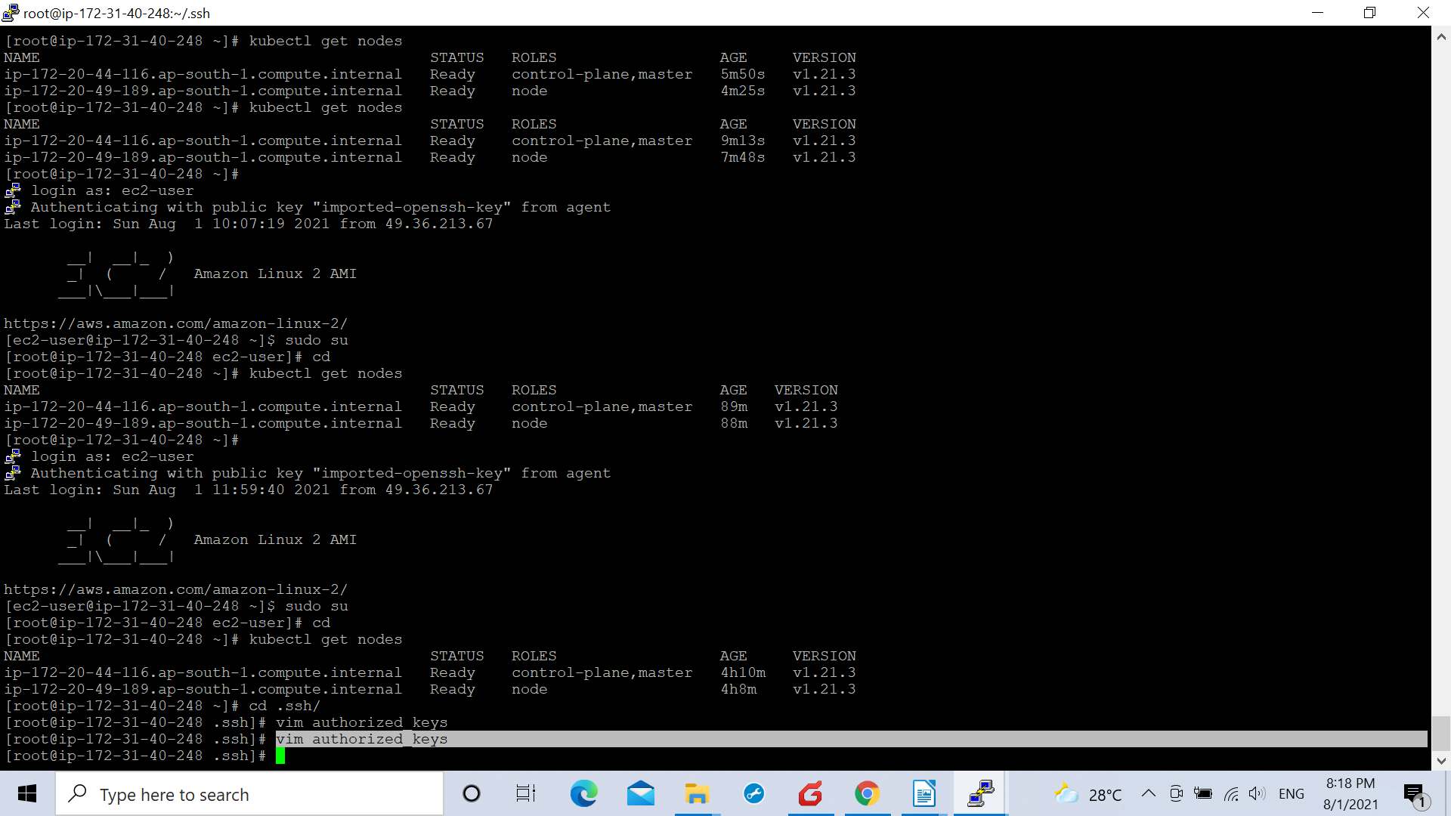

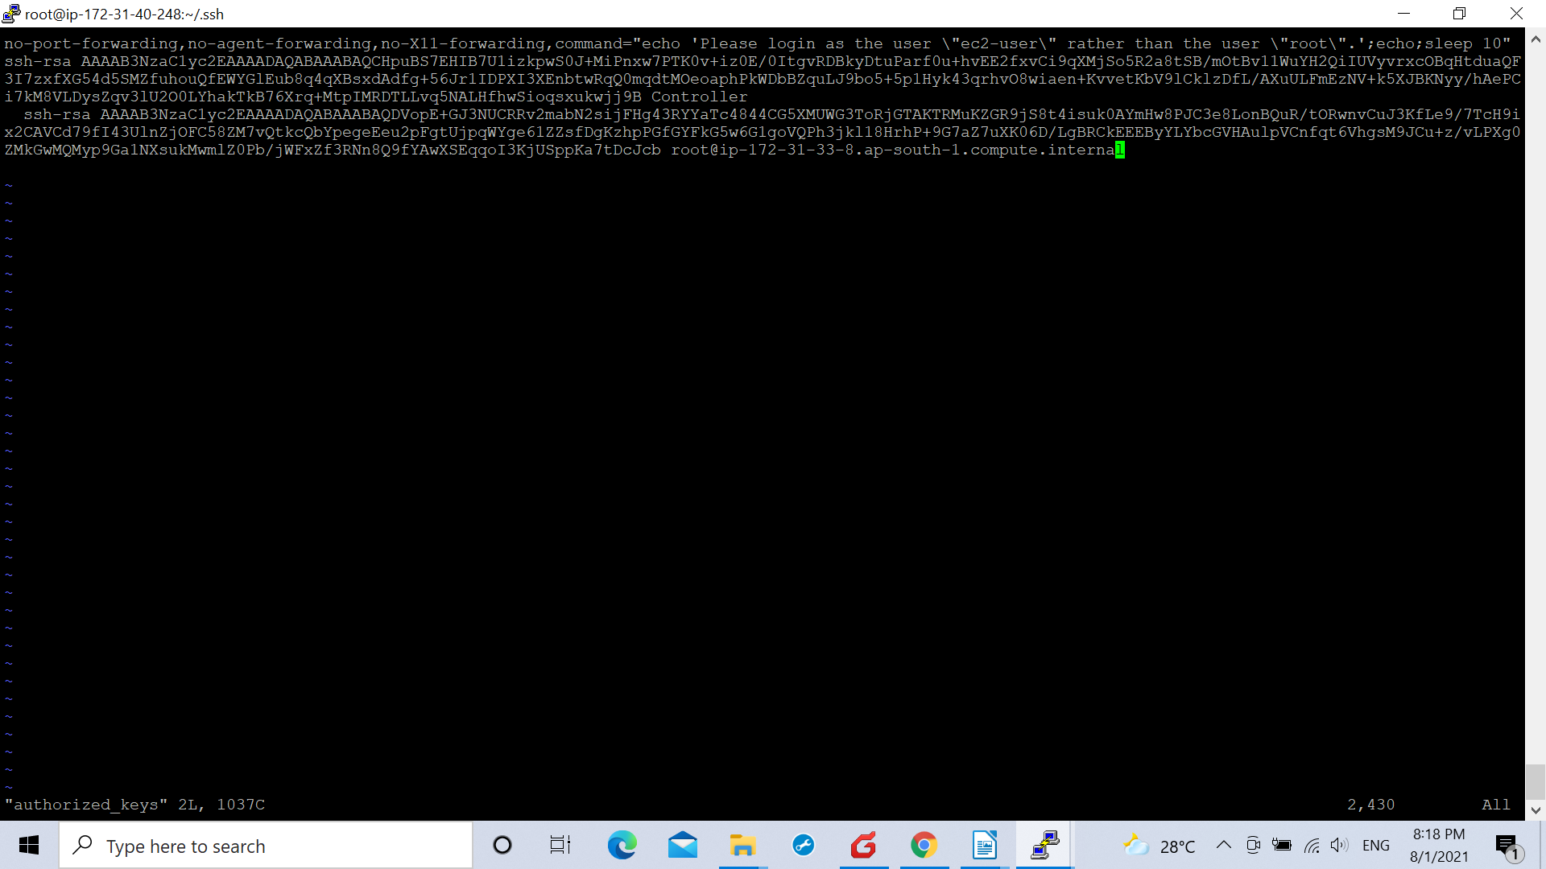

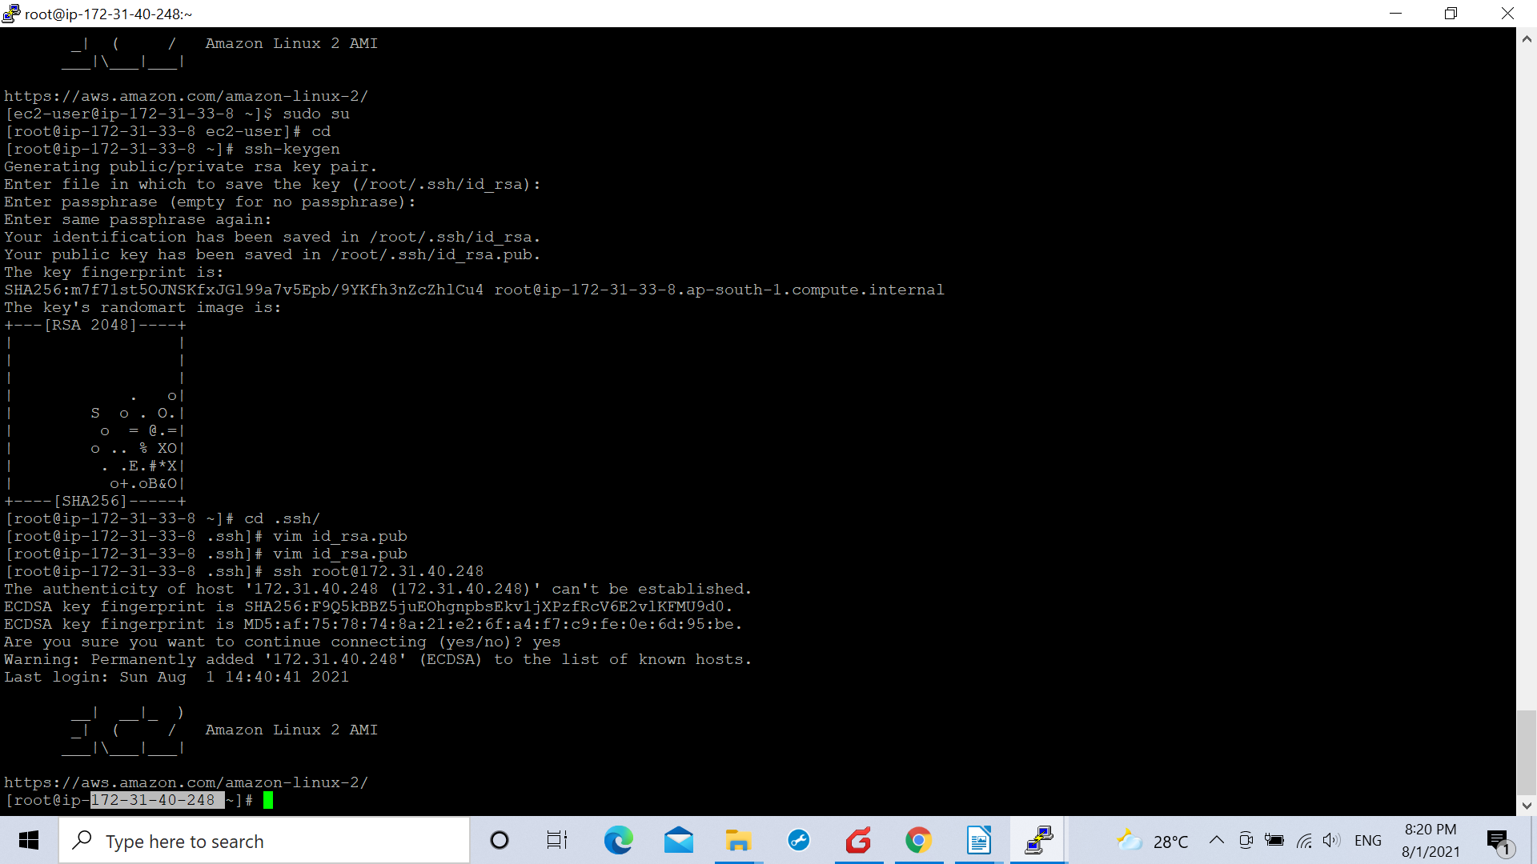
.Hence we made a password-less communicatin between ansible and controller-machine.

.We installed Docker package on the ansible server as the docker image was to be built using docker
package on the ansible server.

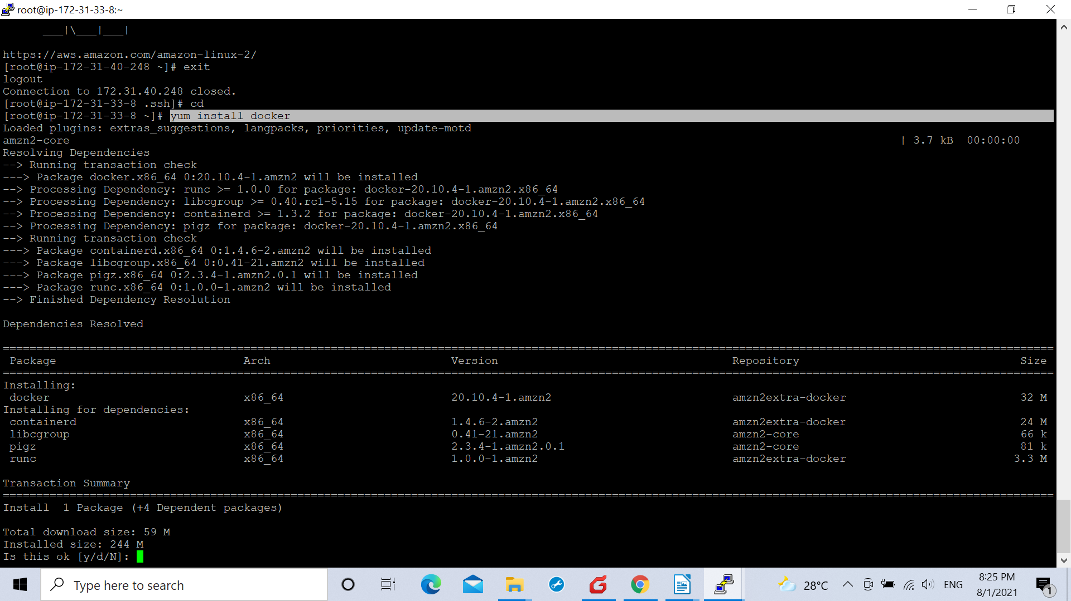

using command :-
yum install docker

and using the commands:-

systemctl start docker

systemctl enable docker

we started docker on our ansible server.

.After this we made a passowrd-less communication between ansible and jenkins server as the jenkins server will receive the docker image file from the dveloper form GITHUB to whom it was integrated and will throw the docker image on the ansible server for its building purpose on the ansible i.e. on the docker host. Hence thats why we made a password less communication between both th servers.

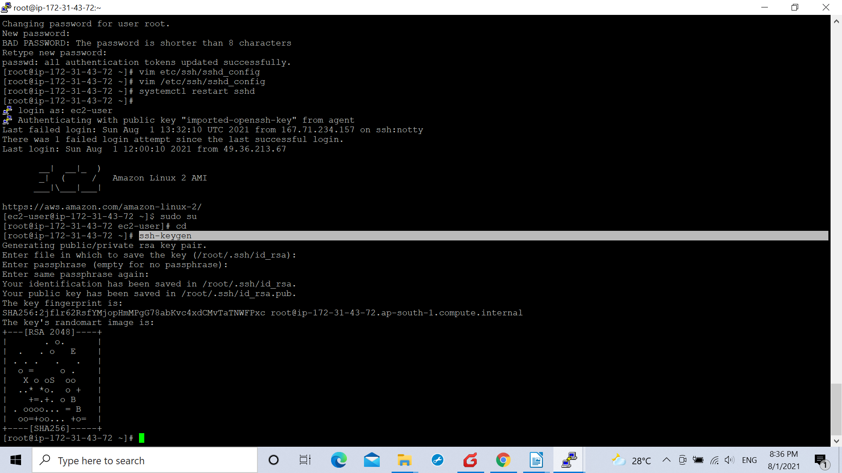

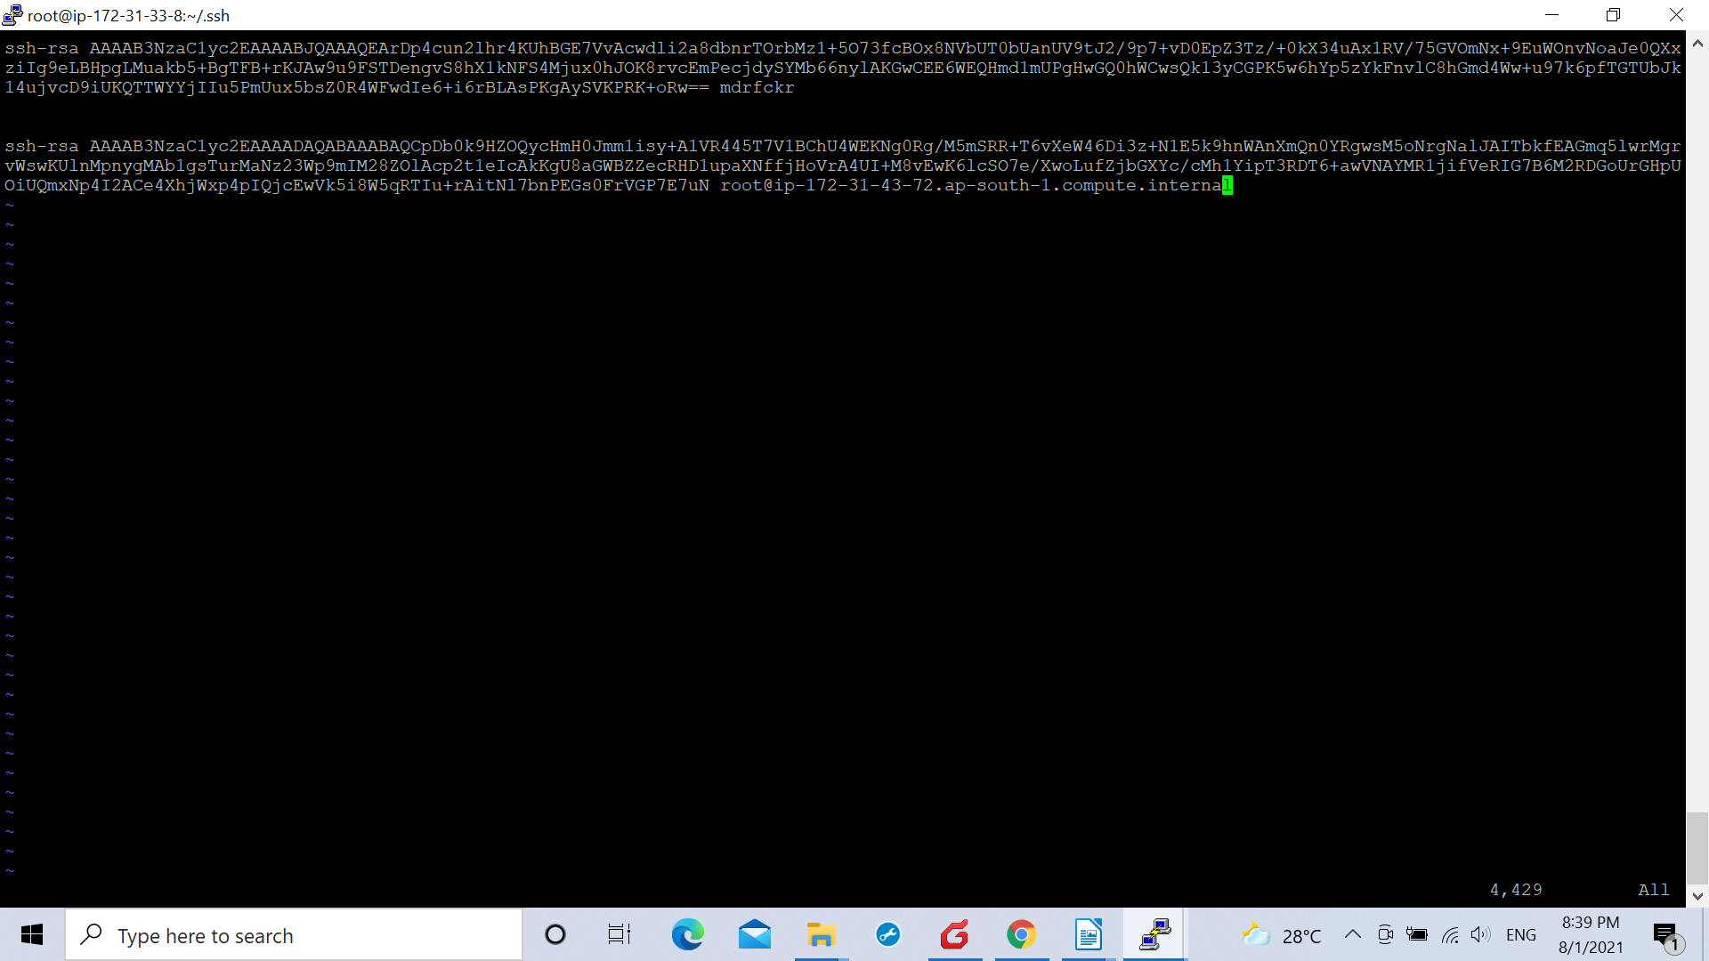

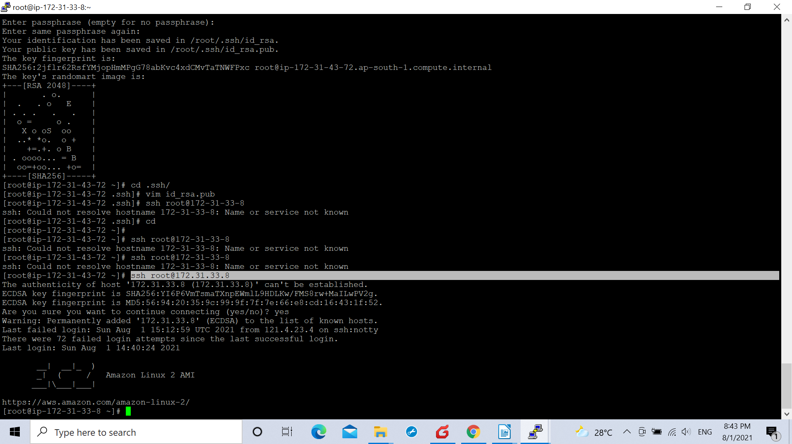

.Hence a passwordless communication between ansible and jenkins is created.

.Post the above process we logged in to our Docker Host (Docker repository) on the ansible server as from the image will be pushed on the cluster .

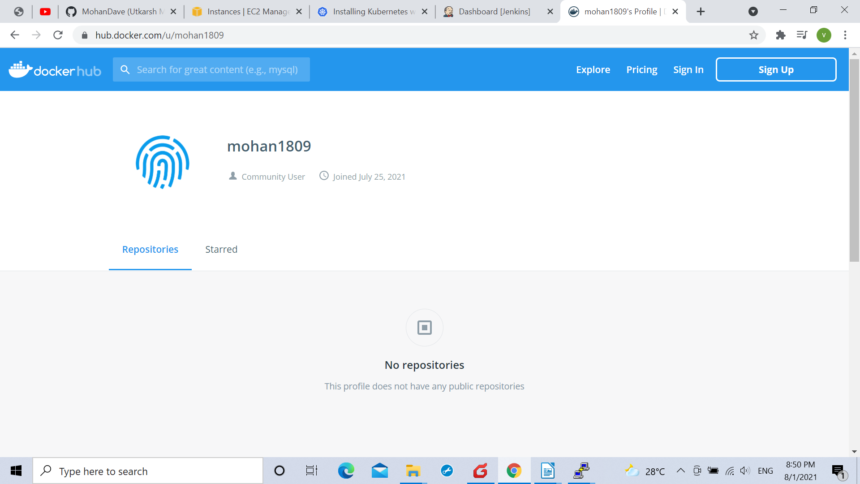

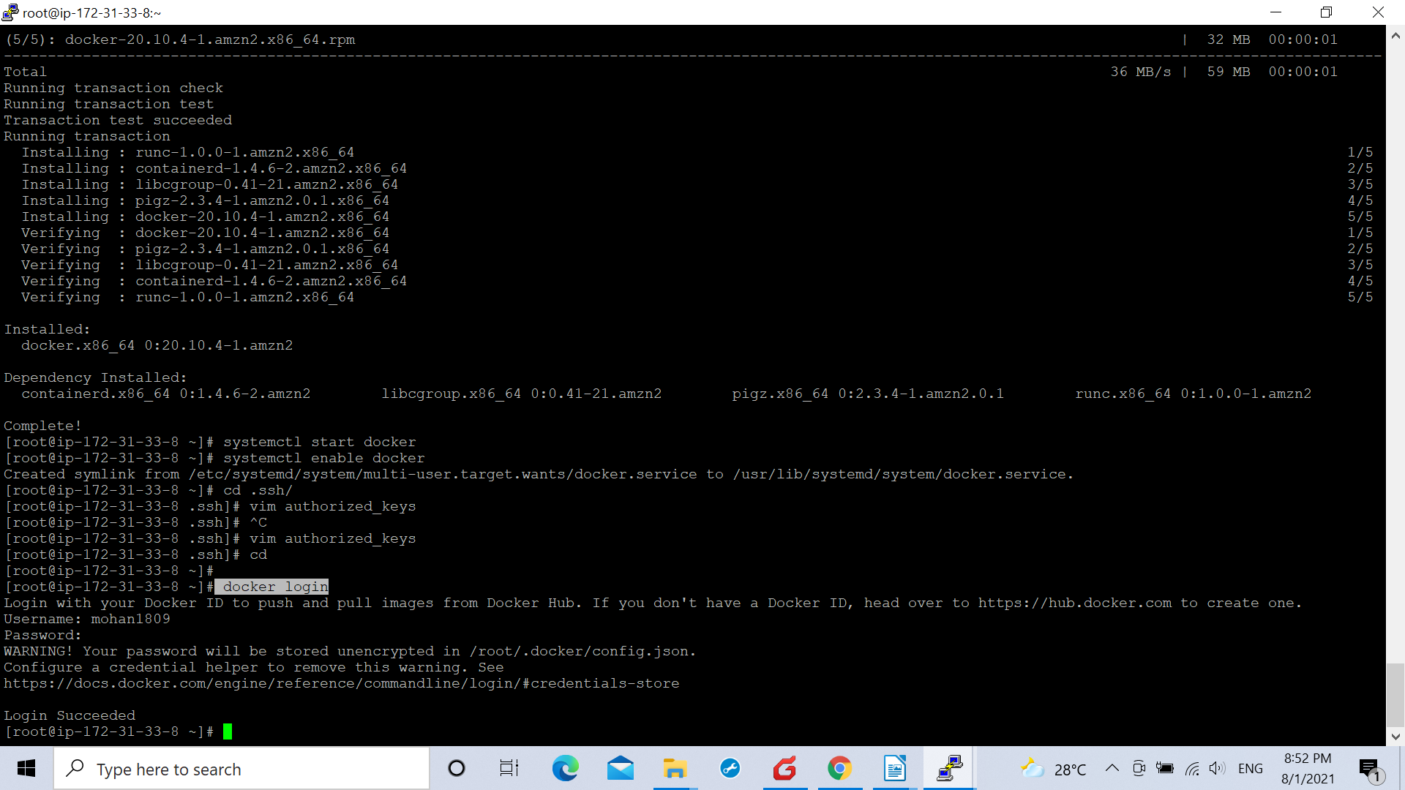

.Hence we logged in to our docker hub profile on the ansible server.

.After that we designed our playbook on the ansible server named ansible.yml

-hosts: all
become: true

- name: create new deployment
command: kubectl apply -f /opt/deployment.yml

- name: create new service
command: kubectl apply -f /opt/service.yml

.After creating in the playbook ansible.yml we added the private id of the controller-machine in the ansible hosts file using the command:-

vim /etc/ansible/hosts

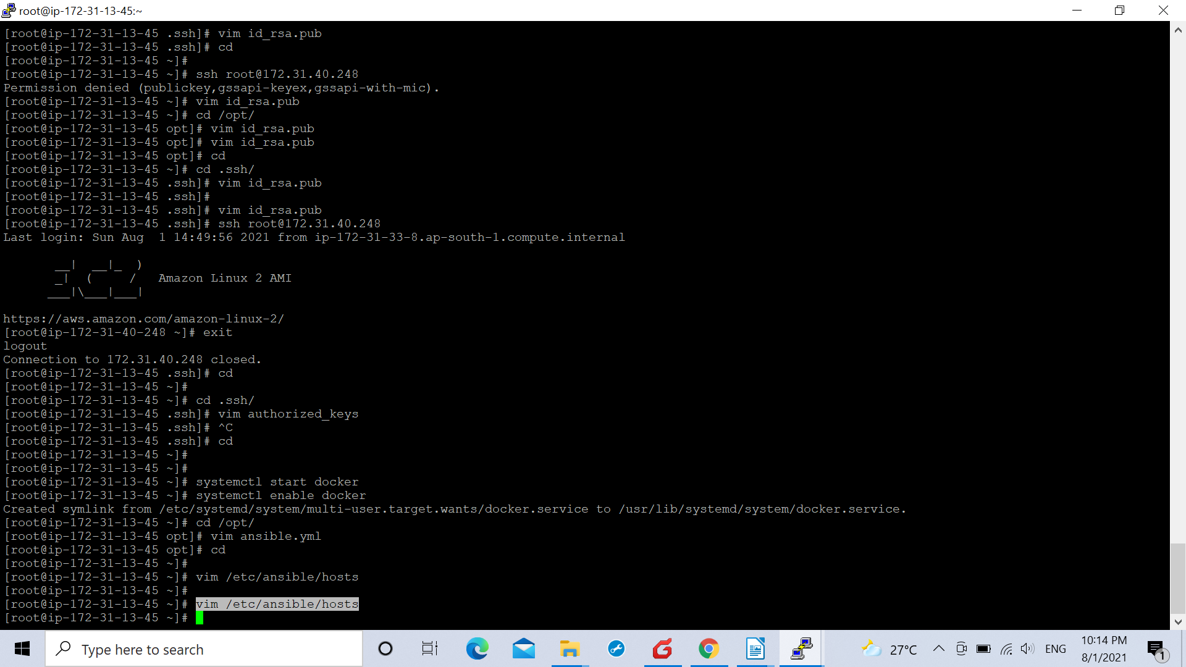

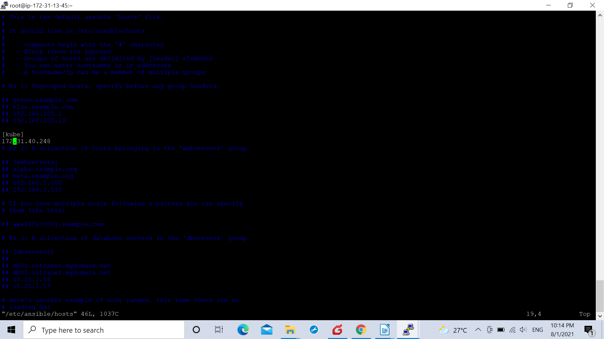
.Post which we created a passwordless communication between the two

.With this arrangement the controller machine tookthe docker file from the docker hub repository logged in on the ansible server and will send it to the master node of the kubernets cluster linked with it for deployment purpose.

