DOCKER

.The Docker Package was installed on the Ansible server using the
‘yum install docker’
command

.The ansible server was created in the Amazon Web Services AWS account on an Amazon Linux 2 (AMI) Instance .

.The image was pushed from the jenkins server to the ansible server for a build which inturn saved in the playbook as ansible.yml file

.From there the an image of the docker file was saved on the Docker hub repository from where the Controller Machine took the file and sent it to the master node in the Kubernetes Cluster.

.The Docker hub was logged in on the ansible server for the above mentioned purpose.

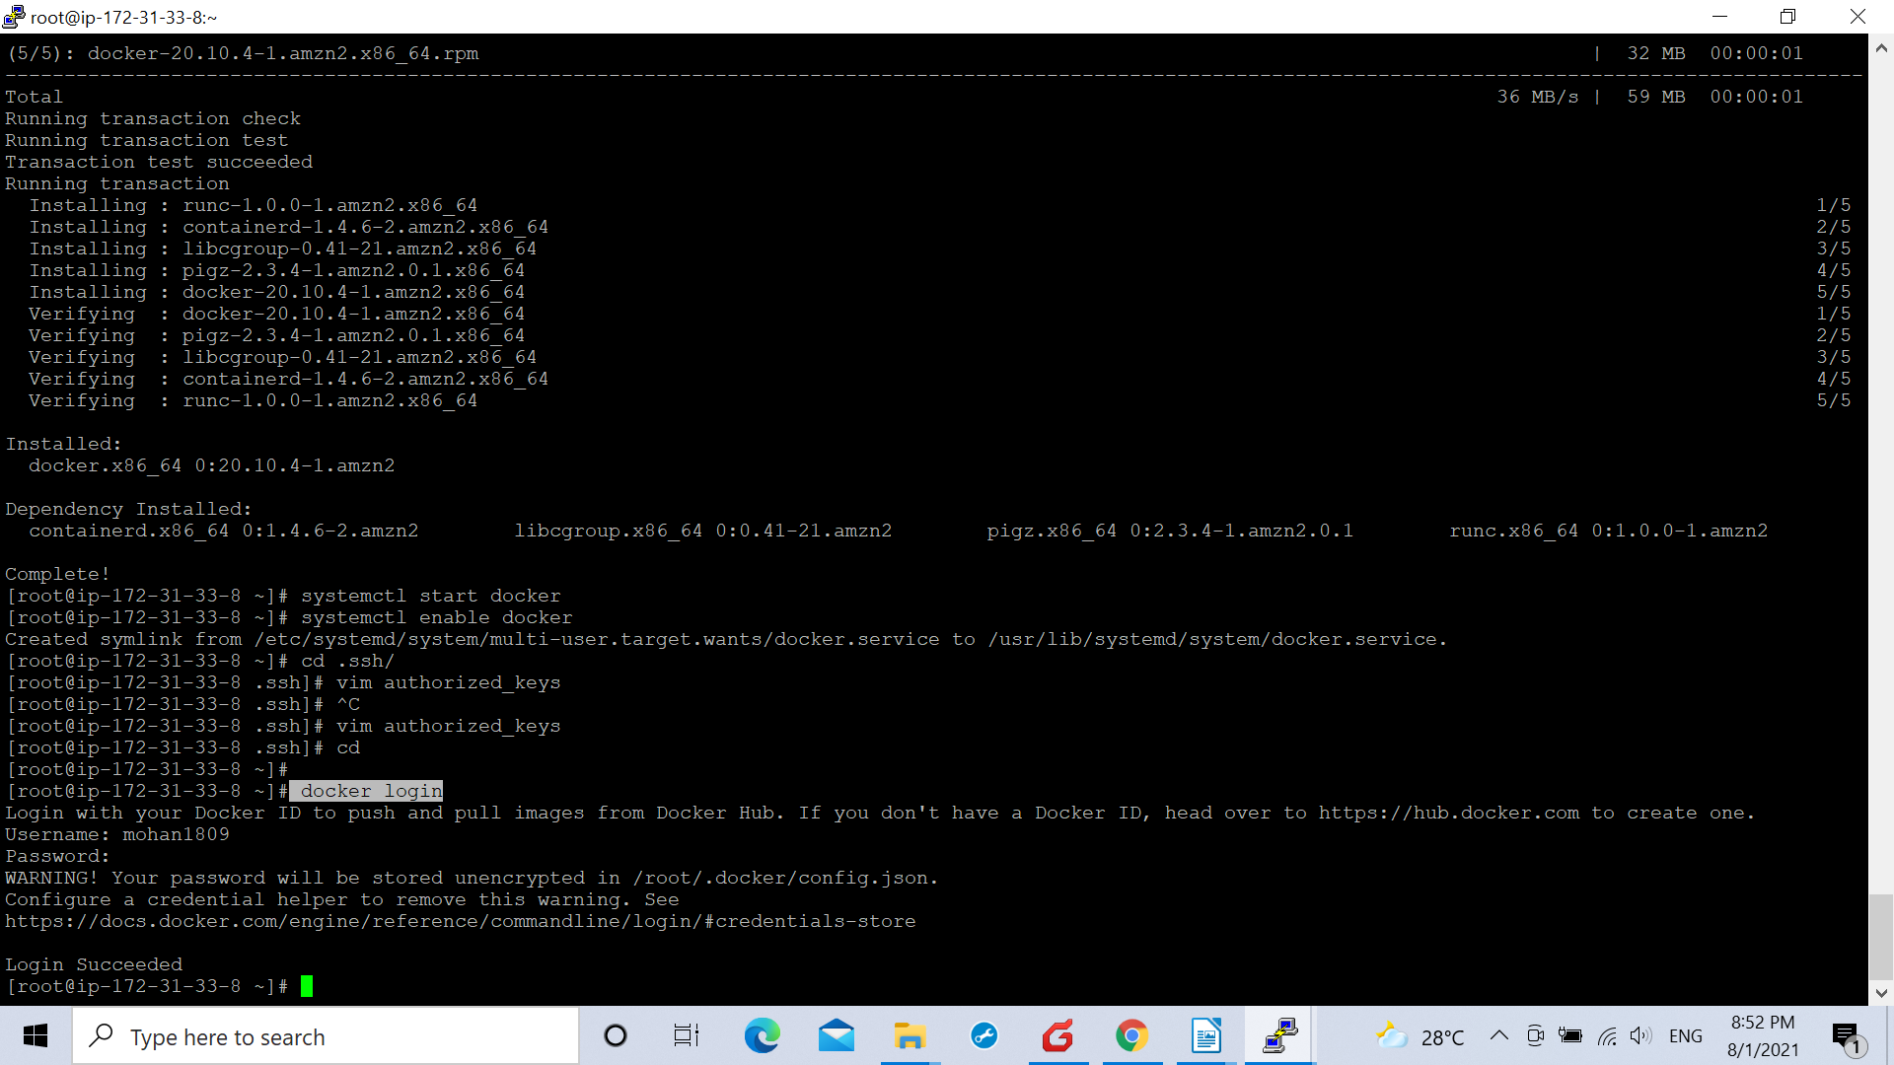

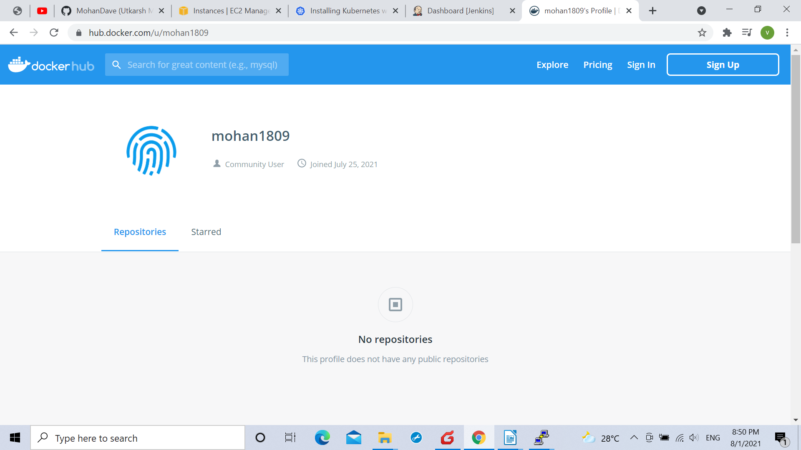
This was our docker hub account.

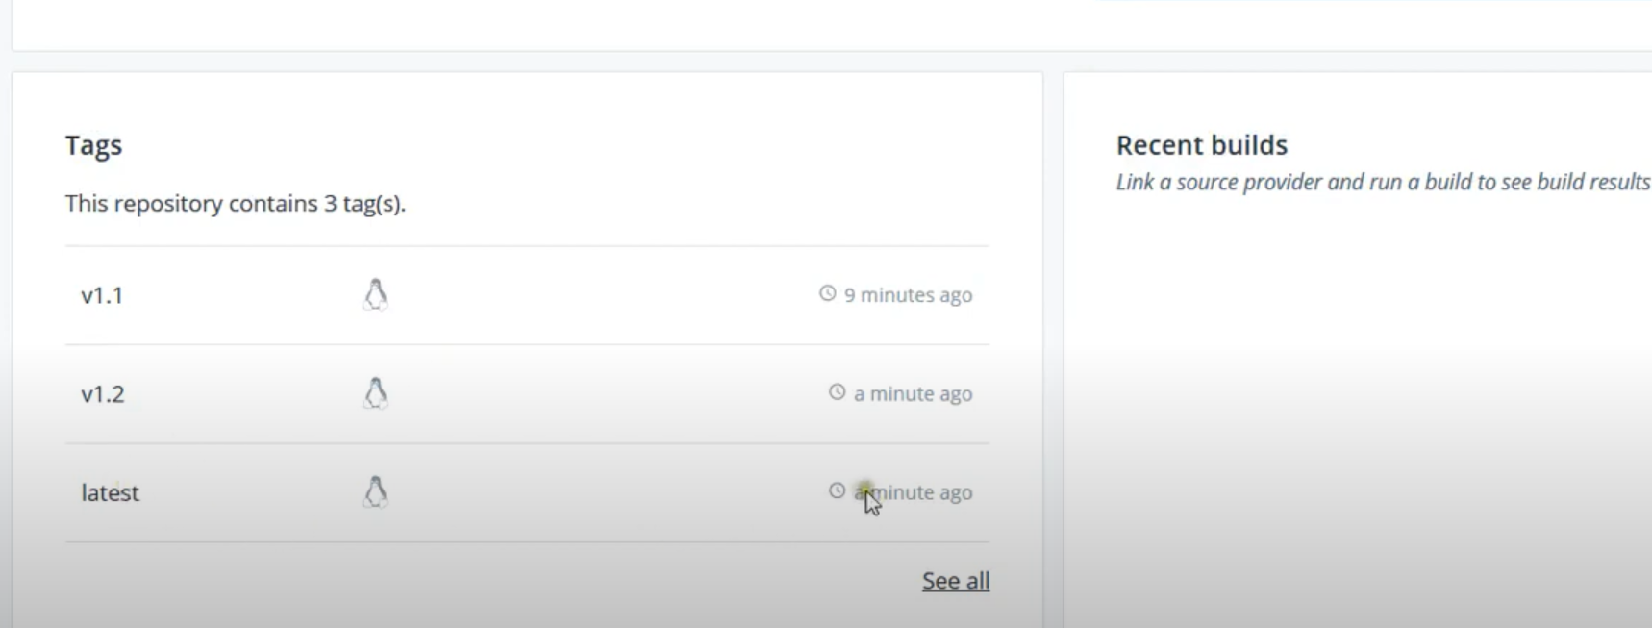
The docker image was saved on it after building the job at the jenkins server and the file also started appearing on the Kubernetes cluster linked with the controller machine.

