GITHUB
.In our pipeline we used GitHub as a server for forwarding the docker image to the Jenkins Server in our pipeline model.

.This practice helped us in transferring the source code (docker image file) provided from the developer’s side to the jenkins server for its deployment on the Kubernetes Cluster.

.The Github was integrated with the jenkins server using the webhook procedure and the file was starts appearing on the jenkins server post the integration of two for its further building purpose.

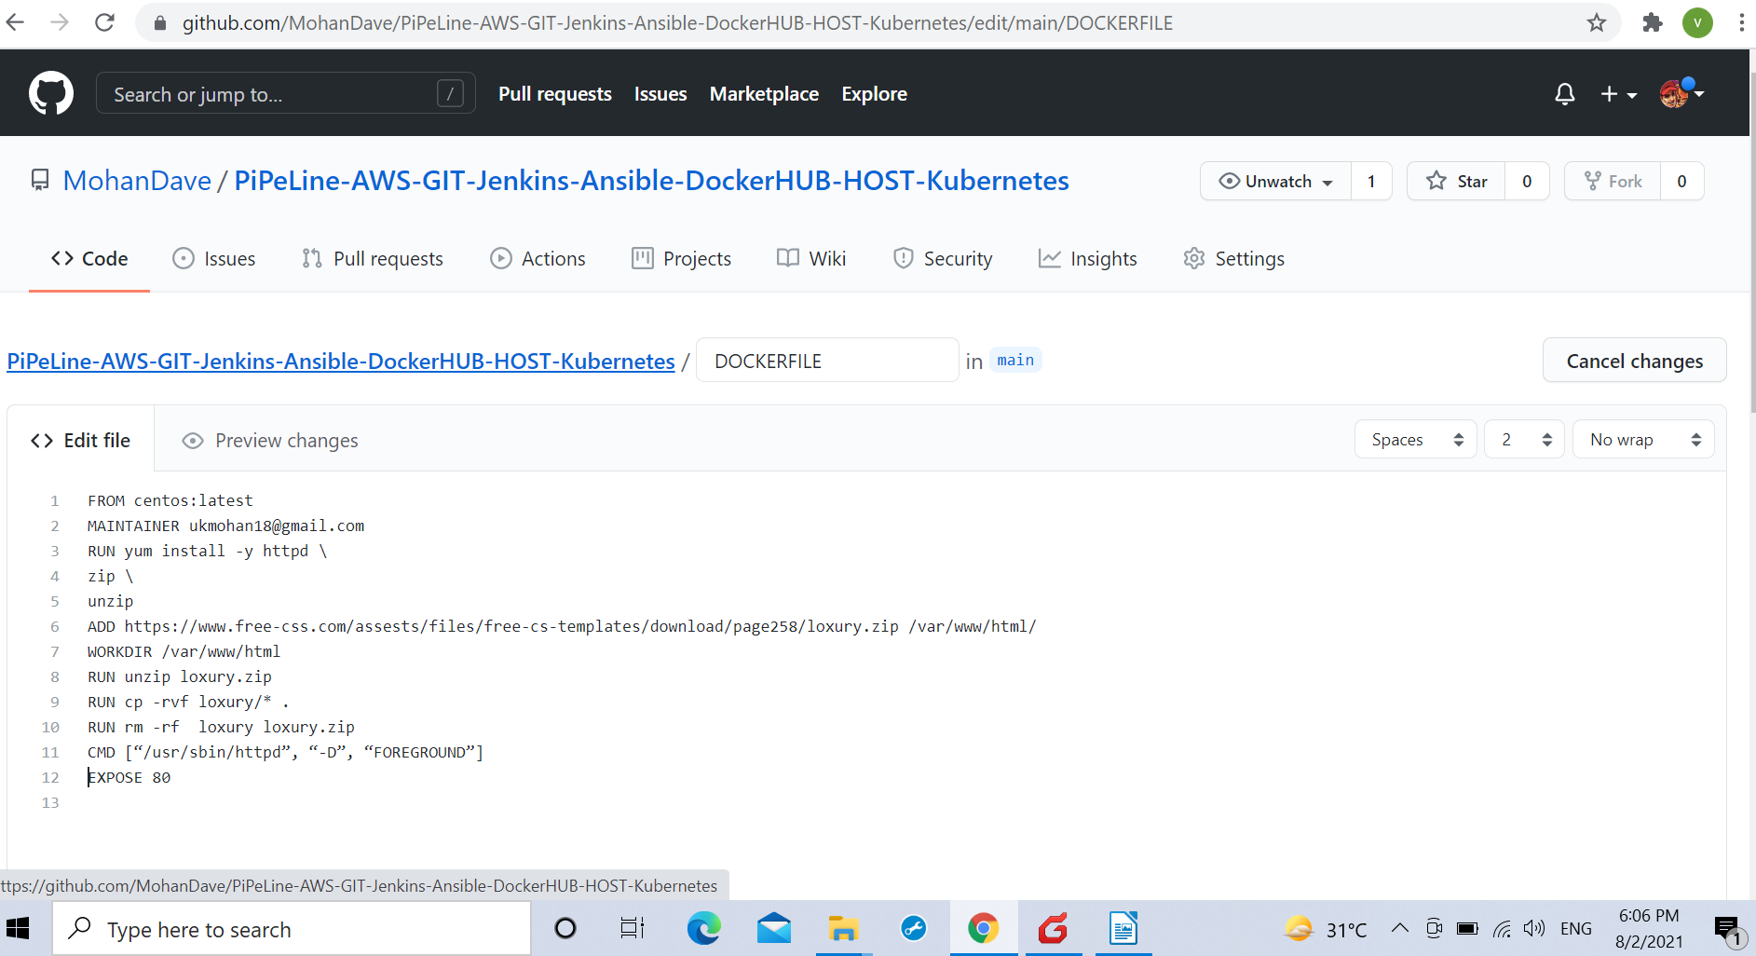

(MY GITHUB PROFILE WITH A SAMPLE DOCKER FILE)

.It is to notice here that the docker file used in this project is a sample docker file containing the url
of a simple css web template which was used as the Docker Source code file image to be sent in the docker container for deployment on the Kubernetes Cluster.

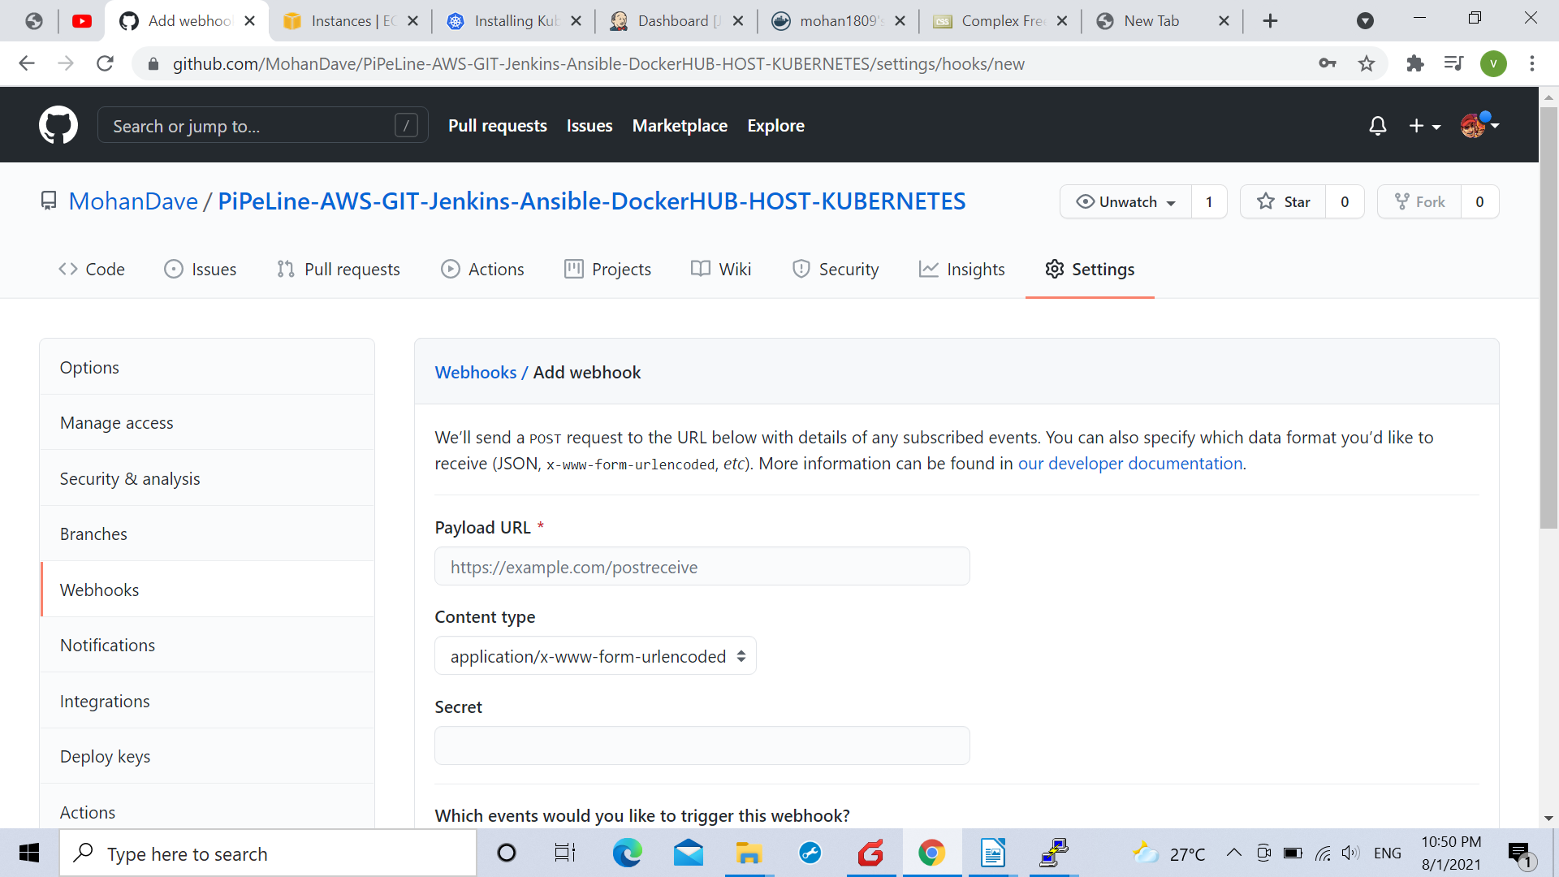
Using webhook for integration with the jenkins server.

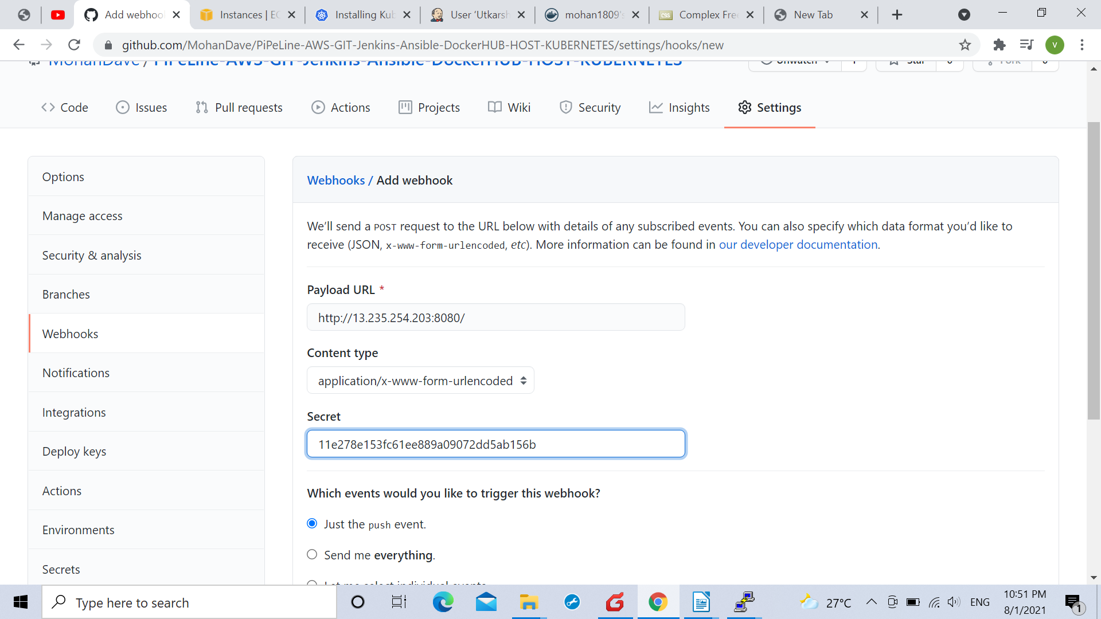

Copying the token to the secret column in the github

