ANSIBLE

.Ansible server in our pipeline project was configured (on an Amzon Linux 2 (AMI) machine in our (AWS) Instances) and was responsible for pushing the built docker image to our docker hub repository. It is to be considered that any centralised repository could be used for storing built docker images but in our project we used our docker hub account as the centralised repository.

.The connections between the ansible and jenkins server and also between ansible and docker server was made password less as shown in the Docker.odt and Jenkins .odt file file in the github repository .
(https://github.com/MohanDave/PiPLine-AWS-GIT-Jenkins-Ansible-DockerHUB-HOST/edit/main/DOCKERFILE)

.The server received the docker image from the jenkins server and the server was also equipped with docker package for building this docker image file. In many cases there could also be a separate machine for building this file of docker image where the file could be pushed from the ansible server and could get build. Though in our project we strictly confined this property of building the docker file within the ansible server itself by configuring the server with required docker packages.

[vim Docker.yml
hosts: docker.host
tasks:
-shell: docker container run -itd –name mycontainer -p 9000:80 (id)/myimage:v1]

.After building the docker image the file was stored in the playbook in Docker.yml file from where it was pushed to our repository(Docker Hub in our case ) from where it could be directly send to the docker container (The Deployment Point of our pipeline).

.Hence post building the docker image in the ansible server , specific commands were inserted for adding a tag to the built docker image file and pushing it to the docker hub repository.

.So when the playbook was running it had a command (docker container run -itd –name mycontainer -p 9000:80 (id)/myimage:v1 ) in the shell module which is a command written to run on the docker , so it created a container within it and searched for the docker image in locals , after not getting the required image it directly pushed the docker image from the docker repository.
.We have to add command in the playbook for removing the container everytime and creating the new container when a new/updated docker image file is inserted in the container.

.Below is the screen shot of the docker.yml in the ansible-playbook on the ansible server
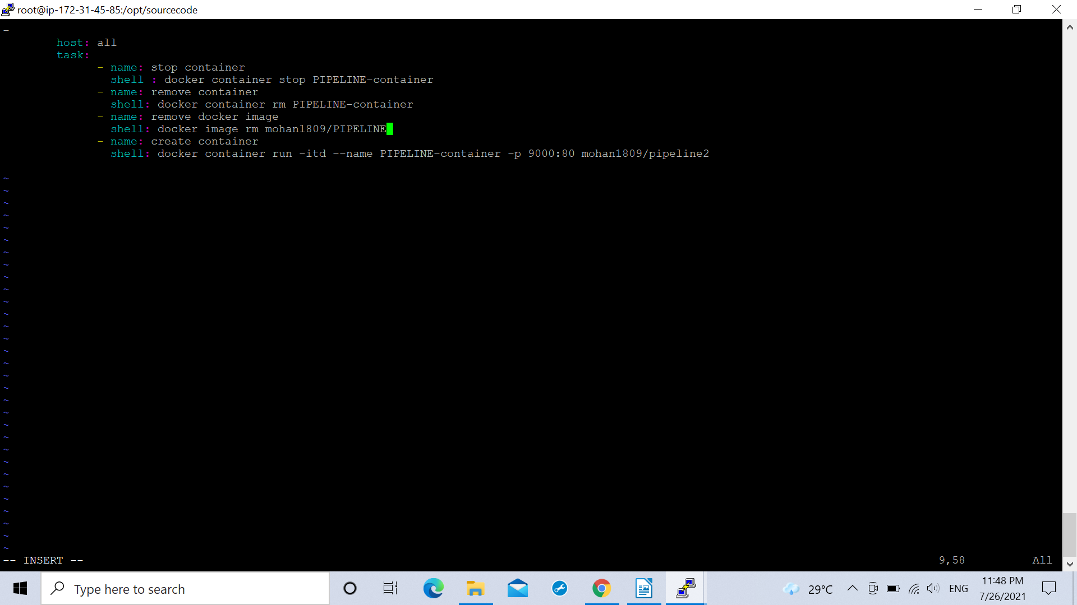

.The ansible server was also added on the jenkins along with the jenkins server itself in the following building modes.
.Build actions(Send files or execute command over ssh)
.Post Build actions(Send builds artifacts over ssh)

In both the building actions we specified certain commands for the operations that were needed to be carried out.
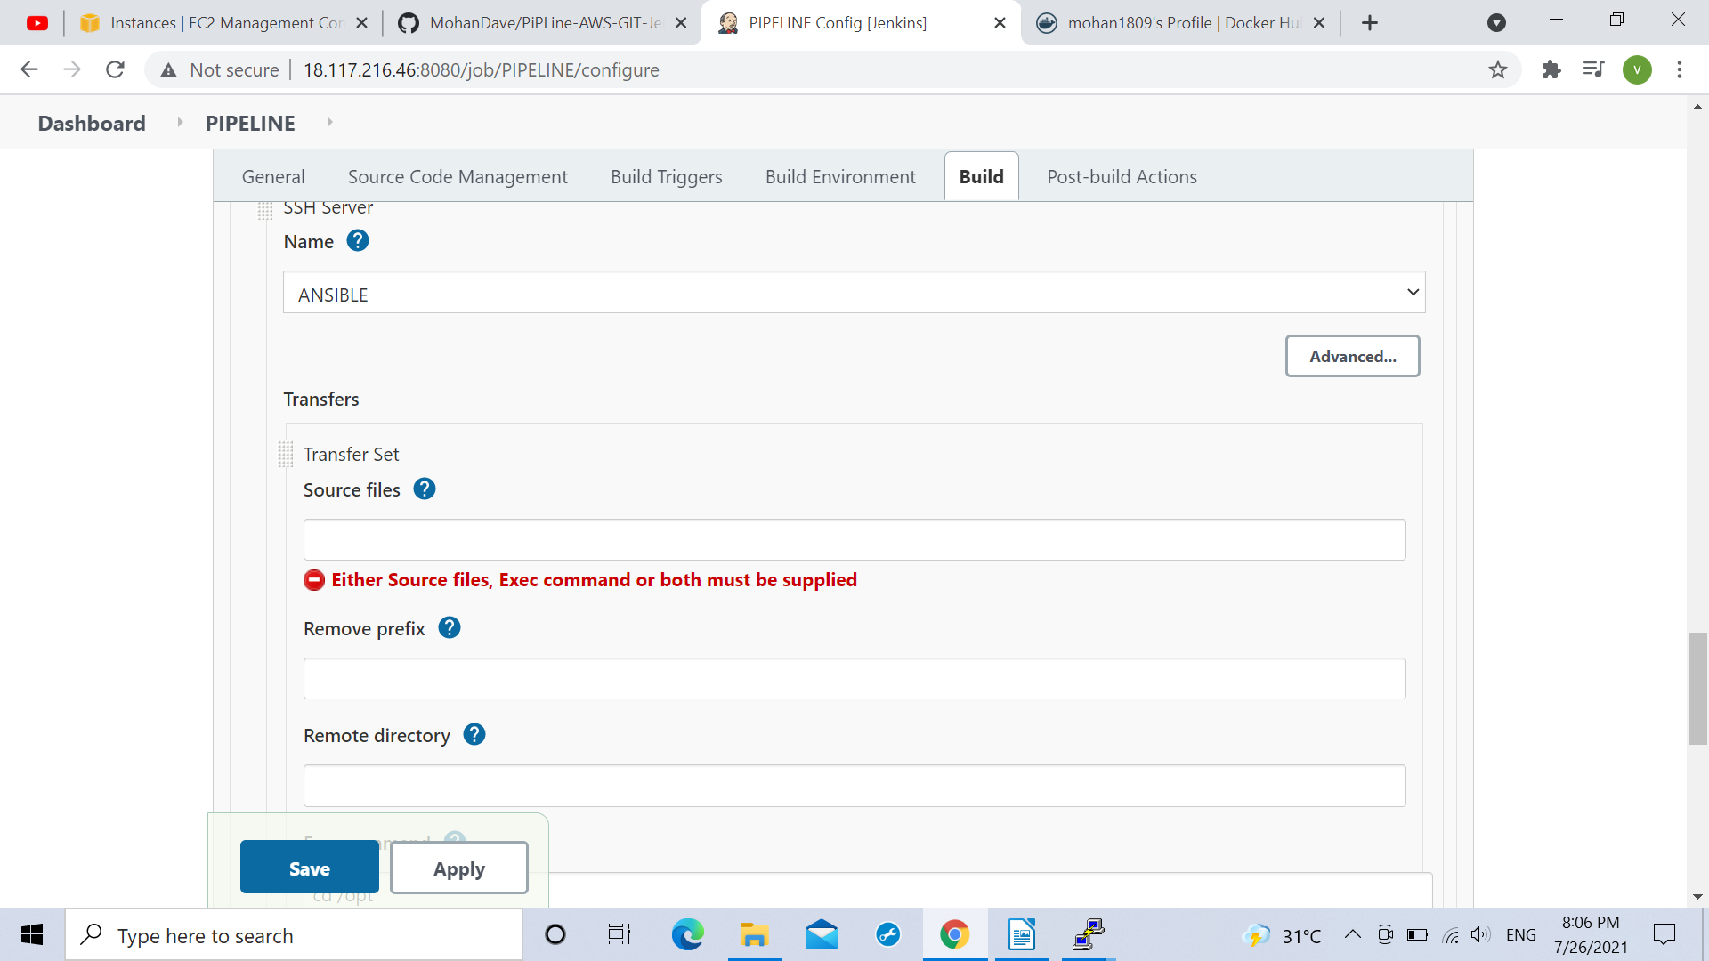

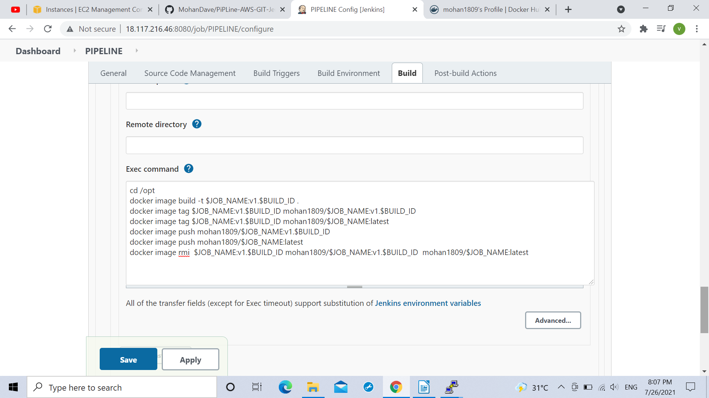

.In this the commands were mentioned using the jenkins predefined variables JOB_NAME(For storing the name and BUILD_ID for storing the ID(like the number of build in the jenkins)
of the docker image as anytime there can be modifications in the docker image or a different image could be given by the developer hence using these variables could hold such constants to avoid any mismatching.

.Followed by that in the post build sections we had under the ansible server the following commands for locating the docker.yml in the playbook .

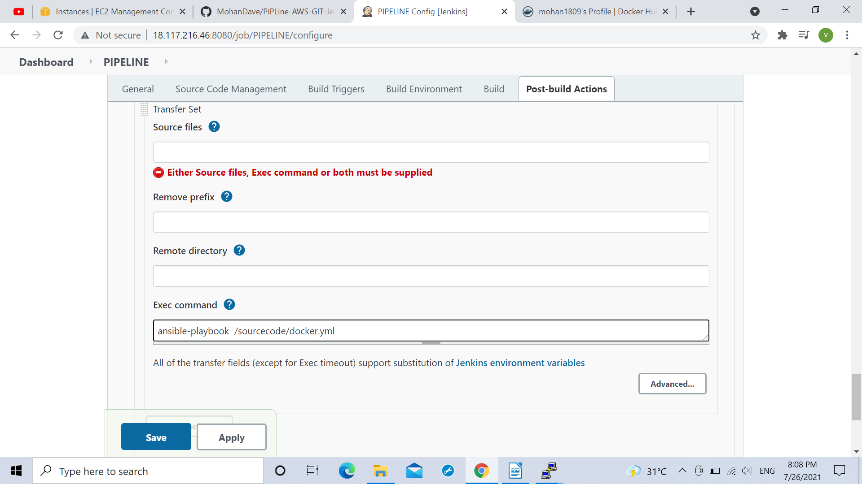

.As the docker container would be looking on the dockerhub repository for the docker image after searching the local server the my docker hub account was logged in from the ansible server as shown below:
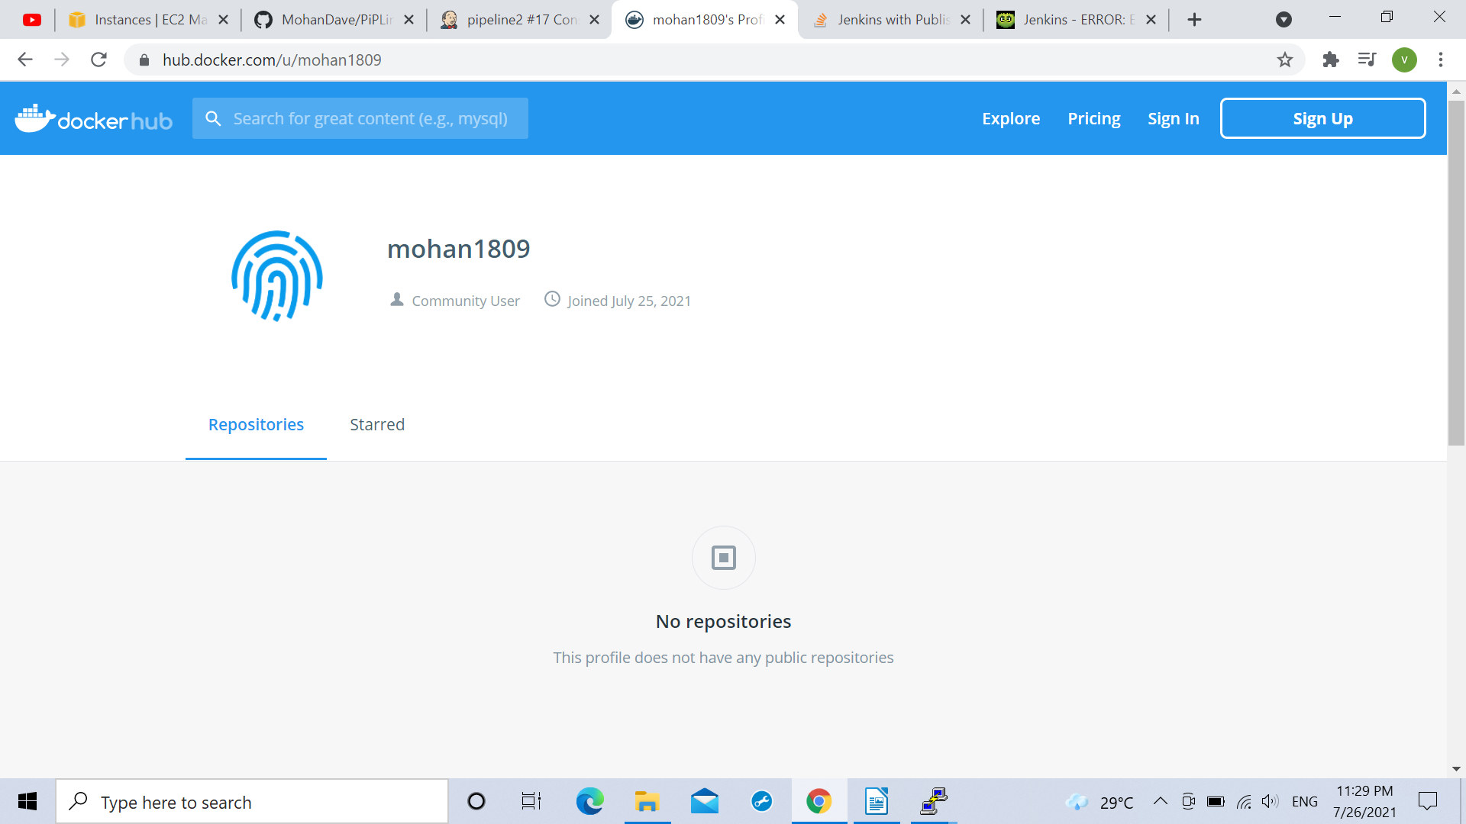

.After building the job on the jenkins with the above mentioned arrangements we had both docker image and the latest docker image being shown in our DockerHub repository.

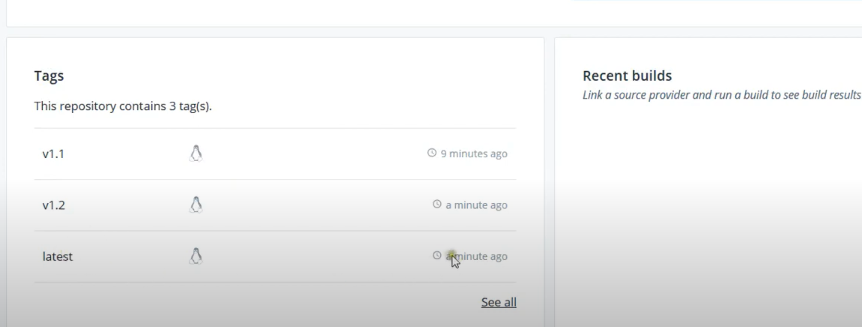

.The docker container will receive the docker file from here for its depoyment in the docker container.

.Everytime a new Docker container is created the image stored or deployed on it and later it is removed and the same happens for every further deployments.

