DOCKER

.The Docker container is our main deployment point of the pipeline.

.The docker container was created in the Amazon Web Services AWS account on an Amazon Linux 2 (AMI) Instance .

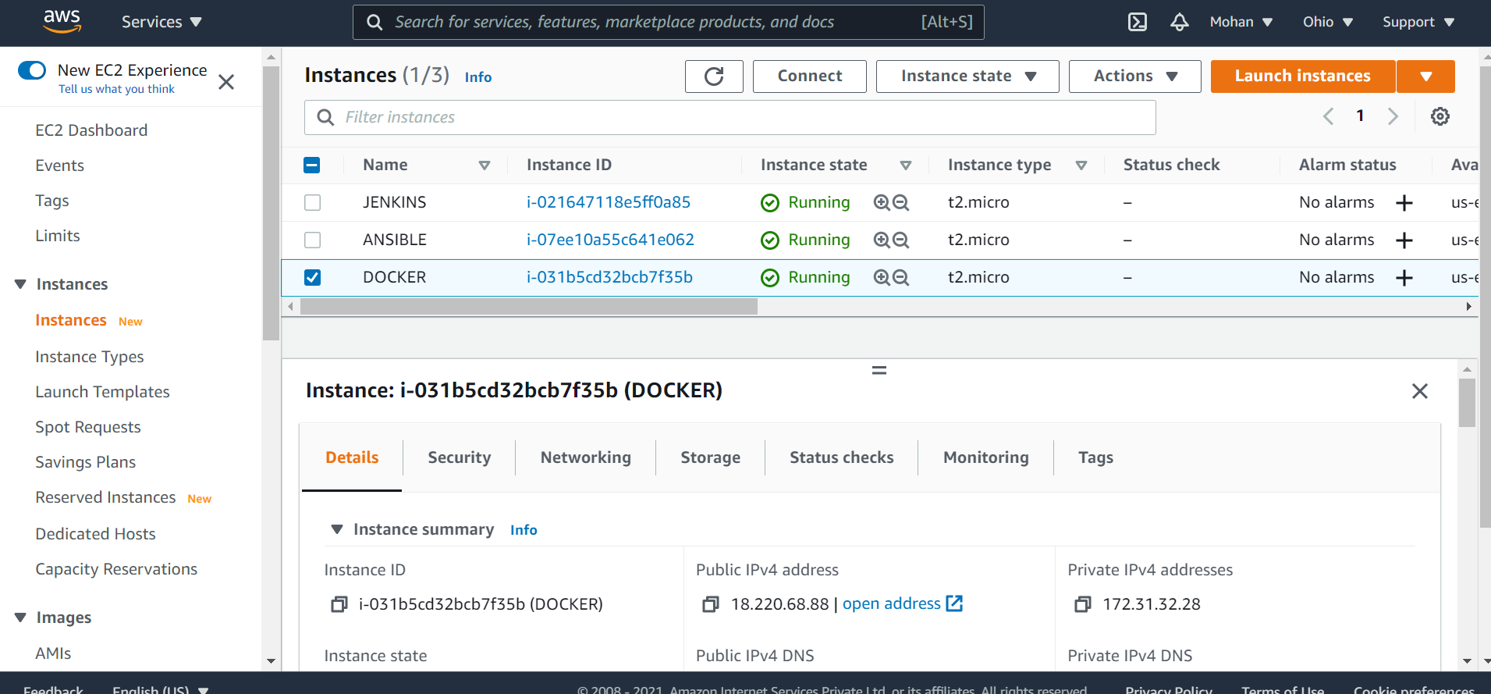
.The server was configured using the putty software.

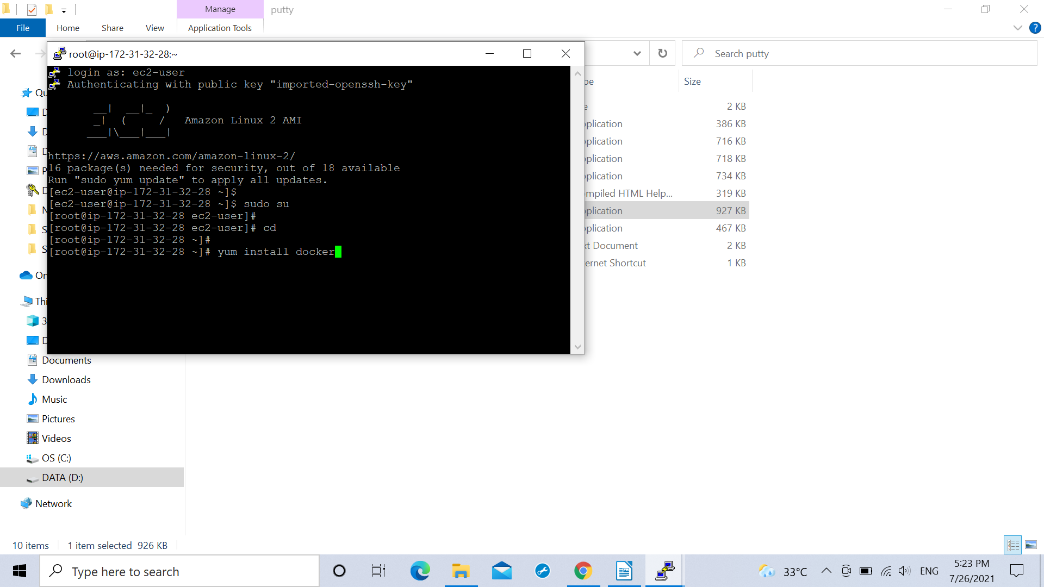
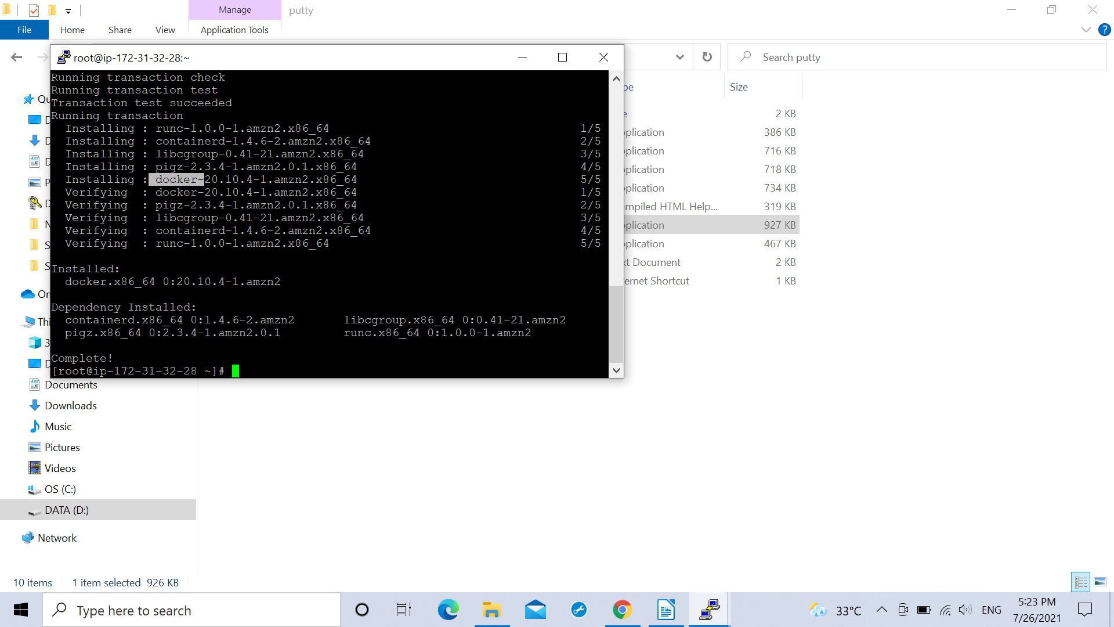

.After configuring the server a password less connection with ansible server was created .

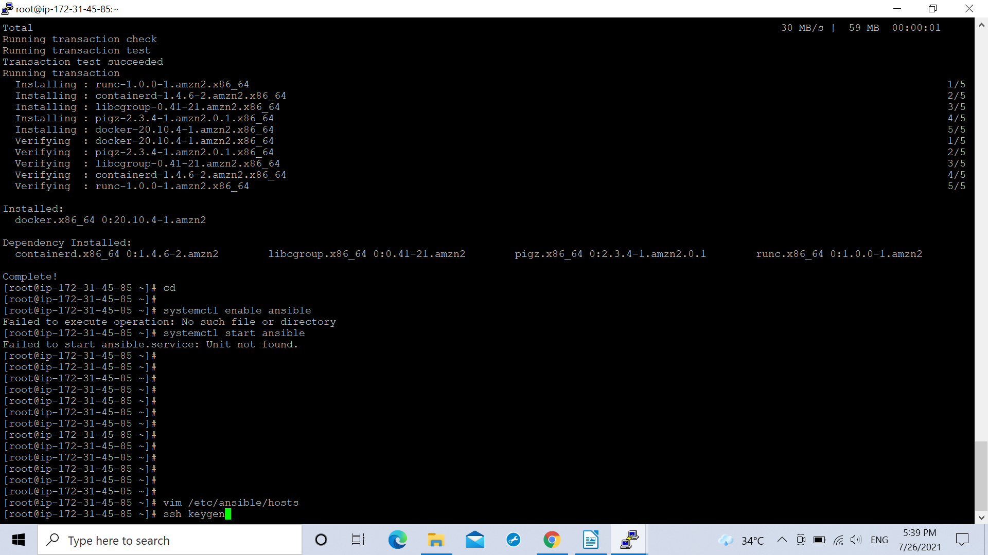
(Generating key from ansible server)

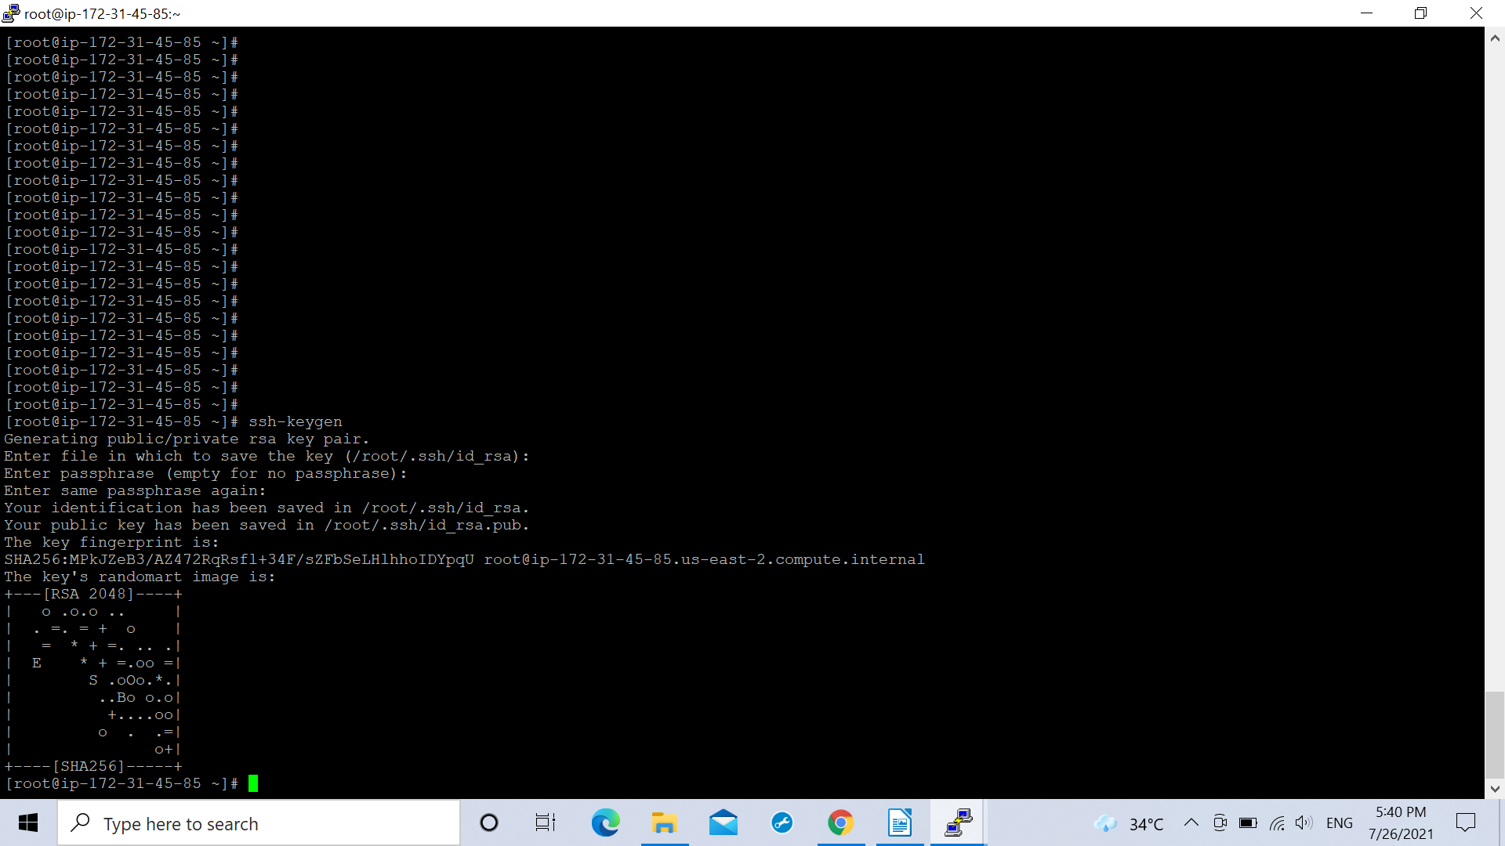

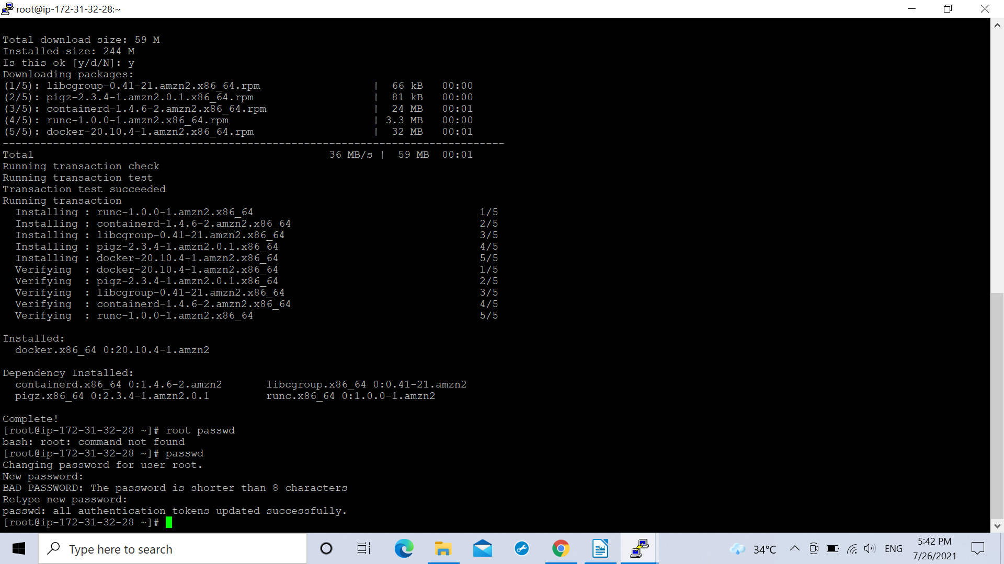
(Setting the root password on docker server)

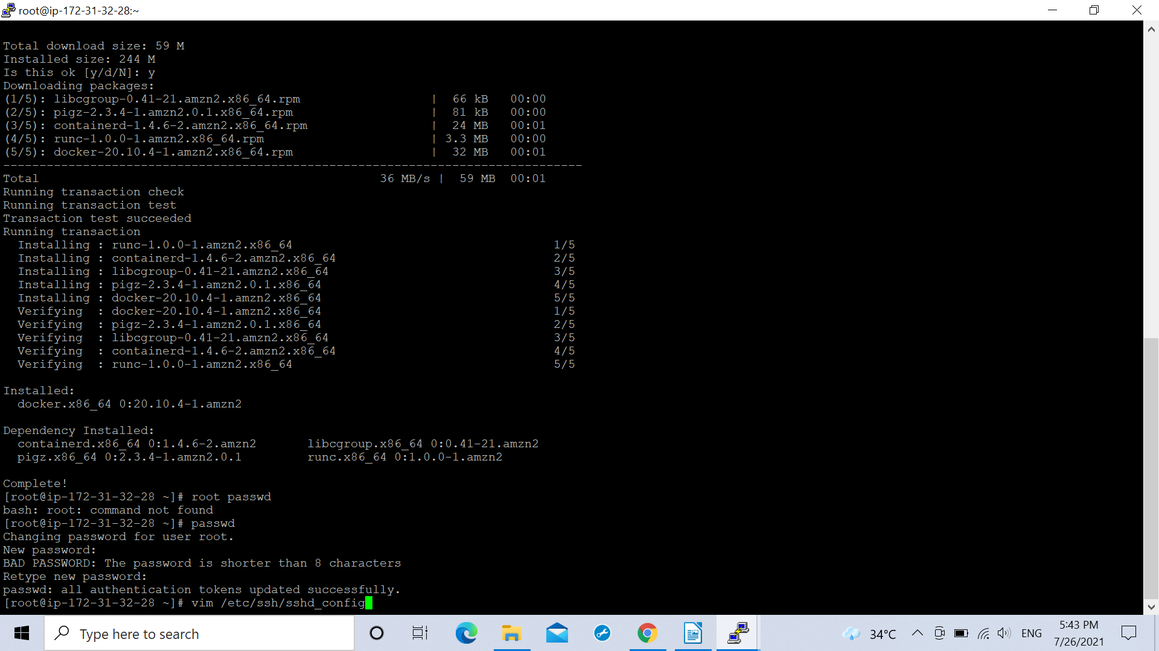

(command to get into sshd_congif file)

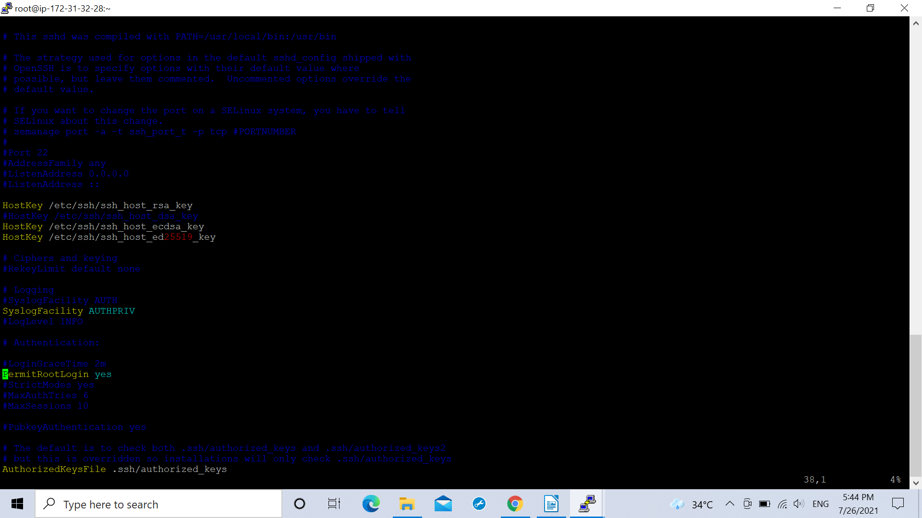

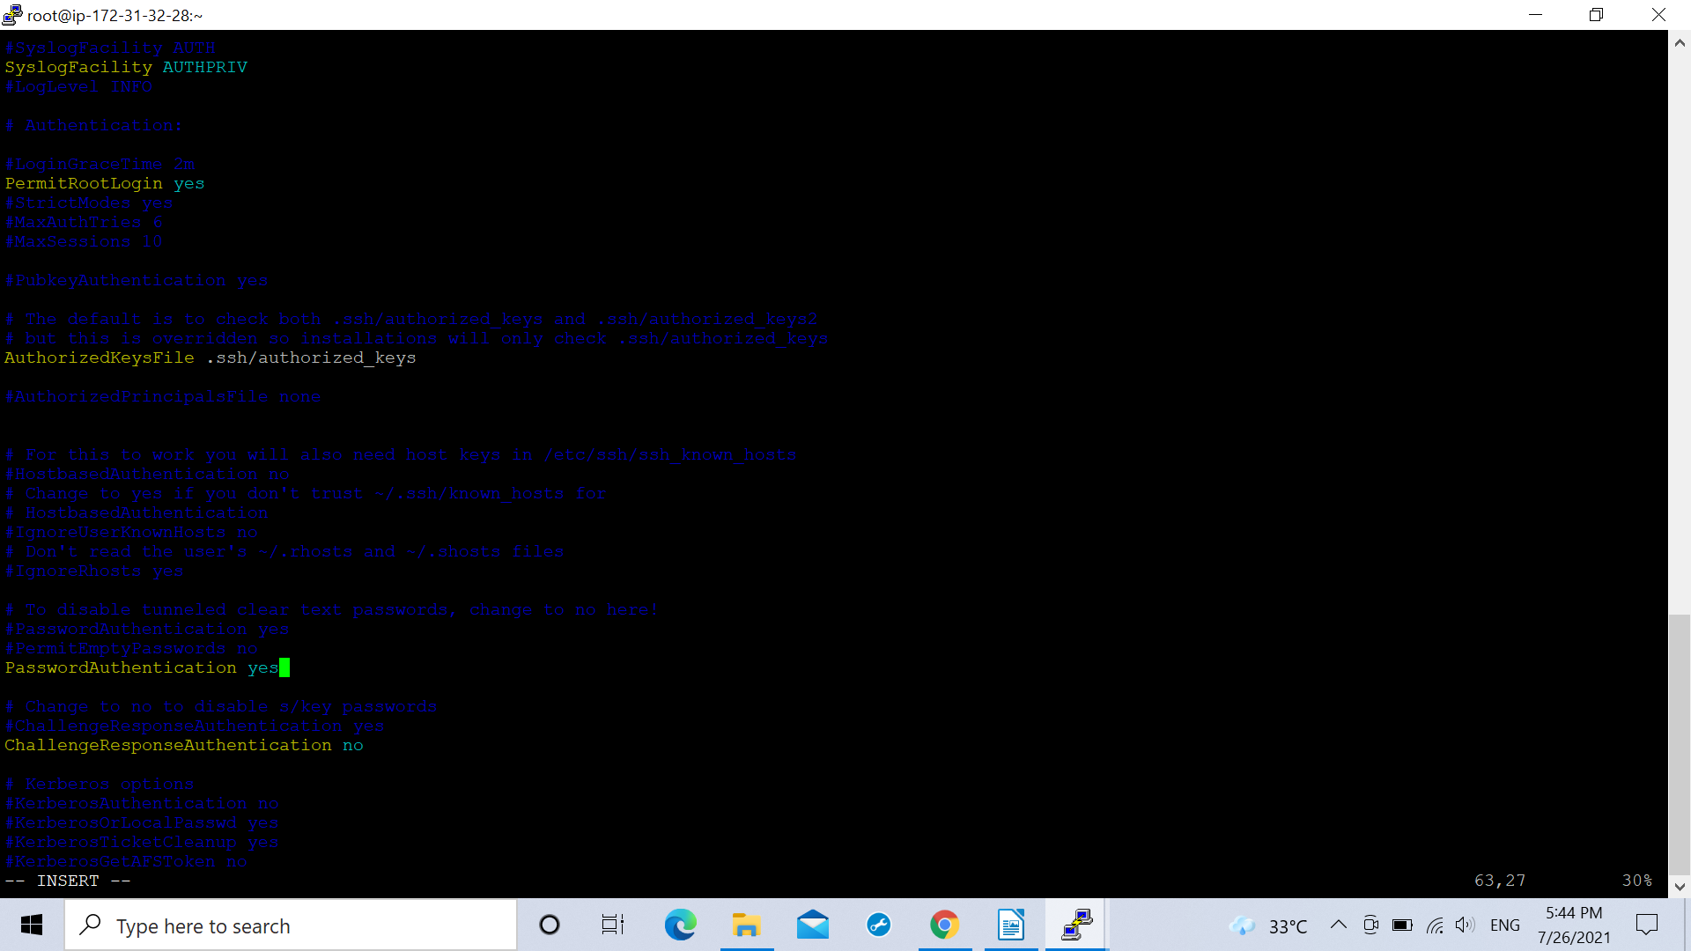
( enabling PermitRootLogin and PasswordAuthentication)

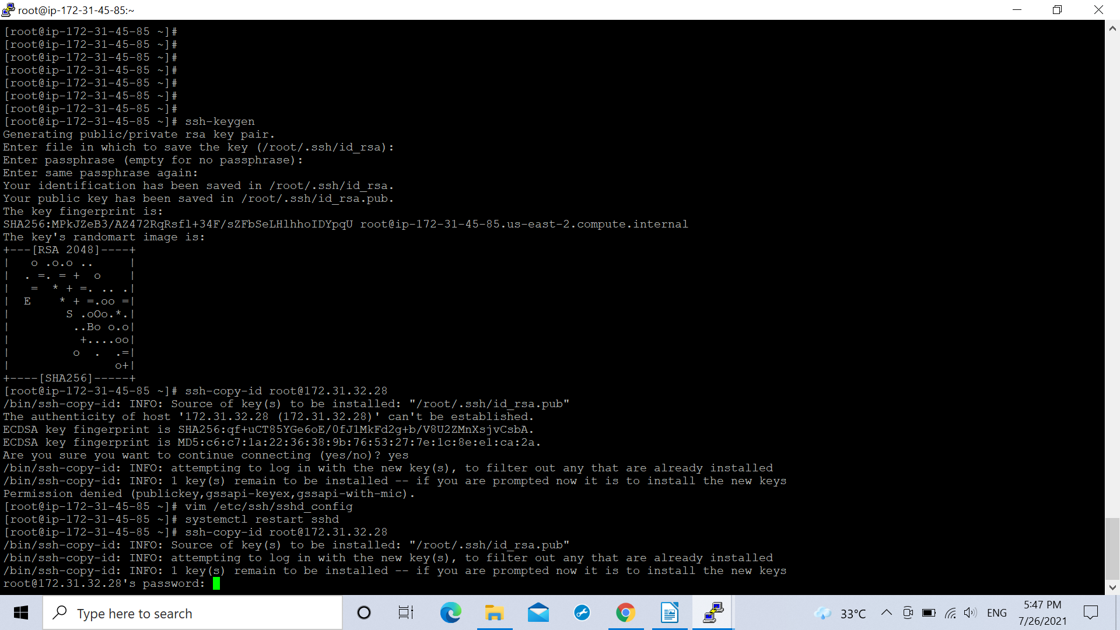

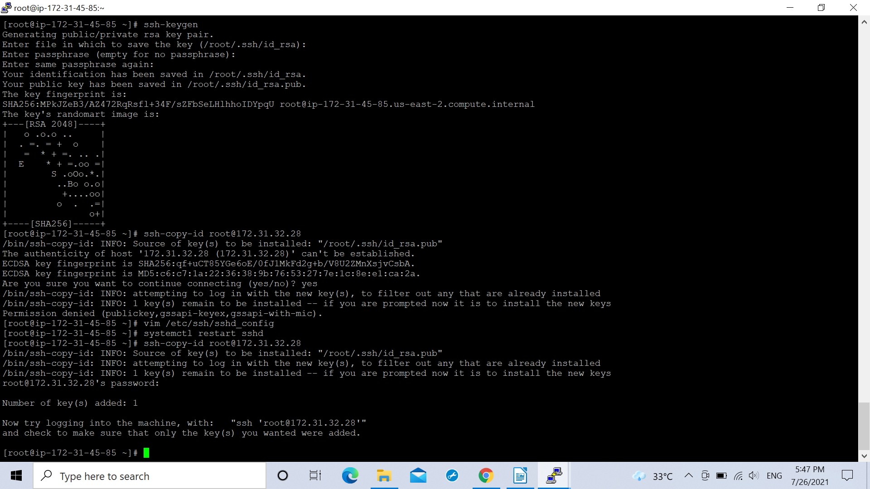

.While pushing the image to the ansible server the docker hub needs to be logged in from the ansible server.

.The docker container first looks for the image in the local servers after which it takes the image from the DockerHub repository (already logged in from the ansible server).

.After buiding the job the docker image will be deployed on the docker container and hence could be seen in the docker server using the command :
docker container ls (All the docker commands used in the project are mentioned in the Docker.md file in the github repository.
and when the public ip of the docker container will be pasted on the url , the url in the docker image(Our source docker file) could be seen.
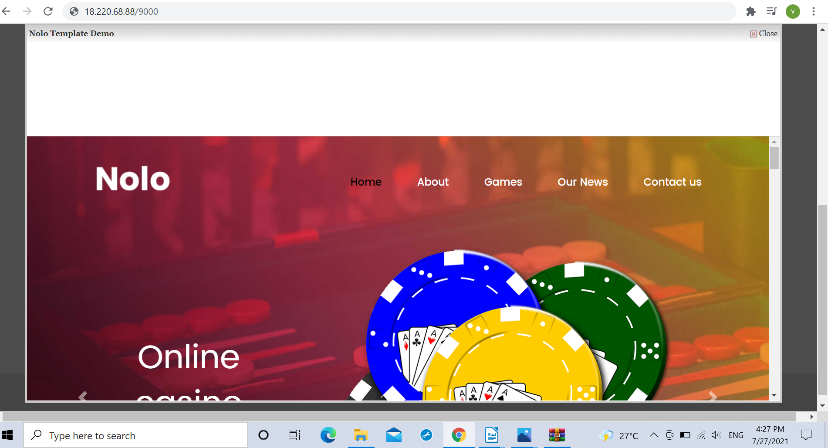

Making it the end point of deployment in our pipeline.Here 18.220.68.88 is our pubic ip of docker container.
.All the docker command used in this project are listed in the Docker.md file in my github repository
https://github.com/MohanDave/PiPLine-AWS-GIT-Jenkins-Ansible-DockerHUB-HOST/edit/main/Docker.md

