GITHUB
.In our pipeline we used GitHub as a server for forwarding the docker image to the Jenkins Server in our pipeline model.

.This practice helped us in transferring the source code (docker image file) provided from the developer’s side to the jenkins server for its deployment in the docker container .

.The Github was integrated with the jenkins server using the webhook method and the file was transferred to the jenkins server for its further building purpose.

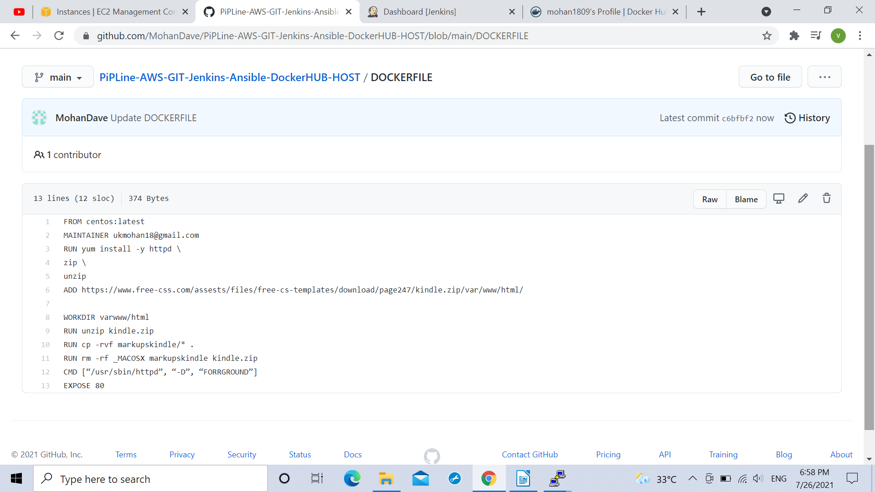

(MY GITHUB PROFILE WITH A SAMPLE DOCKER FILE)

.It is to notice here that the docker file used in this project is a sample docker file containing the url
of a simple css web template which was used as the Docker Source code file image to be deployed in the docker container.

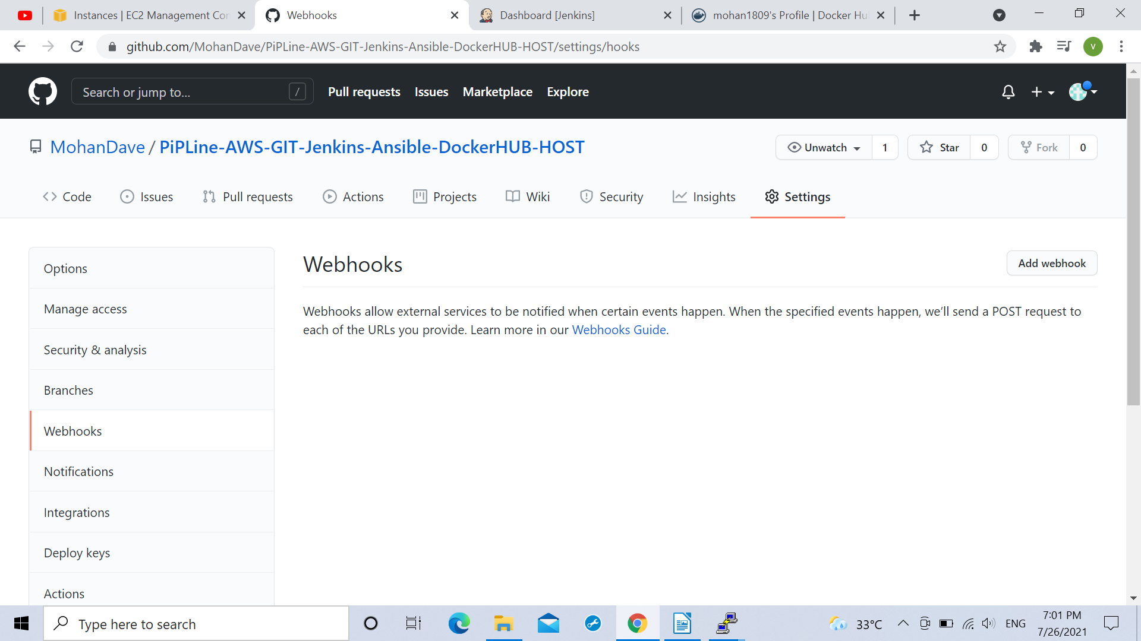

Using webhook integration with the jenkins server.

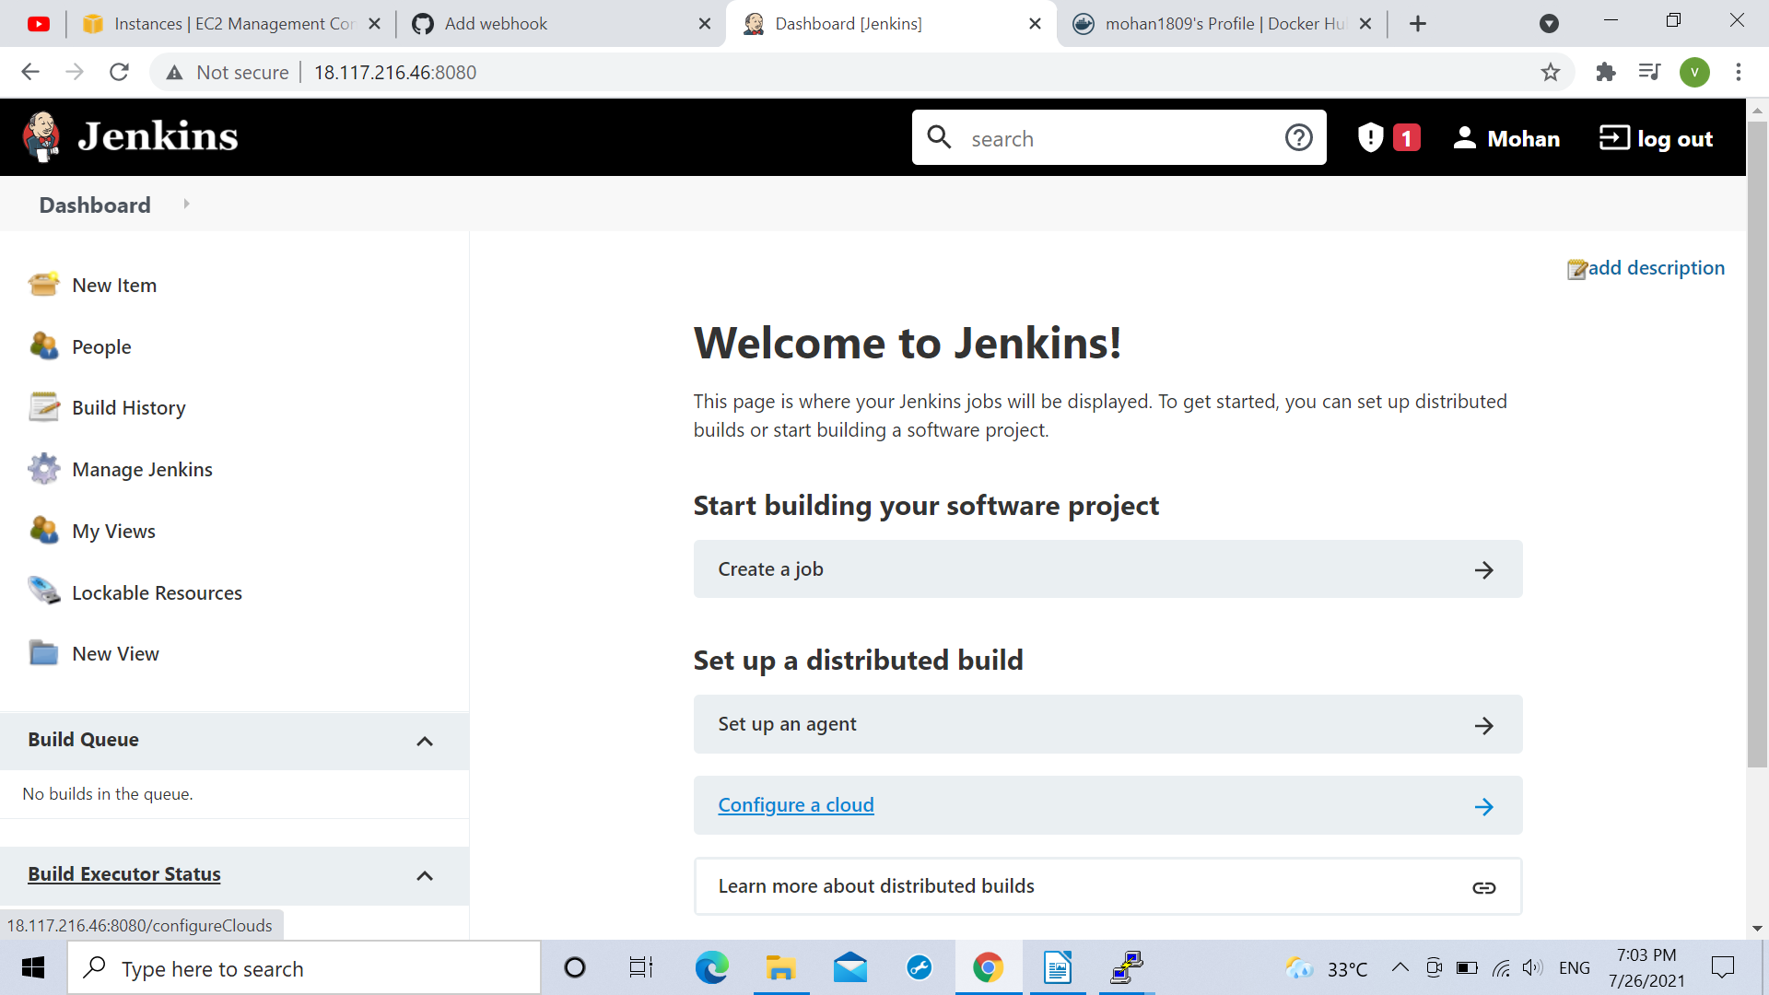

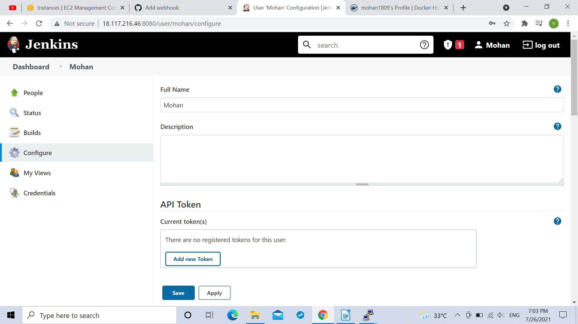

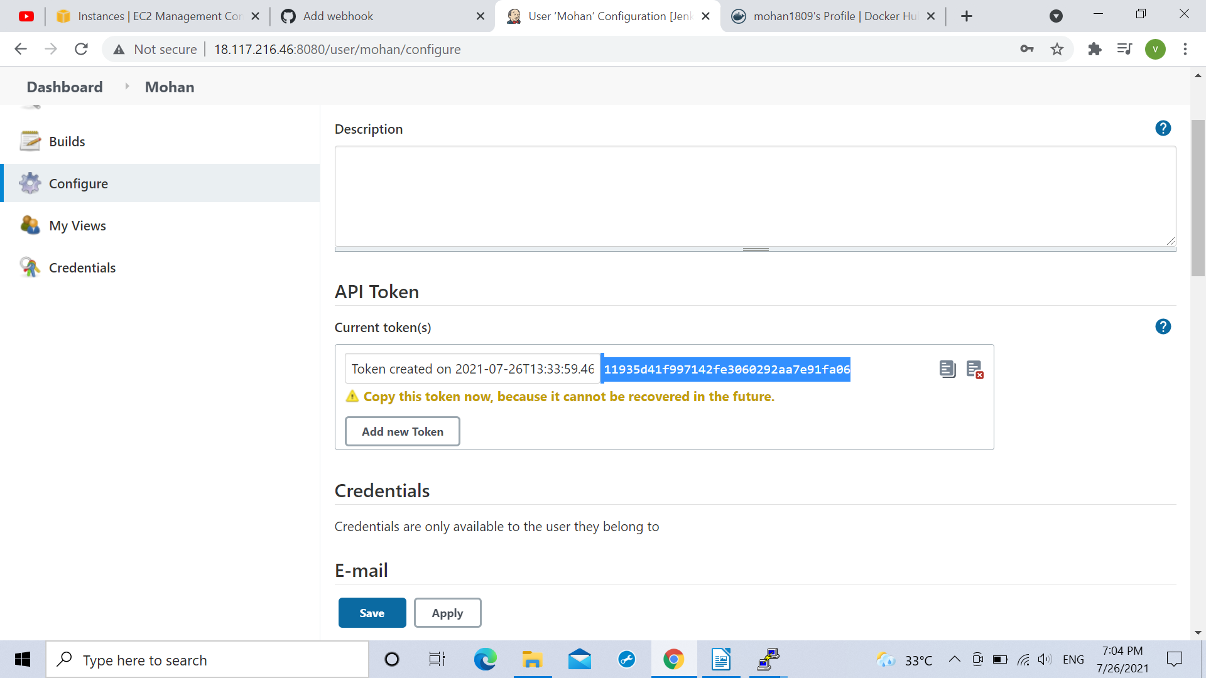
Copying the token to the secret column in the github

