JENKINS
.Our jenkins server was configured on an amazon linux 2 (AMI) machine .

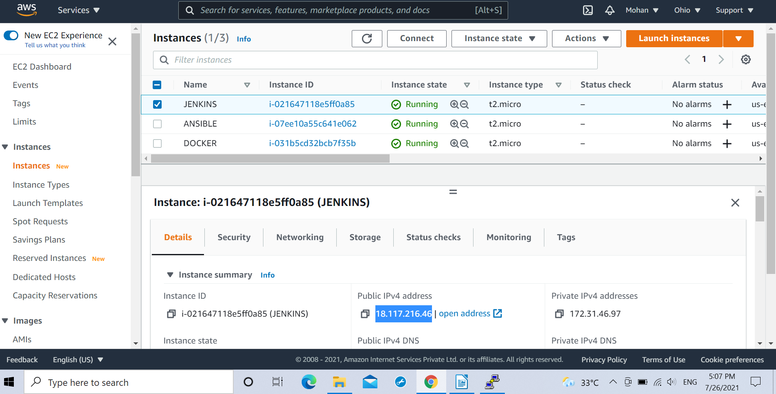
.Putty software was used in this task.

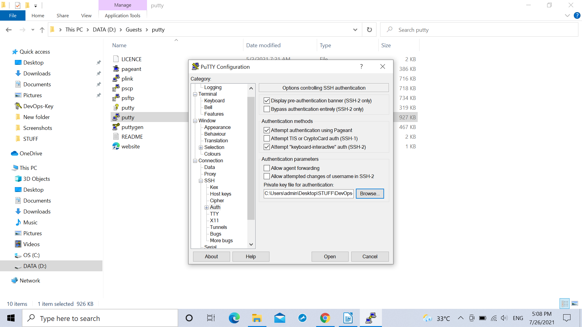
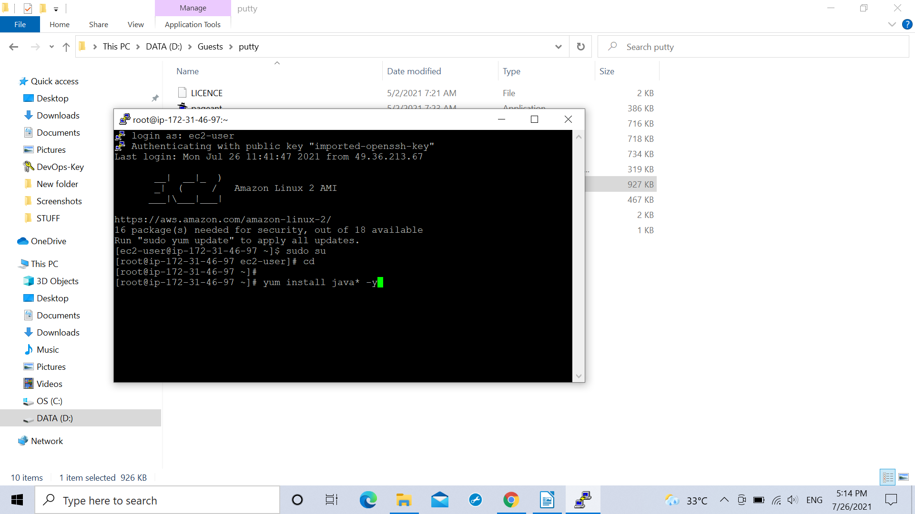

.The jenkins server recieves the docker image file (Source Code File in our pipeline) from the GitHub server.

.The jenkins servers despite of building the file in this project sends the file to ansible server.

.The jenkins server is in password less communiction mode with the ansible server.

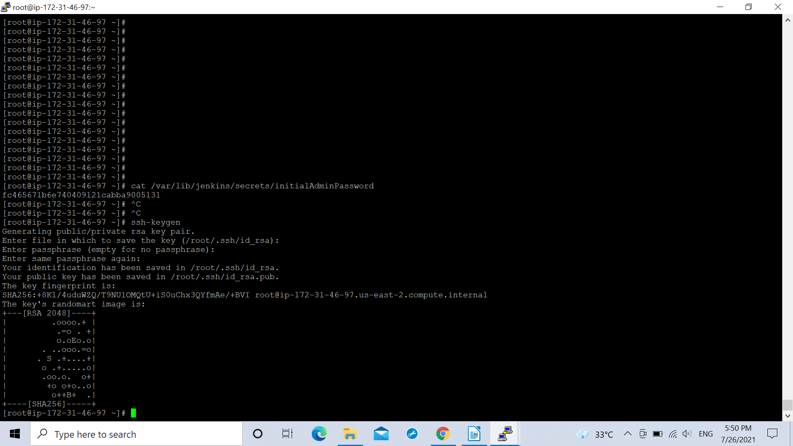
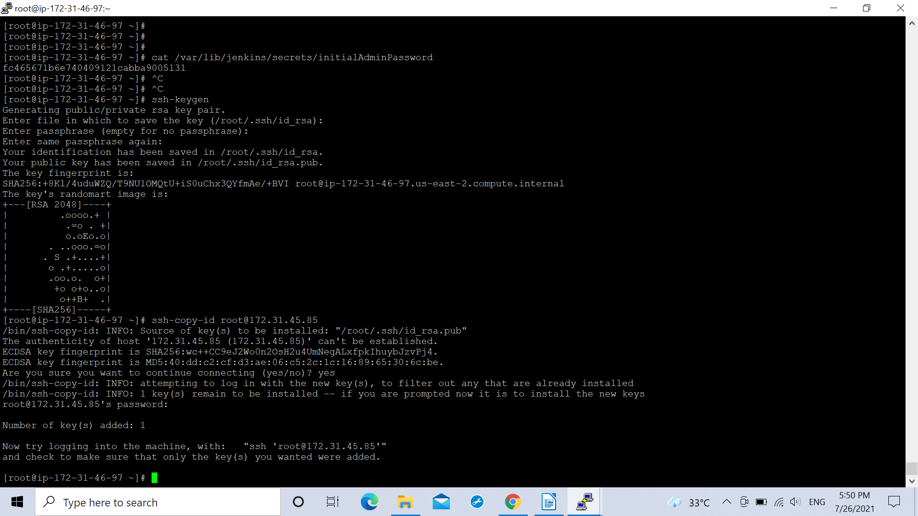

.The jenkins server sends few additional commands along with the Docker image file for its building arrangements in the ansible server itself .
Commands required from the jenkins server for the operations in the ansible server are:
docker image build -t myimage:v1
docker image tag myimage:v1 (id)/myimage:v1
docker image push (id)/myimage:v1

.Every time there is a change in the source code . There is a follow up change in the url within the docker image file which may create hinderances as the above commands are written specifically for myimage:v1 within the jenkins server hence there might be an error. So with every change in the docker image url there needs to be a subsequent change in jenkins server’s job’s build command by changing the tag of the docker image . Ex: myimage:v2 , along with this the same change needs to be reflected within the playbook within the shell module where the above file tag is mentioned.

.For this glitch we introduced another concept of using the predefined variables within the jenkins namingly JOB_NAME & BUILD_ID. We stored the docker image name in the JOB_NAME variable predefined on the jenkins server and the tag in the BUILD_ID (Like Build 1:Build 2:Build 3...in jenkins) variable with the following changes in the above used command:
docker image run -t $JOB_NAME:v1.$BUILD_ID
docker image tag $JOB_NAME:$BUILD_ID (id)/ $JOB_NAME:v1.$BUILD_ID
docker image push (id)/$JOB_NAME:v1.$BUILD_ID
followed by the following commands:
docker image tag $JOB_NAME:$BUILD_ID (id)/ $JOB_NAME:latest
docker image push (id)/$JOB_NAME:latest

for the changes to be reflected on the playbook by adding the variable commands and pushing additional place for the latest build if any change occurs.

Now there happens to accumulate a lot many docker image files on the ansible server hence to remove the file after pushing it to the repository we use the following command :
docker image rm $JOB_NAME:$v1.BUILD_ID (id)/$JOB_NAME:$v1.BUILD_ID (id)/$JOB_NAME:latest

.Hence the jenkins was logged in by pasting the public ip of the jenkins server with the port number 8080.

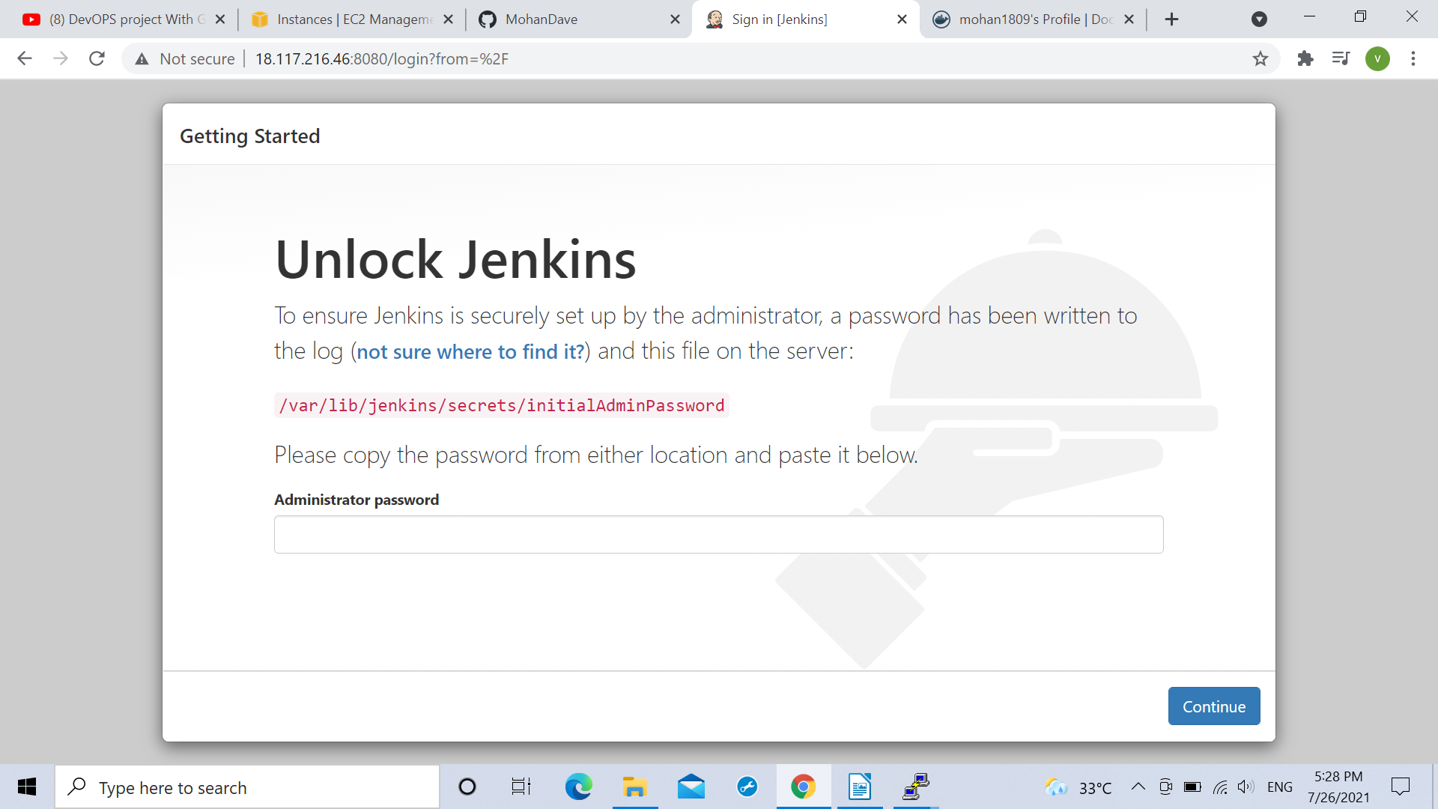

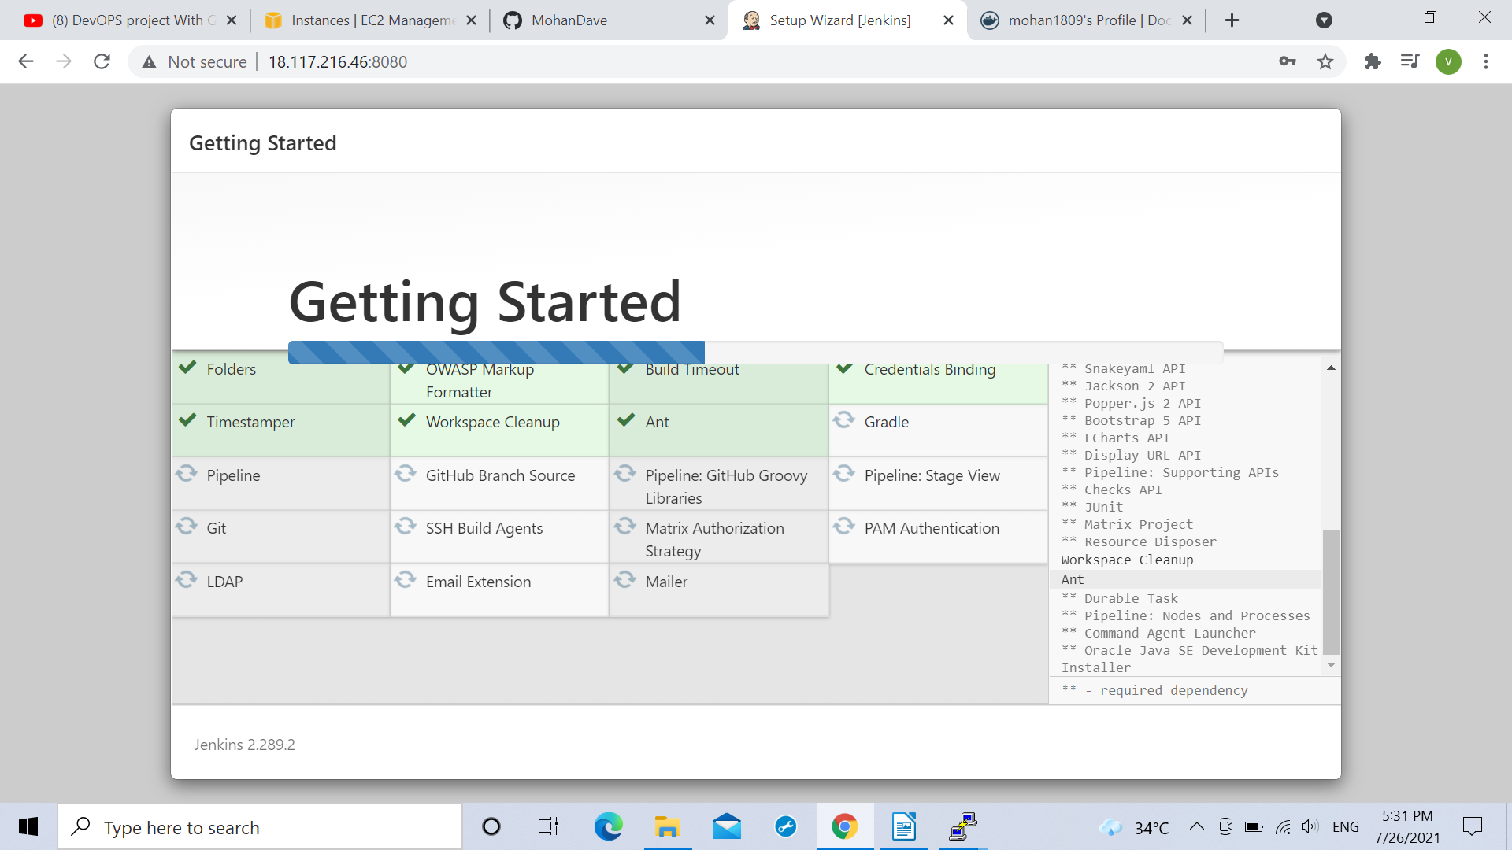

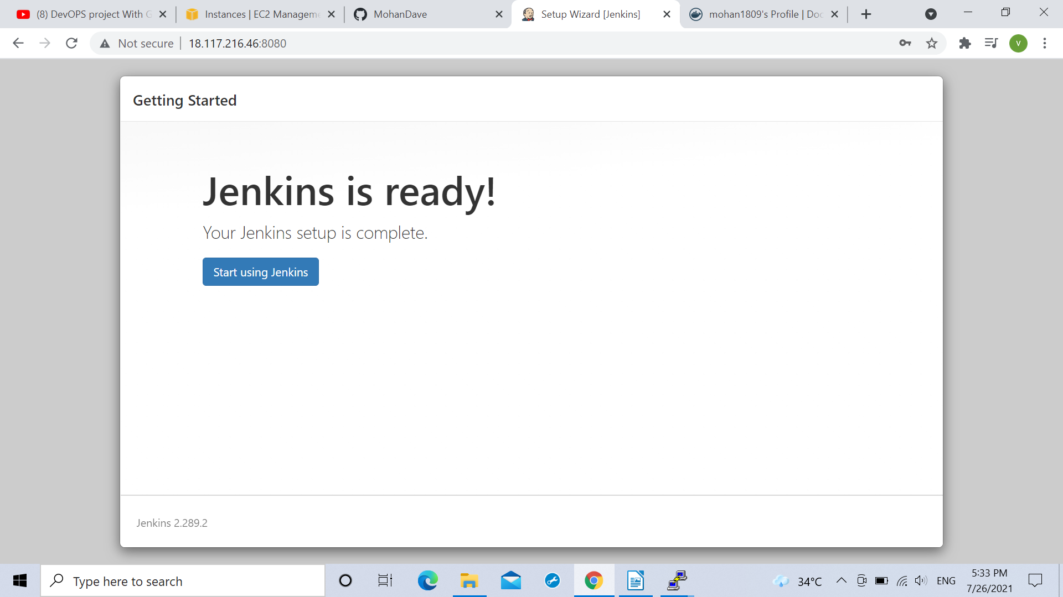

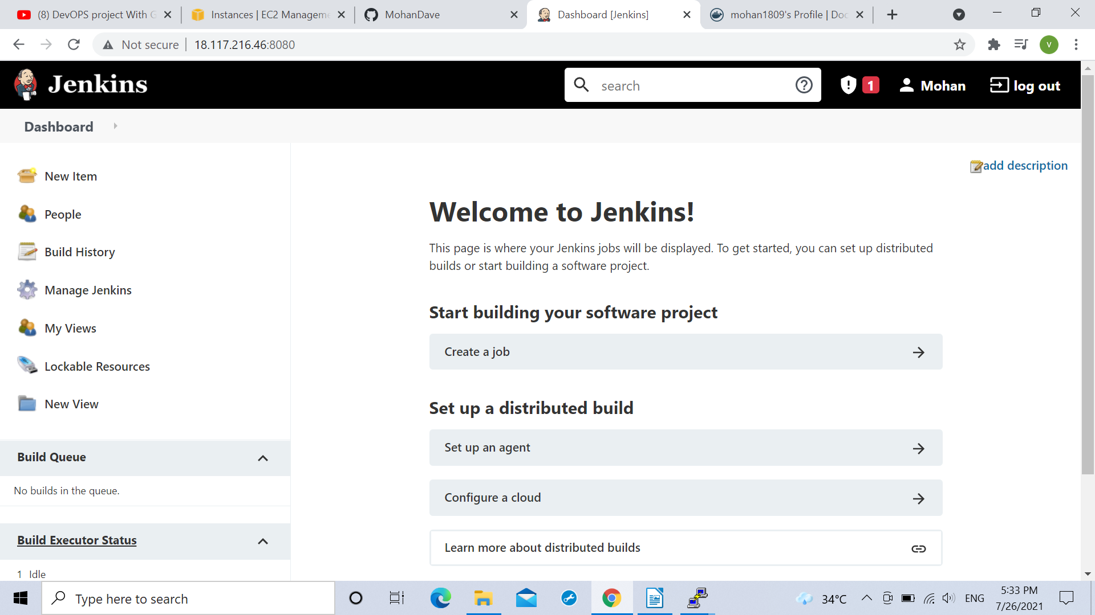

.The jenkins server was integrated with github using the webhook .

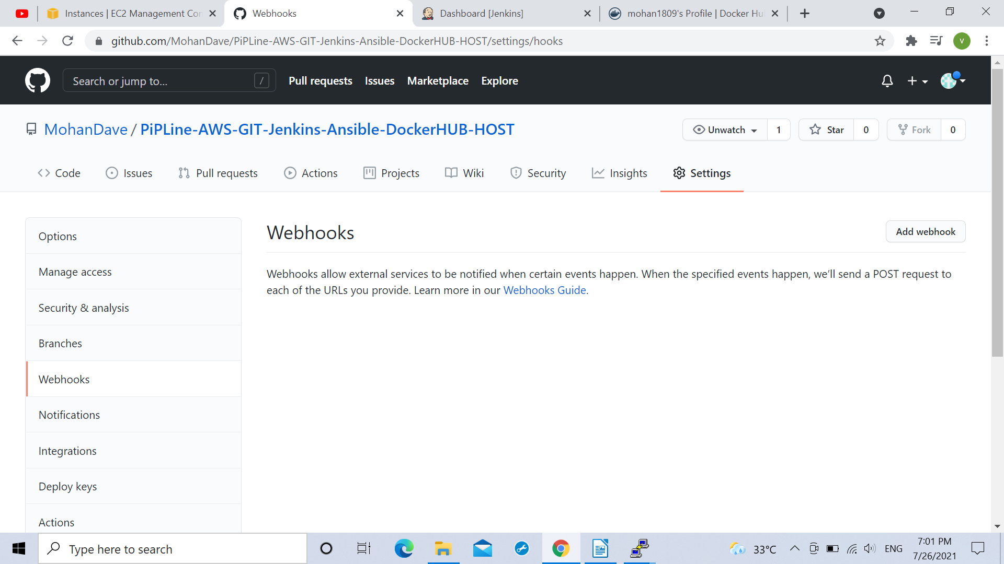
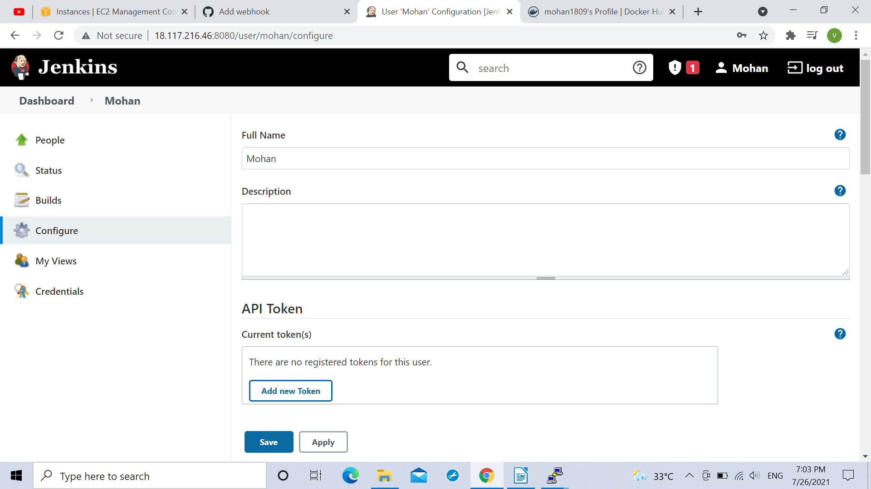

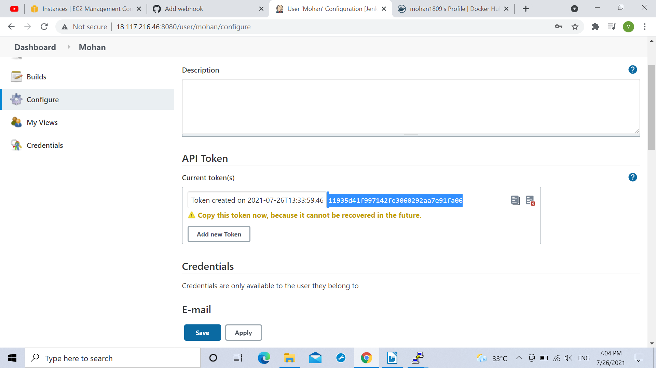

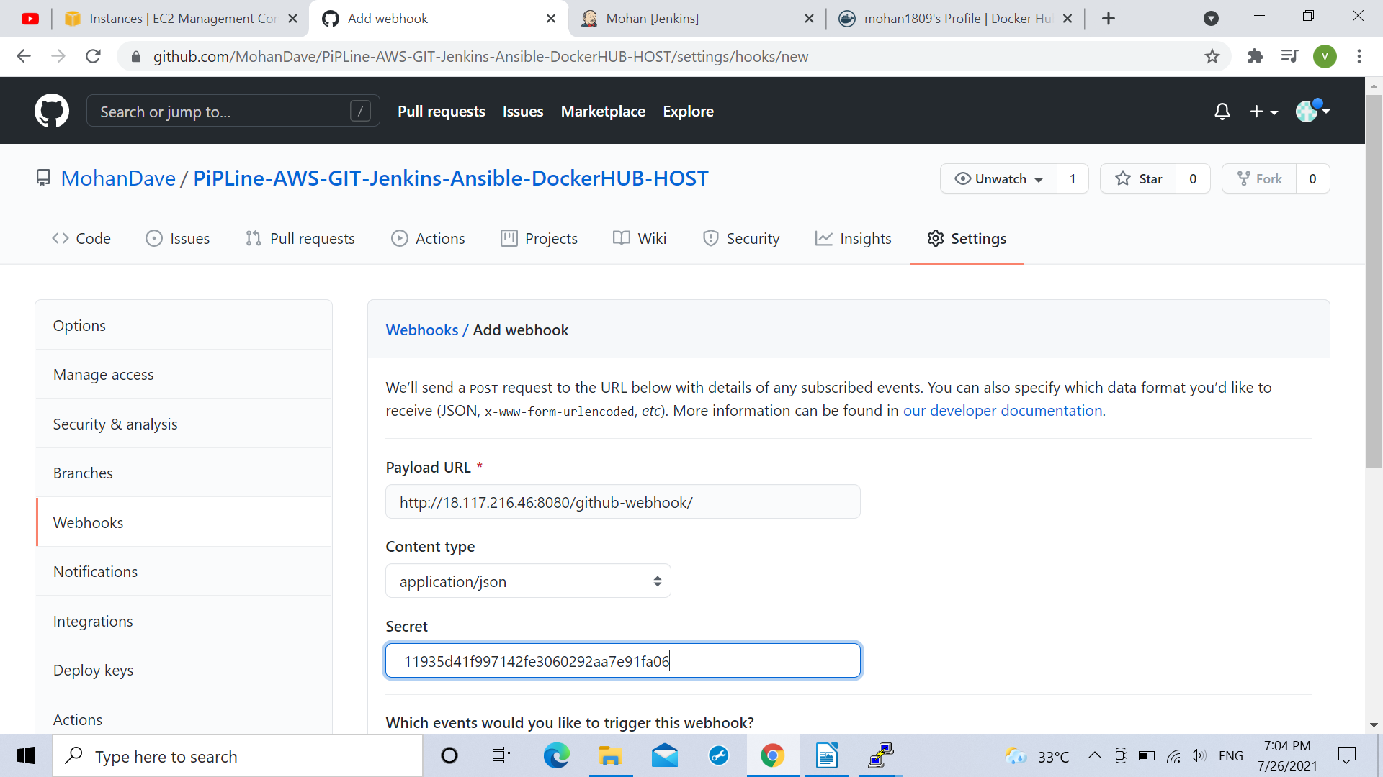

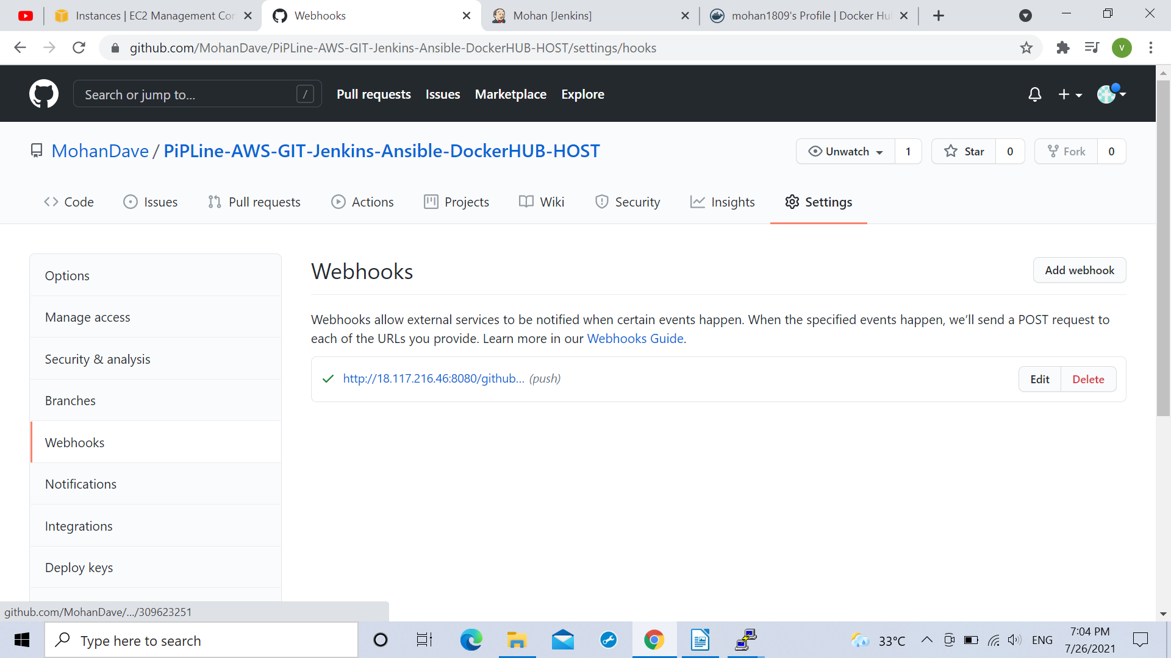
.Jenkins along with ansible server was added on the jenkins in the project pipeline in the building modes Build actions and Post Build action.
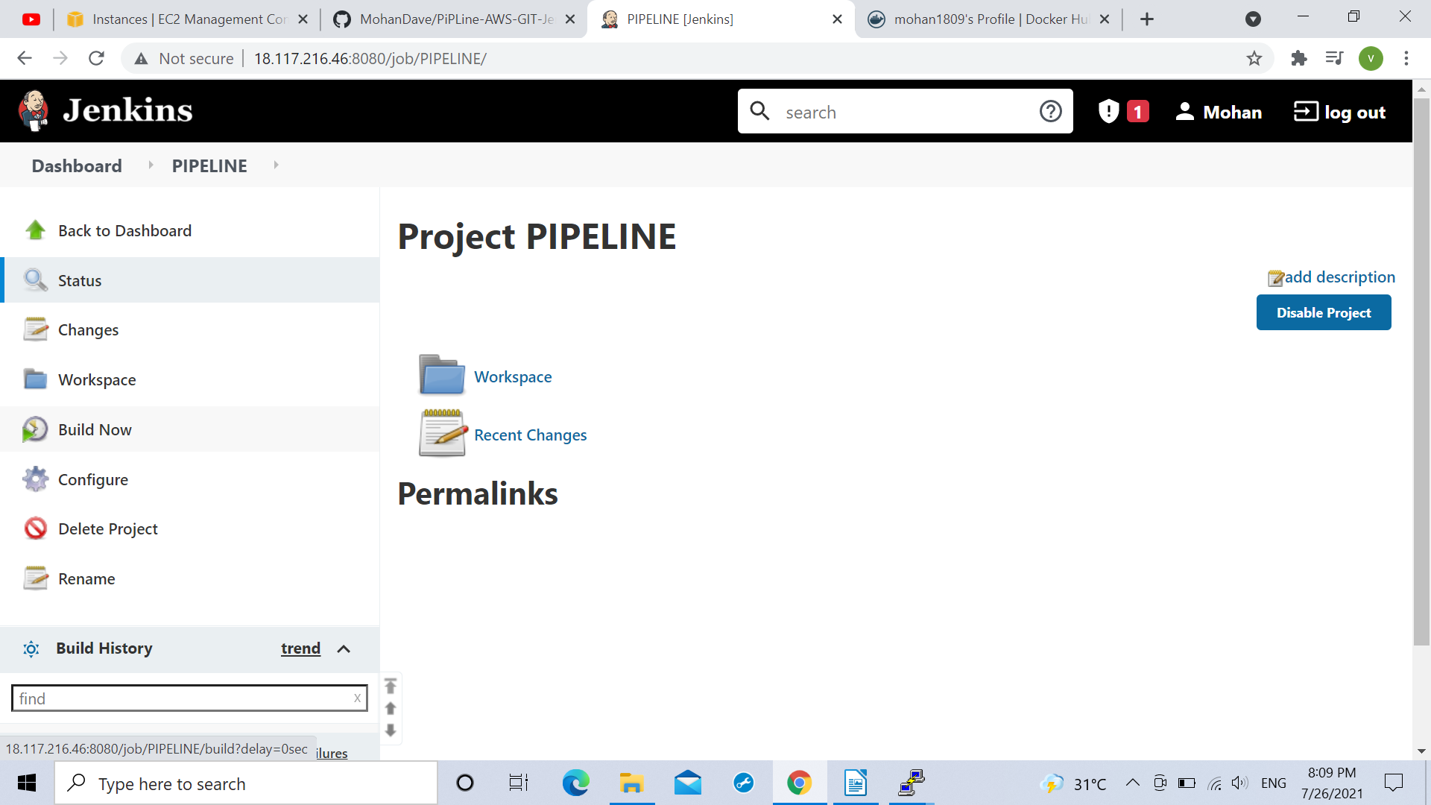
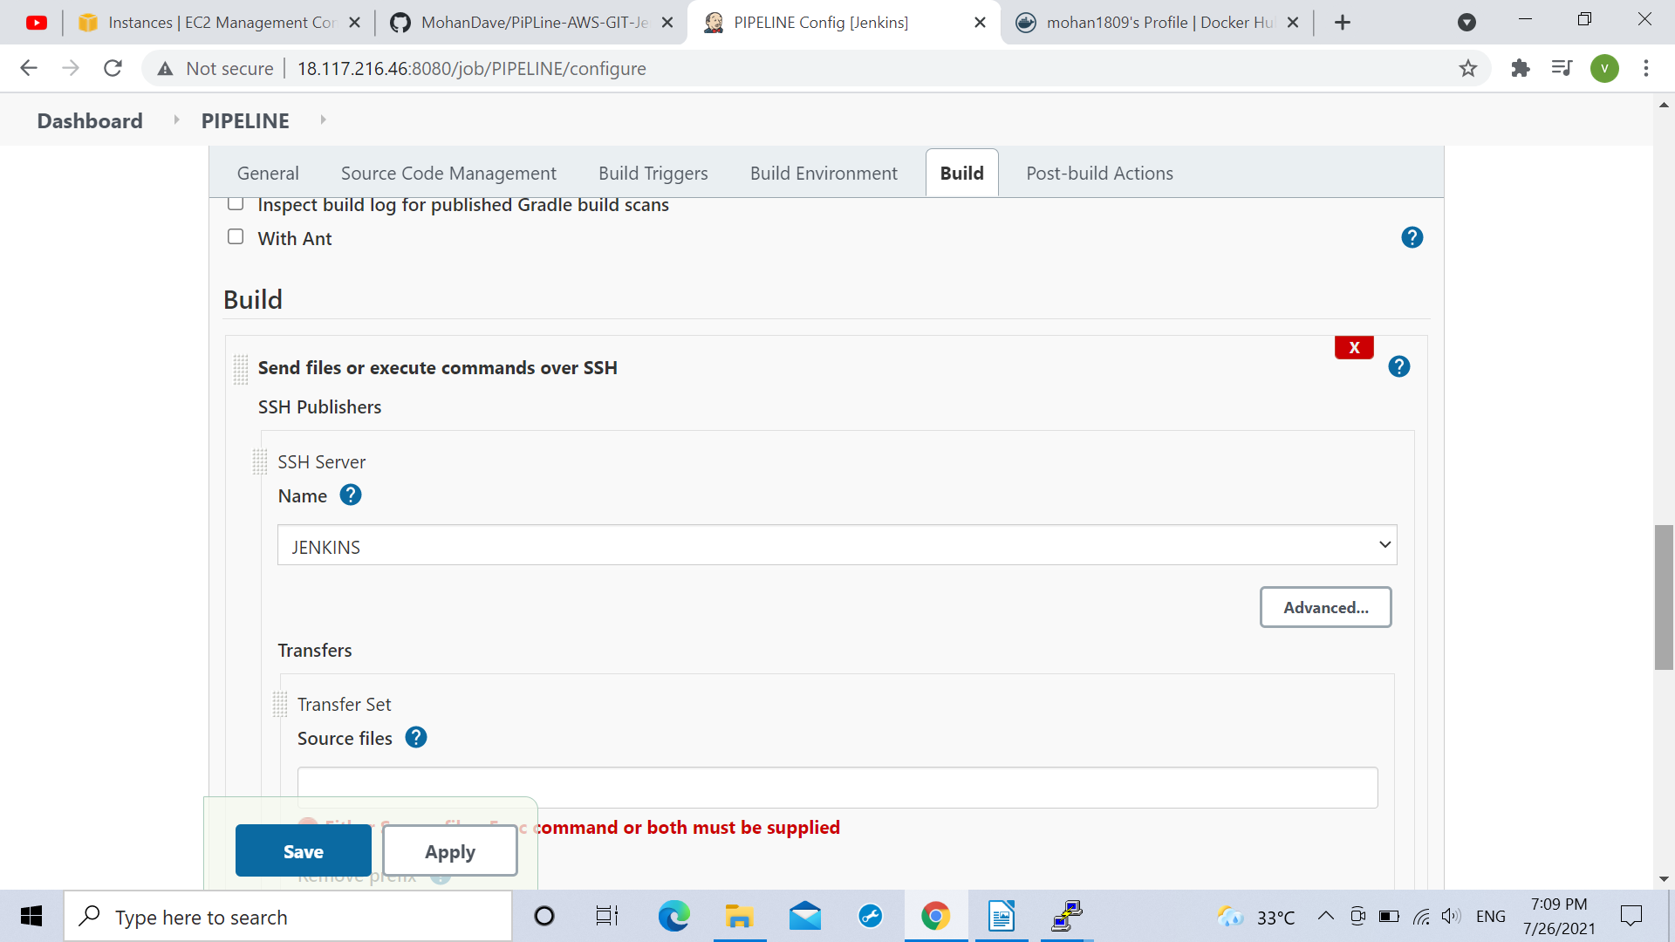
and in commands for execution column following command was given:
rsync -avh var/lib/jenkins/workspace/PIPELINE/DOCKERFILE root@172.31.45.85

for copying or sending the Docker image file from pipeline to the ansible server

