Locus Code-Jam - 2018

**January 21 to January 27  
Central Campus, Pulchowk**

**LOCUS 2018**, at Central Engineering Campus, Pulchowk, is organizing *LOCUS - 15th National Technological Festival* on 19th , 20th and 21st Magh.

This three day exhibition is an annual event which acts as a platform for students and tech-enthusiasts to express their ideas and explore the latest advancements in technology. LOCUS conducts various skill development programs and competitive as well as non-competitive hardware and software events, including exhibitions, seminars, paper presentations, gaming competitions and such, to foster creative and healthy interactions among students.

The annual LOCUS fair attracted more than 25,000 visitors in the previous year, had good media coverage and received wide acclamation in the technological society. The attendees included mainly undergraduate students and +2 students along with active participation by tech-enthusiasts and entrepreneurs. LOCUS 2018 is projected to increase this number of visitors and the quality of the fair in the following ways:

* Focus more on projects supporting to build a Smart City
* Organize various competitions and interesting programs
* Wider media coverage (Television Advertisements, Coverage on national daily )
* Weekly pre-events
* More innovative projects
* Social media campaigns   
  and many more...

*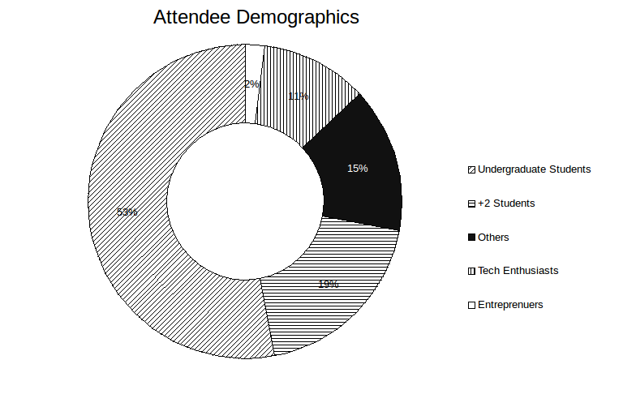(Picture: Pie Chart showing involvement of visitors from different fields. Data sourced from previous Locus events.)*

# 

# 

# CODE-JAM - 2018

**Code-Jam** is one of the pre-events being organized by LOCUS as a means to bring together developers, programmers and stimulate them to involve in a competitive and innovative challenge. It is two long event in which a number of participants engage in coding to solve the particular problem assigned to them. The event will have two levels for the fair competition .viz **Beginners and Advanced.**

Code-jam aspires to transcend the boundaries of primitive coding method and involves a series of proceedings where technique and algorithm are used to evaluate the participant expertise. The main intention of this event is to provide experience to participants with knowledge-intensive processes. In the end, participants will get a chance to bring their algorithm, skill to grow and prosper personally and contribute to IT development in the society and the nation as a whole.

Code-Jam - 2018 aims to continue the legacy of LOCUS by adding more competitive problems, introducing a new way for open challenges and coming up with exciting prizes.

## Levels for Code-Jam -2018

## Beginners

Beginners’ level is particularly targeted to the participants who has just started coding/programming. The main task for them is to solve the problem in the allocated time. The Time and space complexity of the code and algorithm will not be taken in account.

**Expected participants: 35**

2. Advanced

Advanced level is particularly targeted to the participants who has good knowledge in field of coding/programming. The main task for them is to solve the problem in the allocated time. The Time and space complexity of the code and algorithm will be taken in account.

**Expected participants: 25**

## Advantage for participants:

* To shape ideas into algorithms.
* To get extensive knowledge on optimization of program and the challenges therein.
* To get involved in healthy competitions among talented peers.
* To win exciting prizes.
* To bolster the culture of computer science individually and globally
* Fellowship among peer groups and tech-enthusiasts.

## 

## **Program Structure:**

The program is scheduled to be held in two days.

In the first day,

The first day is a selection round, where participants are given a simpler problems that need to be solved programmatically in the given time frame. Points will be given according to the efficiency of the code. The number of participants getting selected for the second round in both the level are:

Beginner **10**

Advanced **10**

In the second day,

The second day is the final round of the code jam, when the winners will be announced. The problems in this round will be comparatively complex. One winner, and two runner-ups will be selected in both the levels. The winners will be provided with the cash prize on the closing ceremony of LOCUS 2018.

## Sponsorship Categories and Mileages

All our sponsors will enjoy a high level of brand exposure at the 15th National Technological Festival, LOCUS, with the following benefits for different sponsors:

|  |  |
| --- | --- |
| **Title Sponsor** | **Associate Sponsor** |
| Free promotional stall (2m*2m) during *LOCUS* exhibition. As an alternative to stall, company representative can conduct an interactive onsite-program on exhibition along with a giveaway. |  |
| Company can hire the selected participants of both the levels for internship. |  |
| 1 banner (not exceeding 6’x8’) location at the *LOCUS* exhibition. | 1 banner (not exceeding 6’x8’) location at the *LOCUS* exhibition. |
| Half page advertisement in ZERONE 2018 (magazine published by LOCUS annually). | Quarter page advertisement in ZERONE 2018 (magazine published by LOCUS annually). |
| Company logo/name will be displayed alongside title on all *code-jam* event banners, event website, press releases, posters, flyers and other marketing materials. | Company logo/name will be displayed on all *code-jam* event banners and event website. |
| Media coverage through Radio, Newspaper, Magazines, Videos and Social Media. | Media coverage through Radio, Newspaper, Magazines, Videos and Social Media. |
| Company acknowledgement throughout the event, during*LOCUS* exhibition and at the closing ceremony. | Company acknowledgement throughout the event. |
| Prizes for the winners can be provided by the chief executive or the representative of the company. |  |

## Sponsor Contribution

|  |  |  |
| --- | --- | --- |
| **S.N.** | **Sponsorship Category** | **Contribution(Rs)** |
| 1 | Title Sponsor | 80,000 |
| 2 | Associate Sponsor | 35,000 |
| 3 | Media | Media coverage of the event |

## 

## Why to sponsor?

* Organized by students and completely non-profit motive event
* Can hire innovative minds for Internship
* Publicity among 5,000+ students throughout various +2 and engineering colleges and IT institutions all around the Kathmandu Valley
* Exposure throughout the event and *LOCUS* exhibition which had 15,000+ visitors last year

## Tentative Budget

### Gross Budget

|  |  |  |
| --- | --- | --- |
| **S. N.** | **Particulars** | **Expenses(NRs.)** |
| 1 | Prizes and certificates | 38,000 |
| 2 | Food | 40,800 |
| 3 | Logistics | 6,000 |
| 4 | Miscellaneous | 5,000 |
| 5 | Social Media Advertisement | 10,000 |
|  | Total | 99,800 |

### Budget Breakdown

#### Food

|  |  |  |  |  |  |
| --- | --- | --- | --- | --- | --- |
| **S.N.** | **Particulars** | **Unit Cost** | **No of unit** | **No. of days** | **Amount(Rs)** |
| 1 | Breakfast | 100 | 70 | 2 | 14,000 |
| 2 | Participant Lunch | 180 | 70 | 2 | 25,200 |
| 3 | Drinking water | 20 | 40 | 2 | 16,00 |

#### Prizes *and certificates*

|  |  |  |  |  |
| --- | --- | --- | --- | --- |
| **S.N.** | **Particulars** | **Unit Cost(Rs)** | **No of Units** | **Amount (Rs)** |
| 1 | Cash prize for winners | - | - | 25,000 |
| 2 | Certificate | 100 | 60 | 6,000 |
| 3 | Token of love | 700 | 10 | 7,000 |

#### 

#### Cash prize for winners

|  |  |  |  |
| --- | --- | --- | --- |
| **S.N.** |  | **Beginner level** | **Advanced level** |
| 1 | Winner | 5,000 | 8,000 |
| 2 | First runner up | 3,000 | 4,000 |
| 3 | Second runner up | 2,000 | 3,000 |
|  | **Total** | 10,000 | 15,000 |

#### 

#### Logistics

|  |  |  |  |  |
| --- | --- | --- | --- | --- |
| **S.N.** | **Particulars** | **Unit Cost(Rs)** | **No of units** | **Amount (Rs)** |
| 1 | Flex | 1000 | 3 | 3,000 |
| 2 | Wall Pamphlet | 100 | 30 | 3,000 |

## 