[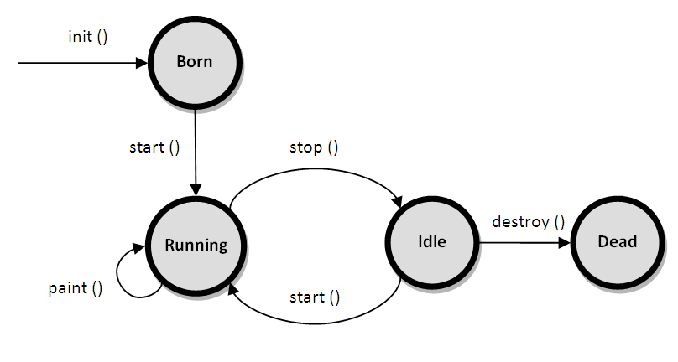](http://www.google.com.np/url?sa=i&rct=j&q=&esrc=s&frm=1&source=images&cd=&cad=rja&uact=8&ved=0CAcQjRw&url=http://javashortcut.blogspot.com/2010/07/applet-lifecycle.html&ei=0Z6sVL3jH9igugTluIG4BQ&bvm=bv.83134100,d.c2E&psig=AFQjCNFysF5EAoOeAfysJ7GorA-n4Do6SQ&ust=1420685390044953)

**Fig: Life Cycle of an applet**