**Creating a thread:**

1. **By extending Thread class**
2. **By implementing Runnable Interface**

|  |
| --- |
| **1) New**  **The thread is in new state if you create an instance of Thread class but before the invocation of start() method.** |

**2) Runnable**

**The thread is in runnable state after invocation of start() method, but the thread scheduler has not selected it to be the running thread.**

**3) RunningThe thread is in running state if the thread scheduler has selected it.**

**4) Non-Runnable (Blocked)**

**This is the state when the thread is still alive, but is currently not eligible to run.**

**5) Terminated**

**A thread is in terminated or dead state when its run() method exits or stop() method is invoked.**

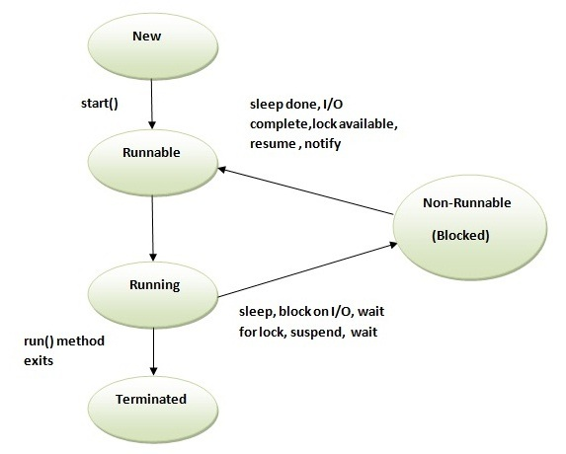

**,Stop()**