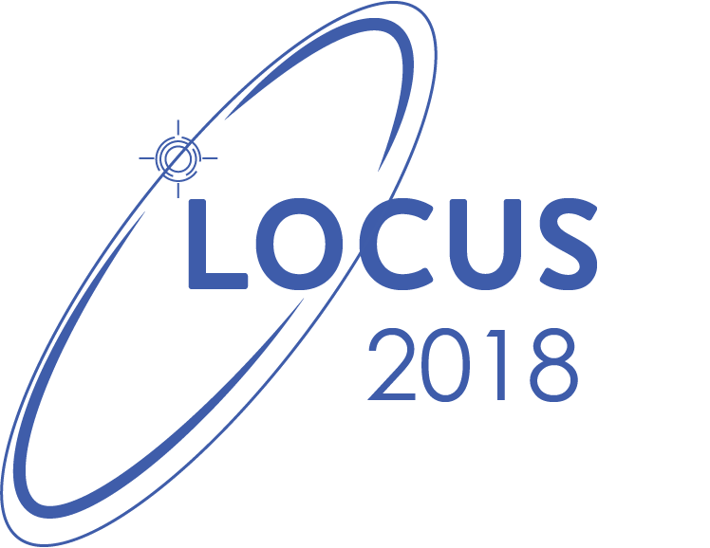

Presents

**ONLINE QUIZ COMPETITION  
2018**

**Proposal**

**(For Sponsorship)**

**LOCUS Online Quiz Competition 2018**

LOCUS is an annual technological festival organized at IOE, Pulchowk by the students of Electronics, Electrical and Computer Engineering Department of IOE, Pulchowk Campus. Under LOCUS, **Online Quiz Competition** is a quiz competition being organized as one of the pre-events among others. This event aims to encourage programming enthusiasts to increase their programming skills and gain knowledge of different algorithms.

The event will be held from **Poush 30** online through facebook daily till the day of exhibition, ie: **Magh 19**. The question will be published through facebook and the participants should give the correct answer of the question. One lucky winner giving the correct answer will be chosen randomely as a winner and provided with the wonderful gift hampers. All the participants need to share the post so that the post will reach to maximum number of users.

**Participation**

**Who can participate?**

Anyone who is interested can participate in Online Quiz Competition. Participants are expected mostly from +2, A-Levels, Undergraduate and Graduate level throughout the valley. However, there is no restriction to anyone to participate except for the committee members.

**Sponsorship Categories and Mileages**

All our sponsors will have a high level of brand exposure at Online Coding Competition 2018 and in the 15th National Technological Festival, LOCUS, with the following benefits for different sponsors:

|  |  |
| --- | --- |
| **Title Sponsor** | **Gold Sponsor** |
| Free promotional stall (2m*3m) during LOCUS exhibition. |  |
| 1 banner (not exceeding 72”x96”) location at the *LOCUS* exhibition. | 1 banner (not exceeding 72”x96”) location at the *LOCUS* exhibition. |
| Company logo/name will be displayed on all event banners, event website, press releases, posters, flyers and other marketing materials. | Company logo/name will be displayed on all event banners, event website, press releases, posters, flyers and other marketing materials. |
| Media coverage through Radio, Newspaper, Magazines, Videos and Social Media. | Media coverage through Radio, Newspaper, Magazines, Videos and Social Media. |
| Company acknowledgement throughout the event and during*LOCUS* exhibition. | Company acknowledgement throughout the event and during*LOCUS* exhibition. |

## **Sponsor Contribution**

|  |  |  |  |  |
| --- | --- | --- | --- | --- |
| **S.N.** | **Sponsorship Category** | **Contribution Quantity**  **(NRs)** | **Number of Sponsors** | **Subtotal** |
| 1 | Title Sponsor | 60,000/- | 1 | 60,000/- |
| 2 | Gold Sponsor | 20,000/- | 2 | 40,000/- |

**Why to sponsor?**

* + Extensive promotion of the company daily for 20 days from the official facebook page of LOCUS, which has 10k+ likes and an average post reach of 25k+ people.
  + Publicity among students throughout various +2, engineering colleges and IT institutions around the Kathmandu Valley.
  + Exposure throughout the event and *LOCUS* exhibition where visitors are expected to be about 35000 (it had 25000 visitors last year).