A Major Project Proposal Report on

Swasthya-Pala; A Meal Planner Mobile Application for Diabetics Specific to Nepal

Submitted in Partial Fulfillment of the Requirements for
the Degree of Bachelor in Software Engineering
under Pokhara University

Submitted By:
Jitendra Bhatta,161747
Ghanshyam Joshi,161613
Mohan Kumar Dhakal, 161657

Under the supervision of
Mr. ABC DEF

Date:
23 March, 2020

Department of Software Engineering
NEPAL COLLEGE OF

INFORMATION TECHNOLOGY
Balkumari,Lalitpur,Nepal

ABSTRACT
Diabetics is growing at an alarming rate, worldwide and in Nepal too. Nepal is currently adapting to a busy and unmanaged urban lifestyle due to which obesity and metabolic syndrome are on rise, which are the major cause of Diabetes. As Diabetes is a lifestyle disease, it can be reversed too, given that we make our consumption conscious and lifestyle a bit more organised. There are many people today, even at the age of 25-30 suffering from diabetes or pre-diabetes, who doesn’t surely want to go for medication as a simple tweak in their eating habits can reverse their condition. Eating the right food, at the right time, and in the right quantity is in itself a challenging task.The challenge is even more sound when it comes to track what we have eaten to control our eating pattern in the future and make safer food choices.

In order to solve this problem we have proposed a solution with a mobile application which can plan a meal for a person according to their nutritional requirement,preference and allergic condition. Also it helps track their blood glucose level to adjust their future meal accordingly. After a certain period of tracking the meal and blood glucose level, the application can also predict the possible BG level at a given time using a linear regression model, which can be a possible replacement for Glucometer in the long run.

Keywords: Diabetes, Glucometer, Blood Glucose, Linear regression model

Table of Contents

Abstract………..……………………………………………..i
Table of contents…………………………….……………………………ii
List of figures………………………………...……………………………..iii
List of Tables………………………………………………………………..iv
- Introduction………………………………………………………………...1
- Problem statement………………………………………………….………….2
- Project Objectives………………………………………………………………3
- Scope And Limitation………………………………………………………….4
4.1 Significance of Study……………………………………………….5
- Literature Review…..………………………………………..…………..…….....6
- Proposed Methodology…………………………………………………….....7
6.1Meal Planning Algorithm…………………………………………...8
6.2 Regression Algorithm for BG level Prediction…………….9
6.3 Software Development model…………………………………..10
7.Tools And Technology…………………………………………………….. 11
8.Deliverables………………………………………………………………………..12
9.System Architecture Design…………………………………………….…13
10.Use Case Diagram…………………………………………………………….14
11.Project Time and Task Schedule…………………………………..….15
11.1 Gantt Chart.………………………………………………………………....16
12.BIBLIOGRAPHY…………………………………………………………………17

1. INTRODUCTION
Diabetes is a disorder in which blood levels of glucose are abnormally high due to either an absolute deficiency of insuline secretion, or as a result of reduced effectiveness of insulin, or both[1]. It is a major challenge to overcome today, thanks to the unmanaged and busy urban lifestyle. Although the causes of diabetes(type-2) are still uncertain, It is believed that it is caused mainly by unhealthy eating habits and sedentary activity and can be reversed with a simple tweak in our lifestyle.
Swasthya-Pala tries to solve this growing issue by providing solutions to diabetics where the system plans what they are going to eat in the day considering their nutritional needs, preferences, eating time, and allergic condition. Our system also provides the flexibility for people to add their own food menu satisfying the criteria set by the experts which the system can use to plan meals.
It is equally important for diabetics to track their Blood Glucose (BG) history to adjust their meal accordingly, our system provides meal adjustment by tweaking meals with different GI levels.
Measuring BG level with Glucometer might not always be feasible, As people start using our system and data is collected for certain time about their eating history we can predict their probable BG level at a given point of time. The system will use a linear regression model to predict the probable BG level for a person and warn the user accordingly before any meal time.

2. PROBLEM STATEMENT

Diabetes prevalence has been rapidly rising especially in low and middle income countries like Nepal. Due to the sedentary lifestyle of people living in urban areas, overweight and obesity is on rise which is a major cause for type-2 diabetes. According to Nepal Diabetes Association(NDA)[2] diabetes affects 15% people of age more than 20 years and 19% of people of more than 40 years of age. According to WHO diabetics worldwide are predicted to reach around 1,238,000 by 2030[3].
As diabetes is considered a lifestyle disease, a healthy diet and regular exercise can help reverse this condition. Eating mindfully with the knowledge of what we are eating is in itself a very challenging task as it requires in-depth knowledge to know what a food contains and how it affects the condition. Tracking what we have eaten is yet another challenging task diabetics face in their daily life. Similarly no patient is able to adjust their meal according to what their BG level says at the given instant. On the other hand people are forced to use glucometer reading for Blood Glucose, but it’s convenience and availability remains questionable. All these problems require systematic planning which obviously requires knowledge, effort, and most importantly the valuable time.
Because of the busy lifestyle and lack of technical knowledge in the particular field diabetes patients aren’t able to manage their lifestyle better so that the condition can be reversed faster and efficiently and doesn’t result in disaster. As the use of mobile devices has been increasing rapidly by all age groups, providing a personalized diet plan alongside some notifying mechanism for patients to control their eating and exercising habits in hand-held devices might be a useful solution.

3. PROJECT OBJECTIVES
- To plan a custom meal plan for diabetics considering nutritional need.
- To help Diabetics track their blood sugar level and warn them when caution needs to be taken.
- To predict probable blood sugar without using glucometer.
- To provide periodic nutrition consumption report.
- To help Diabetics manage their outdoor eating pattern with periodic reminder of future consequences.

4. SCOPE AND LIMITATON

Scope
- Schedule based calorie intake.
- It covers daily dietary intake of the diabetic patient through healthy meal.
- Predict Blood Glucose level with with the meal that has been consumed so that patient does not have to depend on glucometer.
- End nutrition and Blood glucose level report generation which can help both doctor and patient.
- Blood sugar tracking mechanisms.

Limitation

- No insulin tracking mechanism.
- The meal which will be recommended by the app is not expert certified.
- Lack of certified datasets.

4. SIGNIFICANCE OF STUDY
Diabetics being an incurable diesease has become a major challenge for countries today. To overcome this challenge, we needed a mechanism to provide patients with a healthy dietary option considering personal nutritional requirements. In addition to that, patients are also in the dire need of BG level management so that they could adjust their eating habits. Moreover, convenience and availability of glucometer in day to day life for BG measurement remains questionable and unpractical as compared to that provided by mobile devices.

5. LITERATURE REVIEW

The study done by NDA reveals the prevelance of type-2 diabetes in Nepal and it’s increasing trend due to ever-high rate of obesity and overweight, especially due to sedentary lifestyle in urban area. 7 Day Diabetic Meal Plan[4] plans meal for patient in general scenario. There’s no specific preference condition for custom nutrition need for the patient. Glucosio[5] is another app for diabetic patients. It tracks important metrics like body weight, ketones,cholesterol,blood pressure,and more. It also helps users to set targets and reminders to keep their program on point. Similary Carb Manager focuses on tracking carbohydrate intake, as well protein, fat, and calories, with a database of foods and a bar code scanner.There also has been extensive study on how can meal be predicted for custom dietary recommendation such as Intelligent Ontological Agent for taiwanese [6] which uses fuzzy logic to determine the best meal for diabetics specific to taiwan. There has been several studies on BG level prediction for diabetics based on nutrition and insuling administration using various technique such as Personalized Mathematical models[7].We have alternatively purposed BG level predictor based on linear regression model. For meal planning algorithm design we have referenced an extensively documents by Ishwar Subedi on Menu Planning from DFTQC [8] and also the book Fundamental of Food Nutrition and Diet Therapy [9].

6. PROPOSED METHODOLOGY

For meal planning we have made a custom planning algorithm that can plan 3 meals a day for a patients based on the data provide by themselves.

6.1 Meal Planning Algorithm

Problem: Plan 3 meal for the day without repeating the meal. Include recommended unit of all food groups. Verify nutritional need calculated is met by the planned meal.

Precondition:
specification for each meal category:

breakfast:
1. must include food from Ga,Ge,Gc
2. Include High GI food.
Lunch:
1. must include food from Gb,Gf,Gh
2. Must include medium GI food.
Dinner:
1. must include food from Gi,Gj,Gk
2. No High GI food.

Input: Calorie and macro nutrients need and a requirement Card for meal.

Sample:
Calorie need: 1200 kcal
carbohydrates: 300g
fat: 60g
protein: 45g

Expected Output: 3 or 5 major meal for the day satisfying all the nutrients need.

Post-Condition: each meal should be different from previous day’s meal

Methodology:(using 1/3 rule)

1. Divide total nutritional need by 3.
2. Choose which meal to plan( breakfast, lunch or dinner
3. Pick a food from one of the list
3.1 calculate score for each meal.

Requirements | Expected Score | Actual Score
Allergy/Preference | 1 | 1
Food Group | 1 | 0.5
GI index | 1 | 1
Nutrients Satisfied | 1 | 1
Previously Taken | 1 | 0
Total | 5 | 3.5

Table 1. Requirement Card
3.2 compare the score and chose best meal
4. Now update the calculation table after each meal prediction as shown below for first breakfast.

Meal | kcal | carb | fat | protein | Gb | Gc | Gd | Ge | Gh
B1 | 250 | 100 | 10 | 10 | 3 | 1 | 0 | 1 | 0
Ao | 250 | 100 | 10 | 10 | 3 | 1 | 0 | 1 | 0
Eo | 1200 | 300 | 60 | 45 | 4 | 3 | 2 | 1 | 2
result | -950 | -200 | -50 | -35 | -1 | -2 | -2 | 0 | -2

Table 2. Calculation Table

5. Repeat 1 through 4 until Result is around non-negative value in the calculation table. perform Ao=Ao+1

6.2 Regression Algorithm for BG level Prediction
Linear regression attempts[10] to model the relationship between two
variables by fitting a linear equation to observed data. One variable is an explanatory variable, and the other is a dependent variable.
Given by,
y = X β + ε
y = dependent variables (target variables),
X = Independent variables (predictor variables),
β is a linear coefficient
ε = error variable

Sugar level in diabetic patients is directly proportional to carbohydrate consumption. Since carbohydrate is a major factor in controlling
diabetes. We will be using carbohydrate content of food as an
independent variable (X) and blood glucose level as dependent variable (y).
(Blood Glucose Level) = (Carbohydrate) β + ε

6.3 Software Developement Model

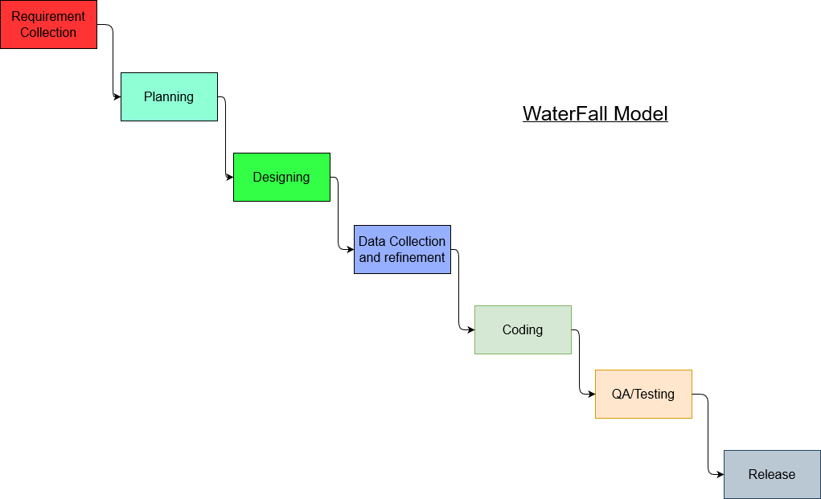
Fig. 1 Waterfall Software Developement Model

7. TOOLS AND TECHNOLOGY
While developing this particular application we will make use of various tools and technologies as mentioned in the below table.

Tools and Technology | Uses
Flutter | For android application developement
Linear Regression Model | BG level prediction
MYSQL | For database
PHP/LARAVEL | Server side coding
Python | Regression model implementation

Table 3. Tools and Technology used

8. DELIVERABLES
Our solution is applicable to nepalese market and is specialized for people suffering from diabetes and pre-diabetes.Some of the key outcome we can expect from this project are:
- Periodic custom meal plan for user
- Periodic nutrition consumption report
- Blood Glucose tracking mechanism
- Predicted Blood Glucose level

9. SYSTEM ARCHITECTURE DESIGN

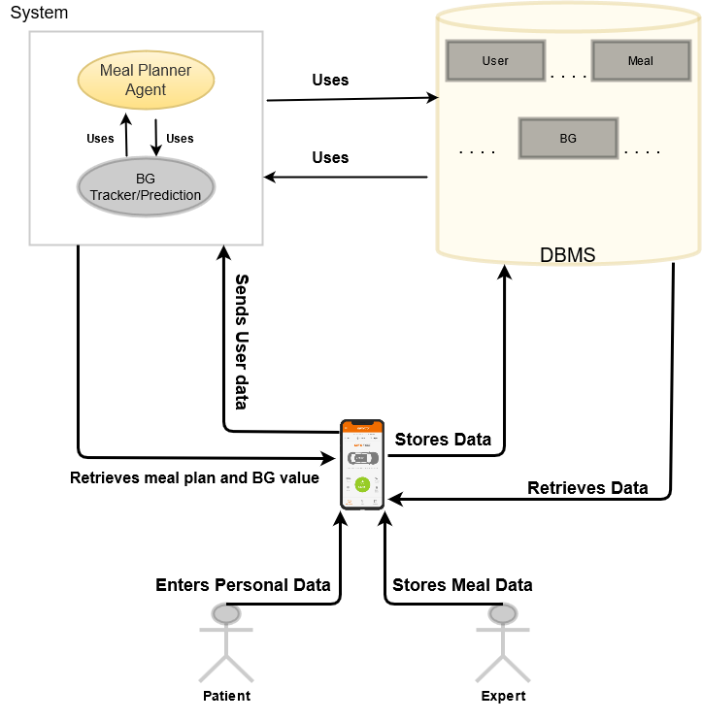

Fig. 2 System Architecture

10. USE CASE DIAGRAM

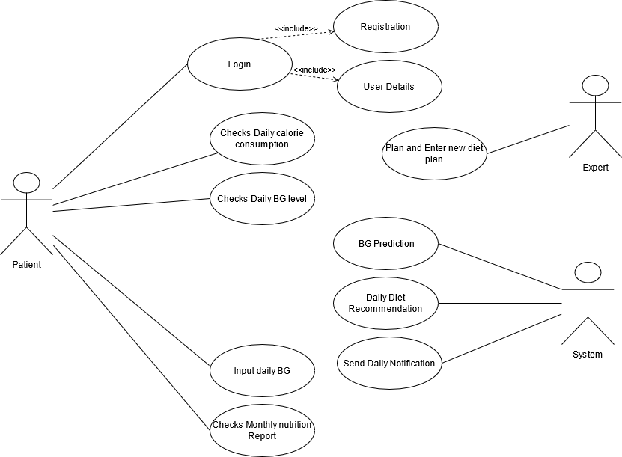

Fig. 3 Use Case Diagram

11. PROJECT TIME AND TASK SCHEDULE
As the concept we have raised required knowledge from different feild that we are in, We have spent most of our time doing research and planning. We have projected to accomplish our project by 7th of may with the duration of 2 months. Duration for each part of our work is given in below table.

PROJECT TIME AND TASK SCHEDULE

Tasks | Projected Duration(Days)
Research, Planning and Documentation | 15
Database Schema Design and UI Desgin | 2
Data collection and refinement for use in meal planning and BG prediction | 6
Application Coding and  Serverside coding, Regression model preparation | 16
Documentation and testing | 3
Application Coding+Server side coding | 11
Final QA and Documentation | 5
 | 58days

TABLE 4. PROJECT SCHEDULE

11.1 GANTT CHART

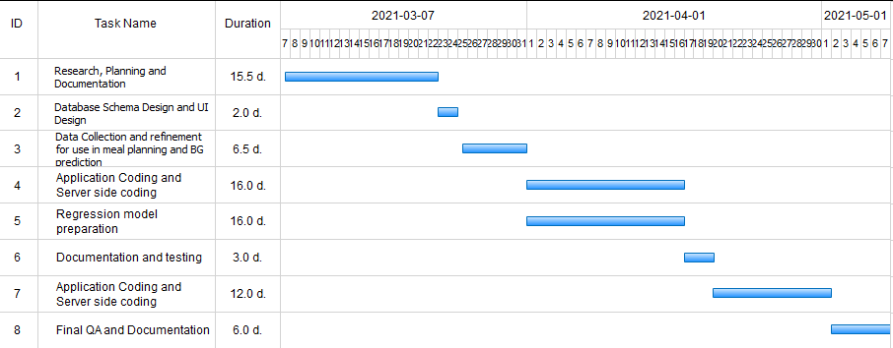
Fig 3. Gantt Chart

12. BIBLIOGRAPHY

[1]American Diabetes Association, 3Standards of medical care in
diabetes-2007, ́ Diabetes Care, vol. 30, no. 1, pp. S4-S41, Jan. 2007.

[2]https://nepaldiabetesassociation.com/research.php

[3]https://www.who.int/news-room/fact-sheets/detail/diabetes#:~:text=The%20number%20of%20people%20with,in%20premature%20mortality%20from%20diabetes.

[4]https://play.google.com/store/apps/details?id=com.DaDiabetes.MealPlanS&hl=en&gl=US

[5]https://play.google.com/store/apps/dev?id=7346203302402258491&hl=en&gl=US

[6]https://ieeexplore.ieee.org/document/4630615

[7]https://www.hindawi.com/journals/jhe/2019/8605206/

[8]http://dftqc.gov.np/

[9]https://alraziuni.edu.ye/uploads/pdf/fundamentals-of-foodnutrition-and-diet-therapy.pdf
[10] https://en.wikipedia.org/wiki/Linear_regression

