A Major Project Final Report on

**Swasthya-Pala; An Expert Meal Planning Agent with Forward Chaining for Diabetics Specific to Nepal**

Submitted in Partial Fulfilment of the Requirements for the Degree of **Bachelor of Engineering in Software Engineering** under Pokhara University

Submitted By:

**Jitendra Bhatta,161747**

**Ghanshyam Joshi,161613**

**Mohan Kumar Dhakal, 161757**

Under the supervision of:

**Madan Kadariya**

Date:

July 26, 2021

**Department of Software Engineering**

**NEPAL COLLEGE OF**

**INFORMATION TECHNOLOGY**

Balkumari, Lalitpur, Nepal

**ACKNOWLEDGEMENT**

This project would not have been possible without the joint efforts of many individuals. It has been a pleasure for us to acknowledge the assistance and contributions that were very important and supportive throughout the project. We would like to extend our sincere thanks to all of them. We owe special thanks to a number of people who has devoted much of their time and expertise without which it would have been very difficult for us to complete our project entitled “Swasthya-Pala; An Expert Meal Planning Agent with Forward Chaining for Diabetics Specific to Nepal”.

We are highly indebted to our Project Supervisor Mr. Madan Kadariya, for his valuable guidance throughout the project development period and for providing technical support with suggestions which helped our project to grow and foster to a certain level we didn’t think of reaching in such a short period.

Last, but not the least, we would like to thank our teachers and friends who have been knowingly or unknowingly the part of this project and lent support and views during the entire development time. We feel obliged in submitting this project as part of our curriculum. Although, there may be still many who are unacknowledged in this humble vote of thanks, there are none who remain unappreciated.

**Ghanshyam Joshi**

**Jitendra Bhatta**

**Mohan Kumar Dhakal**

# ABSTRACT

Diabetes is growing at an alarming rate, worldwide as well as in Nepal. Nepal is currently adapting to a busy and unmanaged urban lifestyle due to which obesity and metabolic syndrome are on rise, which are the major cause of Diabetes. As Diabetes is a lifestyle disease, however, it can be reversed given that we make our consumption conscious and lifestyle a bit more organized. There are many people today, even at the age of 25-30 suffering from diabetes or pre-diabetes, who doesn’t surely want to go for medication as a simple tweak in their eating habits can reverse their condition. Eating the right food, at the right time, and in the right quantity is in itself a challenging task. The challenge is even more sound when it comes to track what we have eaten to control our eating pattern in the future and make safer food choices.

In order to solve this problem, we have proposed a solution with a mobile application which can plan a meal for a person according to their nutritional requirement, preference and allergic condition using a forward-chaining approach of an Expert System. Also, it helps track their blood glucose level to adjust their future meal accordingly. After a certain period of tracking the meal and blood glucose level, the application can also predict the possible BG level at a given time using a linear regression model, which can be a possible replacement for Glucometer in the long run.

***Keywords:*** *Diabetes, Glucometer, BG level, Linear regression model*

Table of Contents

ABSTRACT ii

List of Figures iv

List of tables v

1. INTRODUCTION 1

2. PROBLEM STATEMENT 2

3. PROJECT OBJECTIVES 3

4. SCOPE AND LIMITATON 3

4. SIGNIFICANCE OF STUDY 4

5. LITERATURE REVIEW 5

6. PROPOSED METHODOLOGY 6

6.1 FORWARD CHAINING 6

6.2 FACTS 7

6.3 FORMULAS and Algorithms 8

6.3.1 BMR Calculation 8

6.3.2 BMI calculation 8

6.3.3 Calorie Calculation 8

6.3.4 Calculation for carbohydrate per day for diabetics 8

6.5 REGRESSION ALGORITHM FOR BG LEVEL PREDICTION 10

6.5.1 CALCULATE MEAN AND VARIANCE 10

6.5.2 CALCULATE COVARIANCE 10

7. Software Development Model 12

8. TOOLS AND TECHNOLOGY 13

9 DROOLS 13

10. DELIVERABLES 13

11. SYSTEM ARCHITECTURE DESIGN 14

12. USE CASE DIAGRAM 15

12.1 USE CASE DESCRIPTION 16

13. DELIVERABLE AND TASK SCHEDULE 19

13.1 PROJECT WORK DURATION 19

13.2 GANTT CHART 20

15. BIBLIOGRAPHY 22

16. APPENDIX 24

# List of Figures

1. Forward Chaining…………………………………………………………………………….…….11

2. Forward Chaining Example…………………………………………………………….…………..11

3. Fact Example......................................................................................................................................12

4. Waterfall software Development model…………………………………………,..…….……….…16

5. System Architecture Design….……………………..…………………………….…..….…………19

6. Usecase Diagram………………………………………………………..……………….………….20

7. Gantt chart……………………...…………………………………………..…..………………...…24

# List of tables

1.Tools and Technology used…………………………………………………………………….…...17

2. Login....................................................................................................................................20

3. Checks Daily Calorie Consumption.....................................................................................20

4. Checks Daily BG Level........................................................................................................20

5. Input Daily BG.....................................................................................................................21

6. Checks Monthly nutrition Report.........................................................................................21

7. Plan and enter new diet plan.................................................................................................21

8. BG Prediction………………………...................................................................................22

9. Daily Diet Recommendation................................................................................................22

10. Send Daily Notification......................................................................................................22

11. Project Schedule………………………….........................................................................23

# 1. INTRODUCTION

Diabetes is a disorder in which blood levels of glucose are abnormally high due to either an absolute deficiency of insulin secretion, or as a result of reduced effectiveness of insulin, or both [1]. It is a major challenge to overcome today due to the unmanaged and busy urban lifestyle. Although the causes of diabetes(type-2) are still uncertain, it is believed that it is caused mainly by unhealthy eating habits and sedentary activity and can be reversed with a simple tweak in our lifestyle.

Swasthya-Pala tries to solve this growing issue by providing solutions to diabetics where the Rule-Based expert system plans what they are going to eat in the day considering their nutritional needs, preferences, eating time, and allergic condition etc. Our system also provides the flexibility for user/experts to add their own food menu satisfying the criteria set which will be checked by expert meal planning agent, Here the one who adds the meal will be considered as an expert by the system. It is equally important for diabetics to track their Blood Glucose (BG) level to adjust their meal accordingly, our system provides meal adjustment by tweaking meals with different GI levels.

Measuring BG level with Glucometer might not always be feasible, as people start using our system and data is collected for certain time about their eating history, we can predict their probable BG level at a given point of time. The system will use a linear regression model to predict the probable BG level for a person and warn the user accordingly before any meal time.

# 2. PROBLEM STATEMENT

Diabetes prevalence has been rapidly rising especially in low and middle-income countries like Nepal. Due to the sedentary lifestyle of people living in urban areas, overweight and obesity is on rise which is a major cause for type-2 diabetes. According to Nepal Diabetes Association (NDA) [2] diabetes affects 15% people of age more than 20 years and 19% of people of more than 40 years of age. According to WHO diabetes in Nepal is predicted to reach around 1,238,000 by 2030[3].

As diabetes is considered a lifestyle disease, a healthy diet and regular exercise can help reverse this condition. Eating mindfully with the knowledge of what we are eating is in itself a very challenging task as it requires in-depth knowledge to know what a food contains and how it affects the condition. Tracking what we have eaten is yet another challenging task diabetic face in their daily life. Similarly, no patient is able to adjust their meal according to what their BG level says at the given instant. On the other hand, people are forced to use glucometer reading for Blood Glucose, but it’s convenience and availability remains questionable. All these problems require systematic planning which obviously requires knowledge, effort, and most importantly the valuable time.

Because of the busy lifestyle and lack of technical knowledge in the particular field diabetes patients aren’t able to manage their lifestyle better so that the condition can be reversed faster and efficiently and doesn’t result in disaster. As the use of mobile devices has been increasing rapidly by all age groups, providing a personalized diet plan alongside some notifying mechanism for patients to control their eating and exercising habits in hand-held devices might be a blessing in disguise.

# 3. PROJECT OBJECTIVES

* To plan a custom meal plan for diabetics considering nutritional need.
* To help Diabetics track their blood sugar level and provide warning where needed
* To predict probable blood sugar without using glucometer.
* To provide periodic nutrition consumption report.
* To help Diabetics manage their outdoor eating pattern with periodic reminder of future consequences.

# 4. SCOPE AND LIMITATON

### Scope

* Application is more focused on Type-2 then Type-1 diabetes.
* Works on a android platform
* Food recommendation is based on Nepalese cuisine only.
* Deals with macro nutrients

### Limitation

* No insulin tracking mechanism.
* The meal which will be recommended by the app is not expert certified.
* Cannot be used for any other diseases
* Does not deal with micronutrients

# 4. SIGNIFICANCE OF STUDY

Diabetics being an incurable disease has become a major challenge for countries today. To overcome this challenge, we needed a mechanism to provide patients with a healthy dietary option considering personal nutritional requirements. In addition to that, patients are also in the dire need of BG level management so that they could adjust their eating habits. Moreover, convenience and availability of glucometer in day-to-day life for BG measurement remains questionable and unpractical as compared to that provided by mobile devices.

# 5. LITERATURE REVIEW

The study done by NDA reveals the prevalence of type-2 diabetes in Nepal and it’s increasing trend due to ever-high rate of obesity and overweight, especially due to sedentary lifestyle in urban area.

*7 Day Diabetic Meal Plan* [4] provide general information regarding what to eat and what not for a person suffering from diabetes. This app consists of the food database specific to diabetes patients. Food such as those with low glycemic index and mostly veggies are there in the food database considered by this application which is inconvenient and impractical to our society considering our cultural and other various preferences.

*Glucosio*[5] is another app for diabetic patients. It tracks important metrics like body weight, ketones, cholesterol, blood pressure, and more. It also helps users to set targets and reminders to keep their program on point. Although Glucosio helps patients track different body measurement we needed something that could also determine the personal dietary requirement and make adjustment for the diet accordingly.

Similarly, *Carb Manager* [6] focuses on tracking carbohydrate intake, as well protein, fat, and calories, with a database of foods and a bar code scanner. As diabetes is a disease mostly related with glucose level in the body, we needed a controlling mechanism for simple carbohydrate, this is precisely what this application intends to.

There also has been extensive study on how can meal be predicted for custom dietary recommendation such as *Intelligent Ontological Agent for Taiwanese* [7] which uses fuzzy logic to determine the best meal for diabetics specific to Taiwan. This approach assigns fuzzy number for each match in the system adds it and provides the best match with maximum value in the form of recommendation. There were no informing mechanism to user about their eating pattern and also most of the foods database used were based on Taiwanese food ontology so not really practical and useful for us.

There have been several studies on BG level prediction for diabetics based on nutrition and insulin administration using various technique such as *Personalized Mathematical models* [8].

We have referenced an extensively worked documents *by Ishwar Subedi on Menu Planning from DFTQC* [9] to collect and refine expert advice, that document involves different food groups, what foods belong to that food group, their nutritional value, and an example on how can we plan the meal.

Moreover, the book *Fundamental of Food Nutrition and Diet Therapy helped* us learn about the importance of nutrition in body, and how meal planning can save time and money for balanced diet, we have also collected the calorie calculation strategy from here [10].

# 6. PROPOSED METHODOLOGY

For meal planning we have a Rule-Based Expert System built on the drools inference engine that can plan 3 meals a day for a patient based on the data provide by themselves through the application such as body weight, height, preferences, allergic condition, etc.

Forward-chaining expert system can make recursive decision and plan a best meal with the given criteria from the application as shown in the example of forward-chaining below. Implementation of expert system has been done in Drools inference engine which was based on Java Programming language, whose results has been extracted through the use of middleware server built on Laravel backend framework and is shown to the end users.

# 6.1 FORWARD CHAINING

We used forward chaining so as to recommend meal according to their dietary requirement. It is a method of reasoning in artificial intelligence in which inference rules are applied to existing data to extract additional data until an endpoint is achieved.

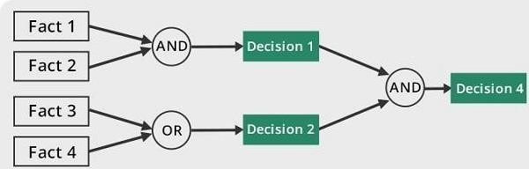

**Fig. 1 Forward Chaining**

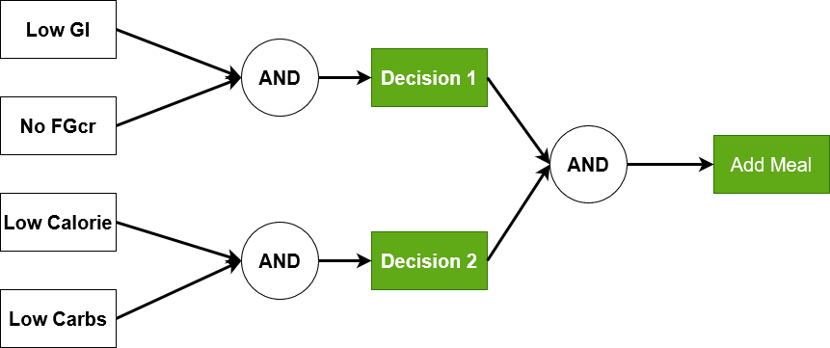

**Fig. 2 Forward Chaining Example**

# 6.2 FACTS

Given below is the sample fact representation for the expert system. The knowledge representations are stored in json format which will be extracted when appropriate rules are fired by the inference engine.

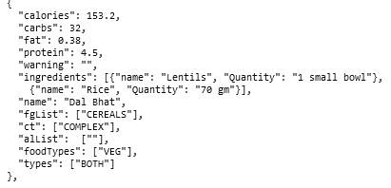

**Fig 3. Fact Example**

# 6.3 FORMULAS and Algorithms

We have made use of different formulas from various sources, we used these formulas to calculate BMR, BMI and Calories.

# 6.3.1 BMR Calculation

*Revised Harris-Benedict Equation* [14]

**Men: BMR = 88.362 + (13.397 * weight) + (4.799 * height) – (5.677 * age)**

**Women: BMR = 447.593 + (9.247 * weight) + (3.098 * height) – (4.330 * age)**

# 6.3.2 BMI calculation

*BMI Equation* [15]:

**BMI = kg/m2**

A BMI of 25.0 or more is overweight, while the healthy range is 18.5 to 24.9. BMI applies to most adults 18-65 years as normal.

# 6.3.3 Calorie Calculation

*Required Calorie as per lifestyle* [18]

Sedentary lifestyle:

**Total_Calorie_Per_Day = BMR * 1.17**

Moderate lifestyle:

**Total_Calorie_Per_Day = BMR * 1.47**

Active Lifestyle

**Total_Calorie_Per_Day = BMR * 1.7**

# 6.3.4 Calculation for carbohydrate per day for diabetics

According to Dietary Guidelines, carbohydrates make up to 50 percent of total daily calorie. The formula for the calculation has been derived from *Total carbohydrate needed per day* [13]. Formula for fat calculation has been reference from Total Fat needed per day [16] and the protein requirement has been retrieved from *Total Protein needed per day* [17].

**6.4 RULES**

It is a set of explicit or understood procedure within a particular area of activity. We hardcoded rules in drools static database which are fired when specific conditions are met by the drools inference engine.

Below is the sample rule stored in the drools engine’s static database.



rule "Dinner Chosen based on calorie and carb"

agenda-group "dinner-plan"

when

pf:Profile()

bf:Meal(carbs<=pf.getCarb(),calorie<=pf.getCalorie())

then

bf.referenceCountD=bf.referenceCountD + 1;

update(bf);

end

# 6.5 REGRESSION ALGORITHM FOR BG LEVEL PREDICTION

Linear regression attempts [10] to model the relationship between two variables by fitting a linear equation to observed data. One variable is an

explanatory variable, and the other is a dependent variable. Given by,

y = X β + ε

y = dependent variables (target variables),

X = Independent variables (predictor variables),

β is a linear coefficient

ε = error variable

Sugar level in diabetic patients is directly proportional to carbohydrate consumption. Since carbohydrate is a major factor in controlling diabetes. We will be using carbohydrate content of food as an independent variable (X) and blood glucose level as dependent variable (y).

**(Blood Glucose Level) = (Carbohydrate) *β +* ε**

# 6.5.1 CALCULATE MEAN AND VARIANCE

The first step is to estimate the mean and variance of both the input and output variables from the training data [19].

The mean of a list of numbers can be calculated as:

**mean(x) = sum(x) / count(x)**

Variance for a list of numbers can be calculated as:

**Variance = sum ((x – mean(x)) ^2)**

# 6.5.2 CALCULATE COVARIANCE

The covariance of two groups of numbers describes how those numbers change together

We can calculate the covariance between two variables as follows:

**Covariance = sum((x(i) - mean(x)) * (y(i) - mean(y)))**

**6.5.3 ESTIMATE COEFFICIENTS**

We must estimate the values for two coefficients in simple linear regression.

The first is b1 which can be estimated as:

**b1 = sum((x(i) - mean(x)) * (y(i) - mean(y))) / sum((x(i) - mean(x)) ^2)**

Simplified version:

**b1 = covariance (x, y) / variance(x)**

Estimation for b0:

**b0 = mean(y) - b1 * mean(x)**

The actual formula [20]:

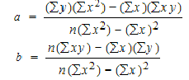

## 7. Software Development Model

Our project requires careful planning at the initial phase of the project followed by designing, coding and testing of the application. As requirements are clear at start and doesn’t require constant communication with stakeholders for change in requirement, we are followed waterfall model of software development to build the project.

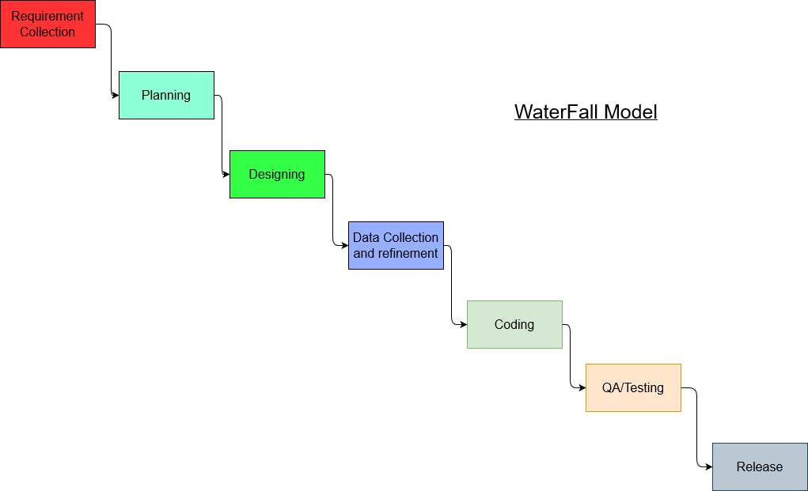

**Fig. 4 Waterfall Software Development Model**

# 8. TOOLS AND TECHNOLOGY

While developing this particular application we will make use of various tools and technologies as mentioned in the below table.

|  |  |
| --- | --- |
| **Tools and Technology** | **Uses** |
| Flutter | For android application development |
| Linear Regression Model | BG level prediction |
| MYSQL | For database |
| PHP/LARAVEL | Server-side coding language |
| Python | Regression model implementation |
| VS Code/Android Studio | Tool for coding |
| Drools | For Expert System Development |

**Table 1. Tools and Technology used**

# 9 DROOLS

Drools is a business rule management system (BRMS) [21] with a forward and backward chaining interface-based rules engine, more correctly known as a production rule system.

Drools engine was built upon the Java programming language and is extensively use to automate the business processes where a lot of expert decision needs to be taken although we had small set of rules we used drools and it was easily integrable to various other components of the system that we’re building.

# 10. DELIVERABLES

Our solution is applicable to Nepalese market and is specialized for people suffering from diabetes and pre-diabetes. Some of the key outcome we can expect from this project are:

1. Periodic custom meal plan for user

1. Periodic nutrition consumption report
2. Blood Glucose tracking mechanism
3. Predicted Blood Glucose level

# 11. SYSTEM ARCHITECTURE DESIGN

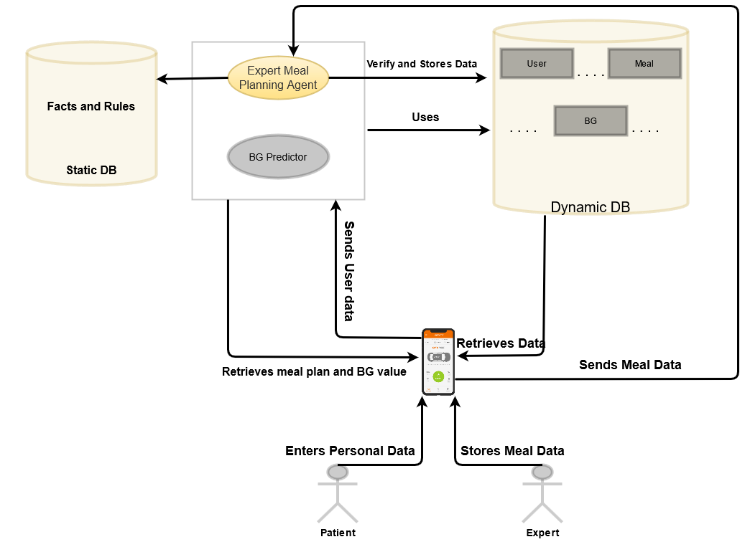

**Fig. 5 System Architecture**

In the fig, diabetic patient enters his/her personal data like height, weight, age, gender and blood glucose level. The application receives those data and sends it to expert meal planning agent and Blood Glucose predictor. Facts and rules are fired in the process. It verifies the incoming data and then stores in dynamic database. At the same time application retrieves meal plan and predicted Blood Glucose value. An expert's meal data can also be added to the database which provides authenticity.

# 12. USE CASE DIAGRAM

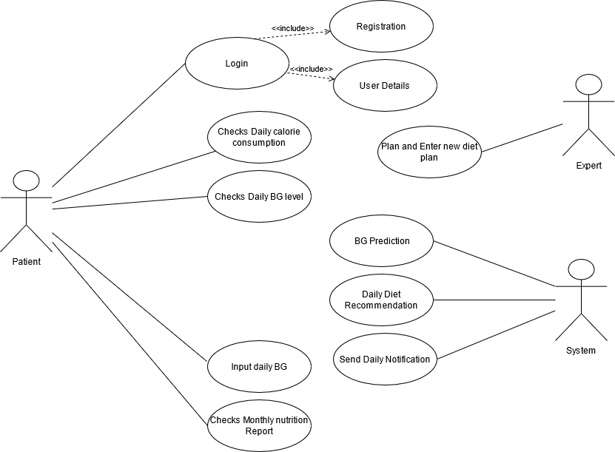

**Fig. 6 Use Case Diagram**

# 12.1 USE CASE DESCRIPTION

|  |  |
| --- | --- |
| Use Case Name | Login |
| Actors | Patient |
| Description | A Diabetic patient open an application to check his/her daily food recommendation. |
| Pre conditions | Insert Username and Phone number |
| Post Conditions | User Logs out |
| Related Use Cases | Add user Details or Register |
| Functional Requirements | User should enter his/her data. |
| Non-functional Requirements | None |

**Table 2. Login**

|  |  |
| --- | --- |
| Use Case Name | Checks Daily Calorie Consumption |
| Actors | Patient |
| Description | A Diabetic patient check his/her calorie consumption to see if it aligns with his/her daily goals. |
| Pre conditions | New Registration or Inputs his/her height, weight, age, gender |
| Post Conditions | User Logs out |
| Related Use Cases | None |
| Functional Requirements | User should have entered his/her data. |
| Non-functional Requirements | None |

**Table 3. Checks Daily Calorie Consumption**

|  |  |
| --- | --- |
| Use Case Name | Checks Daily BG Level |
| Actors | Patient |
| Description | A Diabetic patient opens the application to check if the predicted Blood Glucose level has changed. |
| Pre conditions | Insert Username and Phone number |
| Post Conditions | User Logs out |
| Related Use Cases | None |
| Functional Requirements | User should enter his/her Blood Glucose value. |
| Non-functional Requirements | None |

**Table 4. Checks Daily BG Level**

|  |  |
| --- | --- |
| Use Case Name | Input daily BG |
| Actors | Patient |
| Description | A Diabetic patient opens the application to add the Blood Glucose level that he got from the glucometer after checking. |
| Pre conditions | Insert Username and Phone number |
| Post Conditions | User Logs out |
| Related Use Cases | None |
| Functional Requirements | User should enter his/her data. |
| Non-functional Requirements | None |

**Table 5. Input Daily BG**

|  |  |
| --- | --- |
| Use Case Name | Checks monthly nutrition Report |
| Actors | Patient |
| Description | A Diabetic patient open the application to check his/her nutrition report at the end of the month. |
| Pre conditions | Insert Username and Phone number |
| Post Conditions | User Logs out |
| Related Use Cases | None |
| Functional Requirements | User should enter his/her data. |
| Non-functional Requirements | None |

**Table 6. Checks Monthly nutrition Report**

|  |  |
| --- | --- |
| Use Case Name | Plan and enter new diet plan |
| Actors | Expert |
| Description | An Expert opens the application to add new authentic meal for the diabetic patient. |
| Pre conditions | Insert Username and Phone number |
| Post Conditions | User Logs out |
| Related Use Cases | None |
| Functional Requirements | The Expert should enter his/her data. |
| Non-functional Requirements | None |

**Table 7. Plan and enter new diet plan**

|  |  |
| --- | --- |
| Use Case Name | BG Prediction |
| Actors | System |
| Description | The Simple regression model predicts the next Blood glucose level of the diabetic patient. |
| Pre conditions | Takes input from the Diabetic patient |
| Post Conditions | Passes the predicted value to the Application |
| Related Use Cases | None |
| Functional Requirements | User should enter his/her data. |
| Non-functional Requirements | None |

**Table 8. BG Prediction**

|  |  |
| --- | --- |
| Use Case Name | Daily Diet Recommendation |
| Actors | System |
| Description | All the inputs from diabetic patient and expert are processed vie facts and rules with the help of expert system. |
| Pre conditions | Takes input from the Diabetic patient and Expert |
| Post Conditions | Passes the recommended meal to the Application |
| Related Use Cases | None |
| Functional Requirements | Rules and Facts should match with the incoming data. |
| Non-functional Requirements | None |

**Table 9. Daily Diet Recommendation**

|  |  |
| --- | --- |
| Use Case Name | Send Daily Notification |
| Actors | System |
| Description | Daily Notification about meal plans, recommended food, and warnings. |
| Pre conditions | None |
| Post Conditions | Sends data to the Application |
| Related Use Cases | None |
| Functional Requirements | None |
| Non-functional Requirements | None |

**Table 10. Send Daily Notification**

# 13. DELIVERABLE AND TASK SCHEDULE

As the concept we have raised required knowledge from different field that we are in, we have spent most of our time doing research and planning. We have projected to accomplish our project by 7th of May with the duration of 2 months and accomplished accordingly.

## 13.1 PROJECT WORK DURATION

|  |  |
| --- | --- |
| **Tasks** | **Projected Duration (Days)** |
| Research, Planning and Documentation | 15 |
| Database Schema Design | 2 |
| Data collection, refinement, Facts and Rule Building | 10 |
| Expert System Building,  Server-side coding, Regression model preparation | 20 |
| Documentation and testing | 3 |
| Application Coding | 10 |
| Final QA and Documentation | 4 |
|  | 64 days |

**Table 11. Project Schedule**

## 13.2 GANTT CHART

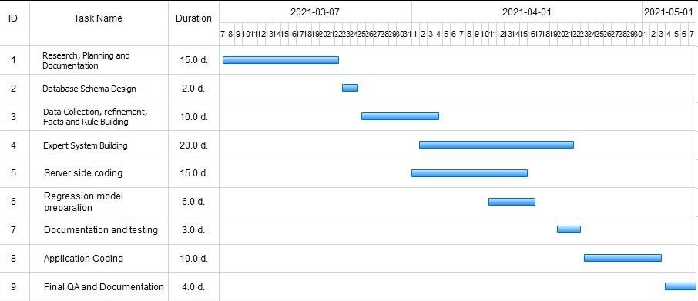

**Fig 7. Gantt Chart**

**14. RESULT AND DISCUSSION**

There are 3 major components of our application namely an Expert System Server, Middleware Server, and an application server. Expert system server takes input of the user data such as BMI, BMR, Activity level and gives the meal such as breakfast, lunch and dinner to be eaten for the day. The middleware server which was built on Laravel simply takes the user input coming from an application and give it to ES server to process, middleware server takes the output of the es server and stores it in the database. The user which is an application requests data and give data to the middleware server some attachments are place below of the above discussion.

**Sample response for meal prediction:**

INPUT=={"activity": "MODERATE",

"gender": "MALE",

"preference": "VEG",

"allergy": ["GLUTEN"],

"BMI": 30.0,

"BMR": 1637.5}

OUTPUT== [ { "id": 7, "created_at": "2021-07-26T15:40:47.000000Z", "updated_at": "2021-07-26T15:40:47.000000Z", "userId": 1, "name": "Apple", "calorie": 52, "carbs": 13.9, "protein": 0.3, "fat": 0.2, "ingredients": "[{"name":"Apple","qty""1 apple"}]", "warning": "", "type": "["BREAKFAST"]" }, { "id": 8, "created_at": "2021-07-26T15:40:47.000000Z", "updated_at": "2021-07-26T15:40:47.000000Z", "userId": 1, "name": "Veg Momo", "calorie": 40, "carbs": 6, "protein": 1, "fat": 2, "ingredients": "[{"name""Veg Momo","qty":"1 piece"}]", "warning": "", "type": "["LUNCH","DINNER"]" }, { "id": 9, "created_at": "2021-07-26T15:40:47.000000Z", "updated_at": "2021-07-26T15:40:47.000000Z", "userId": 1, "name": "Palak Paneer", "calorie": 270, "carbs": 7.5, "protein": 11.25, "fat": 22.5, "ingredients": "[{"name":"Paneer","qty":"50 gm"},{"name":"Palak","qty":"70 gm"}]", "warning": "", "type": "["LUNCH","DINNER"]" } ]

# 15. BIBLIOGRAPHY

1. American Diabetes Association, 3Standards of medical care in diabetes-2007, ́ Diabetes Care, vol. 30, no. 1, pp. S4-S41, Jan. 2007.

1. Nepal Diabetes Association <https://nepaldiabetesassociation.com/research.php>

1. <https://www.who.int/new>[sroom/fac](https://www.who.int/news-room/fact-sheets/detail/diabetes#:~:text=The%20number%20of%20people%20with,in%20premature%20mortality%20from%20diabetes)tsheets/detail/diabetes#:~:text=The%20number%20of%20people%20with,in%20prem [ature% 20mortality%20from%20diabetes.](https://www.who.int/news-room/fact-sheets/detail/diabetes#:~:text=The%20number%20of%20people%20with,in%20premature%20mortality%20from%20diabetes)

1. 7 Day Diabetic Meal Plan, Mobile Application <https://play.google.com/store/apps/details?id=com.DaDiabetes.MealPlanS&hl=en&gl=US>

1. Glucosio, Mobile Application <https://play.google.com/store/apps/dev?id=7346203302402258491&hl=en&gl=US>

1. Carb Manager, Mobile Application

https://www.carbmanager.com/

1. Chang-Shing Lee, Mei-Hui Wang, Huan-Chung Li, Wen-Hui Chen, “ Intelligent ontological agent for diabetic food recommendation”

<https://ieeexplore.ieee.org/document/4630615>

1. Peter Gyuk, Istvan Vassanyi, Istvan Kosa, “ Blood Glucose Level Prediction for Diabetics Based on Nutrition and Insulin Administration Logs Using Personalized Mathematical Models”  [https://www.hindawi.com/journals/jhe/201](https://www.hindawi.com/journals/jhe/2019)[9/8605206/](https://www.hindawi.com/journals/jhe/2019/8605206/)

1. Department of Food Technology and Quality Control, Government of Nepal <http://dftqc.gov.np/>

1. Sumati R. Mudambi, M.V. Rajagopal, “Fundamentals of Foods, Nutrition and Diet Therapy” [https://alraziuni.edu.ye/uploads/pdf/fundamental](https://alraziuni.edu.ye/uploads/pdf/fundamentals)[s-of-foodnutrition-and-diet-therapy.pdf](https://alraziuni.edu.ye/uploads/pdf/fundamentals-of-foodnutrition-and-diet-therapy.pdf)

1. Linear Regression Algortihm<https://en.wikipedia.org/wiki/Linear_regression>
2. Food knowledge acquisition <https://www.healthline.com/nutrition/foods>?
3. Carbs intake calculation <https://www.google.com/search?q=daily+carbs+per+day>
4. Basal metabolic rate calculation <https://www.calculator.net/bmr-calculator.html>
5. Body Mass Index calculation <https://www.google.com/search?client=firefox-b-d&q=BMI+formula>
6. Fat Calculation <https://www.google.com/search?client=firefox-b-d&q=fat+per+day>
7. Protein Calculation <https://www.google.com/search?q=protein+per+day>
8. Calorie calculation <https://www.google.com/search?client=firefox-b-d&q=calorie+according+to+activivyth+level>
9. Linear Regression Model in python <https://machinelearningmastery.com/implement-simple-linear-regression-scratch-python/>
10. Linear regression equation reference <https://owlcation.com/stem/How-to-Create-a-Simple-Linear-Regression-Equation>
11. Drools production rule engine <https://en.wikipedia.org/wiki/Drools>

# 16. APPENDIX

Some screenshot of our application implementation:

