**Introduction:**

Most people already heard about Diabetes disease. However, still many people looked down and take it easy about this disease. They assume that Diabetes just a simple one disease and can be cured easily. But they totally wrong. Diabetes can be cause another chronic disease such as heart failure, nerve damage, eye problem and another organ failures. There are categorization of the diabetes such as Type 1 diabetes, Type 2 diabetes, diabetes that caused by another disease and Gestational diabetes mellitus (GDM).

However, the reason that leading the diabetes still become questions although the potential cause such as obesity and unhealthy lifestyle can tend become the factor . Besides obesity and unhealthy lifestyle, the another reason such as family history, smoking, suger intake daily, and so on. So, we advised to be careful in practise our lifestyle. It maybe become health or unhealthy lifestyle. The choice in our hands. To the obesity patients, are advised to change diet style and take nutrition food in right portion and always do exercise. The diabetes able make us become disable people where there is organ are imputated because of diabetes complication. So, diabetes patient should give attention to their leg. Early preventation more better than cured disease.

**Problem Statement**

The problem about this project is it is not easy to do diagnosis whether it is positive or negative having diabetes. It is because of many reason. Different people maybe have different signs. So it is not easily to assume that they have it or not. The sign of the diabetes is always thirsty, always hungry, weight become decrease, feel weak, have problem of sight, headacnes, always do urination and so on. However, the real diagnosis are still needed to assign the real result.

**OBJECTIVES**

a) To measure the probability of a user for getting diabetes.

b) To implement rule based algorithm as prediction technique into a system

c) To develop the system that function with the real problem.

**SCOPE**

This system will focus on the potential user, admin and system.

**i. Potential user:**

• The user that have signs or not can get early diagnosis about diabetes and takes early preventation.

• User need sign up and then sign in. They need to fill out the personal information. Next, do prediction by using the system.

• User also able to view preventation and information about Diabetes section in this system.

**ii. Admin**

• The person who will coordinate this system and update the system based on situation.

• People who responsible to update information section in the system.

**iii. System**

• Login

- There is login and registeration to enter this system based on type of user.

**• Questionaire module**

- There is questionaire that need be answered and evaluation by potential user and from that, the result can be find out.

• **Domain System(Diabetes)**

-The result can be find out after analyzing through rule based and tree decision technique.

• **Opinion or its rate**

User can give opinion and suggestion and give their rate about the system. Example, the early prediction really can be trusted or not.

• **Information Section**

-User can find out more information of Diabetes

- Through the information, users who potentially have Diabetes can take early preventation.

**LIMITATION OF WORK**

This system is only give the early prediction based on the signs that user had. The result of prediction may not accurate like the diagnosis from doctor. User need to seek consultant with doctor if want the real one diagnosis. This system just able to alert user to take fast action about the diabetes. If the user are predicted have positive diabetes, the system will give suggestion and recommend for healthy diet plan.

**LITERATURE REVIEW:**

Diabetes are known the one of the top disease in this world. Diabetes are not easily to be cured and need to depend on the medicine. If we know earlier that we had diabetes, we can control its impacts become more worse. The people only know that they have diabetes after the effects already become worse. So, the early prediction are required to aware all the people. There are three type of Diabetes that has been identified such as Type 1, Type 2 and Gestational Diabetes. All this type diabetes have its differences and characteristics. Also, the majority patient who has Diabetes is female than male.

Type 1, usually people who suffer this type diabetes, she/he cannot produce insulin anymore in their body because the pancreas totally damaged. Futhermore, the average people have this type of diabetes is below 20 years old [1]. Next,the patient with this type have weight loss. However, this disease is not easily to classified whether the patient can have this type diabetes or can become into Diabetes Type 2.

As well as Type 1, Type2 Diabetes patient also have problem in producing insulin for their body, where their pancreas produce insulin ,however it still no enough because their body resistant toward insulin. The majority of the Diabeties patients had this type diabetes [3]. For normal person, the sugar level cannot low or more from the normal level which is from 4.4 until 6.1 mmol/L.

Gestational Diabetes, commonly the person who have this type diabetes are consist of pregnant women. During pregnancy moment, the pregnant women are advised to do a few test to check they have this kind of diabetes or not. If the person have this diabetes, the production of insulin cannot be produce as usual as before pregnant. The risk for the baby to suffer from diabetes also higher. For information, usually the high weight baby maybe delivered by the Gestational Diabetes mother. Next, for the next pregnancy, the patient have high risk to get the same problem. The bad effect to pregnant women who have this diabetes is bleeding during birth or miscarriage may occur.

**METHODOLOGY:**

We will discuss four phases in this sections:

**1) Planning phase**

Phase where the requirement are collected and risk is assessed. This phase where the title of the project has been discussed with project supervisor. From that discussion,Diabetes meal planner mobile Application System has been proposed. The requirement and risk was assessed after doing study on existing system and do literature review another existing research.

**2) Risk analysis Phase**

Phase where the risk and alternative solution are identified. A prototype are created at the end this phase. If there is any risk during this phase, there will be suggestion about alternate solution.

**3) Engineering phase**

At this phase, a software are created and testing are done at the end this phase.

**4) Evaluation phase**

At this phase, the user do evaluation toward the software. It will done after the system are presented and the user do test whether the system meet with their expectation and requirement or not. If there is any error, user can tell the problem about system.

**Software Requirement:**

|  |  |
| --- | --- |
| SOFTWARE | DESCRIPTION |
| XAMP Server MySQL | Using this software to create database and manipulate database and connect database with PHP or java. |
| Edraw Max | Create and design Different diagrams |
| Flutter |  |

**FRAMEWORK**

Framework is a basic structure that are needed to solve the complex problem or as known as the tools and material or component. In the Diabetes Prediction System, there are only two users that we called it as Admin and user. For Admin, they need log into the system if they want manage their system. After login, they are retrieved into their own interface (different interface with user‟s interface) .They can add, delete or update the information segment. They also can manage their profile, view prediction result of users, delete user and user‟s opinion module. Admin also has right to add new admin for this system. While for user, they need register firstly to gain user ID , email and password. The user ID,user Name and password will be used by them to log into the system. After successfully login, they can use Diabetes Prediction System by answer the questionnaire that given. With the answer, the system will generate the result about the user‟s potential to get Diabetes and they will advised to seek doctors to find out real results. They also can view information about Diabetes and give their opinion through „Contact Us‟ column.

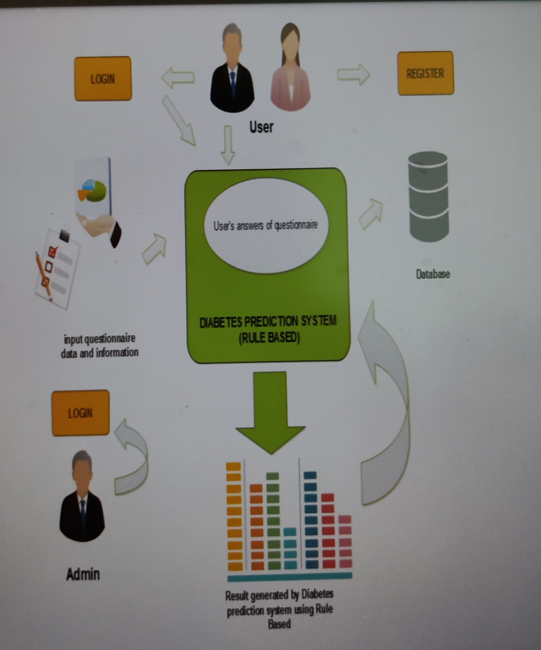

Figure1 :Framework for Diabetes Prediction System.

**CONTEXT DIAGRAM:**

Figure 2 show the Context Diagram for Diabetes Prediction System. There are two actor are involved in this system ; user and Admin. In context diagram, the flow of the actors are explained and their ability in this system.

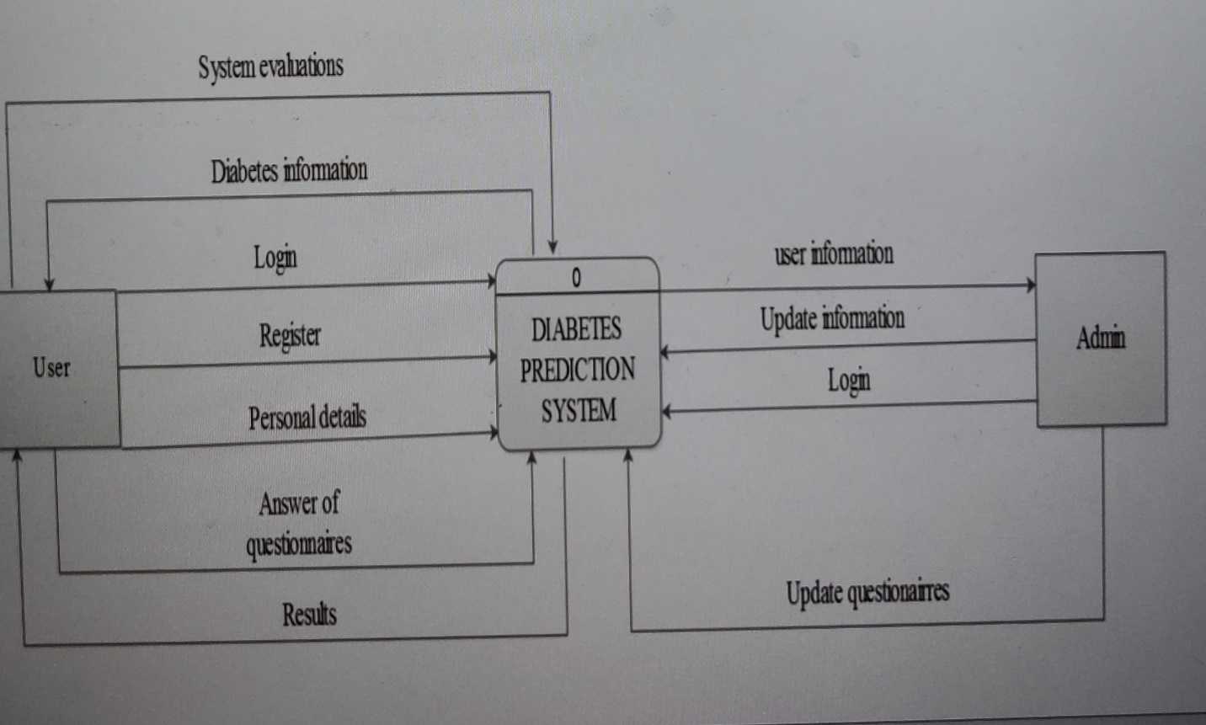

Figure 2 :Context Diagram

**ENTITY RELATIONSHIP DIAGRAM:**

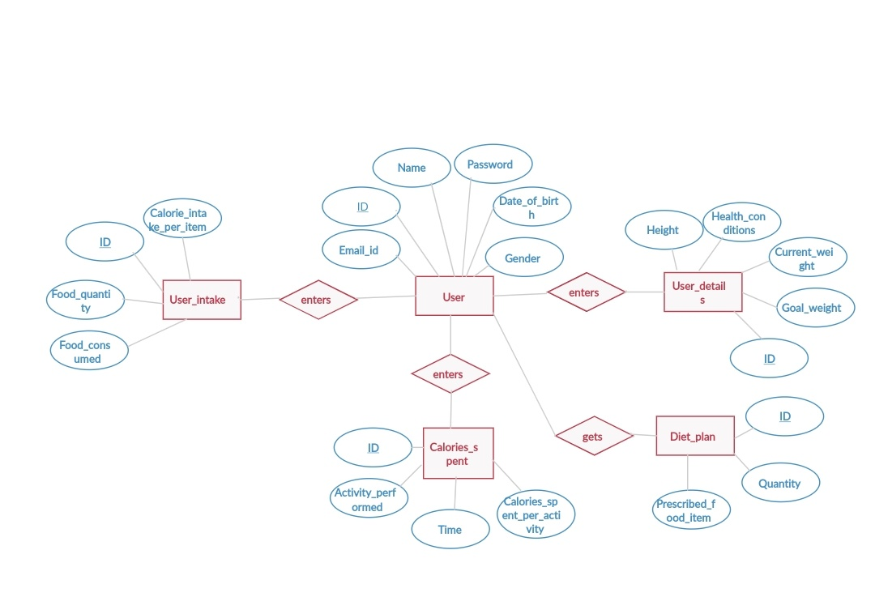

Fig3:ER Diagram