A Major Project Proposal Report on

**Swasthya-Pala; An Expert Meal Planning Agent with Forward Chaining for Diabetics Specific to Nepal**

Submitted in Partial Fulfilment of the Requirements for the Degree of **Bachelor in Software Engineering** under Pokhara University

Submitted By:

**Jitendra Bhatta,161747**

**Ghanshyam Joshi,161613**

**Mohan Kumar Dhakal, 161657**

Date:

24 March, 2020

**Department of Software Engineering**

**NEPAL COLLEGE OF**

**INFORMATION TECHNOLOGY**

Balkumari, Lalitpur, Nepal

# ABSTRACT

Diabetics is growing at an alarming rate, worldwide and in Nepal too. Nepal is currently adapting to a busy and unmanaged urban lifestyle due to which obesity and metabolic syndrome are on rise, which are the major cause of Diabetes. As Diabetes is a lifestyle disease, it can be reversed too, given that we make our consumption conscious and lifestyle a bit more organised. There are many people today, even at the age of 25-30 suffering from diabetes or pre-diabetes, who doesn’t surely want to go for medication as a simple tweak in their eating habits can reverse their condition. Eating the right food, at the right time, and in the right quantity is in itself a challenging task. The challenge is even more sound when it comes to track what we have eaten to control our eating pattern in the future and make safer food choices.

In order to solve this problem, we have proposed a solution with a mobile application which can plan a meal for a person according to their nutritional requirement, preference and allergic condition using a forward-chaining approach of an Expert System. Also, it helps track their blood glucose level to adjust their future meal accordingly. After a certain period of tracking the meal and blood glucose level, the application can also predict the possible BG level at a given time using a linear regression model, which can be a possible replacement for Glucometer in the long run.

***Keywords:*** *Diabetes, Glucometer, Blood Glucose, Linear regression model*

Table of Contents

ABSTRACT i

List of Figures iii

List of tables iii

1. INTRODUCTION 1

2. PROBLEM STATEMENT 2

3. PROJECT OBJECTIVES 3

4. SCOPE AND LIMITATON 3

4. SIGNIFICANCE OF STUDY 4

5. LITERATURE REVIEW 5

6. PROPOSED METHODOLOGY 6

6.1 Regression Algorithm for BG level Prediction 7

6.2 Software Development Model 8

7. TOOLS AND TECHNOLOGY 9

8. DELIVERABLES 9

9. SYSTEM ARCHITECTURE DESIGN 10

10. USE CASE DIAGRAM 11

11. PROJECT TIME AND TASK SCHEDULE 12

11.1 PROJECT WORK DURATION 12

11.2 GANTT CHART 13

12. BIBLIOGRAPHY 14

# List of Figures

1.Forward Chaining…………………………………………………………………………….…….6

2.Forward Chaining Example…………………………………………………………….……...….6

3. Waterfall software Development model…………………………………………………………8

4.System Architecture Design….……………………..……………………………..…………….10

5.Usecase Diagram………………………………………………………..………………………..11

6.Gantt chart……………………...…………………………………………..…..…………………13

# List of tables

1.Tools and Technology used………………………………………….…..………………………9

2.Project Schedule…………………………………………………..………………………………12

# 1. INTRODUCTION

Diabetes is a disorder in which blood levels of glucose are abnormally high due to either an absolute deficiency of insulin secretion, or as a result of reduced effectiveness of insulin, or both [1]. It is a major challenge to overcome today, thanks to the unmanaged and busy urban lifestyle. Although the causes of diabetes(type-2) are still uncertain, it is believed that it is caused mainly by unhealthy eating habits and sedentary activity and can be reversed with a simple tweak in our lifestyle.

Swasthya-Pala tries to solve this growing issue by providing solutions to diabetics where the Rule-Based expert system plans what they are going to eat in the day considering their nutritional needs, preferences, eating time, and allergic condition. Our system also provides the flexibility for user/experts to add their own food menu satisfying the criteria set which will be checked by expert meal planning agent. It is equally important for diabetics to track their Blood Glucose (BG) history to adjust their meal accordingly, our system provides meal adjustment by tweaking meals with different GI levels.

Measuring BG level with Glucometer might not always be feasible, as people start using our system and data is collected for certain time about their eating history, we can predict their probable BG level at a given point of time. The system will use a linear regression model to predict the probable BG level for a person and warn the user accordingly before any meal time.

# 2. PROBLEM STATEMENT

Diabetes prevalence has been rapidly rising especially in low- and middle-income countries like Nepal. Due to the sedentary lifestyle of people living in urban areas, overweight and obesity is on rise which is a major cause for type-2 diabetes. According to Nepal Diabetes Association (NDA) [2] diabetes affects 15% people of age more than 20 years and 19% of people of more than 40 years of age. According to WHO diabetics in Nepal is predicted to reach around 1,238,000 by 2030[3].

As diabetes is considered a lifestyle disease, a healthy diet and regular exercise can help reverse this condition. Eating mindfully with the knowledge of what we are eating is in itself a very challenging task as it requires in-depth knowledge to know what a food contains and how it affects the condition. Tracking what we have eaten is yet another challenging task diabetic face in their daily life. Similarly, no patient is able to adjust their meal according to what their BG level says at the given instant. On the other hand, people are forced to use glucometer reading for Blood Glucose, but it’s convenience and availability remains questionable. All these problems require systematic planning which obviously requires knowledge, effort, and most importantly the valuable time.

Because of the busy lifestyle and lack of technical knowledge in the particular field diabetes patients aren’t able to manage their lifestyle better so that the condition can be reversed faster and efficiently and doesn’t result in disaster. As the use of mobile devices has been increasing rapidly by all age groups, providing a personalized diet plan alongside some notifying mechanism for patients to control their eating and exercising habits in hand-held devices might be a useful solution.

# 3. PROJECT OBJECTIVES

* To plan a custom meal plan for diabetics considering nutritional need.
* To help Diabetics track their blood sugar level and warn them when caution needs to be taken.
* To predict probable blood sugar without using glucometer.
* To provide periodic nutrition consumption report.
* To help Diabetics manage their outdoor eating pattern with periodic reminder of future consequences.

# 4. SCOPE AND LIMITATON

### Scope

* Application is more focused on Type-2 then Type-1 diabetes.
* Works on a android platform
* Food recommendation is based on Nepalese cuisine only.
* Deals with macro nutrients

### Limitation

* No insulin tracking mechanism.
* The meal which will be recommended by the app is not expert certified.
* Cannot be used for any other diseases
* Does not deals with micronutrients

# 4. SIGNIFICANCE OF STUDY

Diabetics being an incurable disease has become a major challenge for countries today. To overcome this challenge, we needed a mechanism to provide patients with a healthy dietary option considering personal nutritional requirements. In addition to that, patients are also in the dire need of BG level management so that they could adjust their eating habits. Moreover, convenience and availability of glucometer in day-to-day life for BG measurement remains questionable and unpractical as compared to that provided by mobile devices.

# 5. LITERATURE REVIEW

The study done by NDA reveals the prevalence of type-2 diabetes in Nepal and it’s increasing trend due to ever-high rate of obesity and overweight, especially due to sedentary lifestyle in urban area.

*7 Day Diabetic Meal Plan* [4] provide general information regarding what to eat and what not for a person suffering from diabetes. This app consists of the food database specific to diabetes patients.

*Glucosio*[5] is another app for diabetic patients. It tracks important metrics like body weight, ketones, cholesterol, blood pressure, and more. It also helps users to set targets and reminders to keep their program on point.

Similarly, *Carb Manager* [6] focuses on tracking carbohydrate intake, as well protein, fat, and calories, with a database of foods and a bar code scanner.

There also has been extensive study on how can meal be predicted for custom dietary recommendation such as *Intelligent Ontological Agent for Taiwanese* [7] which uses fuzzy logic to determine the best meal for diabetics specific to Taiwan.

There have been several studies on BG level prediction for diabetics based on nutrition and insulin administration using various technique such as *Personalized Mathematical models* [8].

We have referenced an extensively worked documents *by Ishwar Subedi on Menu Planning from DFTQC* [9] to collect and refine expert advice, that document involves different food groups, what foods belong to that food group, their nutritional value, and an example on how can we plan the meal.

Moreover, the book *Fundamental of Food Nutrition and Diet Therapy helped* us learn about the importance of nutrition in body, and how meal planning can save time and money for balanced diet, we have also collected the calorie calculation strategy from here [10].

# 6. PROPOSED METHODOLOGY

For meal planning we have a Rule-Based Expert System that can plan 3 meals a day for a patient based on the data provide by themselves.Forward-chaining expert system can make recursive decision and plan a best meal with the given criteria from the application as shown in the example of forward-chaining below. Implementation of expert system will probably be done in Python but it is still a matter of research.

#### Fig. 1 Forward Chaining

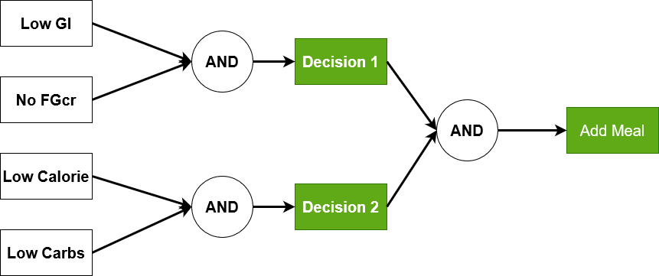

**Fig. 2 Forward Chaining Example**

## 6.1 Regression Algorithm for BG level Prediction

Linear regression attempts [10] to model the relationship between two variables by fitting a linear equation to observed data. One variable is an

explanatory variable, and the other is a dependent variable. Given by,

y = X β + ε

y = dependent variables (target variables),

X = Independent variables (predictor variables),

β is a linear coefficient

ε = error variable

Sugar level in diabetic patients is directly proportional to carbohydrate consumption. Since carbohydrate is a major factor in controlling diabetes. We will be using carbohydrate content of food as an independent variable (X) and blood glucose level as dependent variable (y).

**(Blood Glucose Level) = (Carbohydrate) *β +* ε**

## 6.2 Software Development Model

Our project requires careful planning at the initial phase of the project followed by designing, coding and testing of the application. As requirements are clear at start and doesn’t require constant communication with stakeholders for change in requirement, we are following waterfall strategy to build the project.

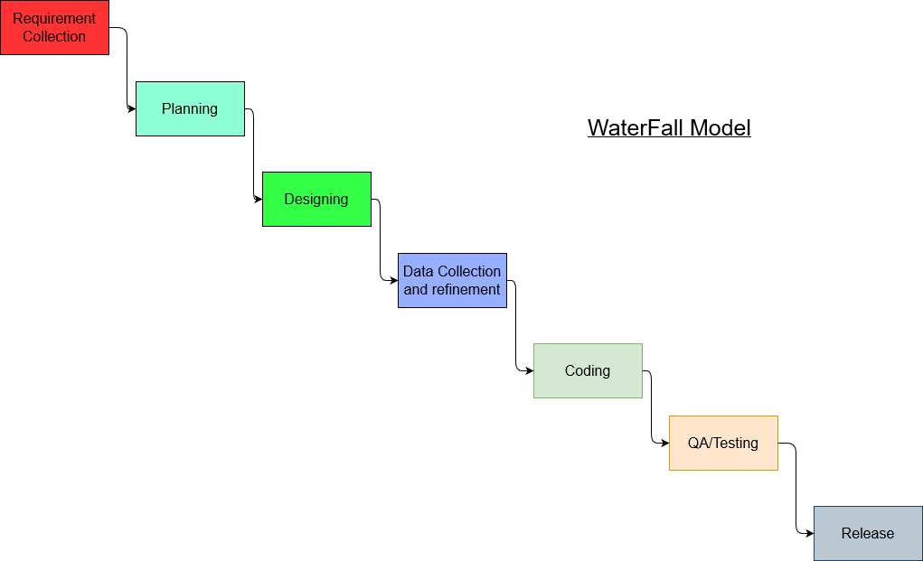

**Fig. 3 Waterfall Software Development Model**

# 7. TOOLS AND TECHNOLOGY

While developing this particular application we will make use of various tools and technologies as mentioned in the below table.

|  |  |
| --- | --- |
| **Tools and Technology** | **Uses** |
| Flutter | For android application development |
| Linear Regression Model | BG level prediction |
| MYSQL | For database |
| PHP/LARAVEL | Server-side coding language |
| Python | Regression model implementation |
| VS Code/Android Studio | Tool for coding |

**Table 1. Tools and Technology used**

# 8. DELIVERABLES

Our solution is applicable to Nepalese market and is specialized for people suffering from diabetes and pre-diabetes. Some of the key outcome we can expect from this project are: 1. Periodic custom meal plan for user

1. Periodic nutrition consumption report
2. Blood Glucose tracking mechanism
3. Predicted Blood Glucose level

# 9. SYSTEM ARCHITECTURE DESIGN

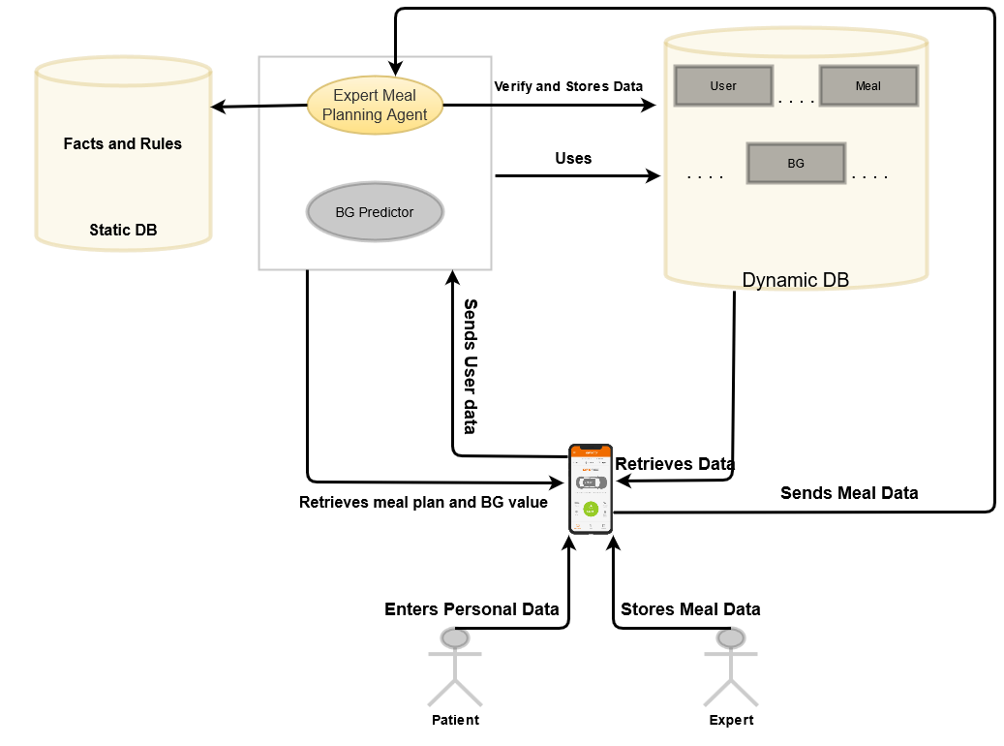

**Fig. 4 System Architecture**

# 10. USE CASE DIAGRAM

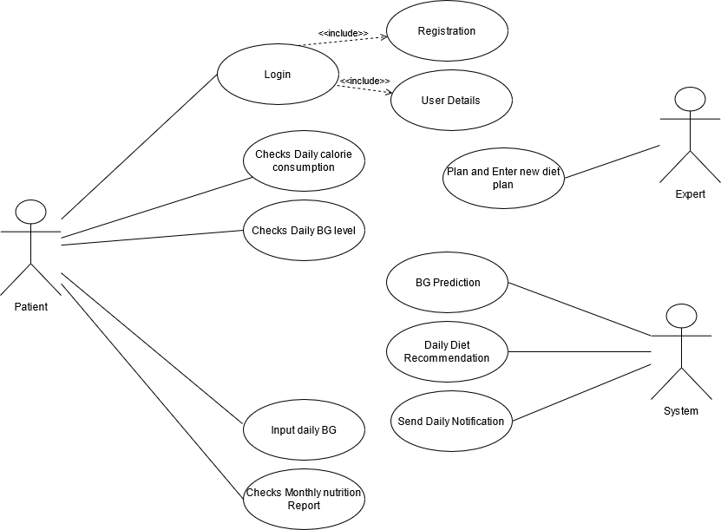

**Fig. 5 Use Case Diagram**

# 11. PROJECT TIME AND TASK SCHEDULE

As the concept we have raised required knowledge from different field that we are in, We have spent most of our time doing research and planning. We have projected to accomplish our project by 7th of May with the duration of 2 months. Duration for each part of our work is given in below table.

## 11.1 PROJECT WORK DURATION

|  |  |
| --- | --- |
| **Tasks** | **Projected Duration (Days)** |
| Research, Planning and Documentation | 15 |
| Database Schema Design | 2 |
| Data collection, refinement, Facts and Rule Building | 10 |
| Expert System Building,  Server side coding, Regression model preparation | 20 |
| Documentation and testing | 3 |
| Application Coding | 10 |
| Final QA and Documentation | 4 |
|  | 64 days |

**Table 2. Project Schedule**

## 11.2 GANTT CHART

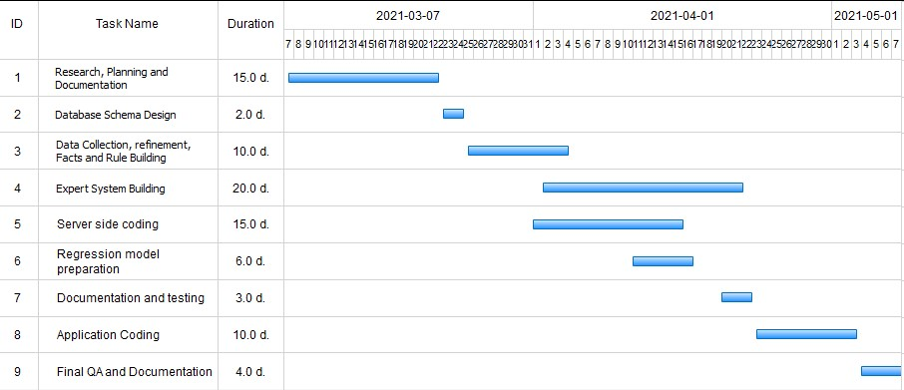

**Fig 6. Gantt Chart**

# 12. BIBLIOGRAPHY

[1] American Diabetes Association, 3Standards of medical care in diabetes-2007, ́ Diabetes Care, vol. 30, no. 1, pp. S4-S41, Jan. 2007.

[2] Nepal Diabetes Association

<https://nepaldiabetesassociation.com/research.php>

[3] <https://www.who.int/news>[-room/factsheets/detail/diabetes#:~:text=The%20number%20of%20people%20with,in%20premature% 20mortality%20from%20diabetes.](https://www.who.int/news-room/fact-sheets/detail/diabetes#:~:text=The%20number%20of%20people%20with,in%20premature%20mortality%20from%20diabetes)

[4] 7 Day Diabetic Meal Plan, Mobile Application

<https://play.google.com/store/apps/details?id=com.DaDiabetes.MealPlanS&hl=en&gl=US>

[5] Glucosio, Mobile Application

<https://play.google.com/store/apps/dev?id=7346203302402258491&hl=en&gl=US>

[6] Carb Manager, Mobile Application

https://www.carbmanager.com/

[7] Chang-Shing Lee, Mei-Hui Wang, Huan-Chung Li, Wen-Hui Chen, “ Intelligent ontological agent for diabetic food recommendation”

<https://ieeexplore.ieee.org/document/4630615>

[8] Peter Gyuk, Istvan Vassanyi, Istvan Kosa, “ Blood Glucose Level Prediction for Diabetics Based on Nutrition and Insulin Administration Logs Using Personalized Mathematical Models”

<https://www.hindawi.com/journals/jhe/2019>[/8605206/](https://www.hindawi.com/journals/jhe/2019/8605206/)

[9] Department of Food Technology and Quality Control, Government of Nepal

<http://dftqc.gov.np/>

[10] Sumati R. Mudambi, M.V. Rajagopal, “Fundamentals of Foods, Nutrition and Diet Therapy”

<https://alraziuni.edu.ye/uploads/pdf/fundamentals>[-of-foodnutrition-and-diet-therapy.pdf](https://alraziuni.edu.ye/uploads/pdf/fundamentals-of-foodnutrition-and-diet-therapy.pdf)

[11] Linear Regression

<https://en.wikipedia.org/wiki/Linear_regression>