**Problem Statement**

The problem about this project is it is not easy to do diagnosis whether it is positive or negative having diabetes. It is because of many reason. Different people maybe have different signs. So it is not easily to assume that they have it or not. The sign of the diabetes is always thirsty, always hungry, weight become decrease, feel weak, have problem of sight, headacnes, always do urination and so on. However, the real diagnosis are still needed to assign the real result.

**OBJECTIVES**

a) To measure the probability of a user for getting diabetes.

b) To implement rule based algorithm as prediction technique into a system

c) To develop the system that function with the real problem.

**SCOPE**

This system will focus on the potential user, admin and system.

**i. Potential user:**

• The user that have signs or not can get early diagnosis about diabetes and takes early preventation.

• User need sign up and then sign in. They need to fill out the personal information. Next, do prediction by using the system.

• User also able to view preventation and information about Diabetes section in this system.

**ii. Admin**

• The person who will coordinate this system and update the system based on situation.

• People who responsible to update information section in the system.

**iii. System**

• Login

- There is login and registeration to enter this system based on type of user.

**• Questionaire module**

- There is questionaire that need be answered and evaluation by potential user and from that, the result can be find out.

• **Domain System(Diabetes)**

-The result can be find out after analyzing through rule based and tree decision technique.

• **Opinion or its rate**

User can give opinion and suggestion and give their rate about the system. Example, the early prediction really can be trusted or not.

• **Information Section**

-User can find out more information of Diabetes

- Through the information, users who potentially have Diabetes can take early preventation.

**LIMITATION OF WORK**

This system is only give the early prediction based on the signs that user had. The result of prediction may not accurate like the diagnosis from doctor. User need to seek consultant with doctor if want the real one diagnosis. This system just able to alert user to take fast action about the diabetes. If the user are predicted have positive diabetes, the system will give suggestion and recommend for healthy diet plan.

**FRAMEWORK**

Framework is a basic structure that are needed to solve the complex problem or as known as the tools and material or component. In the Diabetes Prediction System, there are only two users that we called it as Admin and user. For Admin, they need log into the system if they want manage their system. After login, they are retrieved into their own interface (different interface with user‟s interface) .They can add, delete or update the information segment. They also can manage their profile, view prediction result of users, delete user and user‟s opinion module. Admin also has right to add new admin for this system. While for user, they need register firstly to gain user ID , email and password. The user ID,user Name and password will be used by them to log into the system. After successfully login, they can use Diabetes Prediction System by answer the questionnaire that given. With the answer, the system will generate the result about the user‟s potential to get Diabetes and they will advised to seek doctors to find out real results. They also can view information about Diabetes and give their opinion through „Contact Us‟ column.

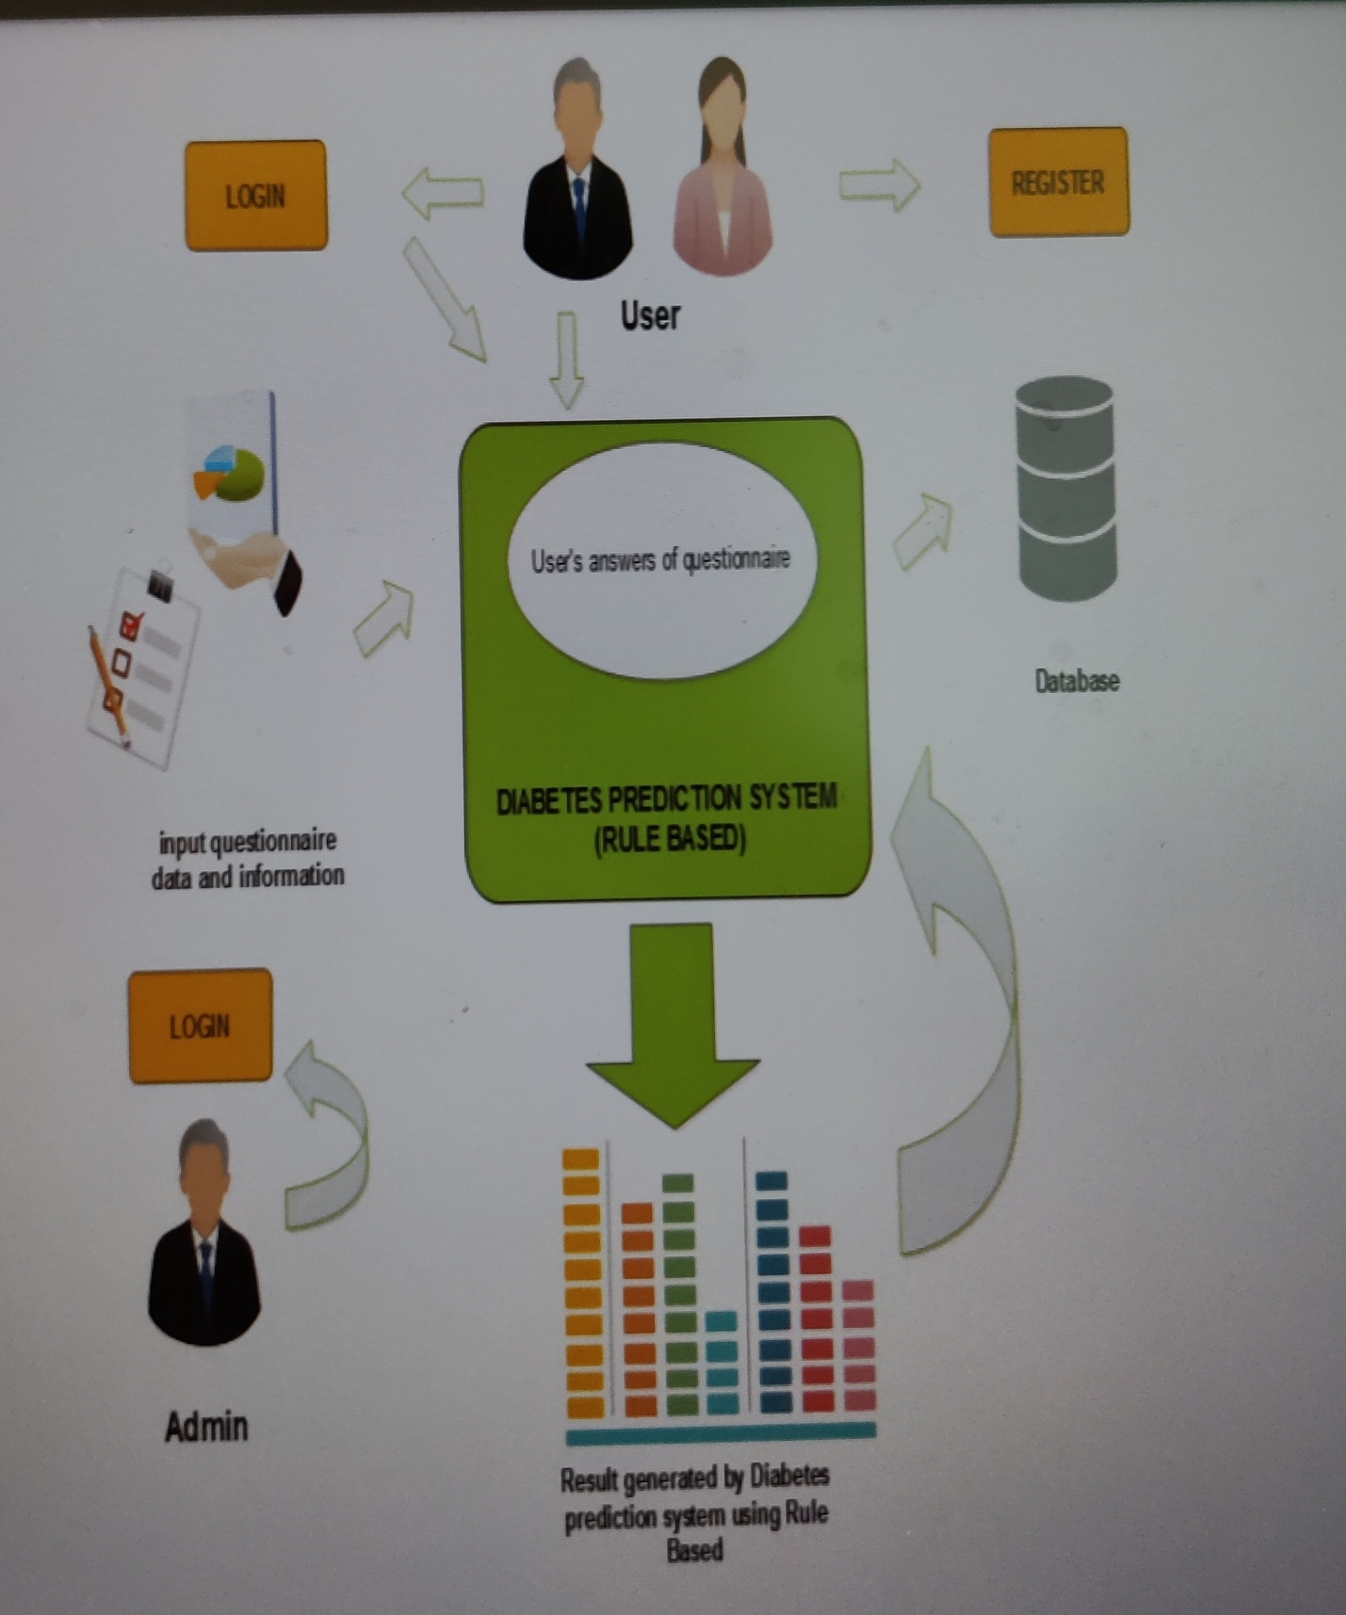

Figure1 :Framework for Diabetes Prediction System.

**CONTEXT DIAGRAM:**

Figure 2 show the Context Diagram for Diabetes Prediction System. There are two actor are involved in this system ; user and Admin. In context diagram, the flow of the actors are explained and their ability in this system.

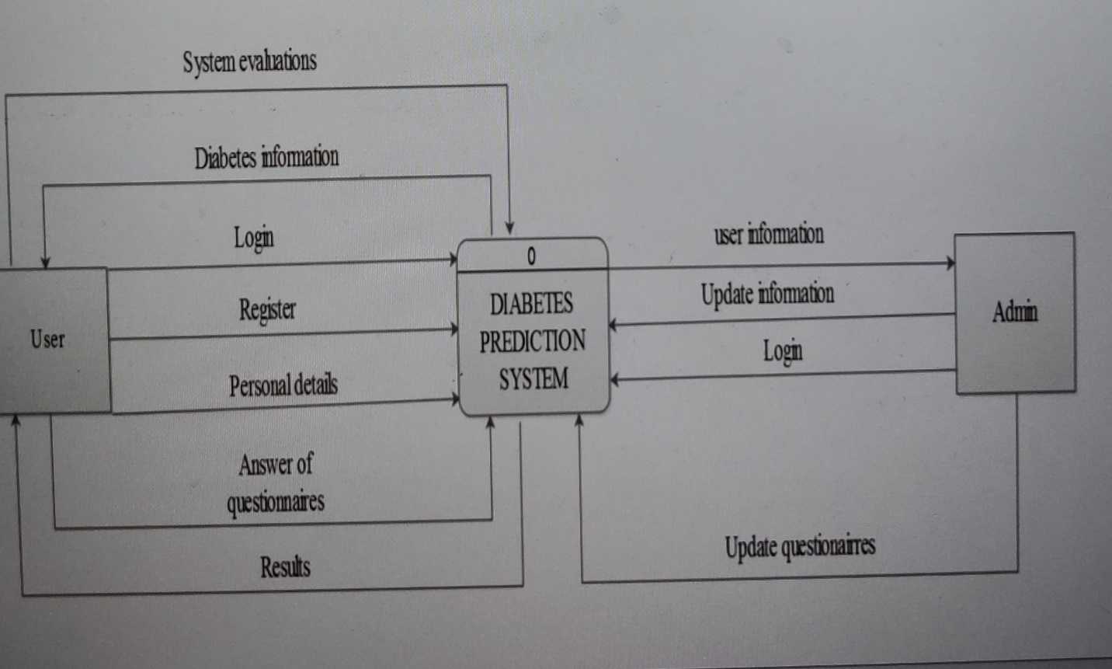

Figure 2 :Context Diagram