­

A Minor Project Proposal Report on

**Nutritional information extraction using Mask R-CNN deep learning model with food images**

Submitted in Partial Fulfillment of the Requirements for the Degree of **Bachelor in Software Engineering**

Under Pokhara University

Submitted by :

Mohan Kumar Dhakal, 161651

Jitendra Bhatta, 161747

Keshav Kunwar, 161749

Sumit Paudel, 161752

Under the supervision of

Chandra Prakash Bhatta

Date:

27thJuly, 2019



**Department of Software Engineering**

**NEPAL COLLEGE OF**

**INFORMATION TECHNOLOGY**

Balkumari,Lalitpur,Nepal

**Abstract**

*This application provides the nutritional facts about the food we consume in daily basis. Knowing what goes inside our body is critical to keep ourselves healthy and change our lifestyle. In this application we use Mask R-CNN (deep learning algorithm) to classify food and provide approximate nutritional value the food contains. Macronutrients such as protein, carbohydrate, fats are available in every food we eat. This application updates user on how much such macronutrients they have consumed so that they could decide on what is needed and what not. This application also has flexibility that user can change the amount of food than the application has predicted and application will automatically updates it’s nutritional contents in the database accordingly.*

**Keywords**: Deep-Learning, Mask R-CNN, Protein, *Carbohydrate*, Fats, Micronutrients

**Table of Contents**

Abstract………………………………………………………………………………………..ii

Table of contents…………………………….…………………………………………….……iii

List of figures………………………………...…………………………………………………iv

List of Tables…………………………………………………………………………….……...iv

1. Introduction………………………………………………………………….…….……1
   1. Problem Statement………………………………………………….………........2
   2. Project Objectives………………………………………………….…………….3
   3. Significance of study…………………………………………….………….…...3
2. Scope and Limitation………………………………………………….………….…......4
   1. Scope ………………………………………………………….…………………4
   2. Limitation…………………………………………………….…………………..4
3. Literature review…………………………………………………………………..….....5
4. Use case Diagram…………………………………………………………….….…........6
5. Activity Diagram………………………………………………..……..………………...7
6. Proposed Methodology…..………………………………………..…………..….….....8
7. Tools and Technology used………………………………………………………...........9
8. Expected Outcomes………………………………………………………………….......10
9. Project task and time schedule……………………………………………………...........10
   1. Project Schedule…………………………………………………………….........11
   2. Gantt chart…………………………………………………………………..……11
10. References…………………………………………………………………………..……12.

**List of Figures**

1. Use case Diagram…………………………………………………………………….6
2. Activity Diagram …………………………………………………………………….7
3. Proposed Methodology………………………………………………………………8
4. Gantt Chart…………………………………………………………………………..10

**List of Tables**

1. Tools and technology used…………………………………………………………...9

2. Project Schedule……………………………………………………………………...11

**1. Introduction**

Knowing about nutrients of foods that we are consuming is very important to be fit and healthy. It also helps us to live a beautiful and healthy life.

This application tries to provide the fact of nutrients that we consume with the help of photo that we capture. This application asks for camera permission and tries to classify the food in the image using the Mask R-CNN model which is a popular model for object classification in an image used by many. After successfully completing the classification process we take the name of the food and query on the database to extract it’s additional nutritional information. As we are using the in-device database specifically for android devices we will be using MYSQL as local database to store the nutritional information about the food.

In initial phase the application provide the link to the Facebook and Instragram account of user for login directly. Then the user capture a image of the food that they are being consumed and this application provide the exact nutritional information about some very common Asian foods such as Momo , Chowmein and French Fries and later provide the report about the nutrients they used on the basis of weekly, monthly and annually.

**1.1 Problem Statement**

According to World Health Organization [1], almost 20% of deaths worldwide are due to an unhealthy diet. The problem here is not consuming sufficient food; the problem is that people do not knowing what’s in their diet. If people are able to estimate their nutrient of food using the images of their food, they can easily decide on the amount of nutrients they want to consume. If people knew how much calories their food contains, then this problem will be somewhat controlled.

Almost every person has smartphone in their hand today, people can get all the nutritional information regarding the food they consume which helps them control the unnecessary food from entering their body. People can easily monitor on doctor’s prescription by knowing the amount of macronutrient they consume by just a simple image click.

**1.2 Project Objectives**

Our project objectives are to:

* Provide user the nutritional information about that food they consumed and help them reach their fitness goal.
* Eliminate the irritating process of searching food preference in text-based database just to know about their nutrients value.
* It adjusts itself to the amount so don’t need to manually calculate nutrients value for different quantity.

**1.3 Significance of Study**

The significance of study of this android application is to provide user with the information about the food they consume in their mobile screen. As android is one of the leading mobile operating system with around 70% market share we can provide the critical information about user’s food preference in just a few clicks in the their device to majority. This will significantly save the user’s time to search and surf to the internet for the same purpose time and again. Using real time images we have also reduced user’s time of typing in the name of the food to search for it’s nutrition value and manually calculate it’s nutritional value according to quantity.

1. **Scope and Limitations**

**2.1 Scope**

The application has following scopes:

* It can be a useful application to be informed about what goes inside our body.
* With this application user don’t have to remember the name of the food they consume and manually calculate it’s nutritional value.
* User can also review their daily nutritional intake as we have the feature of editing and saving information locally.

**2.2 Limitations**

The application has limitations as mentioned below:

* This requires android version more than 4.0 (Kit Kat) to run.
* This application only has information about few common foods.
* The amount of food it predicts might not be exact though user can manually change the value according to their preference and the application will remember this.

**3. Literature review**

Mask R-CNN [2] is developed based on Faster R-CNN, which is a region-based Convolutional Neural Network. A Convolutional Neural Network (ConvNet/CNN) is a Deep Learning algorithm that can take in an input image, assign importance (learnable weights and biases) to various aspects/objects in the image and can differentiate one type of image from the other.

Recently the implementation of Mask R-CNN was done by one of the employee at Leapfrog Technology [3] which was a reference point for us to learn and explore more about it.

1. **Use Case Diagram**

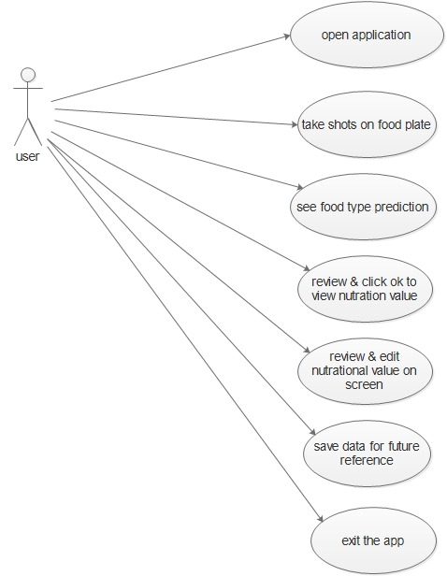

**Fig. Use Case Diagram**

**5. Activity Diagram**

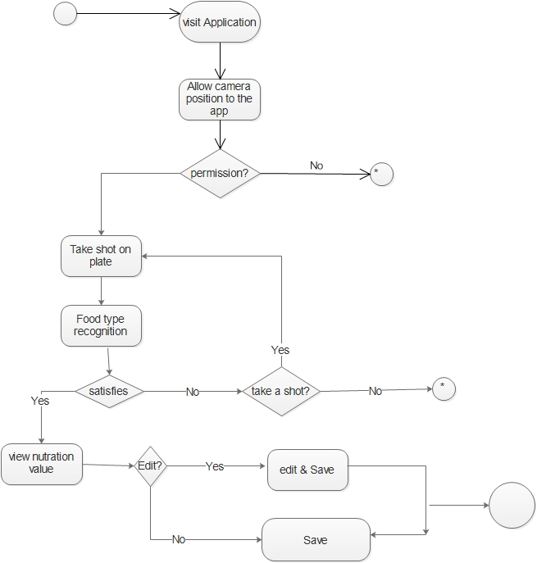

**Fig. Activity Diagram**

**6. Proposed Methodology**

Based on the nature and requirement of a project waterfall model has been chosen for developing this application. Using this model we can simplify the process of making an application. As our requirements are clear and well defined earlier we take waterfall model as a perfectly suitable model for us.

Our Final product will go through the below mentioned steps in waterfall model:

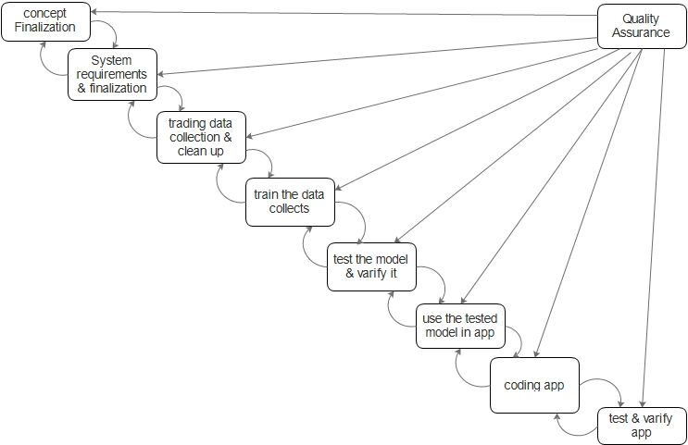

**Fig. Water fall Model of software development process**

1. **Tools and technology used**

While developing the software we have made use of following tools and technologies for different purpose as mentioned below.

|  |  |
| --- | --- |
| **Tools and Technology** | **Uses** |
| Java | Programming Language for android with native support |
| Android Studio/VS Code/PyCharm | Native environment for android application development/Server site coding/For machine learning |
| Adobe XD | User Interface design using Adobe Experienced Design |
| R-CNN | Popular Deep learning model for instance segmentation of images. |

**Table 1.Tools and technology used**

1. **Expected outcomes**

Our application is informative and useful for almost everyone who wants to maintain their healthy lifestyle.

Our expected outcomes are:

* Reliable nutritional information regarding the food consumed.
* Daily report on calorie and macronutrients intake.

1. **Project time and task schedule**

The project schedule has been designed as per requirements and constraints involved. This project is scheduled to be completed around 2 month. Learning Deep learning algorithms and implementing R-CNN model as we mentioned above has been challenging part and has been given more time. Once the training is completed with the data collected by us we’ll simply use it in the application we are developing. We also are researching on fixing weather to use a high end device or using cloud computing resources to train our models. The coding parts won’t take much time and has been given less time.

**9.1 Project Schedule**

|  |  |
| --- | --- |
| **TASK** | **APPROX.DURATION(in days)** |
| Learning the basics of Deep Learning | 15 |
| Implementing Basics algorithm in Java | 10 |
| Learning about Mask R-CNN model and it’s use cases | 5 |
| Training on collected data using Mask R-CNN | 5 |
| Application analysis and Design | 5 |
| Data Collection and cleaning up the data | Ongoing until training |
| Application Coding and debugging | 5 |
| Testing and verification | 2 |
| Final documentation | 2 |

**Table 2**

**Fig. Project Schedule**

**9.2 Gantt Chart**

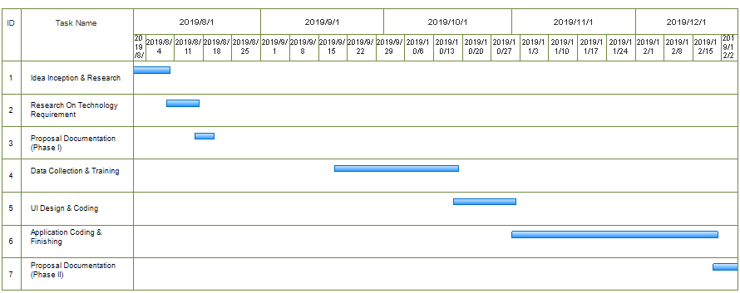

**Fig. Gantt Chart**

1. **References**

[1]<https://www.who.int/> accessed at 26 ,July 2019 at 12:52 pm

[2]<https://arxiv.org/abs/1703.06870> accessed at 27, July 2019 at 2:30pm.

[3]<https://www.lftechnology.com/blog/image-calorie-estimation-deep-learning/>accessed at 27 , July 2019 at 5:00 pm.