Customer Statement Processor

Use Case 1:

Input: The below input has duplicate reference number.

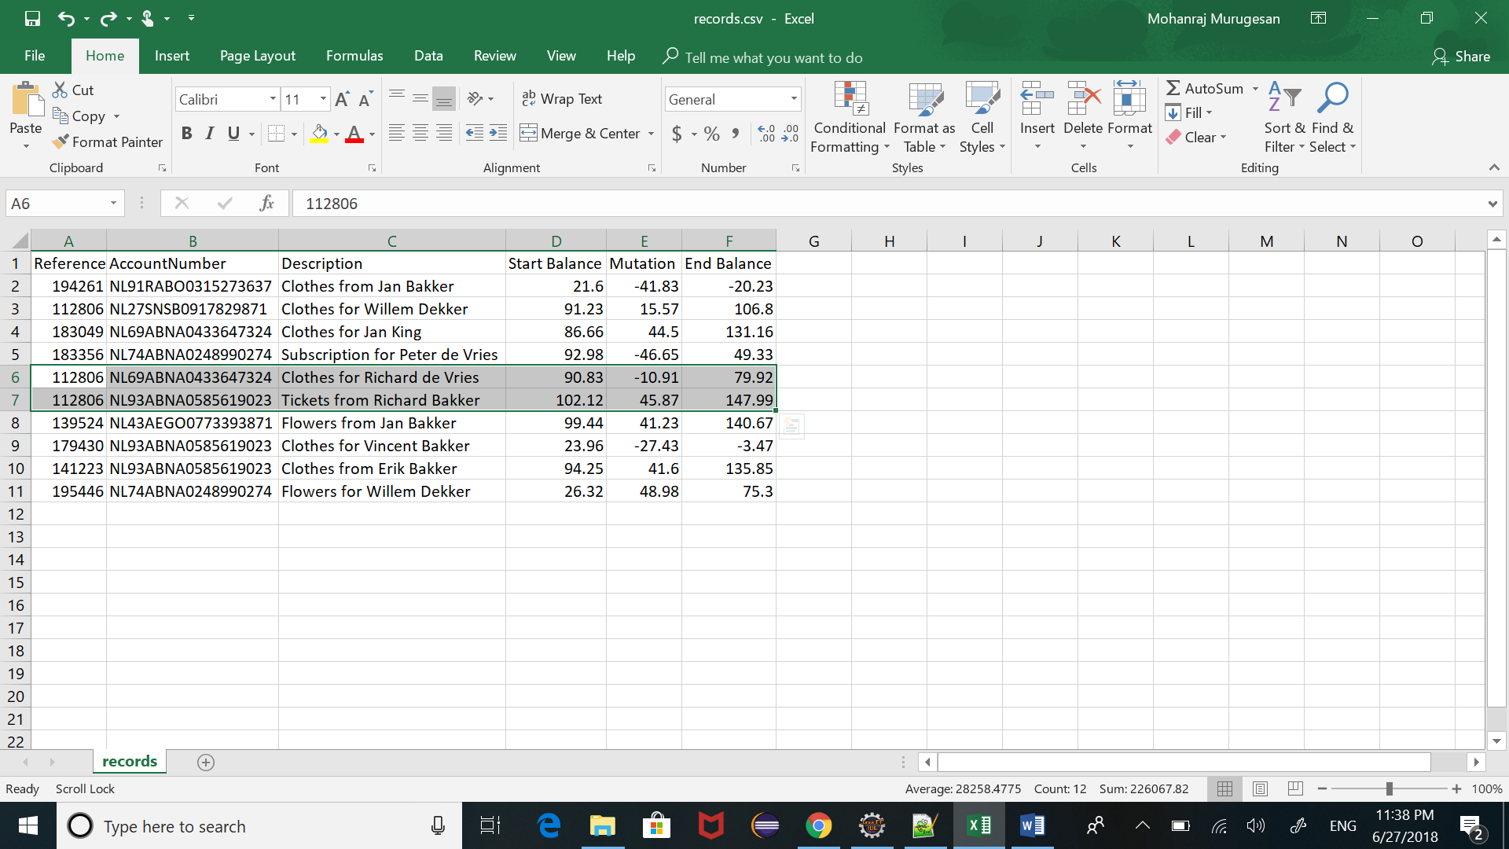

Output: The transaction which has duplicate reference number will be displayed as shown in the below image. This output format can be modified further as per need with only minimal change.

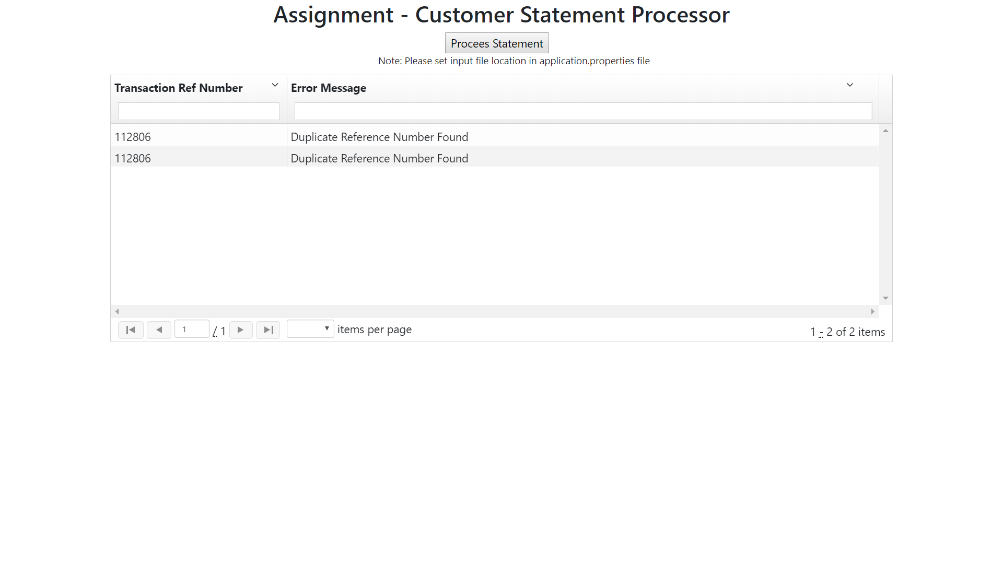

Use Case 2:

Input: The below input has some invalid end balance.

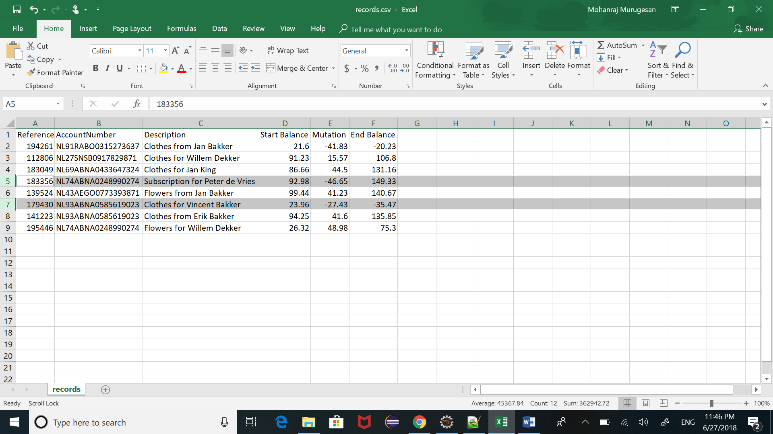

Output: The transaction which has invalid end balance will be displayed as shown in the below image. This output format can be modified further as per need with only minimal change.

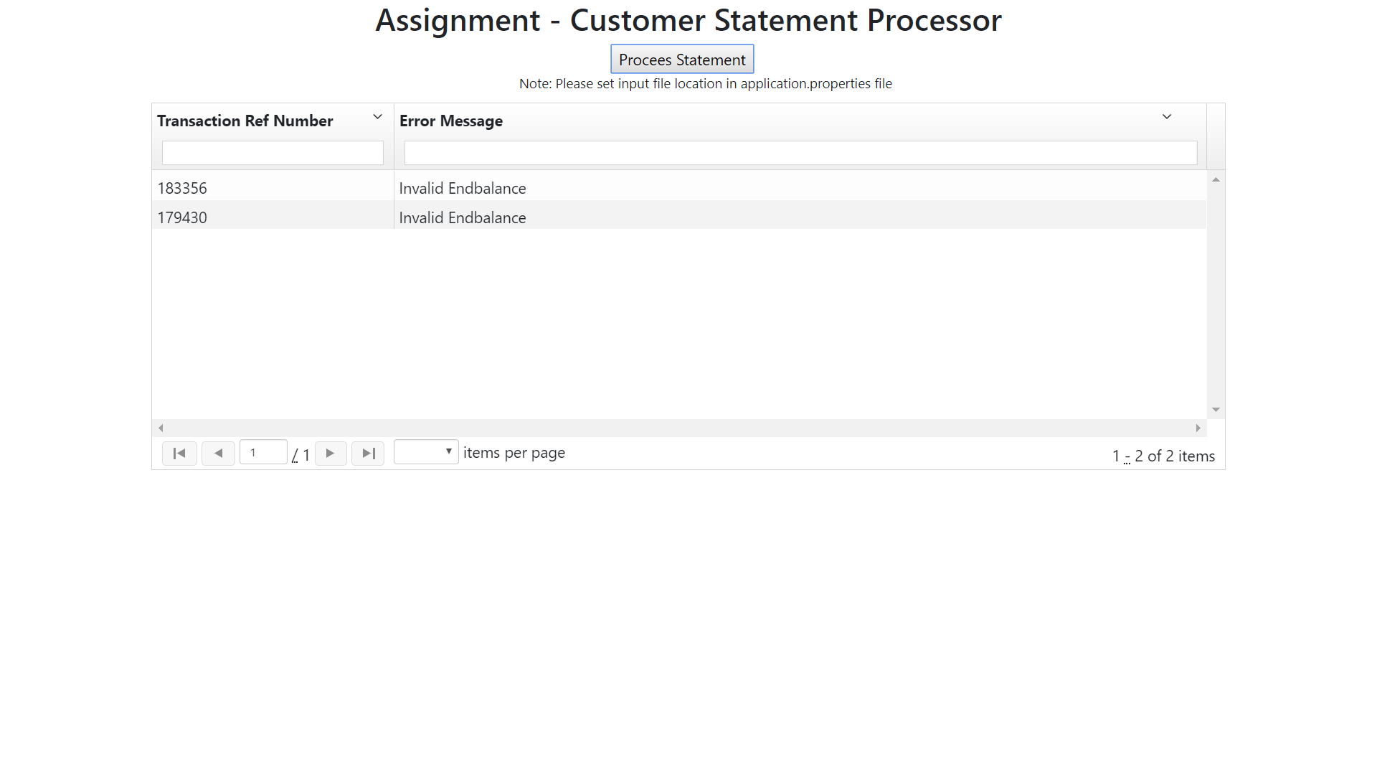

Use Case 3:

Input: The below input has some duplicate transaction number and invalid end balance.

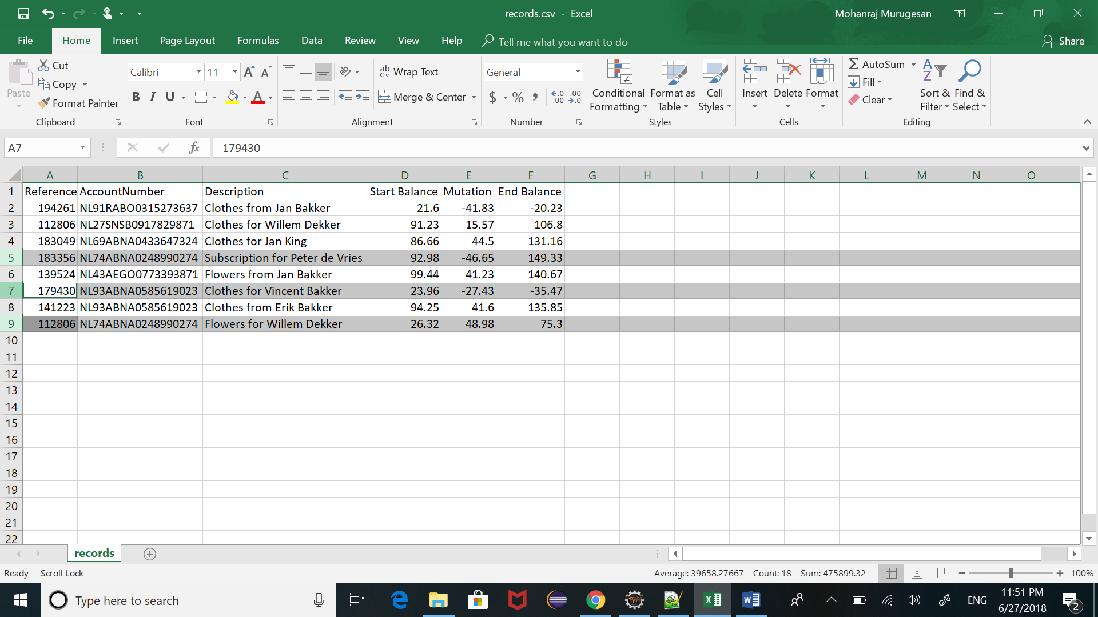

Output: The transaction which has duplicate reference number and invalid end balance will be displayed as shown in the below image. This output format can be modified further as per need with only minimal change. For example, we can merge validation results based on transaction reference number. So that there will be only one entry for each transaction.

