**1.**

class Outer {

int a;

void test() {

Inner in =new Inner();

in.display();

}

Outer(int a){

this.a=a;

}

class Inner {

void display()

{

System.out.println("The value of a is "+a);

}

}

void localTest(){

class LocalInner{

void test() {

System.out.println("A is accesed in local class"+a);

}

}

LocalInner li = new LocalInner();

li.test();

}

}

public class Main{

public static void main(String args[]){

Outer out = new Outer(48);

out.test();

out.localTest();

Outer.Inner in = new Outer(19).new Inner();

in.display();

}

}

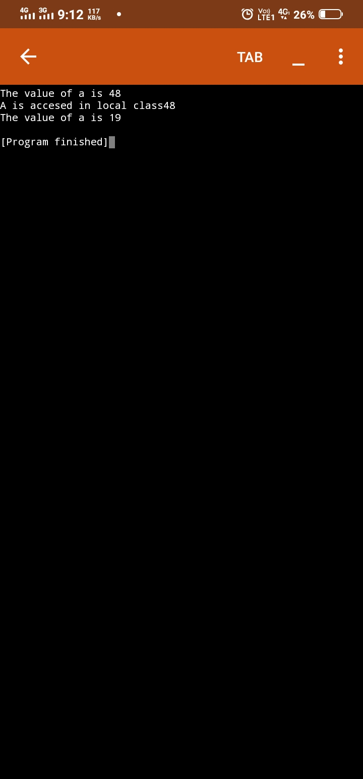

**2.Anonimus Class**

class Outer {

int a;

void test() {

Inner in =new Inner();

in.display();

}

Outer(int a){

this.a=a;

}

class Inner {

void display()

{

System.out.println("The value of a is "+a);

}

}

void localTest(){

class LocalInner{

void test() {

System.out.println("A is accesed in local class"+a);

}

}

LocalInner li = new LocalInner();

li.test();

}

}

abstract class AnTest {

public abstract void print();

}

public class Main{

public static void main(String args[]){

Outer out = new Outer(19);

out.test();

out.localTest();

Outer.Inner in = new Outer(19).new Inner();

in.display();

AnTest at = new AnTest() {

public void print() {

System.out.println("It is an Anonymous class method");

}

};

at.print();

}

}

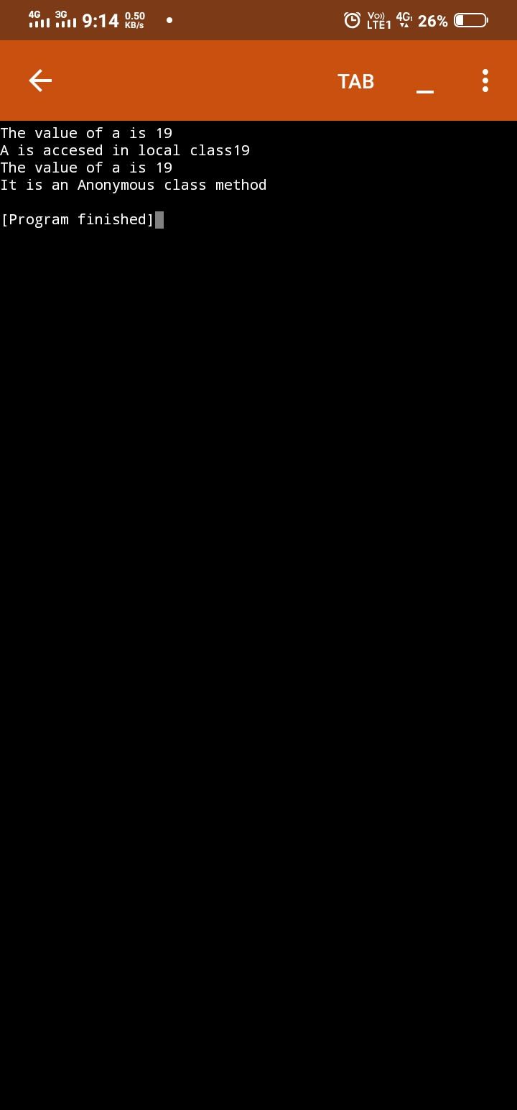

**3.**

import java.util.*;

public class Main

{

public static void main(String[] args) {

System.out.println("Hello World");

ArrayList<String> al = new ArrayList<String>();

ArrayList<Integer> ai = new ArrayList<Integer>();

ArrayList<Float> af = new ArrayList<Float>();

System.out.println("the size of array list is "+ al.size());

al.add("gopi");

al.add("sai krishna");

al.add("goutham");

al.add("krishna");

al.add(3,"khasim");

System.out.println("the size of array list is "+ al.size());

System.out.println("elements of al are "+ al);

al.remove("gopi");

al.remove("khasim");

System.out.println("the size of array list is "+ al.size());

System.out.println("elements of al are "+ al);

ai.add(5);

ai.add(10);

System.out.println("the size of array list is "+ ai.size());

System.out.println("elements of ai are "+ ai);

af.add(10.0f);

af.add(11.2f);

System.out.println("the size of array list is "+ af.size());

System.out.println("elements of af are "+ af);

}

}

