CSE18R272-LAB MANUAL

KALASALINGAM ACADEMY OF RESEARCH AND EDUCATION

COMPUTER SCIENCE AND EDUCATION

Date: 16-09-2020

Day: Wednesday

Name:G.Mohan Gopi Krishna

Regno: 9919004081

Section: A5

Course name: java programming

Course Code: CSE18R272

Date of submission : 16-09-2020

1.Create a class called Employee that includes three pieces of information as instance variables—a first name (typeString), a last name (typeString) and a monthly salary (double). Your class should have a constructor that initializes the three instance variables. Provide a set and a get method for each instance variable. If the monthly salary is not positive, set it to 0.0. Write a test application named EmployeeTest that demonstrates class Employee’s capabilities.Create two Employee objects and display each object’s yearly salary. Then give each Employee a 10% raise and display each Employee’s yearly salary again.

Program:

class Employee{

String firstname;

String lastname;

double salary;

public Employee(String fn,String ln,double sal){

firstname = fn;

lastname = ln;

if(salary<0){

salary=0.0;

}

else{

salary = sal;

}

}

void setFn(String fn){

firstname = fn;

}

void setLn(String ln){

lastname=ln;

}

void setSal(double sal){

if(salary<0){

salary=0.0;

}

else{

salary = sal;

}

}

String getFn(){

return firstname;

}

String getLn(){

return lastname;

}

double getsal(){

return salary;

}

double sal(int percent){

salary+=salary\*((percent/100.0));

return salary;

}

}

public class Main

{

public static void main(String[] args) {

Employee em1 = new Employee("gopi","Gandikota",200000);

Employee em2 = new Employee("kotewara rao","Gandikota",300000);

System.out.println(em1.getFn() + em1.getLn() +em1.getsal());

System.out.println(em2.getFn() + em2.getLn() +em2.getsal());

double s = em1.sal(10);

System.out.println("Annual salary is " + (s\*12));

double s2 = em2.sal(15);

System.out.println("Annual salary is " + (s2\*12));

}

}

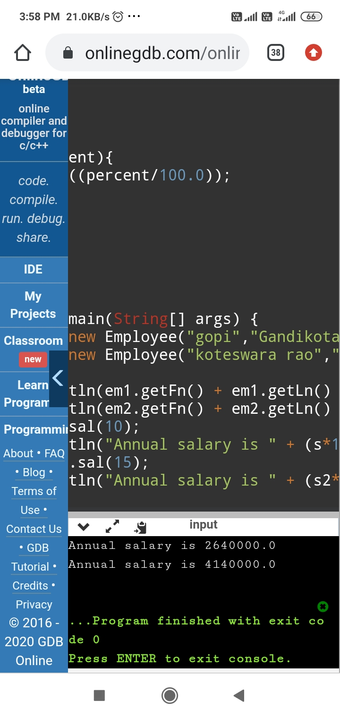

2.Create a class called Invoice that a hardware store might use to represent an invoice for an item sold at the store. An Invoice should include four pieces of information as instance variables‐a part number(type String),a part description(type String),a quantity of the item being purchased (type int) and a price per item (double). Your class should have a constructor that initializes the four instance variables. Provide a set and a get method for each instance variable.In addition, provide a method named getInvoice Amount that calculates the invoice amount (i.e., multiplies the quantity by the price per item), then returns the amount as a double value. If the quantity is not positive, it should be set to 0. If the price per item is not positive, it should be set to 0.0. Write a test application named InvoiceTest that demonstrates class Invoice’s capabilities.

Program:

class Invoice{

String partnumber;

String partdescription;

double price;

int quantity;

public Invoice(String pno,String pds,double rate,int qu){

partnumber = pno;

partdescription = pds;

price = rate;

quantity = qu;

if(price<0){

price=0.0;

}

else{

price = rate;

}

if(quantity<0){

quantity=0;

}

else{

quantity = qu;

}

}

void setPno(String pno){

partnumber = pno;

}

void setPds(String pds){

partdescription = pds;

}

void setPrice(double rate){

if(price<0){

price=0.0;

}

else{

price = rate;

}

}

void setQu(int qu){

if(quantity<0){

quantity=0;

}

else{

quantity = qu;

}

}

String getPno(){

return partnumber;

}

String getPds(){

return partdescription;

}

double getPrice(){

return price;

}

int getQuant(){

return quantity;

}

double getInvoice(){

return (price\*quantity);

}

}

public class Main

{

public static void main(String[] args) {

Invoice i = new Invoice("sc481","key board",220,3);

System.out.println("the invoice is " + i.getPno() + " "+i.getPds()+" "+i.getPrice()+" "+i.getQuant());

double bill = i.getInvoice();

System.out.println("the net amount is "+ bill );

}

}

